“Meat” Your Next Career
Created: 02/2024 by the National FFA Organization
Description of Lesson: Meat processing is a unique SAE and career path. In this lesson, learn how Kylie Skadberg got started in her SAE. We will then learn what part of the animal different cuts of beef, pork and lamb come from. Finally, we will explore the everyday products we use that come from animal products.

Student Learning Objectives:
After completing these activities, students will …
- Examine the components of a meat processing SAE.
- Explain the difference between a wholesale and retail cut of meat.
- Identify the cuts of meat from pork.
- Identify the cuts of meat from lamb.
- Identify the cuts of meat from beef.
- Identify everyday products that come from animal products.

Suggested Grade Level:
Grades 9 and 10 (This lesson is written so instructors can scale up or down based on class needs.)

Suggested Time: 60 minutes (*Time requirements may vary based upon student understanding and class schedule.)

Resources/References:
- Video: “Meat Processing SAE- Kylie Skadberg,” https://vimeo.com/901202016
- Presentation: University of Florida Animal Sciences - “Identifying Retail Cuts,” https://animal.ifas.ufl.edu/media/animalifasufledu/animal-sciences-website/extension/youth/meat-resources/identifying_retail_cuts.pdf
- Website: Farm Credit of the Virginias - Everything But the … Animal Byproduct Resources, https://www.farmcreditofvirginias.com/knowledge-center/educator-resources/everything-but-the

Related Resources:
- Meats Evaluation and Technology CDE, FFA.org/participate/cdes/meats-evaluation-and-technology/
- Tough Work for Tender Meats, https://FFA.box.com/s/8z2mr92evtdueznsrfk6bx7q7c3agsb0
- New Horizons Teaching Guide, Spring/Summer 2022 - Appendix 2: Beefing Up Community Service, https://FFA.box.com/s/vn4gv5y2j65f5lj01a9tb9hvpqt9c46x
- New Horizons Teaching Guide, Spring/Summer 2024 -Appendix 4: For the Love of Livestock: https://FFA.app.box.com/folder/240552292640?s=890vochpjt1x5ghri2dcolrg6s0l1mpi

Equipment and Supplies Needed:
- A copy of the “‘Meat’ Your Next Career” worksheet for each student
- Internet access to play the video in real-time or embed it in a PowerPoint ahead of time

Vocabulary:
- Byproduct
- Retail cut
- Wholesale cut

Cross-Curricular Connections:
Science
- Identify different cuts of meats and their uses.
- Identify byproducts from animal products.

Virtual Instruction Ideas:
This entire lesson can be taught virtually. All student handouts can be sent or posted electronically.

Student Activity Sheets:
Direct access to student activity sheets without lesson plan or answer key for easy upload to a learning management system or printing for classwork.

https://ffa.box.com/s/wc6qsy8364wqtmm8k8j8vbl4m8rsgf8g (Word)
https://ffa.box.com/s/g3x9w6x71515xlqey8ftsxdve597g8kp (PDF)
https://docs.google.com/document/d/13WeTmJSph6uGV7V6aadIY_Y1PDFd2fNOmTdZBDVgAQ0/copy (Google)

These Activities Are Aligned to the Following Standards:
AFNR Performance Element
- CS.05. Describe career opportunities and means to achieve those opportunities in each of the Agriculture, Food & Natural Resources career pathways.
FFA Precept
- FFA.PL-C. Vision: Visualize the future and how to get there.
- FFA.PL-E. Awareness: Understand personal vision, mission and goals.
- FFA.PG-I. Professional Growth: Assume responsibility for attaining and improving upon the skills needed for career success.
- FFA.CS-P. Technical/Function Skills in Agriculture: Obtain knowledge and skills needed for a career in agriculture and related industries.
Common Career Technical Core
- AG5 Describe career opportunities and means to achieve those opportunities in each of the Agriculture, Food & Natural Resources Career Pathways.
NASDCTEc
- AGC09.02 Select, research and examine critical aspects of career opportunities in one or more AFNR career pathways in order to gain an understanding of the breadth of occupations within this cluster.
Common Core – Reading: Informational Text
- CCSS.ELA-Literacy.RI.9-10.4 Determine the meaning of words and phrases as they are used in a text, including figurative, connotative, and technical meanings; analyze the cumulative impact of specific word choices on meaning and tone (e.g., how the language of a court opinion differs from that of a newspaper).
Common Core – Speaking and Listening
- CCSS.ELA-Literacy.SL.9-10.1 Initiate and participate effectively in a range of collaborative discussions (one-on-one, in groups, and teacher-led) with diverse partners on grades 9-10 topics, texts, and issues, building on others’ ideas and expressing their own clearly and persuasively.
Common Core – Literacy in Science & Technical Subjects: Writing
- CCSS.ELA-Literacy.WHST.9.10.6 Use technology, including the Internet, to produce, publish, and update individual or shared writing products, taking advantage of technology’s capacity to link to other information and to display information flexibly and dynamically.
AFNR Career Ready Practices
- CRP.02. Apply appropriate academic and technical skills. Career-ready individuals readily access and use the knowledge and skills acquired through experience and education to be more productive.
- CRP.04. Communicate clearly, effectively, and with reason. Career-ready individuals communicate thoughts, ideas and action plans with clarity, whether using written, verbal and/or visual methods.
- CRP.07. Employ valid and reliable research strategies. Career-ready individuals are discerning in accepting and using new information to make decisions, change practices or inform strategies.
Partnership for 21st Century Skills
- Communication
- Critical Thinking and Problem Solving
- Flexibility and Adaptability
- Initiative and Self-direction
- Leadership

Lesson Plan:
- Bell Ringer: What products that you use every day come from animals? List as many as you can think of. (This could be on the board/screen or could be responded to digitally through a Google form, a JamBoard or other response method for students to see their peers’ answers.)

- Introduction: Many of the products we use every day come from animal products. Today, we are going to learn about the importance of meat processing as a career and learn how we are impacted every day by animal products.

- Activity: Each student needs a copy of the worksheet “‘Meat’ Your Next Career.”
  - Part 1: Have students watch the video “Meat Processing SAE- Kylie Skadberg,” available at https://vimeo.com/901202016, and answer the questions about Kylie’s SAE on their worksheets.
  - Part 2: Knowing the different cuts of meat is important for understanding the way those cuts can be used. Students will use the images of each species (cattle, swine, lamb) and the resource (https://animal.ifas.ufl.edu/media/animalifasufledu/animal-sciences-website/extension/youth/meat-resources/identifying_retail_cuts.pdf) to complete the following:
- Identify the difference between a wholesale and retail cut of meat.
- Take each species (cattle, swine, lamb) and label the wholesale cuts we get from each animal. Write this on the inside of the animal.
- Identify one specific retail cut that comes from each wholesale cut. Draw a line and write this on the outside of the animal.
  - Part 3: Students will learn which products we use every day come from animals. They will choose one animal (beef cow, dairy cow, pig, sheep or goat) and use the resource (https://www.farmcreditofvirginias.com/knowledge-center/educator-resources/everything-but-the) to complete the following activity:
- Sketch a picture of your chosen animal.
- Identify at least 10 byproducts that come from that animal.
- Write those products inside the animal, and list the part of the animal that they come from.

- Optional – Extended Learning Opportunities (Not factored into time requirement):
  - Have students create a poster of pork, beef or lamb and the cuts of meat that come from them.
  - Have students create a poster of everyday items that come from animal products. They could cut out pictures of these items from magazines or print them out.

- Exit Ticket: How does the meat science industry impact your daily life?

“Meat” Your Next Career
Aligned to the following standards:
CS.05.; FFA.PL-C; FFA.PL-E; FFA.PG-I; FFA.CS-P; AG5; AGC08.01; AGC09.02; CCSS.ELA.RI.9-10.4; CCSS.ELA.SL.9-10.1; CCSS.ELA.WHST.9.10.6; CRP.02.; CRP.04; CRP.07

Aligned to the following standards:
CS.05.; FFA.PL-C; FFA.PL-E; FFA.PG-I; FFA.CS-P; AG5; AGC08.01; AGC09.02; CCSS.ELA.RI.9-10.4; CCSS.ELA.SL.9-10.1; CCSS.ELA.WHST.9.10.6; CRP.02.; CRP.04; CRP.07

Directions:
Answer the questions below as you watch the video “Meat Processing SAE – Kylie Skadberg,” available at https://vimeo.com/901202016.
Part 1
From the video, complete the following quote from Kylie: “I don’t have goals on changing the world, but I do like to make sure that people …

Why did Kylie choose to join FFA?
How did Kylie get started in her SAE?
Would you enjoy working at a meats lab like Kylie? Why or why not?
What are some of Kylie’s daily tasks for her SAE?

What animals does Kylie process at Barton Meats?

What chapter is Kylie representing?

What pathway does Kylie’s SAE fall into?
Part 2
Directions:
Knowing the different cuts of meat is important for understanding the way those cuts can be used. Use the images of each species (cattle, swine, lamb) and the resource identified below to complete the following:

- Identify the difference between a wholesale and retail cut.
- Take each species (cattle, swine, lamb) and label the wholesale cuts we get from each animal. Write this on the inside of the animal.
- Identify one specific retail cut that comes from each wholesale cut. Draw a line and write this on the outside of the animal.
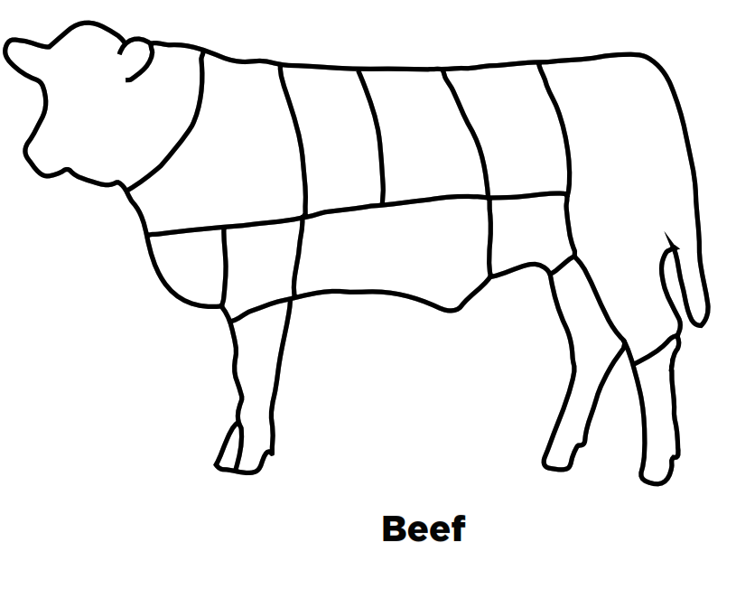
Resource: University of Florida, https://animal.ifas.ufl.edu/media/animalifasufledu/animal-sciences-website/extension/youth/meat-resources/identifying_retail_cuts.pdf
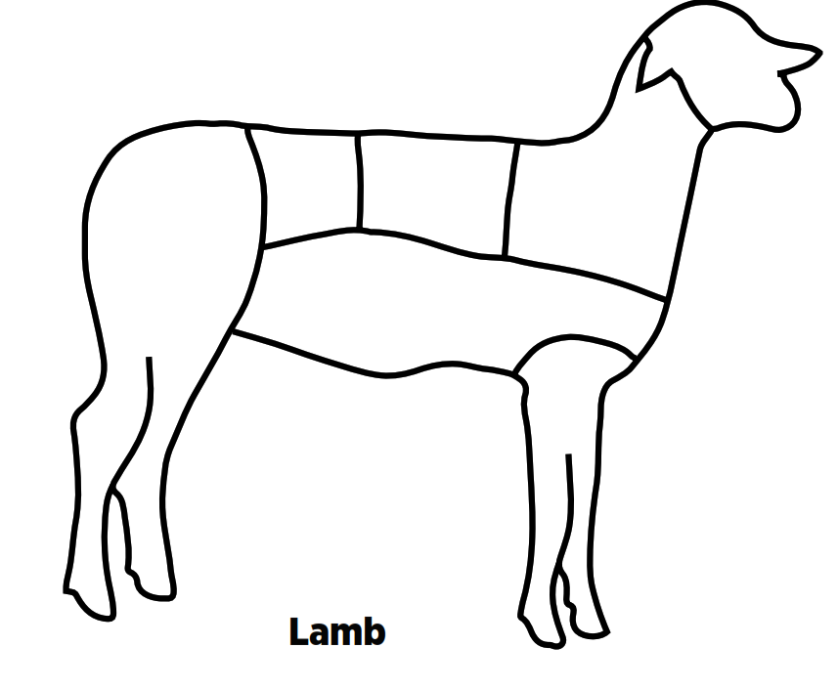
What is the difference between a wholesale cut and a retail cut of meat?

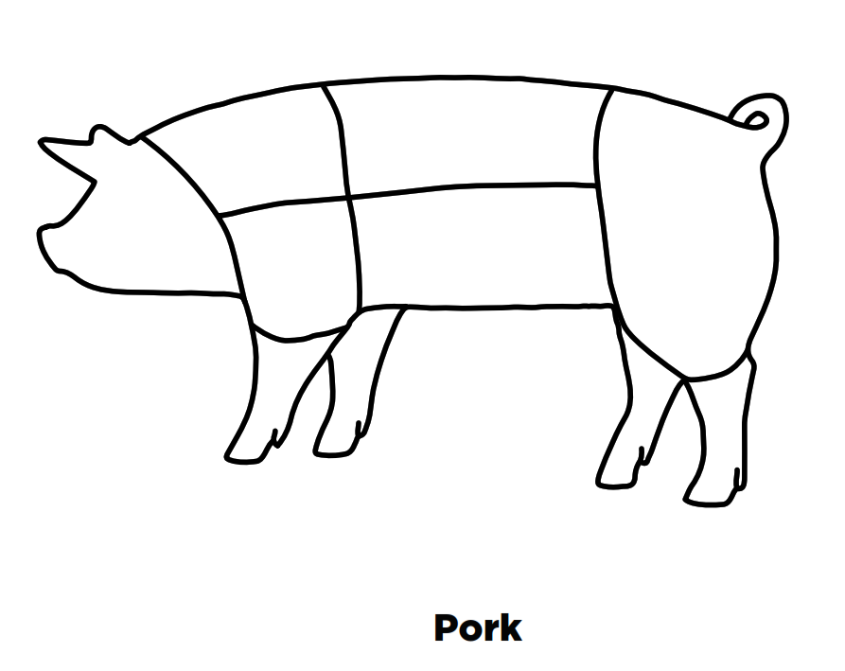

Part 3
Directions:
Learn which everyday products come from animal products. Choose one animal (beef cow, dairy cow, pig, sheep or goat), and use the resource below to complete the following activity:

- Sketch a picture of your chosen animal.
- Identify at least 10 byproducts that come from that animal.
- Write those products inside the animal, and list the part of the animal they come from.
- Answer the discussion question below.

Resource: Farm Credit of Virginia, https://www.farmcreditofvirginias.com/knowledge-center/educator-resources/everything-but-the

Discussion Question:
How many of these animal byproducts do you use in your everyday life, and how would your life be impacted if you didn’t have access to them?
KEY: “Meat” Your Next Career
Aligned to the following standards:
CS.05.; FFA.PL-C; FFA.PL-E; FFA.PG-I; FFA.CS-P; AG5; AGC08.01; AGC09.02; CCSS.ELA.RI.9-10.4; CCSS.ELA.SL.9-10.1; CCSS.ELA.WHST.9.10.6; CRP.02.; CRP.04; CRP.07

Directions:
Answer the questions below as you watch the video “Meat Processing SAE – Kylie Skadberg,” available at https://vimeo.com/901202016.

Part 1
From the video, complete the following quote from Kylie: “I don’t have goals on changing the world, but I do like to make sure that people …
Know where their food does come from.
Why did Kylie choose to join FFA?

She thought the blue corduroy jackets were the coolest thing ever, and she looked up to the upper classmen who were in FFA.
How did Kylie get started in her SAE?
She called her boss and said she was interested, and he took a chance on her.
Would you enjoy working at a meats lab like Kylie? Why or why not?

Answers will vary.
What are some of Kylie’s daily tasks for her SAE?

- Clean equipment.
- Process meat.
- Meet with the meat inspector.
- Correctly label and date products.
What animals does Kylie process at Barton Meats?

- Beef
- Pigs
- Lambs
- Deer

What chapter is Kylie representing?
Carrington
What pathway does Kylie’s SAE fall into?

Food Products and Processing Systems
Part 2
Directions:
Knowing the different cuts of meat is important for understanding the way those cuts can be used. Use the images of each species (cattle, swine, lamb) and the resource identified below to complete the following:

- Identify the difference between a wholesale and retail cut.
- Take each species (cattle, swine, lamb) and label the wholesale cuts we get from each animal. Write this on the inside of the animal.
- Identify one specific retail cut that comes from each wholesale cut. Draw a line and write this on the outside of the animal.
Retail cut answers will vary.
Picnic Shoulder
Boston Butt
Side
Ham
Loin
Shoulder
Loin
Breast
Leg
Rack
Flank
Fore Shank
Short Plate
Brisket
Round
Sirloin
Short Loin
Beef Rib
Beef Chuck
Resource: University of Florida, https://animal.ifas.ufl.edu/media/animalifasufledu/animal-sciences-website/extension/youth/meat-resources/identifying_retail_cuts.pdf

What is the difference between a wholesale cut and retail cut of meat?
Wholesale cuts are large meat cuts that the animal carcass is cut into for ease in handling and shipping. Retail cuts are the specific cuts, often displayed at the grocery store.

Part 3
Directions:
Learn which everyday products come from animal products. Choose one animal (beef cow, dairy cow, pig, sheep or goat), and use the resource below to complete the following activity:

- Sketch a picture of your chosen animal.
- Identify at least 10 byproducts that come from that animal.
- Write those products inside the animal, and list the part of the animal that they come from.

Answers will vary.
Resource: Farm Credit of Virginia, https://www.farmcreditofvirginias.com/knowledge-center/educator-resources/everything-but-the

Discussion Question:
How many of these animal byproducts do you use in your everyday life, and how would your life be impacted if you didn’t have access to them?

Answers will vary.

