Gray Space
Aligned to the following standards:
FFA.PL-A; FFA.PL-C; FFA.PL-E; FFA.PG-J; FFA.CS-N; MP1; MP5; MP6; CRP.02; CRP.04; CRP.06; CRP.08
Directions:
Fill in the blanks and answer the questions below while watching “The Gray Area,” the retiring address of 2018-19 National FFA Secretary Layni LeBlanc. The video is available at https://vimeo.com/370524943.
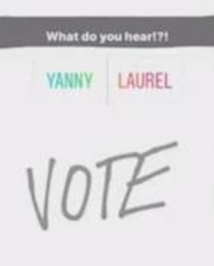
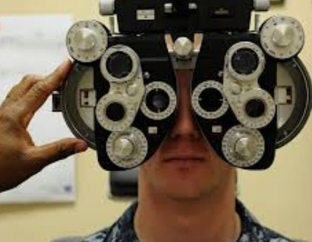
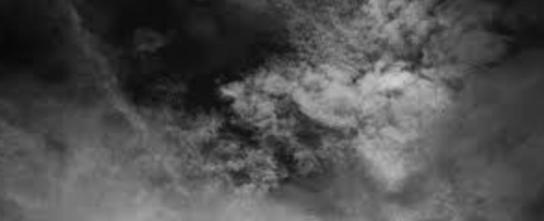
Look at the picture in the video, and circle the color you see.
Blue and Black or White and Gold

While listening to the video, circle what word you hear.

Yanny or Laurel

Why do people see things differently?
Perceiving is _______________ more _______________ about what you simply _____________.
What is a lemming?
- A small cat
- A small bird
- A small rodent
- A small reptile

According to Layni, what is the “gray area”?

- A part of the brain
- The deep, vast unknown
- The space between right and wrong
Be curious enough to ask _______.

- questions
- for the rules
- the color
Which of the following would NOT be considered “lemming” behavior?

- Running for class office because all your friends are
- Going to see a scary movie with your friends even though you do not like scary movies
- You decide to play soccer even though all your friends are playing football.
Identify two specific times you exhibited “lemming” behavior. Why did you exhibit this behavior?

1.

2.

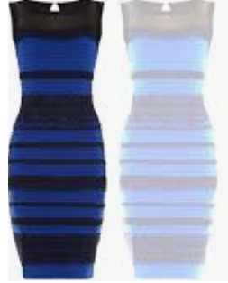


What group did Layni start?

- Humans of FFA
- People of Louisiana
- Humans of New York
- Humans of Agriculture

What does living in the “gray area” mean?
What does Layni’s RA mean to you?
Summarize Layni’s RA in one sentence.
What are two questions that you can and need to ask today?
What are two questions that you can and need to ask this month?
What are two questions that you can and need to ask this year?
We will ________________ run out of _____________ to ask.
Why would Layni want to start this type of a group?

