Gray Space
Aligned to the following standards:
FFA.PL-A; FFA.PL-C; FFA.PL-E; FFA.PG-J; FFA.CS-N; MP1; MP5; MP6; CRP.02; CRP.04; CRP.06; CRP.08
Directions:
Fill in the blanks and answer the questions below while watching “The Gray Area,” the retiring address of 2018-19 National FFA Secretary Layni LeBlanc. The video is available at https://vimeo.com/370524943.

- Look at the picture in the video, and circle the color you see.
Blue and Black or White and Gold
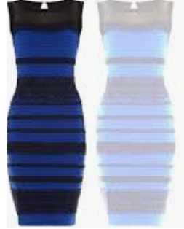

- While listening to the video, circle what word you hear.
Yanny or Laurel

- Why do people see things differently?

- Perceiving is _______________ more _______________ about what you simply _____________.

- According to Layni, what is the “gray area”?
- A part of the brain
- The deep, vast unknown
- The space between right and wrong

- Be curious enough to ask _______.
- questions
- for the rules
- the color

- Which of the following would NOT be considered “lemming” behavior?
- Running for class office because all your friends are
- Going to see a scary movie with your friends even though you do not like scary movies
- You decide to play soccer even though all your friends are playing football.

- What is a lemming?
- A small cat
- A small bird
- A small rodent
- A small reptile

- Identify two specific times you exhibited “lemming” behavior. Why did you exhibit this behavior?

1.

2.

- What group did Layni start?

- Humans of FFA
- People of Louisiana
- Humans of New York
- Humans of Agriculture
- Why would Layni want to start this type of a group?

- We will ________________ run out of _____________ to ask.

- What does living in the “gray area” mean?

- What are two questions that you can and need to ask today?

- What are two questions that you can and need to ask this month?

- What are two questions that you can and need to ask this year?

- Summarize Layni’s RA in one sentence.

- What does Layni’s RA mean to you?

