Interpreting and Designing Nutritional Food Labels
Created: 08/2022 by the National FFA Organization
The purpose of this lesson is to interpret and design a nutritional food label. This lesson will help prepare students to complete part of the “Team Product Development” section of the food science CDE.
Student Learning Objectives:
After completing these activities, students will …
- Identify the parts of a nutrition label.
- Describe the importance of a nutrition label.
- Calculate parts of a nutrition label.
- Design a nutrition facts label.

Suggested Grade Level:
Grades 9 and 10 (This lesson is written so instructors can scale up or down based on class needs.)

Suggested Time: 120 minutes (*Time requirements may vary based upon student understanding and class schedule.)

Resources/References:
- Textbook: Principles of Food Science, 4th Edition, Janet D. Ward (Facts/information in this lesson were obtained from the textbook.)
- Website: The Food and Drug Administration, https://www.fda.gov/food/new-nutrition-facts-label/how-understand-and-use-nutrition-facts-label (used in the Follow-up in the lesson)

Related Resources:
- The Food and Drug Administration, https://www.fda.gov/files/food/published/Food-Labeling-Guide-%28PDF%29.pdf (PDF also included in this lesson) Highly recommended that students read this document if they are planning to compete in the food science CDE

Equipment and Supplies Needed:
- Activity 1:
  - “Go Get It: Nutrition Facts” cards — make copies, cut out and place around the room prior to class starting.
  - “Activity 1: Go Get It — Nutrition Facts” student worksheet
  - Powerpoint: “It’s All in a Label” https://ffa.box.com/s/kuiix0ucmwdte500te2nfdvsbvswmlha
- Student worksheet “Activity 2: Nutritional Label Interpretation Challenge”
- Student copy of handout “Food and Drug Administration’s Specifications for Health Claims and Descriptive Terms”
- Activity 3:
  - Powerpoint: “Food Science: Product Development”
  - “Activity 3: Product Development” student worksheet
  - A copy of the Bread Kit scenario for each student, https://ffa.box.com/s/cufsuc6dcqhfg8jge4w1rynb7ey27i31
  - A copy of the FFA Costs and Nutritional chart for each student, https://ffa.box.com/s/fylpgjhawkjx2dndiqqj8d0m2j40i1z6
  - A copy of the product development chart for each student
  - A copy of the “Label Design Challenge” worksheet for each student
- Student “Exit Tickets”
- Optional Activity:
  - Need a variety of prepackaged food items containing nutritional labels
  - “Label Design Challenge” worksheet, one copy/student
    - Note: There are no wrong answers for this activity. Be sure to grade or check for completion/accuracy in label creations.

Vocabulary:
- Serving size
- Calories
- Total fat
- Cholesterol
- Sodium
- Total carbohydrates
- Protein
- Nutritional label
- Optional Vocabulary: Use all vocabulary listed on the “Food and Drug Administration’s Specifications for Health Claims and Descriptive Terms” handout.

Cross-Curricular Connections:
English/Language Arts | Mathematics
- Bell ringer, Activity 1, Activity 2: Students are challenged to read, interpret, analyze and record information for each activity. | - Nutritional Label Interpretation, Exit Ticket: Students are required to interpret and calculate numbers found on nutritional labels.  - Optional Activity: Challenges students to create a nutritional label using realistic numbers.

Virtual Instruction Ideas:
This lesson can be converted to a virtual and/or online lesson. Students would need shared copies of all the handouts/activities and the PowerPoint. This lesson would work best virtually compared to online because the teacher could guide students through the activities as it would be done in the classroom.

Student Activity Sheets:
Direct access to student activity sheets without lesson plan or answer key for easy upload to a learning management system or printing for classwork.

https://ffa.box.com/s/dryn7ihiusho1kpwevup5c1gtp3mel34 (Word)
https://ffa.box.com/s/bn6rjjjqdah4frn23wo4pa7qfir4i30c (PDF)
https://ffa.box.com/s/bavvnnwa880gw47ak6neb2qtnv4b51do (Non-Designed)
https://docs.google.com/document/d/1Nf-jh74m7qJk4rHBa6P8VkKKvBok2S0NKYtxwrEO8I4/copy (Google)

These Activities are Aligned to the Following Standards:
FFA Precept
- FFA.PL-A.Action: Assume responsibility and take the necessary steps to achieve the desired results, no matter what the goal or task at hand.
- FFA.PG-J.Mental Growth: Embrace cognitive and intellectual development relative to reasoning, thinking and coping.
- FFA-CS-M.Communication: Effectively interact with others in personal and professional settings.
Common Core – Reading: Informational Text
- CCSS.ELA-Literacy.RI.9-10.1 Cite strong and thorough textual evidence to support analysis of what the text says explicitly as well as inferences drawn from the text.
- CCSS.ELA-Literacy.RI.9-10.2 Determine a central idea of a text and analyze its development over the course of the text, including how it emerges and is shaped and refined by specific details; provide an objective summary of the text.
Common Core – Writing
- CCSS.ELA-Literacy.W.9-10.2 Write informative/explanatory texts to examine and convey complex ideas, concepts, and information clearly and accurately through the effective selection, organization, and analysis of content.
Common Core – Speaking and Listening
- CCSS.ELA-Literacy.SL.9-10.1.C Propel conversations by posing and responding to questions that relate the current discussion to broader themes or larger ideas; actively incorporate others into the discussion; and clarify, verify, or challenge ideas and conclusions.
- CCSS.ELA-Literacy.SL.9-10.4 Present information, findings, and supporting evidence clearly, concisely, and logically such that listeners can follow the line of reasoning and the organization, development, substance, and style are appropriate to purpose, audience, and task.
Common Core – Science & Technical Subjects
- CCSS.ELA-Literacy.RST.9-10.1 Cite specific textual evidence to support analysis of science and technical texts, attending to the precise details of explanations or descriptions.
- CCSS.ELA-Literacy.RST.9-10.3 Follow precisely a complex multistep procedure when carrying out experiments, taking measurements, or performing technical tasks, attending to special cases or exceptions defined in the text.
Common Core – Literacy in Science & Technical Subjects: Writing
- CCSS.ELA-Literacy.WHST.9-10.4 Produce clear and coherent writing in which the development, organization, and style are appropriate to task, purpose, and audience.
- CCSS.ELA-Literacy.WHST.9-10.7 Conduct short as well as more sustained research projects to answer a question (including a self-generated question) or solve a problem; narrow or broaden the inquiry when appropriate; synthesize multiple sources on the subject, demonstrating understanding of the subject under investigation.
Common Core – Math Practices
- CCSS.MATH.PRACTICE.MP1 Make sense of problems and persevere in solving them.
- CCSS.MATH.PRACTICE.MP3 Construct viable arguments and critique the reasoning of others.
- CCSS.MATH.PRACTICE.MP6 Attend to precision.
National Standards for Financial Literacy
- Buying Goods and Services, Benchmarks: Grade 12, Statement 7 Governments establish laws and institutions to provide consumers with information about goods or services being purchased and to protect consumers from fraud.
- Buying Goods and Services, Benchmarks: Grade 12, Statement 1 Consumer decisions are influenced by the price of a good or service, the price of alternatives, and the consumer’s income as well as his or her preferences.
- Buying Goods and Services, Benchmarks: Grade 12, Statement 2 When people consume goods and services, their consumption can have positive and negative effects on others.
AFNR Career Ready Practices
- CRP.02. Apply appropriate academic and technical skills. Career-ready individuals readily access and use the knowledge and skills acquired through experience and education to be more productive.
- CRP.04. Communicate clearly, effectively, and with reason. Career-ready individuals communicate thoughts, ideas and action plans with clarity, whether using written, verbal and/or visual methods.
- CRP.05. Consider the environmental, social and economic impact of decisions. Career-ready individuals understand the interrelated nature of their actions and regularly make decisions that positively impact and/or mitigate negative impact on other people, organizations and the environment.
- CRP.06. Demonstrate creativity and innovation. Career-ready individuals regularly think of ideas that solve problems in new and different ways, and they contribute those ideas in a useful and productive manner to improve their organization.
- CRP.07. Employ valid and reliable research strategies. Career-ready individuals are discerning in accepting and using new information to make decisions, change practices or inform strategies.
- CRP.08. Utilize critical thinking to make sense of problems and persevere in solving them. Career-ready individuals readily recognize problems in the workplace, understand the nature of the problem, and devise effective plans to solve the problem.
- CRP.09. Model integrity, ethical leadership and effective management. Career-ready individuals readily recognize problems in the workplace, understand the nature of the problem, and devise effective plans to solve the problem.
- CRP.11 Use technology to enhance productivity. Career-ready individuals find and maximize the productive value of existing and new technology to accomplish workplace tasks and solve workplace problems.
Partnership for 21st Century Skills
- Critical Thinking and Problem Solving
- Flexibility and Adaptability
- Implement Innovations
- Information Literacy
- Productivity and Accountability
- Think Creatively
Lesson Plan:
- Bell Ringer:
  - Have the following written on the board as students enter the classroom: “On a piece of paper, write down every food you have consumed/eaten in the past 24 hours.”
  - Once all students are seated and have recorded their responses, ask them to guess how many calories they have consumed from the foods they listed. Allow students to share (or teachers can share their calories/foods). Ask students: How many of you think you are 100% correct on the number of calories you consumed? Why or why not? (Allow students to answer.) What would have made it easier to count our calories? Answer — food labels!
  - Tell students: A food label for each item would be the first thing we would need before taking another shot at estimating the number of calories. The nutritional requirements of our bodies and the nutrients contained in the foods we eat don’t always align! For a healthy lifestyle, it is important to understand the nutrient levels in the foods we eat. So, today we will learn how to read a food label.
  - Move into the Introduction section of this lesson.

- Introduction:
  - Begin the PowerPoint titled “It’s All in a Label.” Discuss all slides. When finished, move to Activity 1 in this lesson plan. It is recommended to have students take notes to be prepared for the activities to follow.

- Activity:
  - Activity 1:
    - Teacher Note: Be sure to have the cards that go with this activity cut out and placed around the room prior to the start of the class.
    - Activity 1: Announce to students: When you receive this activity sheet, quickly and quietly travel to each of the information sheets around the room and record information for each section of the sheet. The activity sheet has blanks for each component of a food label, and the sheets of paper around the room contain the information to be placed in each blank. Pay close attention to what we are recording; we will use it for real food labels. When finished, return to your seat and quietly wait for further directions. Please do not talk while completing this activity. What questions do you have?
    - Give each student a copy of the worksheet “Activity 1: Go Get It — Nutrition Facts.” Read directions with students. Ask for questions; release students to find cards.
    - Once all students have returned to their seats, go over the answers with them.
    - Utilize the “It’s All in a Label” https://ffa.box.com/s/kuiix0ucmwdte500te2nfdvsbvswmlha to review content.
    - Move into Activity 2.
  - Activity 2:
    - Tell students: Now that we know the basic components of a food label, let’s have a look at a few of them. Upon receiving this next activity sheet, read it carefully before beginning. The sheet contains four food labels and poses questions that challenge us to evaluate the labels. Feel free to refer to the information recorded from the last activity. Please turn sheets face down upon completion. This individual activity should take no more than five minutes to complete. What questions are there about this task?
    - Give each student a copy of “Activity 2: Nutritional Label Interpretation Challenge.” Read through directions with students. Ask if there are any questions. Allow approximately five minutes to complete this challenge.
    - Once all students have flipped their papers over, review the answers with them. This may be collected for a grade if desired.
  - Activity 3:
    - Open the Powerpoint “Food Science: Product Development”. Tell students: Now we are going to learn how to calculate the different parts of a food nutrition label. When new food products are being developed, a nutrition label must also be developed.
    - Give each student a copy of “Activity 3: Product Development” and a copy of the “Product Development Chart”. Have students record notes about how to develop a nutrition facts label. Students will use this notes sheet for the next step.
    - Introduce students to the “Label Design Challenge” activity by handing out a worksheet to each student. This activity may take more than one day and/or may take additional teacher assistance for students in the classroom. This activity is part of the National FFA Food Science and Technology CDE (part of the Team Product Development portion of the contest). Have students read the Bread Kit scenario, https://ffa.box.com/s/cufsuc6dcqhfg8jge4w1rynb7ey27i31, and use the FFA Costs and Nutritional chart, https://ffa.box.com/s/fylpgjhawkjx2dndiqqj8d0m2j40i1z6, and develop the nutrition label for a product that meets the scenario requirements. Tip: If you have time, consider having students practice making the entire package, including nutrition label, so that students can see multiple concepts come together.

- Follow-up:
  - Pull the following website up on the class overhead projector: https://www.fda.gov/food/new-nutrition-facts-label/how-understand-and-use-nutrition-facts-label. Scroll down through this site and discuss with students the pictures shown. It is a good review from todays’ information! No need to read all the information. Simply highlight the seven components of a nutritional label that were discussed in class.
  - Provide each student with a copy of the handout “Food and Drug Administration’s Specifications for Health Claims and Descriptive Terms.” Go over the terms with students. (This information will be important if/when they create their own food product later.)
  - If time, move on to the Extended Learning Opportunities section. Otherwise, move on to the Exit Ticket to end class for the day.
- Optional – Extended Learning Opportunities (Not factored into time requirement):
  - Have students examine nutritional labels on packaged snacks in their lockers, backpacks, etc. Be sure to have a variety of prepackaged items available for students to use. What are the similarities among the labels? Differences? What packaging is easy to read? Hard? Which catches the eye and why?

- Exit Ticket: Approximately five minutes needed to complete the exit ticket.
  - Give each student an “Exit Ticket.” Direct students to answer the three questions listed and turn their tickets in as they exit the classroom.
  - Answers for Exit Tickets:
    - 1) C
    - 2) A
    - 3) 200 calories

Aligned to the following standards: FFA.PL-A; FFA.PG-J; FFA-CS-M; CCSS.ELA.RI.9-10.1; CCSS.ELA.RI.9-10.2; CCSS.ELA.W.9-10.2; CCSS.ELA.SL.9-10.1.C; CCSS.ELA.SL.9-10.4; CCSS.ELA.WHST.9-10.7; MP1; MP3; MP6; Buying Goods and Services, Benchmarks: Grade 12, Statement 7 Governments; Buying Goods and Services, Benchmarks: Grade 12, Statement 1; Buying Goods and Services, Benchmarks: Grade 12, Statement 2; CRP.02; CRP.04; CRP.05; CRP.06; CRP.07; CRP.08; CRP.09; CRP.11

Activity 1: Go Get It — Nutrition Facts
Directions:
When given permission, move about the classroom to find 3 cards that contain different descriptions of the different parts of a nutrition label, seen below. When you find a description in the room, match it with the correct location on the nutrition label shown below; write the information found on the card in the space provided. Two of the categories will have the same information. 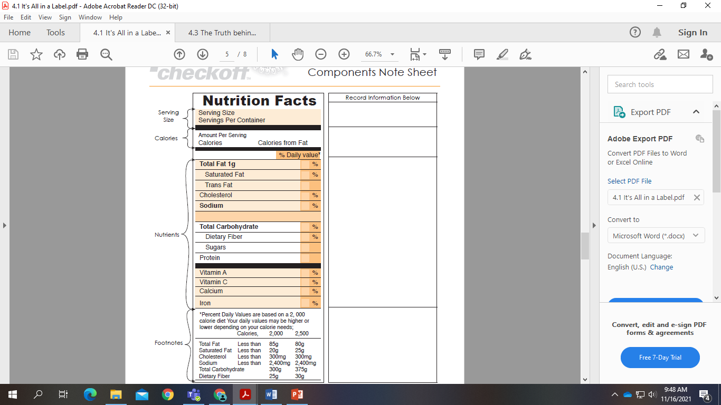
What would you tell someone about what is included on a nutrition label based on the above activity?
Aligned to the following standards: FFA.PL-A; FFA.PG-J; FFA-CS-M; CCSS.ELA.RI.9-10.1; CCSS.ELA.RI.9-10.2; CCSS.ELA.W.9-10.2; CCSS.ELA.SL.9-10.1.C; CCSS.ELA.SL.9-10.4; CCSS.ELA.WHST.9-10.7; MP1; MP3; MP6; Buying Goods and Services, Benchmarks: Grade 12, Statement 7 Governments; Buying Goods and Services, Benchmarks: Grade 12, Statement 1; Buying Goods and Services, Benchmarks: Grade 12, Statement 2; CRP.02; CRP.04; CRP.05; CRP.06; CRP.07; CRP.08; CRP.09; CRP.11

Activity 2: Nutritional Label Interpretation Challenge
Directions:
Study food labels A, B, C and D below. Use the information in each label to answer the questions at the bottom of the page.
A B C D
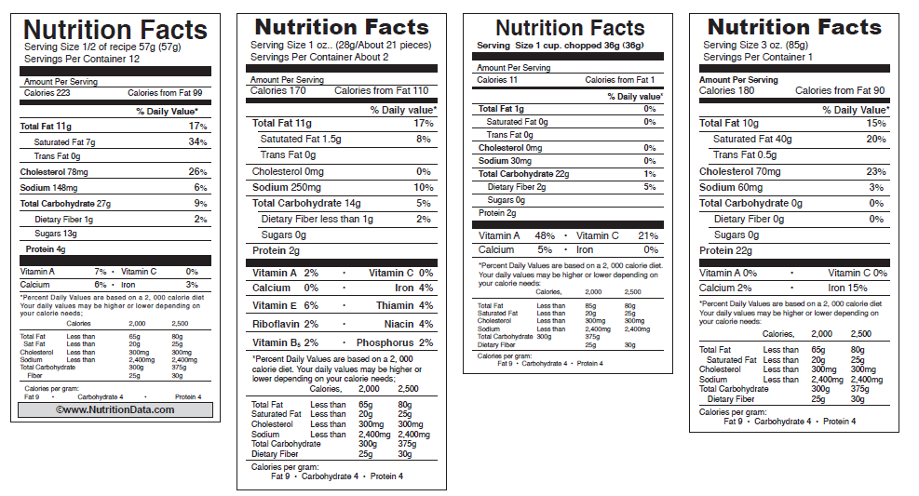
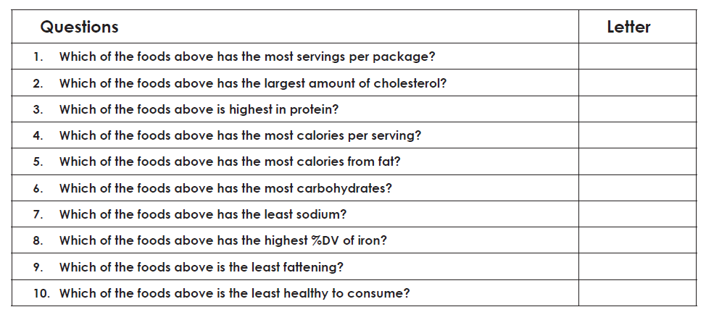
Why do you think it is important for all of the above information to be included on a nutrition label?
Activity 3: Product Development
Directions:
Complete the following as you learn about product development. Use what you learn to complete the following activities.
- Identify the possible product categories:
Categories | Platform | Market
Cereal | F | R
S | Refrigerated | Wholesale
M | Shelf-stable | Food Service
Side dishes | C | C
B | R
Supplements | Heat and Serve
Condiments | ___________________________________ | ___________________________________
D | ___________________________________ | ___________________________________
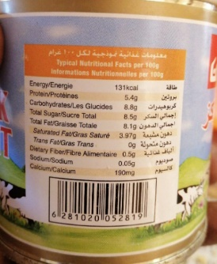
- What changed between the original label and the new label from the FDA?

- What questions should be considered when thinking about a product in development?

- Step 1: C________________ I____________________

- Step 2: D_______________ A____________________

  - What should the percentage equal? _________%

- Step 3: Calculate amounts.
  - In your own words describe how this calculation is completed. Give an example.

- Step 4: C ________________________ N _____________________________
  - In your own words describe how this calculation is completed. Give an example.

- Step 5: Determine percent D_____________________ V__________________
  - In your own words describe how this calculation is completed. And give an example.

- Step 6: Enter Values into N_________________________________________ F__________________ P_________________

- How should the ingredient list for the ingredient statement be listed?
Label Design Challenge
Aligned to the following standards: FFA.PL-A; FFA.PG-J; FFA-CS-M; CCSS.ELA.RI.9-10.1; CCSS.ELA.RI.9-10.2; CCSS.ELA.W.9-10.2; CCSS.ELA.SL.9-10.1.C; CCSS.ELA.SL.9-10.4; CCSS.ELA.WHST.9-10.7; MP1; MP3; MP6; Buying Goods and Services, Benchmarks: Grade 12, Statement 7 Governments; Buying Goods and Services, Benchmarks: Grade 12, Statement 1; Buying Goods and Services, Benchmarks: Grade 12, Statement 2; CRP.02; CRP.04; CRP.05; CRP.06; CRP.07; CRP.08; CRP.09; CRP.11

DIRECTIONS:
As the developer of a new product, you must now design a nutritional label to go on the product. Using all the information learned in class regarding food labels, complete the required information below as it pertains to the food item you create based up on the provided scenario and chart. Remember to include 7 parts + any additional needed information. Add lines, use markers, etc. to make your label look as realistic as possible.
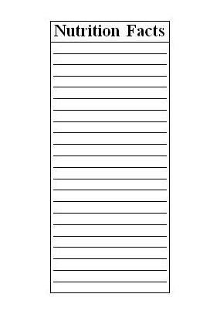

EXIT TICKET
Aligned to the following standards: FFA.PL-A; FFA.PG-J; FFA-CS-M; CCSS.ELA.RI.9-10.1; CCSS.ELA.RI.9-10.2; CCSS.ELA.W.9-10.2; CCSS.ELA.SL.9-10.1.C; CCSS.ELA.SL.9-10.4; CCSS.ELA.WHST.9-10.7; MP1; MP3; MP6; Buying Goods and Services, Benchmarks: Grade 12, Statement 7 Governments; Buying Goods and Services, Benchmarks: Grade 12, Statement 1; Buying Goods and Services, Benchmarks: Grade 12, Statement 2; CRP.02; CRP.04; CRP.05; CRP.06; CRP.07; CRP.08; CRP.09; CRP.11

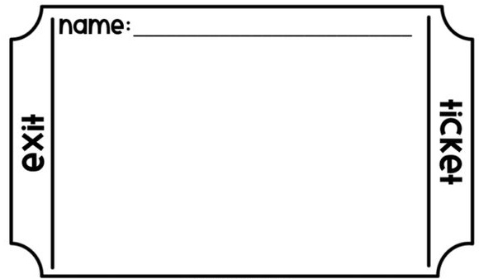
1. Sugar is an example of a ______________.
a. calorie
b. fat
c. carbohydrate
2. Calories are a source of _____________.
a. energy
b. fat
c. strength
3. If you consume a 4-oz. candy bar with 50 calories per each 1-oz. serving, how many calories are you consuming?

4. Why are nutrition labels important for food products on the market?

5. How do food labels impact you or someone you know on a daily basis?

GO GET IT: Nutrition Facts Cards (To be used in Activity 1)
Directions for TEACHERS:
Make as many copies of this sheet as needed. Cut along each section line and place the sections around the classroom.
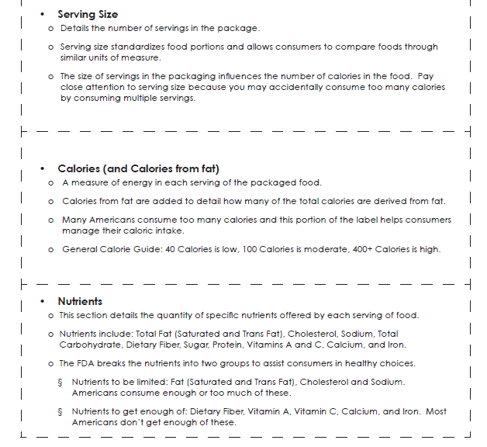

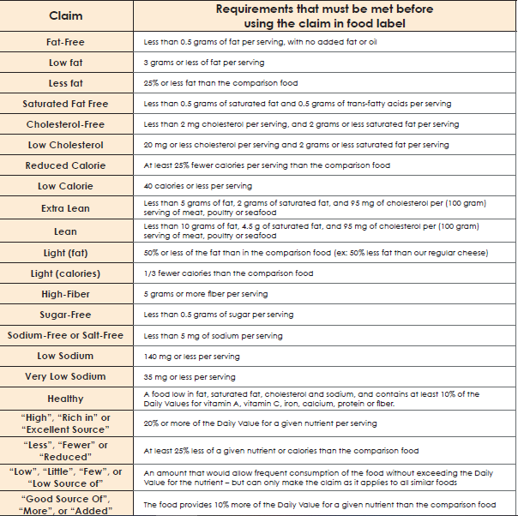
Food and Drug Administration’s Specifications for Health Claims and Descriptive Terms:

Product Development Chart
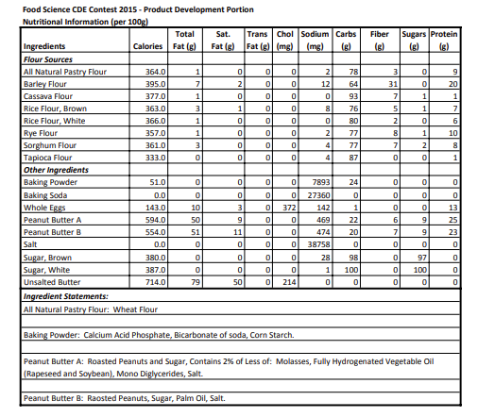
KEY: Activity 1: Go Get It — Nutrition Facts

= matches with the “Serving Size” section on student worksheet

=matches with the “calories” section on the student worksheet

=matches with the “nutrients and footnotes” section on the student worksheet

KEY: Activity 2: Nutritional Label Interpretation Challenge
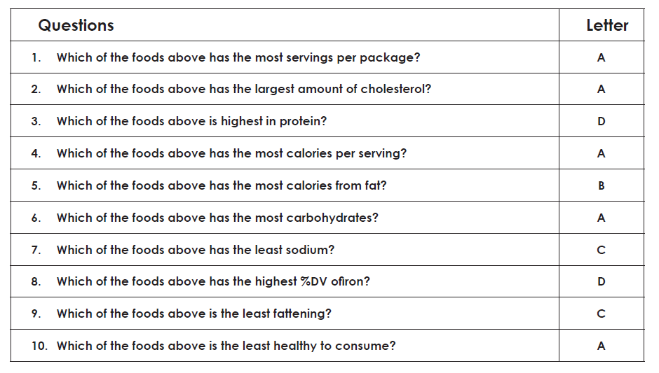

Why do you think it is important for all of the above information to be included on a nutrition label?
Knowing what Is on a nutrition label can ensure consumers are informed about their food choices which allows them to ensure a diet that meets their individual needs.

KEY: Activity 3: Product Development
Directions:
Complete the following as you learn about product development. Use what you learn to complete the following activities.
- Identify the possible product categories:
Categories | Platform | Market
Cereal | Frozen | Retail
Snack | Refrigerated | Wholesale
Meals | Shelf-stable | Food Service
Side dishes | Convenience | Convenience Store
Beverages | Ready to eat
Supplements | Heat and Serve
Condiments | ___________________________________ | ___________________________________
Desserts | ___________________________________ | ___________________________________
- What changed between the original label and the new label from the FDA?

Answers will vary. Examples, larger calorie font, addition of added sugar, etc.

- What questions should be considered when thinking about a product in development?
  - Do certain ingredients need to make up most of the product?
  - Does a certain ingredient need to be replaced?
  - Did I make these into easy-to-calculate percentages?
- Step 1: Choose Ingredients

- Step 2: Determine Amounts

  - What should the percentage equal? 100%

- Step 3: Calculate amounts.
  - In your own words describe how this calculation is completed. And give an example.
Answers will vary.

- Step 4: Calculate Nutritionals
  - In your own words describe how this calculation is completed. And give an example.
Answers will vary.

- Step 5: Determine percent Daily Value
  - In your own words describe how this calculation is completed. And give an example.

Answers will vary.

- Step 6: Enter Values into Nutritional Facts Panel

- How should the ingredient list for the ingredient statement be listed?
Ingredients should be listed from most to least.

