Introduction to Water Use and Conservation
Created: 07/2025 by the National FFA Organization
Description of Lesson: In this lesson, students will explore the importance of water conservation in society and their own lives. Through engaging activities, students will examine their personal water usage, investigate and promote water conservation practices as well as discuss the broader impacts of water scarcity and conservation efforts on the environment and society.
Thank you to our current partners in sustainability:


Student Learning Objectives:
After completing these activities, students will …
- Define water conservation.
- Examine their personal water usage patterns and explore ways to conserve water.
- Create a poster promoting one water conservation practice.

Suggested Grade Level:
Grades 9 and 10 (This lesson is written so instructors can scale up or down based on class needs.)

Suggested Time: 60 minutes (*Time requirements may vary based upon student understanding and class schedule.)
Resources/References:
- Website: U.S. Environmental Protection Agency (EPA), Our Water, https://www.epa.gov/watersense/our-water
- Website: U.S. EPA, How We Use Water, https://www.epa.gov/watersense/how-we-use-water
- Website: U.S. EPA, Water Topics, https://www.epa.gov/environmental-topics/water-topics
- Website: Water Footprint Calculator, https://watercalculator.org/

Related Resources:
- Food and Agricultural Literacy Curriculum, Natural Resources, Unit 3: Water, https://FFA.box.com/s/w5ypjcs5s1v6h5er5819j2lcvicvzdoq
- AgExplorer Sustainability Systems Focus Area, AgExplorer.FFA.org/focus/sustainability-systems/
- Introduction to Sustainability Lesson Series, https://FFA.box.com/v/introtosustainability
- Darling Ingredients Educational Resources, https://FFA.box.com/s/3ko8e9w6zygohv1ewfsnc8byobjzeuxa
- Valent — Sustainability in Agriculture Lesson Series, https://FFA.box.com/v/sustainabilityinagriculture

Equipment and Supplies Needed:
- A copy of the “How Much Water Do You Use?” student activity sheet for each student
- A copy of the “Save Our Water!” student activity sheet for each student
- Student devices with internet access
- Blank sheets of white paper
- Markers, colored pencils, crayons and other supplies for making posters
- Green and red dot stickers

Vocabulary:
- Conservation
- Embedded Water
- Indirect Water
- Water Footprint
- Virtual Water
Cross-Curricular Connections:
English/Language Arts | Technology | Mathematics | Social Studies
Reflect on water usage patterns and thoughts on water conservation in writing. | Use an online tool to calculate and learn more about water usage. | Use a number line and mathematical symbols to estimate and explain water usage patterns. | Discuss the impact of water shortages and water conservation practices on society as a whole.

SAE and FFA Connections
- Environmental and Natural Resources CDE, FFA.org/participate/cdes/environmental-and-natural-resources/
- Agricultural Proficiency Areas: Environmental Science and Natural Resources Management, FFA.org/participate/awards/proficiencies/
- Foundational SAE Connections: Agricultural Literacy
Student Activity Sheets:
Direct access to student activity sheets without lesson plan or answer key for easy upload to a learning management system or printing for classwork.

https://ffa.box.com/s/2g5ztrn1a4wqy5ms7jy8fa9j5s8i5t21 (Word)
https://ffa.box.com/s/hwlj137l0x0chp6wplrfn34w2c7m5i4m (PDF)
https://docs.google.com/document/d/1F4T6PsVOEzNzn1a121pp8OuN-Jh0cQop_9h8m9i3B4c/copy (Google)

These Activities Are Aligned to the Following Standards:
AFNR Performance Element
- CS.03. Examine and summarize the importance of health, safety and environmental management systems in AFNR workplaces.
- CS.04. Demonstrate stewardship of natural resources in AFNR activities.
- NRS.01. Plan and conduct natural resource management activities that apply logical, reasoned, and scientifically based solutions to natural resource issues and goals.
- NRS.02. Analyze the interrelationships between natural resources and humans.
- NRS.04. Demonstrate responsible management procedures and techniques to protect, maintain, enhance, and improve natural resources.
FFA Precept
- FFA.PL-A.Action: Assume responsibility and take the necessary steps to achieve the desired results, no matter what the goal or task at hand.
- FFA.PL-C.Vision: Visualize the future and how to get there.
- FFA.PL-E.Awareness: Understand personal vision, mission and goals.
- FFA.PL-F.Continuous Improvement: Accept responsibility for learning and personal growth.
- FFA.CS-N.Decision Making: Analyze a situation and execute an appropriate course of action.
Common Career Technical Core
- AG3 Examine and summarize the importance of health, safety, and environmental management systems in AFNR businesses.
- AG4 Demonstrate stewardship of natural resources in AFNR activities.
- AG-NR1 Plan and conduct natural resource management activities that apply logical, reasoned, and scientifically based solutions to natural resource issues and goals.
- AG-NR2 Analyze the interrelationships between natural resources and humans.
- AG-NR4 Demonstrate responsible management procedures and techniques to protect or maintain natural resources.
NASDCTEc
- AGPE01.01 Conduct system management activities in natural habitats to demonstrate recognition of the important relationships between natural resource preservation and human intervention.
- AGPE01.03 Apply scientific principle and processes when planning and conducting natural resource management activities to determine the need, feasibility and application of logical, reasoned solutions to natural resource system problems and issues.
- AGPE01.05 Practice responsible control and management procedures and techniques to protect or maintain natural resources in a variety of settings.
Common Core – Writing
- CCSS.ELA-Literacy.W.9-10.2 Write informative/explanatory texts to examine and convey complex ideas, concepts, and information clearly and accurately through the effective selection, organization, and analysis of content.
- CCSS.ELA-LITERACY.W.9-10.7 Conduct short as well as more sustained research projects to answer a question (including a self-generated question) or solve a problem; narrow or broaden the inquiry when appropriate; synthesize multiple sources on the subject, demonstrating understanding of the subject under investigation.
Common Core – Speaking and Listening
- CCSS.ELA-LITERACY.SL.9-10.5 Make strategic use of digital media (e.g., textual, graphical, audio, visual, and interactive elements) in presentations to enhance understanding of findings, reasoning, and evidence and to add interest.
Common Core – Language
- CCSS.ELA-LITERACY.L.9-10.6 Acquire and use accurately general academic and domain-specific words and phrases, sufficient for reading, writing, speaking, and listening at the college and career readiness level; demonstrate independence in gathering vocabulary knowledge when considering a word or phrase important to comprehension or expression.
Common Core – Science & Technical Subjects
- CCSS.ELA-Literacy.RST.9.10.4 Determine the meaning of symbols, key terms, and other domain-specific words and phrases as they are used in a specific scientific or technical context relevant to grades 9-10 texts and topics.
Common Core – Literacy in Science & Technical Subjects: Writing
- CCSS.ELA-Literacy.WHST.9.10.7 Conduct short as well as more sustained research projects to answer a question (including a self-generated question) or solve a problem; narrow or broaden the inquiry when appropriate; synthesize multiple sources on the subject, demonstrating understanding of the subject under investigation.
Common Core – Math Practices
- CCSS.MATH.PRACTICE.MP1 Make sense of problems and persevere in solving them.
- CCSS.MATH.PRACTICE.MP2 Reason abstractly and quantitatively.
- CCSS.MATH.PRACTICE.MP4 Model with mathematics.
Common Core – Math (Specific)
- CCSS.MATH.CONTENT.HSS.ID.A.1 Represent data with plots on the real number line (dot plots, histograms, and box plots).
Next Generation Science
- HS-ETS1-3 Evaluate a solution to a complex real-world problem based on prioritized criteria and trade-offs that account for a range of constraints, including cost, safety, reliability, and aesthetics as well as possible social, cultural, and environmental impacts.
Green/Sustainability Knowledge and Skill Statements
- AFNR Career Cluster, Statement 1 Apply understanding of ecosystems and systems thinking to the management of natural resources to maximize the health and productivity of the environment, agriculture, communities, and society.
- AFNR Career Cluster, Statement 3 Communicate the impact of green and sustainability principles on agriculture, food and natural resource systems.
- AFNR Career Cluster, Statement 7 Demonstrate an understanding of green and sustainability trends that are impacting processes and markets in AFNR.
- AFNR Career Cluster-Natural Resources Systems Pathway, Statement 2 Develop strategies to influence natural resource management and utilization policies and practices through application of sustainability principles.
AFNR Career Ready Practices
- CRP.02. Apply appropriate academic and technical skills. Career-ready individuals readily access and use the knowledge and skills acquired through experience and education to be more productive.
- CRP.04. Communicate clearly, effectively, and with reason. Career-ready individuals communicate thoughts, ideas and action plans with clarity, whether using written, verbal and/or visual methods.
- CRP.05. Consider the environmental, social and economic impact of decisions. Career-ready individuals understand the interrelated nature of their actions and regularly make decisions that positively impact and/or mitigate negative impact on other people, organizations and the environment.
- CRP.06. Demonstrate creativity and innovation. Career-ready individuals regularly think of ideas that solve problems in new and different ways, and they contribute those ideas in a useful and productive manner to improve their organization.
- CRP.08. Utilize critical thinking to make sense of problems and persevere in solving them. Career-ready individuals readily recognize problems in the workplace, understand the nature of the problem, and devise effective plans to solve the problem.
- CRP.11. Use technology to enhance productivity. Career-ready individuals find and maximize the productive value of existing and new technology to accomplish workplace tasks and solve workplace problems.
Partnership for 21st Century Skills
- Communication
- Critical Thinking and Problem Solving
- Environmental Literacy
- Global Awareness
- Information, Communications, and Technology Literacy
- Initiative and Self-direction
- Leadership and Responsibility
- Technology Literacy
- Think Creatively

Lesson Plan:
- Bell Ringer: List three ways you or your family use water every day. Which of these do you think uses the most?

- Introduction: After students have answered the bell ringer, begin a class discussion on water use. Ask students how they use water and begin recording those activities on the board or on a document on screen under the heading “Residential Use.” Then add two more headings: “Industrial Use” and “Agricultural Use” and begin to ask students how they think water is used in each of those contexts. Continue recording activities under each heading until students are finished listing uses for water. Say: Wow, that is a lot of different ways that we use water! These three categories are the major ways that we use water, and as you can see, there is a wide range of uses for the water on our planet. But did you know that only about one percent of the water on Earth is fresh and readily available for human use? The rest is either salt water in our oceans, frozen within the polar ice caps or just too difficult for us to practically access (according to the EPA). This is why it is vital that we are wise in our use of this precious resource and do our best to conserve it.

- Activity: (20 minutes) Each student needs a copy of the student activity sheet “How Much Water Do You Use?”
  - Part 1:
    - Prior to students beginning this activity, have them answer the pre-activity questions on their student activity sheets.
    - Students will access the Water Footprint Calculator at https://watercalculator.org/. They will go through the online activity, answering questions about their family’s water usage. If students don’t know the answers to some of the questions, have them take their best guess or ask their classmates what their families do.
    - When they get to the end of the activity, it will show their family’s water footprint, and they can scroll down to see how they compare to the U.S. average in each area.
    - Have students review this information and answer the reflection questions on their student activity sheets.
    - Students may choose to save their results by entering their emails, but it is not required.
  - Part 2: There is a “learn more” column in the results section where they can explore tips on how to conserve water in each area. Students will click to explore these different tips and select five of them to record in the table on their student activity sheets. These should be tips that the students could see themselves implementing in their lives relatively easily. They will then answer the conclusion questions for this activity on their student activity sheets.

- Activity: (25 minutes) Each student needs a copy of the student activity sheet “Save Our Water!”
  - Part 1
    - Students will select one of the five tips that they explored in Part 2 of the first activity. Again, this should be an action they could envision themselves implementing in their lives or in the school community and should be something they consider important or impactful. They will use this tip to make a promotional poster.
    - Have students review the criteria for the poster on their student activity sheets. All posters should include the following items:
      - A catchy title
      - A brief explanation of the water conservation practice
        - What it is
        - How it helps conserve water
        - Why it’s important
      - Visuals (drawings, images, diagrams, charts) that represent the water conservation practice
      - One source where people can go to learn more about this practice (web URL, QR code, etc.)
    - Students may design the poster either by hand or by using a digital tool such as Canva, PowerPoint, Google Slides, etc.
    - Remind students to be creative with their designs. The posters should be both informative and visually appealing so they will catch people’s attention and encourage them to practice water conservation.
  - Part 2 Have students hang up their posters and get a chance to look at each other’s. Provide students with colored dot stickers to indicate whether they could see themselves implementing these practices
    - Green sticker = I could see myself doing that.
    - Red sticker = It would be hard for me to limit my water in this way.
Have a class discussion about the overall patterns they noticed in the practices. Why are some of the practices more difficult to implement than others?

- Follow-up: Encourage students to commit to this practice on their own, as well as find a place to hang their posters. They could hang them at home in their bathroom or kitchen or even laminate them and hang them in the school restroom, near the water fountains or in the cafeteria, promoting water conservation practices to all students and faculty.

- Optional – Extended Learning Opportunities (Not factored into time requirement):
  - Have students research additional water conservation practices and discuss which strategies would integrate well into their lives and homes.

- Exit Ticket: What do you think would happen if everyone started practicing water conservation every day?

Teacher Note: This lesson’s activities depend wholly on students’ personal results, thoughts and reflections, so no answer keys are included.

How Much Water Do You Use?
Aligned to the following standards:
CS.03; CS.04; NRS.01; NRS.02; NRS.04; FFA.PL-A; FFA.PL-C; FFA.PL-E; FFA.PL-F; FFA.PL-N; AG3; AG4; AG-NR1; AG-NR2; AG-NR4; CCSS.ELA.W.9-10.2; CCSS.ELA.W.9-10.7; CCSS.ELA.SL.9-10.5; CCSS.ELA.L.9-10.6; CCSS.ELA.RST.9.10.4; CCSS.ELA.WHST.9.10.7; MP1; MP2; MP4; CCSS.HSS.ID.A.1; HS-ETS1-3; CRP.02; CRP.04; CRP.05; CRP.06; CRP.08; CRP.11;
Part 1
Directions: Answer the pre-activity questions. Then go to https://watercalculator.org/ and complete the “What’s Your Water Footprint?” activity and answer the analysis questions afterward.
Terms to Know:
- Water Footprint – A calculation of water-use patterns at different levels, both direct and virtual
- Water Conservation – Beneficial reduction in water loss, waste or use; making choices to use water efficiently, use only what is needed and avoid waste
- Virtual Water – also called “embedded water” or “indirect water,” is the water needed to produce the products, services and processes that people buy and use every day. Although it is not directly used by the end-user of a product or service, that water has been consumed throughout the value chain and adds to one’s overall water footprint.
Sources: Water Footprint Calculator (https://watercalculator.org/) and Washington Department of Ecology (https://ecology.wa.gov/)
Pre-Activity Questions:
- The average American’s water footprint is 1,802 gallons of water per day (including virtual water). On the number line below, mark where you think your water footprint is compared to the average.
1,802 Gallons
(Average)
2,400 Gallons
3000 Gallons
1,200 Gallons
600 Gallons

Why did you place the mark where you did?

- How do you think the food you eat, the clothes you wear and the things you use at home impact water usage?

- Have you ever tried to reduce water waste in your daily routine before? What changes did you make? If you haven’t, why not?
- How do you think your daily activities could be different if water was more scarce?

Now, go to https://watercalculator.org/ and complete the “What’s Your Water Footprint?” activity.
Do NOT close the window of your results yet. You will need them again in Part 2.

Analysis Questions:

- Record your actual water footprint in the blank water drop below. Draw a greater than (>), less than (<) or equal (=) sign in the box to indicate how your water footprint compares to the average American’s.
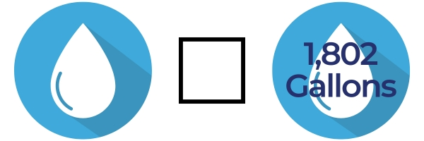

- What was your initial reaction when seeing your water footprint score?

- How did your actual water footprint compare to what you predicted before completing the activity? Why do you think it was/wasn’t different?
- What are three things that surprised you about your water footprint?

- What part of your lifestyle uses the most water?

- How does your diet and your clothing affect your score?
- How can understanding your water footprint change the way you use water in your daily life?
- Now that you know your actual water usage, do you think you should make changes to decrease that? Why or why not?

Part 2
Directions: There is a “learn more” column in the results section of the website where you can explore tips on how to conserve water in each area. Click to explore these different activities and tips. Select five of them that you could see yourself implementing easily and record them in the table below. When finished, answer the conclusion questions.

Activity | Type of Water Use (Indoor/Outdoor/Virtual) | Conservation Tip | Potential Impact
Example:  Washing dishes | Indoor water | Use one sink filled with warm water for washing and one filled with cold water for rinsing. | This could eliminate a lot of running water wasted when washing/rinsing and conserve several gallons every time I wash dishes.
 |  |  | 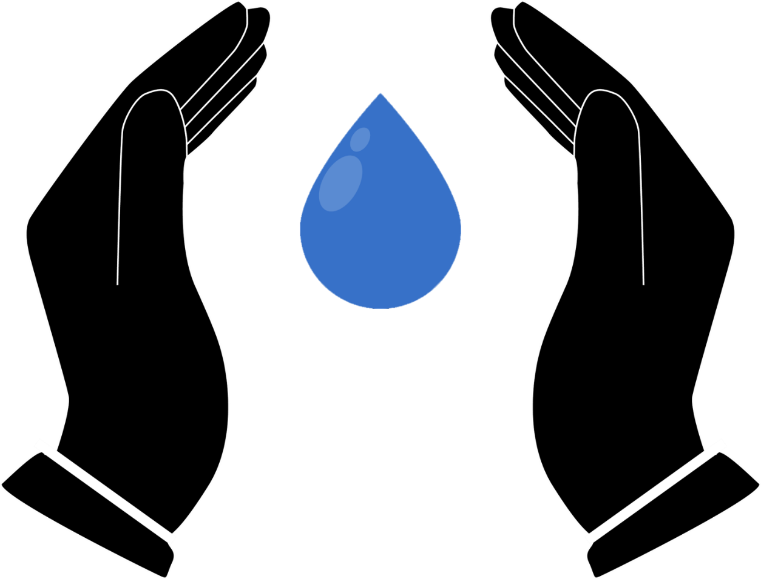

Conclusion Questions:

- Which of the tips above do you think would have the greatest impact on your water footprint? Why?

- Which tip could you most easily implement starting today?

- Why is it important for you to consider how much water you are using?
- How can you advocate for conserving water at home with your family?

Save Our Water!
Aligned to the following standards:
CS.03; CS.04; NRS.01; NRS.02; NRS.04; FFA.PL-A; FFA.PL-C; FFA.PL-E; FFA.PL-F; FFA.PL-N; AG3; AG4; AG-NR1; AG-NR2; AG-NR4; CCSS.ELA.W.9-10.2; CCSS.ELA.W.9-10.7; CCSS.ELA.SL.9-10.5; CCSS.ELA.L.9-10.6; CCSS.ELA.RST.9.10.4; CCSS.ELA.WHST.9.10.7; MP1; MP2; MP4; CCSS.HSS.ID.A.1; HS-ETS1-3; CRP.02; CRP.04; CRP.05; CRP.06; CRP.08; CRP.11;
Directions:
Select one of the five tips you explored in Part 2 of “How Much Water Do You Use?” This should be an action you could envision implementing in your life or in the school community. It should be something you consider important or impactful. You will use this tip to make a promotional poster.

Your poster should include the following items:
- A catchy title
- A brief explanation of the water conservation practice
  - What it is
  - How it helps conserve water
  - Why it’s important
- Visuals (drawings, images, diagrams, charts) that represent the water conservation practice
- One source where people can go to learn more about this practice (web URL, QR code, etc.)

- You may design the poster either by hand or by using a digital tool such as Canva, PowerPoint, Google Slides, etc.
- Be creative with your design. Your poster should be both informative and visually appealing so it will catch people’s attention and encourage them to practice water conservation.
- See the rubric on the next page for more guidelines on how the poster will be evaluated.
- Answer the conclusion questions below when you are finished with your poster.

Conclusion Questions:

- What inspired you to choose the water conservation practice that you did for your poster?

- Why is this practice important for others to adopt?

- Other than the poster, how can you use the information you learned through this activity to encourage others in your community or school to conserve water?

Water Conservation Poster Rubric

Category | Excellent  (4 pts) | Good  (3 pts) | Developing  (2 pts) | Needs Improvement  (1 pt)
Content Accuracy | Poster accurately and thoroughly explains the selected water conservation practice with clear details about its impact and importance. | Poster explains the selected water conservation practice with most details correct but may lack depth. | Poster explains the selected practice, but some important details may be missing or inaccurate. | Poster does not accurately explain the selected practice or is unclear.
Creativity and Visual Appeal | Poster is visually engaging, well-organized and creatively designed. It uses images, colors and text effectively to grab attention and convey the message. | Poster is visually appealing with good use of images, colors and text but could be more creative or organized. | Poster is functional but lacks creativity or visual appeal. It may be cluttered or too plain. | Poster is poorly designed, disorganized or lacks visual appeal.
Clarity and Readability | Text is clear and easy to read with a well-organized layout. Fonts, colors and images are chosen to enhance readability and communication. | Text is generally readable, though some parts may be harder to read due to font choices or layout. | Text is somewhat difficult to read or poorly organized. Font choices or layout may detract from the clarity. | Text is difficult to read or unclear. The layout makes the poster hard to follow.
Use of Visuals | Visuals (images, drawings, graphs, etc.) are highly relevant and effectively support the message of the poster. | Visuals are relevant and support the message but may not be as well integrated into the design. | Visuals are somewhat relevant, but their connection to the message is unclear or weak. | Visuals are irrelevant or missing altogether and do not enhance the message.
Persuasiveness and Impact | The poster is highly persuasive, making a compelling case for the importance of water conservation. The message is clear and inspiring. | The poster makes a good case for water conservation, but it may not be as compelling or inspiring as it could be. | The poster provides basic information about water conservation but lacks strong persuasive elements. | The poster does not make a strong case for water conservation or fails to persuade effectively.
Effort and Neatness | The poster is neat, well-crafted and shows a high level of effort. All elements are polished and carefully executed. | The poster shows good effort and is generally neat, but there may be a few areas that appear rushed or incomplete. | The poster shows some effort, but several areas appear unfinished or not well-thought-out. | The poster shows minimal effort with many areas rushed or poorly executed.
Total Score |  |  |  | /24

Comments: __________________________________________________________________________________________________________
________________________________________________________________________________________________________________________________________________________________________________________________________________________________________________________________________________________________________________________________________________________________________

