Sensory Evaluation in Food Science
Created: 08/2022 by the National FFA Organization
The purpose of this lesson is to challenge the human sense of smell and taste to make informed decisions. This lesson will train students how to compete in the “Sensory Evaluation” (triangle tests, aroma identification) portion of the National FFA Food Science and Technology CDE.
Student Learning Objectives:
After completing these activities, students will …
- Describe the purpose and role of sensory evaluation in the food science industry.
- Develop informed decisions based upon sensory evaluation.
- Determine differences in products by executing a triangle test
- Determine differences in products through aroma identification.

Suggested Grade Level:
Grades 9 and 10 (This lesson is written so instructors can scale up or down based on class needs.)

Suggested Time: 90 to 120 minutes (*Time requirements may vary based upon student understanding and class schedule.)

Resources/References:
- Textbook: Principles of Food Science, 4th Edition, Janet D, Ward (Facts/information in this lesson were obtained from the textbook.)
- Video: for Extended Learning, https://www.youtube.com/watch?v=mFm3yA1nslE

Equipment and Supplies Needed:
- Plug in an air freshener (or something similar). Seek to use a food scent (cookie dough, coffee, apples, pumpkin spice, etc.).
- “Imitation Apple Pie Lab” materials (see lab sheet for details on supplies needed)
- “Activity 3: Imitation Apple Pie Lab” worksheet
- One copy of the “Exit Ticket: Sensory Preferences” worksheet for each student
- One copy of the “Activity 1: Odor Recognition/Aroma Testing” lab sheet for each student
- Aroma testing samples (See list of aroma options at bottom of this lesson.)
  - Aromas may be purchased at https://www.flavor.education/.
- Triangle test samples (See list of ideas in Lesson Preparation section, Activity 2 items.)
- Paper plates, enough for each student to have two plus extra to place food samples on
- Disposable spoons
- Napkins
- Glass jars for aroma samples (See reference at end of the lesson.)
- Cotton balls
- Food coloring
- One copy of the “Activity 2: Taste Recognition/Triangle Testing” lab sheet for each student
- “Maps for Note Taking” examples (for use in the Follow-up section of this lesson)

Lesson Preparation:
- The NIGHT BEFORE this lesson (when no students are in the classroom), plug in an air freshener as listed in the Equipment/Supplies Needed section of this lesson.
- This lab requires perishable food items! Read the “Activity 3: Imitation Apple Pie Lab” handout prior to beginning this lesson.
- Activity 1: Odor Recognition/Aroma Testing — The day before this lesson, prepare all aromas to be used. Ideally, select 10 different aromas. These may be purchased online or at a local grocery store. It is recommended to use liquid scents. Use only the scents found on the FFA food science CDE aroma list (attached to this lesson). Consider using small glass containers (as shown on the same page as the list of aromas); dab a small amount of the aroma on a cotton ball, add food coloring if desired (to trick the brain). Keep lids on all containers. Number containers randomly (Example: 305, 672, 492, etc.) so the brain does not associated numbers with a particular order. This is common practice in food science testing. Create “aroma stations” with all the samples. Be sure to spread the samples out so students have enough room to move.
- Activity 2: Taste Evaluation/Triangle Testing — Prepare samples before class begins. This can be done the day before class. Any food items may be used. Ideas include Sprite/7Up, Nestle Chocolate chips/generic brand chocolate chips, Fig Newton/Fat-Free Fig Newton, name brand hot dog buns/generic hot dog buns, Kellogg Corn Flakes/generic cornflakes. The task is to find two items that are similar but have a slight difference. Fat free, sugar free, etc. may be used as well. See the drawing at the end of this lesson on how to set up the lab and the lab sheet for students.
- One copy of the “Unit 5 Assessment” per student (Note: This assessment requires set-up time and materials. See the assessment “Key” for details.) The assessment will use the following:
  - Various aroma samples (determined by teacher)
  - Various triangle test samples (determined by teacher)

Vocabulary:
- Sensory evaluation
- Taste blind
- Supertaster
- Medium taster
- Nontaster
- Appearance
- Flavor
- Texture

Cross-Curricular Connections:
Science | English/Language Arts | Mathematics
- Activity 3: Students will be challenged with the question of “how the imitation apple pie tasted like a real apple pie.” Students should make the connection with the interaction of ingredients, thus creating an “apple” flavor and texture of pie. | - Activity 1, Activity 2: Students are required to read and follow directions and write responses to lab questions.  - Exit Ticket: Students are required to interview another individual in their home and record responses. | - Activity 3: Students are required to use numbers and measure accurately.

Virtual Instruction Ideas:
- This lesson can be fully adapted and taught online/virtually, but students will need access to the same lab supplies as the teacher. Virtual-learning/online students would need another adult to assist with setting up labs and the final unit assessment. It is recommended that the teacher require online/virtual-learning students to 1) go to school for the lab and/or assessment portion of this lesson OR 2) require students to use a camera for completing each section plus confirming another adult set up the lab.
- Teachers may also wish to make “take-home lab kits” for this lesson for students completing it virtually/online. To make kits, include all items listed in supplies section of this lesson.

Student Activity Sheets:
Direct access to student activity sheets without lesson plan or answer key for easy upload to a learning management system or printing for classwork.

https://ffa.box.com/s/c6au591wrl46ocl3qq5n7xnqskaylwue (Word)
https://ffa.box.com/s/ryysf5pz1ykltmwcvp29jrx3a3dda7hm (PDF)
https://ffa.box.com/s/kii28yt4radib2o2epv5ka65zt16w9ln (Non-Designed)
https://docs.google.com/document/d/1xoqhXr2WIyjXuuE64OWjZV7NRF7WAQLEEUtP06tB1yY/copy (Google)

These Activities are Aligned to the Following Standards:
AFNR Performance Element
- FPP.02. Apply principles of nutrition, biology, microbiology, chemistry and human behavior to the development of food products.
FFA Precept
- FFA.PL-A.Action: Assume responsibility and take the necessary steps to achieve the desired results, no matter what the goal or task at hand.
- FFA.PL-C.Vision: Visualize the future and how to get there.
- FFA.PG-J.Mental Growth: Embrace cognitive and intellectual development relative to reasoning, thinking and coping.
- FFA-CS-M.Communication: Effectively interact with others in personal and professional settings.
- FFA.CS-N.Decision Making: Analyze a situation and execute an appropriate course of action.
Common Career Technical Core
- AG-FD2 Apply principles of nutrition, biology, microbiology, chemistry and human behavior to the development of food products.
Common Core – Reading: Informational Text
- CCSS.ELA-Literacy.RI.9-10.1 Cite strong and thorough textual evidence to support analysis of what the text says explicitly as well as inferences drawn from the text.
- CCSS.ELA-Literacy.RI.9-10.8 Delineate and evaluate the argument and specific claims in a text, assessing whether the reasoning is valid and the evidence is relevant and sufficient; identify false statements and fallacious reasoning.
Common Core – Writing
- CCSS.ELA-Literacy.W.9-10.2 Write informative/explanatory texts to examine and convey complex ideas, concepts, and information clearly and accurately through the effective selection, organization, and analysis of content.
Common Core – Speaking and Listening
- CCSS.ELA-Literacy.SL.9-10.1.A Come to discussions prepared, having read and researched material under study; explicitly draw on that preparation by referring to evidence from texts and other research on the topic or issue to stimulate a thoughtful, well-reasoned exchange of ideas.
- CCSS.ELA-Literacy.SL.9-10.1.C Propel conversations by posing and responding to questions that relate the current discussion to broader themes or larger ideas; actively incorporate others into the discussion; and clarify, verify, or challenge ideas and conclusions.
- CCSS.ELA-Literacy.SL.9-10.4 Present information, findings, and supporting evidence clearly, concisely, and logically such that listeners can follow the line of reasoning and the organization, development, substance, and style are appropriate to purpose, audience, and task.
Common Core – Science & Technical Subjects
- CCSS.ELA-Literacy.RST.9-10.3 Follow precisely a complex multistep procedure when carrying out experiments, taking measurements, or performing technical tasks, attending to special cases or exceptions defined in the text.
- CCSS.ELA-Literacy.RST.9-10.9 Compare and contrast findings presented in a text to those from other sources (including their own experiments), noting when the findings support or contradict previous explanations or accounts.
Common Core – Literacy in Science & Technical Subjects: Writing
- Literacy.WHST.9-10.2 Write informative/explanatory texts, including the narration of historical events, scientific procedures/ experiments, or technical processes.
- CCSS.ELA-Literacy.WHST.9-10.4 Produce clear and coherent writing in which the development, organization, and style are appropriate to task, purpose, and audience.
- CCSS.ELA-Literacy.WHST.9-10.5 Develop and strengthen writing as needed by planning, revising, editing, rewriting, or trying a new approach, focusing on addressing what is most significant for a specific purpose and audience.
- CCSS.ELA-Literacy.WHST.9-10.8 Gather relevant information from multiple authoritative print and digital sources, using advanced searches effectively; assess the usefulness of each source in answering the research question; integrate information into the text selectively to maintain the flow of ideas, avoiding plagiarism and following a standard format for citation.
- CCSS.ELA-Literacy.WHST.9-10.9 Draw evidence from informational texts to support analysis, reflection, and research.
Common Core – Math Practices
- CCSS.MATH.PRACTICE.MP3 Construct viable arguments and critique the reasoning of others.
- CCSS.MATH.PRACTICE.MP6 Attend to precision.
AFNR Career Ready Practices
- CRP.02. Apply appropriate academic and technical skills. Career-ready individuals readily access and use the knowledge and skills acquired through experience and education to be more productive.
- CRP.04. Communicate clearly, effectively, and with reason. Career-ready individuals communicate thoughts, ideas and action plans with clarity, whether using written, verbal and/or visual methods.
- CRP.05. Consider the environmental, social and economic impact of decisions. Career-ready individuals understand the interrelated nature of their actions and regularly make decisions that positively impact and/or mitigate negative impact on other people, organizations and the environment.
- CRP.06. Demonstrate creativity and innovation. Career-ready individuals regularly think of ideas that solve problems in new and different ways, and they contribute those ideas in a useful and productive manner to improve their organization.
- CRP.07. Employ valid and reliable research strategies. Career-ready individuals are discerning in accepting and using new information to make decisions, change practices or inform strategies.
- CRP.08. Utilize critical thinking to make sense of problems and persevere in solving them. Career-ready individuals readily recognize problems in the workplace, understand the nature of the problem, and devise effective plans to solve the problem.
- CRP.09. Model integrity, ethical leadership and effective management. Career-ready individuals readily recognize problems in the workplace, understand the nature of the problem, and devise effective plans to solve the problem.
- CRP.11 Use technology to enhance productivity. Career-ready individuals find and maximize the productive value of existing and new technology to accomplish workplace tasks and solve workplace problems.
Partnership for 21st Century Skills
- Collaboration
- Communication
- Critical Thinking and Problem Solving
- Health Literacy
- Productivity and Accountability
- Social and Cross-cultural Skills
- Think Creatively
Lesson Plan:
- Bell Ringer:
- Have the following written on the board or projected for students to see as they enter the classroom: “Please answer the following on a scrap piece of paper: What is that smell? Why would I have this smell in class? What do you think our topic is for class today? Why?” (Note: If doing this lesson virtually/online, or you do not have access to an air freshener, direct students to pretend to smell a scent and answer the questions.
- Once the bell rings, ask students to share their responses to the above questions.
- Transition into the Introduction section of this lesson. Have students put their bell ringer activity away or collect it.

- Introduction:
- To prepare students to take notes, before the lesson begins, teachers may wish to use one of the map styles as found in the Follow-up section of this lesson to set a visual road map for the content to come. Students can then use a visual road map for note taking if they wish.
- Say to students: You used your sense of smell to notice the smell of the classroom earlier. Our food preferences are based on personal life experiences (good and bad), advertisement we see or hear, peer pressure, culture and habits. Can anyone think of a good example of how any of this has impacted a specific food you like or dislike? Give students time to answer. Examples to share: the smell of grandma’s house because of the cookies she always bakes; disliking a food because you ate too much and got sick; loving to make spicy dishes because your family raises peppers; your preferences as a young adult because of what your parents or household did growing up (like smooth or chunky peanut butter, mushrooms or meat in your spaghetti sauce, etc)
- Continue sharing with students: Is there a way or a tool to measure what food people will like? (No.) How do food scientists create or develop new food and food products? How do they know people will eat it? (Allow students time to think or answer.) When new food products are developed, researchers look at the human factors that affect food choices. They can then make predictions about a product’s potential for success or failure. You are going to get the chance to act as a food scientist and create and market a new food item in this class!
- Share the following and encourage students to copy vocabulary in their notes: We are going to test your senses today by evaluating foods and aromas/smells. What is sensory evaluation? (The human analysis of taste, smell, sound, feel and appearance of food.) Many factors can influence how we perceive foods. Some people are “taste blind,” meaning they are unable to distinguish between tastes. Genetic makeup will affect what you taste and how you identify flavors. The number of taste buds, gender, health and age also contribute.
- Share the following and encourage students to copy vocabulary in their notes: Studies show that people can be classified into three groups based on how they taste: supertasters, medium tasters and nontasters. Supertasters can identify subtle differences in flavor and aroma. On average, nontasters prefer higher fat salad dressings. On average, supertasters have an average body max index of 23.5, medium tasters 26.6 and nontasters nearly 30. Is there a correlation between taste-bud sensitivity and weight? Perhaps!
- Share with students the following additional characteristics about sensory identification: In order to identify food, we must first identify the desirable characteristics of the products. Three main sensory characteristics are appearance, flavor and texture. It is important to consider all three when sampling food. Example: You want crackers to be crunchy, not soggy; cake should be moist, not dry.
- Be sure students write the following terms and definitions:
- Appearance is the shape, size, condition and color of a food product — what you see.
  - Say to students: Think about how color impacts what you think. Has anyone ever tried green ketchup? It is odd eating green when our brain says it should be red!
- Flavor: is the combined effect of taste and aroma.
  - Taste starts in the mouth with taste buds. There are five basic taste buds — salty, bitter, sour, sweet, savory.
  - Aroma is the second component of flavor — the odor of the food.
  - Say to students: Your brain will remember the combination of aromas and tastes and then will work to identify the food based on experiences.
- Texture is how a food product feels to the fingers, tongue, teeth and palate (roof of mouth). Texture is expressed as chewy, grainy, brittle, firm.
- Transition into Activity 1. Tell students: Let’s begin by challenging your sense of smell with our first lab.

- Activity 1: Odor Recognition/Aroma Testing Lab
- Be sure to have all aroma samples ready for testing prior to starting this portion of the lesson.
- Give each student the lab sheet titled “Activity 1: Odor Recognition/Aroma Testing.”
- Read the purpose and directions with students. Ask students what questions they have prior to starting the lab.
- Instruct students on how to sample each aroma. Students should remove the lid and use their hand to “wave” the aroma to their nose. Students should not inhale the aromas. This not only can be unsafe but is not good practice in food science.
- Allow students to circulate about the room to each aroma station.
- When all students are finished, review the answers with them.
- Go over the lab questions together. Ask students which aromas were the most challenging. The easiest? Why? This lab sheet may be collected for a grade, if desired.
- Transition into Activity 2.

- Activity 2: Taste Recognition/Triangle Testing Lab
  - Be sure to have all triangle test labs prepared and ready before beginning this lab. It is recommended to have all samples set up in stations — five stations total. Have students move about the classroom to obtain samples. Be sure students return to their seats when they have all samples.
  - Give each student the lab sheet titled “Activity 2: Taste Recognition/Triangle Testing.”
  - Read the purpose and directions with students. Show students how to set up their sample plates (as found in the picture at the end of this lesson).
  - Instruct students on how you want them to rotate to each station. Ask students what questions they have prior to starting the lab.
  - Dismiss students to begin obtaining samples. Remind students there should be NO TALKING while evaluating samples!
  - After all students have returned to their seats, travel the classroom to be sure students are recording their responses.
  - When all students have finished responding, instruct them to dispose of any extra samples. Go over answers with students.

- Activity 3: Imitation Apple Pie Lab
  - NOTE: 60 minutes are needed for this activity.
  - Depending on the number of students in the class, this lab may create more than one imitation pie. It is recommended to have groups no larger than four students per group. Be sure to account for enough supplies when adding more groups. The supplies listed for this lab are for one group only.
  - Give each student the lab sheet titled “Activity 3: Imitation Apple Pie.” Read the purpose and directions with the class. Be sure to ask for questions prior to allowing students to begin working. Assign student groups, and discuss where supplies are located. (It is recommended to have all supplies in a central location at the front of the room.)
  - Be sure to bake the real apple pie and have one real apple pie and one imitation apple pie available for students to sample. If you end up making multiple pies, bake them all and allow students to take them home the next class day.
  - When cutting for samples, remember that samples are ideal when at room temperature. Slice enough pieces so each student may have one piece. Have students get one piece of each pie on a paper plate, then return to their seats for observations. Direct students to complete the data table and questions on their lab sheets.
  - When all observations have been recorded, discuss the lab sheet data table and questions with students. Questions to ask: “Which pie did you prefer? Why? Did the imitation one surprise you? What ingredient(s) do you think gave the imitation pie its ‘apple’ flavor?”
  - Teachers may wish to collect completed lab sheets for participation and/or grading.

- Follow-up: Cartographer E-Moment — Let your students’ brains draw on their abilities to represent relationships.
  - Examples of maps to create: After students have captured the information from above (introduction and all activities) share with them the various types of “maps”: cluster, mind map, or concept map or add your own style of map). Or, if more appropriate, simply share one map style. You could then share a different map after each subsequent lesson, enlarging students’ repertoire of visual organizers. (See examples of maps at the bottom of this lesson plan.)
  - Have students create their map. Invite students to represent the information they just learned using the map style(s) presented. Note: Students gain optimal benefit when they choose the map they feel best represents the information.
  - Have them share. Students can share in pairs or trios or walk about the room noticing how people represented the information. If students were only shown one map style, they could compare their maps to the teacher’s. Students may turn maps in rather than sharing.

- Optional – Extended Learning Opportunities (Not factored into time requirement):
  - Direct students to watch the following video to learn more on how taste and smell affect our brain and mood: https://www.youtube.com/watch?v=mFm3yA1nslE (10:29 minutes).

- Exit Ticket: Within the last five to 10 minutes of class, give each student a copy of the “Exit Ticket: Sensory Preferences” worksheet. Go over directions with the students. Tell them the due date (teacher can decide when). Ask if there are any questions. Students may begin working on the assignment until the bell rings for dismissal.

- Unit 5 Assessment: Once done with this lesson, students are ready for the Unit 5 Assessment. Note: The assessment requires set-up time and supplies. See the assessment “Key” for directions on setting up the assessment. Allow at least 30 minutes for students to complete the assessment.

Activity 1: Odor Recognition/Aroma Testing Lab
Aligned to the following standards: FPP.02; FFA.PL-A; FFA.PL-C; FFA.PG-J; FFA-CS-M; FFA.CS-N; AG-FD2; CCSS.ELA.RI.9-10.1; CCSS.ELA.RI.9-10.8; CCSS.ELA.W.9-10.2; CCSS.ELA.SL.9-10.1.A; CCSS.ELA.SL.9-10.1.C; CCSS.ELA.SL.9-10.4; CCSS.ELA.RST.9-10.3; CCSS.ELA- RST.9-10.9; CCSS.ELA.WHST.9-10.2; CCSS.ELA.WHST.9-10.4; CCSS.ELA.WHST.9-10.5; CCSS.ELA- WHST.9-10.8; CCSS.ELA.WHST.9-10.9; MP3; MP6; CRP.02; CRP.04; CRP.05; CRP.06; CRP.07; CRP.08; CRP.09; CRP.11

Purpose:
The purpose of this lab is to challenge your sense of smell. You will examine how accurately you can identify common aromas by only their smell. This lab will also train you on how to compete in the aroma portion of the National FFA Food Science and Technology CDE.
    - Do not taste samples.
    - Do not inhale aromas. “Wave” the scent to your nose using your hand.

Directions:
When given permission, you will smell aromas to determine what they may be. Record your answers below. When finished, answer the post-lab questions.
Sample No. | Your Response/Guess | Identified Correctly? Yes or No | Actual Aroma

Post-Lab Questions:

- Which aromas did you find the most challenging to identify? Why?

- Which aroma was most often identified incorrectly? (Consider your classmates responses.)

- Is taste or aroma more important in food identification? Explain your answer:

- What role does aroma and flavor have in how consumer purchase different food products?

- How do you think food production companies leverage flavor and aroma preferences to increase consumer purchasing decisions?

Activity 2: Taste Recognition/Triangle Testing Lab
Purpose: The purpose of this lab is to challenge your sense of taste. This lab will also train you on how to compete in the triangle testing portion of the National FFA Food Science and Technology CDE.
You will evaluate 5 different samples. Each of the five samples have 3 samples to try. Of the three samples, determine which one is different from the other two.

Directions: 5 different triangle tests are provided. Obtain 1 sample of each item provided. Be sure to set up your sample plate as directed by your teacher. Return to your seat. Identify the different samples through flavor, aroma, visual cues and/or textural differences.
For each test, you are to identify the one sample that is DIFFERENT from the other two.
Circle the correct number that represents the different sample.

TEST 1:
- 647
- 992
- 381

TEST 2:
- 716
- 433
- 250

TEST 3:
a. 521
b. 688
c. 954

TEST 4:
- 182
- 825
- 293

TEST 5:
- 341
- 976
- 258

Post-Lab Questions:

- Which test did you find the most challenging to identify? Why?

- Which product was most often identified incorrectly? (Consider your classmates responses.)

- How do you think flavor and aroma impact each other in overall food product selection?
Activity 3: Imitation Apple Pie
Aligned to the following standards: FPP.02; FFA.PL-A; FFA.PL-C; FFA.PG-J; FFA-CS-M; FFA.CS-N; AG-FD2; CCSS.ELA.RI.9-10.1; CCSS.ELA.RI.9-10.8; CCSS.ELA.W.9-10.2; CCSS.ELA.SL.9-10.1.A; CCSS.ELA.SL.9-10.1.C; CCSS.ELA.SL.9-10.4; CCSS.ELA.RST.9-10.3; CCSS.ELA- RST.9-10.9; CCSS.ELA.WHST.9-10.2; CCSS.ELA.WHST.9-10.4; CCSS.ELA.WHST.9-10.5; CCSS.ELA- WHST.9-10.8; CCSS.ELA.WHST.9-10.9; MP3; MP6; CRP.02; CRP.04; CRP.05; CRP.06; CRP.07; CRP.08; CRP.09; CRP.11

Purpose: This lab will test the theory that human senses can be fooled. Food chemists create food products that look and taste just like the real thing but are imitations! Did you know, the first frozen lemon pies did not contain lemon nor eggs! This lab will compare the taste of a real apple pie to the taste of an imitation apple pie.
Supplies Needed:
- Oven (a way to bake two full-sized pies)
- 2-quart saucepan, 1 per group
- Stove or hotplates
- Disposable forks
- Mixing spoon and spatula/wooden spoon
- Paper plates
- 2 mixing bowls per group
- 1 frozen apple pie — crumb-topping kind only (the real apple pie)

Imitation Pie:
- 500 ml water
- 375 ml sugar
- 7 ml cream of tartar
- 36 round snack crackers (Ritz work best)
- 1 pie crust + pie pan
- 5 ml cinnamon
- 1 ml nutmeg
- 30 ml margarine/butter

Crumb Topping:
- 125 ml flour
- 125 ml brown sugar
- 2 ml cinnamon
- 45 ml margarine/butter

Procedure:
- Heat water to boiling in a 2-quart saucepan.
- Mix sugar with cream of tartar.
- Add this mixture to the boiling water. Turn heat down to low.
- Add round snack crackers to the mixture, one at a time.
- Simmer gently for 3 minutes. Do not stir!
- Pour this mixture into a pastry-lined pie pan.
- Sprinkle with cinnamon and nutmeg.
- Dot lightly with slices of margarine or butter.
- Cover with the crumb topping.
- Bake at 400°F for 30 minutes or until the filling is bubbly.
*NOTE: Bake REAL apple pie at the same time (notice potential different baking times).

Crumb Topping:
- Use a fork or pastry blender to combine flour, brown sugar and cinnamon in a mixing bowl.
- Cut in margarine or butter. Mixture should resemble coarse crumbs.
- Sprinkle evenly over the top of the pie filling.

Carefully examine a sample of each pie. Record your observations in the table below:

Observations | Real Apple Pie | Imitation Apple Pie
Flavor
Texture
Aroma
Color
Post-Lab Questions:
- Convert the metric measurements in this experiment to English using the following equivalents: 250 ml = 1 cup; 5 ml = 1 teaspoon.
500 ml water
375 ml sugar
7 ml cream of tartar
5 ml cinnamon
1 ml nutmeg
30 ml margarine/butter
125 ml flour
125 ml brown sugar
2 ml cinnamon
45 ml margarine/butter

- How did the two pies compare in terms of color, aroma and texture? Be specific:

- What flavors could you detect in the imitation apple pie?

- Which pie was your favorite and why?

Exit Ticket: Sensory Preferences
Aligned to the following standards: FPP.02; FFA.PL-A; FFA.PL-C; FFA.PG-J; FFA-CS-M; FFA.CS-N; AG-FD2; CCSS.ELA.RI.9-10.1; CCSS.ELA.RI.9-10.8; CCSS.ELA.W.9-10.2; CCSS.ELA.SL.9-10.1.A; CCSS.ELA.SL.9-10.1.C; CCSS.ELA.SL.9-10.4; CCSS.ELA.RST.9-10.3; CCSS.ELA- RST.9-10.9; CCSS.ELA.WHST.9-10.2; CCSS.ELA.WHST.9-10.4; CCSS.ELA.WHST.9-10.5; CCSS.ELA- WHST.9-10.8; CCSS.ELA.WHST.9-10.9; MP3; MP6; CRP.02; CRP.04; CRP.05; CRP.06; CRP.07; CRP.08; CRP.09; CRP.11

Purpose:
This worksheet will help you analyze factors that affect your food preferences. You will complete the first 2 columns regarding your food preferences (Example: your favorite beverage, your least favorite beverage). You will then interview 2 other people you live with, or are related to, for the 2 far-right columns. Once you have completed the chart, answer the questions below.

Food Category | My Most Favorite | My Least Favorite | Most Favorite of Family Member/Roommate/Other Person in My Home | Least Favorite of Family Member/Roommate/Other Person in My Home
Beverage
Vegetable
Cake
Candy
Cookie
Fruit
Ice Cream
Meat
Pie
Snack Food
Soft Drink

- What similarities and differences did you discover between your most and least favorites and the people you interviewed? Were any of them the same? Any explanation as to why they may have been the same?

- In what ways do you think your family affects your food preferences, and why?

TEACHER NOTES: Food Science CDE
Potential AROMA List:

Cited from the National FFA website regarding the National FFA Food Science and Technology CDE, Aroma Testing:
“Each participant will be asked to identify four different aromas from vials provided at each station and record the answer on the sheet provided. A list of potential aromas will be provided to each person. Each sample is worth 5 points. (20 points total)”

Potential Aromas:
Apple | Banana | Basil | Butter | Cherry | Chocolate | Cinnamon | Clove | Coconut | Coffee | Garlic | Ginger Grape | Lemon | Licorice (anise) | Lime | Maple | Molasses | Nutmeg | Onion | Orange | Oregano | Peach Peppermint | Raspberry | Sage | Smoke (liquid) | Strawberry | Vanilla | Watermelon | Wintergreen
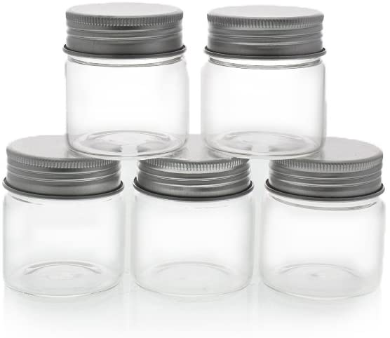 Glass jar example to contain samples for student testing.

*Place a cotton ball in each jar after dipping/dabbing with the desired aroma.
*Add food coloring if desired to the cotton ball.
*Keep all jar lids tightly closed; remind students to close the lids when they are finished testing.

Set-up Example: Taste Recognition/Triangle Testing Lab
One paper plate, divided into five sections. Each of the five sections divided into three.

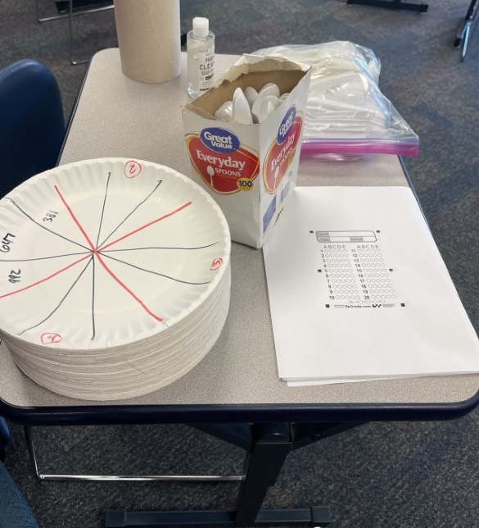
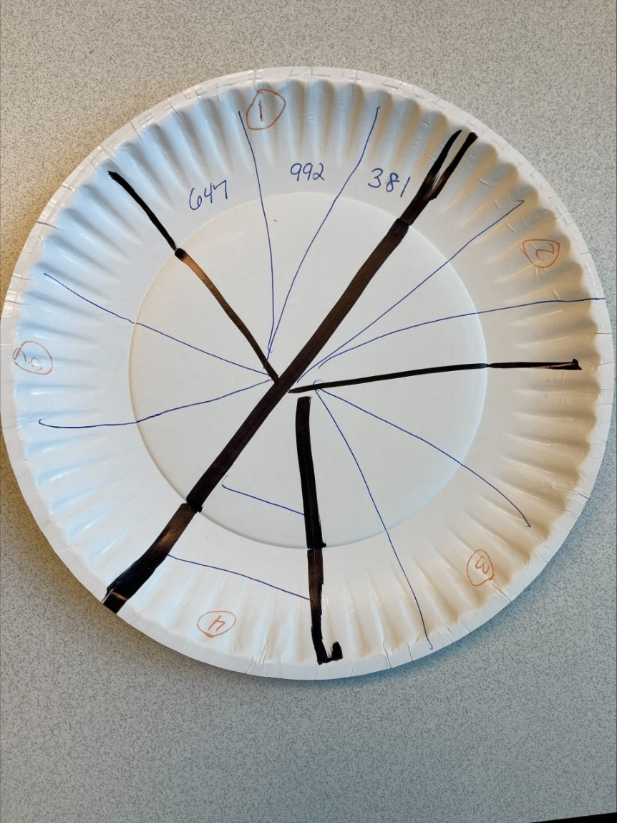

Example of Set-up for Triangle Testing:

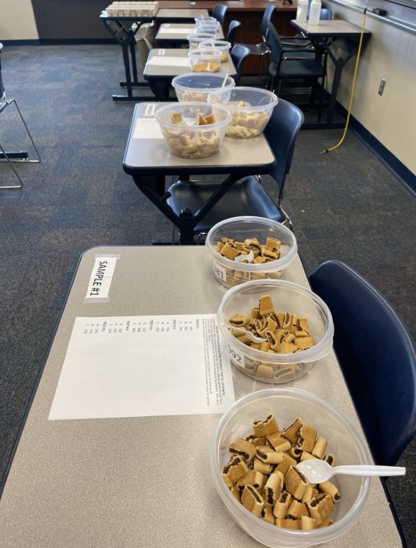

Set-up Example: Odor Recognition/Aroma Testing Lab
One container/sample with aroma sample. May be done as a liquid or a drop placed on a cotton ball and then placed in the sample container.

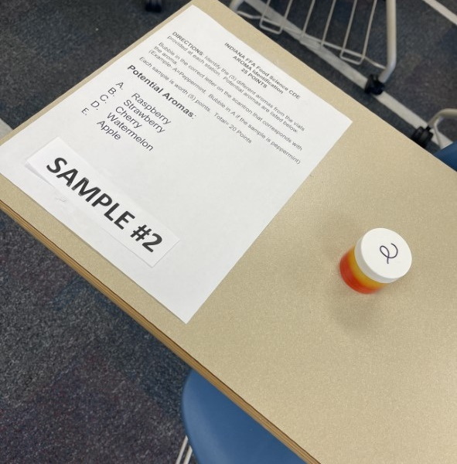

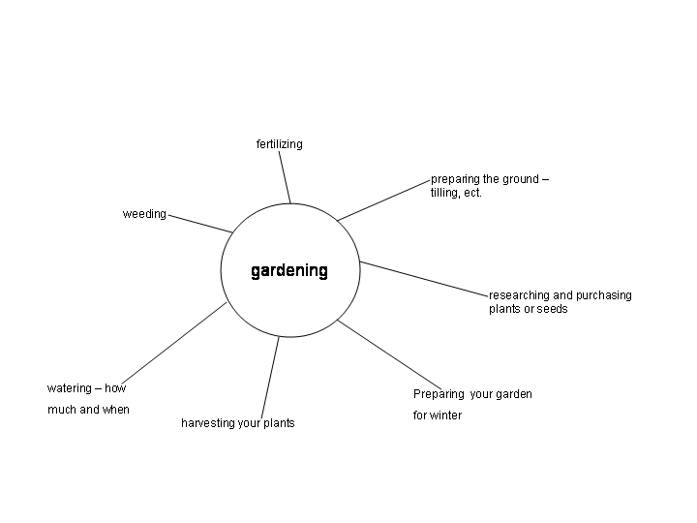
Maps for Note Taking EXAMPLES
*To be used in the Follow-up section of this lesson plan. Note: Student maps will appear different, depending what map style is used and concepts addressed.

Cluster Map:

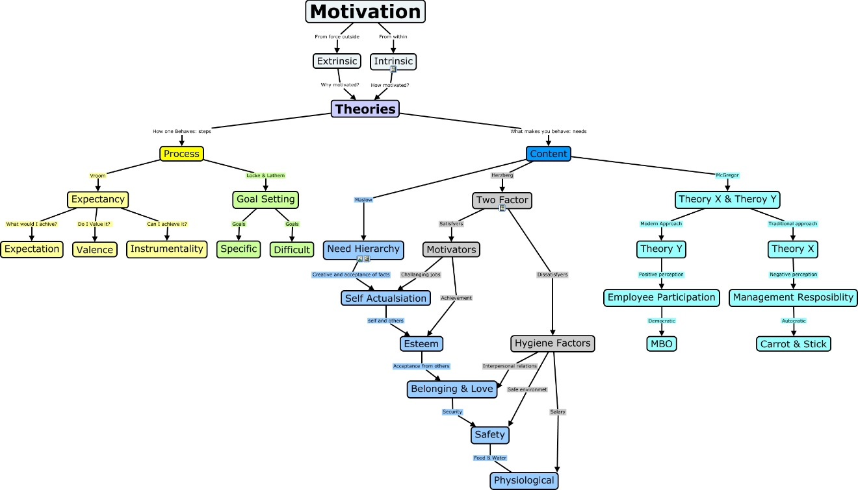
Concept Map:

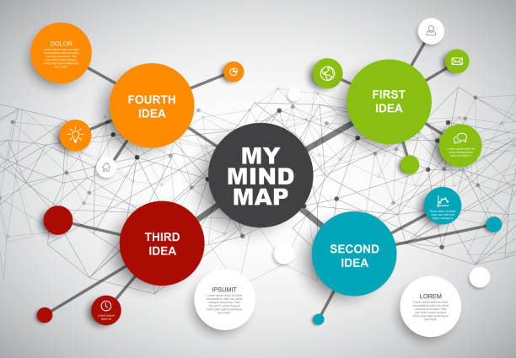
Mind Map:

KEY: Activity 3: Imitation Apple Pie
Aligned to the following standards: FPP.02; FFA.PL-A; FFA.PL-C; FFA.PG-J; FFA-CS-M; FFA.CS-N; AG-FD2; CCSS.ELA.RI.9-10.1; CCSS.ELA.RI.9-10.8; CCSS.ELA.W.9-10.2; CCSS.ELA.SL.9-10.1.A; CCSS.ELA.SL.9-10.1.C; CCSS.ELA.SL.9-10.4; CCSS.ELA.RST.9-10.3; CCSS.ELA- RST.9-10.9; CCSS.ELA.WHST.9-10.2; CCSS.ELA.WHST.9-10.4; CCSS.ELA.WHST.9-10.5; CCSS.ELA- WHST.9-10.8; CCSS.ELA.WHST.9-10.9; MP3; MP6; CRP.02; CRP.04; CRP.05; CRP.06; CRP.07; CRP.08; CRP.09; CRP.11

Data Chart Observations/Notes: Answers will vary by student. When evaluating student work, look for complete thoughts and descriptive terms. Students should not use “good, bad, OK, tastes like a pie, etc.” They should use descriptive terms such as bland, salty, sweet, cinnamon flavor, soft, chewy, moist, dry, etc.

Post-Lab Questions:
Convert the metric measurements in this experiment to English using the following equivalents:
250 ml = 1 cup; 5 ml= 1 teaspoon
- 500 ml water = 2 cups
- 375 ml sugar = 75 teaspoons or 25 tablespoons or 1.5 cups
- 7 ml cream of tartar = 1 ½ teaspoons
- 5 ml cinnamon = 1 teaspoon
- 1 ml nutmeg = ¼ teaspoon
- 30 ml margarine/butter = 2 tablespoons
- 125 ml flour = ½ cup
- 125 ml brown sugar = ½ cup
- 2 ml cinnamon = ½ teaspoon
- 45 ml margarine/butter = 3 tablespoons

How did the two pies compare in terms of color, aroma and texture? Be specific:

Answers will vary, but the pies should smell similar, texture may be softer/more “mushy” in the imitation pie and color will vary; the imitation pie often is lighter in color in the center of the pie.

What flavors could you detect in the imitation apple pie?

Cinnamon, nutmeg

Which pie was your favorite and why?

Answers will vary.

