What Is Sustainable Agriculture?
Created: 02/2020 by the National FFA Organization

Description: Valent USA is a leader in sustainable solutions for a changing world, and maintaining the ability to continue feeding the growing population requires sustainability. Through this lesson series, students will have the opportunity to learn about the importance of sustainability throughout the Agriculture, Food and Natural Resources Value Chain.
Student Learning Objectives:
After completing these activities, students will …
- Identify the characteristics of sustainable agriculture practices.
- Identify sustainable practices utilized by Valent USA.
- Give examples of sustainable agriculture practices in use.
- Apply the concepts of sustainable agriculture practices to the development of a product.

Time Required: 120 minutes
Resources:
- Sustainable Agriculture Practices, https://www.conserve-energy-future.com/sustainable-farming-practices.php
- Valent USA, https://youtu.be/zjcMn0QttOU
- Agricultural Sustainability Institute, https://asi.ucdavis.edu/programs/ucsarep/about/what-is-sustainable-agriculture

Equipment and Supplies Needed:
- A copy of the “What Is Sustainability?” worksheet for each student
- Poster paper
- Markers
- Internet access
- A copy of the “Sustainable Practices Gallery Walk” worksheet for each student
- A copy of the “Learning Pyramid Exit Ticket” worksheet for each student

This quick lesson plan would work well as:
- An introduction to sustainability.

These activities are aligned to the following standards:
AFNR Performance Element
- CS.04: Demonstrate stewardship of natural resources in AFNR activities.
FFA Precept
- FFA.PL-A.Action: Assume responsibility and take the necessary steps to achieve the desired results, no matter what the goal or task at hand.
- FFA.PG-J.Mental Growth: Embrace cognitive and intellectual development relative to reasoning, thinking and coping.
- FFA.CS-M.Communication: Effectively interact with others in personal and professional settings.
- FFA.CS-N.Decision Making: Analyze a situation and execute an appropriate course of action.
Common Core – Writing
- CCSS.ELA-Literacy.W.9-10.2: Write informative/explanatory texts to examine and convey complex ideas, concepts, and information clearly and accurately through the effective selection, organization, and analysis of content.
Common Core – Speaking and Listening
- CCSS.ELA-Literacy.SL.9-10.1: Initiate and participate effectively in a range of collaborative discussions (one-on-one, in groups, and teacher-led) with diverse partners on grades 9-10 topics, texts, and issues, building on others' ideas and expressing their own clearly and persuasively.
- CCSS.ELA-Literacy.SL.9-10.2: Integrate multiple sources of information presented in diverse media or formats (e.g., visually, quantitatively, orally) evaluating the credibility and accuracy of each source.
- CCSS.ELA-Literacy.SL.9-10.4: Present information, findings, and supporting evidence clearly, concisely, and logically such that listeners can follow the line of reasoning and the organization, development, substance, and style are appropriate to purpose, audience, and task.
Common Core – Literacy in Science & Technical Subjects: Writing
- CCSS.ELA-Literacy.WHST.9.10.4: Produce clear and coherent writing in which the development, organization, and style are appropriate to task, purpose, and audience.
Green/Sustainability Knowledge and Skill Statements
- AFNR Career Cluster, Statement 2: Analyze community practice or policy development related to sustainability in AFNR.
- AFNR Career Cluster, Statement 3: Communicate the impact of “green” and sustainability principles on agriculture, food and natural resource systems.
- AFNR Career Cluster, Statement 7: Demonstrate an understanding of green and sustainability trends that are impacting processes and markets in AFNR.
AFNR Career Ready Practices
- CRP.02: Apply appropriate academic and technical skills. Career-ready individuals readily access and use the knowledge and skills acquired through experience and education to be more productive.
- CRP.04: Communicate clearly, effectively, and with reason. Career-ready individuals communicate thoughts, ideas and action plans with clarity, whether using written, verbal and/or visual methods.
- CRP.05: Consider the environmental, social and economic impact of decisions. Career-ready individuals understand the interrelated nature of their actions and regularly make decisions that positively impact and/or mitigate negative impact on other people, organizations and the environment.
- CRP.06: Demonstrate creativity and innovation. Career-ready individuals regularly think of ideas that solve problems in new and different ways, and they contribute those ideas in a useful and productive manner to improve their organization.
- CRP.07: Employ valid and reliable research strategies. Career-ready individuals are discerning in accepting and using new information to make decisions, change practices or inform strategies.
- CRP.08: Utilize critical thinking to make sense of problems and persevere in solving them. Career-ready individuals readily recognize problems in the workplace, understand the nature of the problem, and devise effective plans to solve the problem.
- CRP.10: Plan education and career path aligned to personal goals. Career-ready individuals take personal ownership of their own educational and career goals, and they regularly act on a plan to attain these goals.
- CRP.11: Use technology to enhance productivity. Career-ready individuals find and maximize the productive value of existing and new technology to accomplish workplace tasks and solve workplace problems.
Partnership for 21st Century Skills
- Communication
- Critical Thinking and Problem Solving
- Flexibility and Adaptability
- Global Awareness
- Initiative and Self-Direction
- Leadership and Responsibility
- Think Creatively

Lesson Plan:
- Bell Ringer: (5–7 minutes) What Is Sustainability?
  - Provide students with the “What Is Sustainability?” handout.
  - Show this short video (https://youtu.be/zjcMn0QttOU) from Valent USA.
    - If access to the video is unavailable, have students read about sustainability on the Valent USA website found at https://www.valent.com/sustainability/sustainable-growing-solutions
  - Ask students to define the term sustainability. Allow students to share their answers with another person and then work with that person to develop a common definition.
  - Call on a few groups to share their answers with the whole class.

- Introduction: (10 minutes) Sustainable agricultural practices are those in which agriculture is meeting the needs of society without damaging the resources needed to continue meeting those needs through agriculture. Ensuring sustainability is critical in continuing to meet the needs of a growing population.
  - Students will work in pairs to brainstorm a list of at least five agriculture practices that they believe are “sustainable.”
  - Ask each group to share its list with the class. As students share their answers, capture all the practices on the white board.
    - Examples of sustainable practices:
      - Renewable energy
      - Integrated pest management
      - Crop rotation
      - Minimizing soil erosion
      - Crop diversity
      - Natural pest eliminators
      - Managed grazing
      - Manual labor
      - Agroforestry
      - Integrated crop-livestock production
*For more examples, visit https://asi.ucdavis.edu/programs/ucsarep/about/what-is-sustainable-agriculture.

- Activity 1: (30 minutes) Sustainable Practices Research and Poster
  - Students will work in pairs or triads to create a poster and short presentation about one of the sustainable agriculture practices listed above. The following should be included on the poster:
    - Title
    - Description of the practice
    - Description of how this practice is sustainable and should be used
    - A picture (hand-drawn or printed) of the sustainable practice
  - The instructor may assign a practice to each group or allow students to self-select a practice to research.
  - Students will become “experts” on their assigned sustainable agriculture practice.
  - Students will then develop a logo to represent the term sustainability.

- Activity 2: (30 minutes) Gallery Walk
  - Students will hang their posters up around the classroom and then move about the room to complete the “Sustainable Practices Gallery Walk” worksheet.
  - Have students stand in front of a poster that they did not create and capture the information for their worksheet. Once they have finished, they can move on to the next poster. Have students continue to move around the room until they have completed their worksheet.
  - When they have finished their worksheets, have students name 10 of their favorite snacks and identify the components to another U.S. favorite, trail mix. Students will then identify sustainable practices that would be used in the production of the trail mix components and describe that practice in production. Finally, students will write a letter to a local newspaper describing the importance of sustainability in agriculture.
    - Teacher note: Throughout this lesson plan series, students will be learning about sustainability through the food value chain. To help demonstrate this concept, a trail mix product will be used. The final three questions after students complete the gallery walk have been developed to get students to make connections as well as prepare them for the next lesson.

- Follow-up: Review the definition of sustainable agriculture and a few highlights of sustainable agriculture practices.

- Leveling Up: Find a local agriculture company that follows sustainable agriculture practices. Invite that company to your classroom to share their sustainable practices with students.

- Exit Ticket: Have students complete the “Learning Pyramid Exit Ticket” worksheet. Once all students have completed the activity, have them share with a neighbor. The learning pyramid includes the following:
  - Three things I learned today.
  - Two things I need to find out more about.
  - One thing I knew before but know better now.

What Is Sustainability?
Aligned to the following standards:
CS.04; FFA.PL-A; FFA.PG-J; FFA.CS-M; FFA.CS-N; CCSS.ELA.W.9-10.2; CCSS.ELA.SL.9-10.1; CCSS.ELA.SL.9-10.2; CCSS.ELA.SL.9-10.4; CCSS.ELA.WHST.9.10.4; AFNR Career Cluster, Statement 2; AFNR Career Cluster, Statement 3; AFNR Career Cluster, Statement 7; CRP.02; CRP.04; CRP.05; CRP.06; CRP.07; CRP.08; CRP.10; CRP.11
Directions:
Watch this introductory video from Valent, “Valent Sustainable Solutions,” and answer the following questions. The video is available at https://www.youtube.com/watch?v=zjcMn0QttOU

What are the goals of Valent USA related to sustainability?

How does Valent USA offer sustainable solutions to its customers?

In your own words, define sustainability.

Partner Definition: Find a partner and capture his or her definition of sustainability.

Common Definition: Work with your partner to develop a shared definition for sustainability in agriculture.

Why is Valent USA so focused on sustainability? Why might sustainability be important for agriculture?

Develop and draw a logo to represent your shared definition.

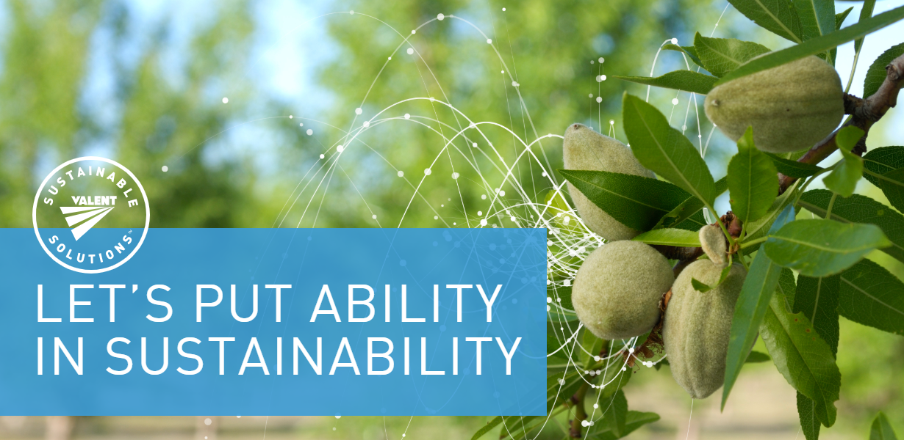
Sustainable Practices Gallery Walk
Aligned to the following standards:
CS.04; FFA.PL-A; FFA.PG-J; FFA.CS-M; FFA.CS-N; CCSS.ELA.W.9-10.2; CCSS.ELA.SL.9-10.1; CCSS.ELA.SL.9-10.2; CCSS.ELA.SL.9-10.4; CCSS.ELA.WHST.9.10.4; AFNR Career Cluster, Statement 2; AFNR Career Cluster, Statement 3; AFNR Career Cluster, Statement 7; CRP.02; CRP.04; CRP.05; CRP.06; CRP.07; CRP.08; CRP.10; CRP.11
Directions:
Walk around the classroom and visit each poster that highlights one of the sustainable agriculture practices. Record information about the practice in the table below.

Name of the Practice | Description of the Practice | Examples of the Practice in Use (Draw a picture.) | Questions You Have About the Practice

What are 10 of your favorite snacks?

- _________________________________
- _________________________________
- _________________________________
- _________________________________
- _________________________________
- _________________________________
- _________________________________
- _________________________________
- _________________________________
- _________________________________

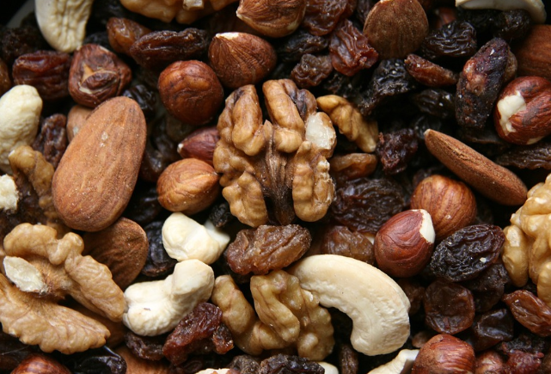
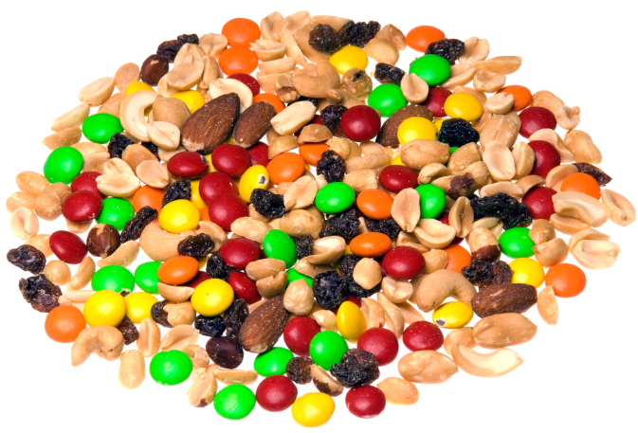
The local newspaper has contacted you to write an article about sustainability in agriculture. Write a brief article (minimum of five sentences) about the importance of sustainability in agriculture using the information you just learned in your gallery walk. ____________________________________________________________________________________________________________________________________________________________________________________________________________________________________________________________________________________________________________________________________________________________________________________________________________________________________________________________________________________________________________________________________________________________________________________________________________________________________________________________________________________________________________________________________________________________________________________________________________________________________________________________________________________________________________________________________________________________________________________________________________________________________________________________________________________________________________________________________________________________________________________
List five sustainable practices that could be used in the production and development of trail mix.

- ____________________
- ____________________
- ____________________
- ____________________
- ____________________
Select one practice and describe how that practice would be used.

Another common favorite snack in the U.S. is trail mix. List five components you would find in trail mix.
- ______________________
- ______________________
- ______________________
- ______________________
- ______________________
Exit Ticket: Learning Pyramid
Aligned to the following standards:
CS.04; FFA.PL-A; FFA.PG-J; FFA.CS-M; FFA.CS-N; CCSS.ELA.W.9-10.2; CCSS.ELA.SL.9-10.1; CCSS.ELA.SL.9-10.2; CCSS.ELA.SL.9-10.4; CCSS.ELA.WHST.9.10.4; AFNR Career Cluster, Statement 2; AFNR Career Cluster, Statement 3; AFNR Career Cluster, Statement 7; CRP.02; CRP.04; CRP.05; CRP.06; CRP.07; CRP.08; CRP.10; CRP.11
Directions:
Complete this learning pyramid exit ticket.
1 thing I knew before but understand better now:

2 things I want to learn more about:
3 things I learned today:



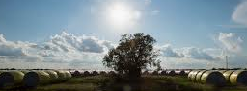
KEY: Poster Rubric
Aligned to the following standards:
CS.04; FFA.PL-A; FFA.PG-J; FFA.CS-M; FFA.CS-N; CCSS.ELA.W.9-10.2; CCSS.ELA.SL.9-10.1; CCSS.ELA.SL.9-10.2; CCSS.ELA.SL.9-10.4; CCSS.ELA.WHST.9.10.4; AFNR Career Cluster, Statement 2; AFNR Career Cluster, Statement 3; AFNR Career Cluster, Statement 7; CRP.02; CRP.04; CRP.05; CRP.06; CRP.07; CRP.08; CRP.10; CRP.11

Poster Rubric
Criteria | Below Average  (0–1 points) | Average  (2–3 points) | Above Average  (4–5 points)
Knowledge | Work shows little to no understanding of the topic. | Work shows some understanding of the topic. | Work shows excellent understanding of the topic.
Quality | Work is very low quality with little evidence of effort. | Work shows some effort and is mostly neat. | Work shows excellent effort and is of high quality.
Instructions | Student did not follow instructions for the task. | Student followed some of the instructions. | Student followed all instructions for the task.
Timeliness | Work was submitted more than one day late. | Work was one day late. | Work was submitted on time.
Total

KEY: What Is Sustainability?
Aligned to the following standards:
CS.04; FFA.PL-A; FFA.PG-J; FFA.CS-M; FFA.CS-N; CCSS.ELA.W.9-10.2; CCSS.ELA.SL.9-10.1; CCSS.ELA.SL.9-10.2; CCSS.ELA.SL.9-10.4; CCSS.ELA.WHST.9.10.4; AFNR Career Cluster, Statement 2; AFNR Career Cluster, Statement 3; AFNR Career Cluster, Statement 7; CRP.02; CRP.04; CRP.05; CRP.06; CRP.07; CRP.08; CRP.10; CRP.11
Directions:
Watch this introductory video from Valent USA, “Valent Sustainable Solutions,” and answer the following questions. The video is available at https://www.youtube.com/watch?v=zjcMn0QttOU.

What are the goals of Valent USA related to sustainability?
Working with producers to make changes that will enable more sustainable and profitable production that will last. People, productivity, planet

How does Valent USA offer sustainable solutions to its customers?
Through innovative products and chemistry based on scientific evidence and data that supports sustainable agriculture practices

In your own words, define sustainability.
Answers will vary. Example: Caring for the food, water and people so that the globe can sustain itself.

Partner Definition: Find a partner and capture his or her definition of sustainability.
Answers will vary.

Common Definition: Work with your partner to develop a shared definition for sustainability in agriculture. Answers will vary.

Why is Valent USA so focused on sustainability? Why might sustainability be important for agriculture? Answers will vary.

Develop and draw a logo to represent your shared definition.
Answers will vary.

KEY: Sustainable Practices Gallery Walk
Aligned to the following standards:
CS.04; FFA.PL-A; FFA.PG-J; FFA.CS-M; FFA.CS-N; CCSS.ELA.W.9-10.2; CCSS.ELA.SL.9-10.1; CCSS.ELA.SL.9-10.2; CCSS.ELA.SL.9-10.4; CCSS.ELA.WHST.9.10.4; AFNR Career Cluster, Statement 2; AFNR Career Cluster, Statement 3; AFNR Career Cluster, Statement 7; CRP.02; CRP.04; CRP.05; CRP.06; CRP.07; CRP.08; CRP.10; CRP.11
Directions:
Walk around the classroom and visit each poster that highlights one of the sustainable agriculture practices. Record information about the practice in the table below.

Name of the Practice | Description of the Practice | Examples of the Practice in Use (Draw a picture.) | Questions You Have About the Practice
Integrated Pest Management | A way to safely and effectively control different kinds of pests | Answers will vary. | Answers will vary.
Crop Rotation | Growing different crops in a pattern  Example: corn one year and soybeans the next | Answers will vary. | Answers will vary.
Crop Diversity | Differences in the genetics of crops | Answers will vary. | Answers will vary.
Managed Grazing | A method in which herds or flocks of animals are systematically moved to ensure proper forage growth for animal consumption. | Answers will vary. | Answers will vary.
Agroforestry | A segment of agriculture that looks at how trees are managed | Answers will vary. | Answers will vary.
Integrated Crop-Livestock Production | Combining the use of livestock and crops | Answers will vary. | Answers will vary.
Renewable Energy | A resource that is naturally replenished  Examples: waves, sun, wind | Answers will vary. | Answers will vary.
Avoiding Soil Erosion | Putting practices in place to prevent soil loss  Example: cover crops | Answers will vary. | Answers will vary.
Natural Pest Eliminators | Having a balance of organisms can help to decrease damage-causing pests and thus reduce some chemical usage. | Answers will vary. | Answers will vary.
Manual Labor | Individuals working to reach a common goal without the use of machines | Answers will vary. | Answers will vary.

