World Hunger: A Growing Concern
Created: 07/2019 by the National FFA Organization

Student Learning Objectives:
After completing these activities, students will …
- Describe undernourishment and hunger.
- Illustrate the impact of hunger on nations.
- Describe food access and the role in food security.

Time Required: 120 minutes
Resources:
- National Geographic video 7 Billion, https://youtu.be/sc4HxPxNrZ0
- Worldometers, http://www.worldometers.info/
- Hunger Awareness Dinner Resource, http://www.differencedifferently.edu.au/reference/hunger_banquet_script.pdf
- World Food Prize: World Hunger Simulation, https://www.scribd.com/document/390538867/World-Hunger-Simulation-FAF331EDF3DD9.

Equipment and Supplies Needed:
- A copy of the “Who Is Hungry” worksheet for each student
- Internet access to play the video in real time or embed it in a PowerPoint ahead of time
- Internet access for the webquest
- A copy of the Bell Ringer/Exit Ticket worksheet for each student
- A copy of the “Hunger Infographic” worksheet for each student
- Copies of the “World Snapshot” for each group (three to 12 copies)
- A copy of the “Why Are People Hungry?” worksheet for each student

This quick lesson plan would work well as:
- An agriscience lesson.
- A biotechnology lesson.

Student Activity Sheets
https://ffa.box.com/s/4lsoy5fm2y9khehxcd99fp1ffhqoku1i (Word)
https://ffa.box.com/s/whys24jqsqocwk7yfd377dll3kbcx6xe (PDF)

These activities are aligned to the following standards:
FFA Precept
- FFA.PL-A.Action: Assume responsibility and take the necessary steps to achieve the desired results, no matter what the goal or task at hand.
- FFA.PG-G.Physical Growth: Take care of one’s health by eating well, exercising, getting enough sleep, respecting one’s body and setting personal goals for long-term health.
- FFA.PG-I.Professional Growth: Assume responsibility for attaining and improving upon the skills needed for career success.
- FFA.PG-J.Mental Growth: Embrace cognitive and intellectual development relative to reasoning, thinking and coping.
- FFA.CS-M.Communication: Effectively interact with others in personal and professional settings.
- FFA.CS-N.Decision Making: Analyze a situation and execute an appropriate course of action.
Common Core–Reading: Informational Text
- CCSS.ELA-Literacy.RI.9-10.4: Determine the meaning of words and phrases as they are used in a text, including figurative, connotative, and technical meanings; analyze the cumulative impact of specific word choices on meaning and tone (e.g., how the language of a court opinion differs from that of a newspaper).
- CCSS.ELA-Literacy.RI.9-10.8: Delineate and evaluate the argument and specific claims in a text, assessing whether the reasoning is valid and the evidence is relevant and sufficient; identify false statements and fallacious reasoning.
Common Core–Speaking and Listening
- CCSS.ELA-Literacy.SL.9-10.1: Initiate and participate effectively in a range of collaborative discussions (one-on-one, in groups, and teacher-led) with diverse partners on grades 9-10 topics, texts, and issues, building on others' ideas and expressing their own clearly and persuasively.
- CCSS.ELA-Literacy.SL.9-10.2: Integrate multiple sources of information presented in diverse media or formats (e.g., visually, quantitatively, orally) evaluating the credibility and accuracy of each source.
- CCSS.ELA-Literacy.SL.9-10.4: Present information, findings, and supporting evidence clearly, concisely, and logically such that listeners can follow the line of reasoning and the organization, development, substance, and style are appropriate to purpose, audience, and task.
Common Core–Science & Technical Subjects
- CCSS.ELA-Literacy.RST.9-10.7: Translate quantitative or technical information expressed in words in a text into visual form (e.g., a table or chart) and translate information expressed visually or mathematically (e.g., in an equation) into words.
Common Core–Literacy in Science & Technical Subjects: Writing
- CCSS.ELA-Literacy.WHST.9.10.4: Produce clear and coherent writing in which the development, organization, and style are appropriate to task, purpose, and audience.
Common Core–Math Practices
- CCSS.MP1: Make sense of problems and persevere in solving them.
- CCSS.MP3: Construct viable arguments and critique the reasoning of others.
- CCSS.MP5: Use appropriate tools strategically.
- CCSS.MP6: Attend to precision.
AFNR Career Ready Practices
- CRP.02. Apply appropriate academic and technical skills. Career-ready individuals readily access and use the knowledge and skills acquired through experience and education to be more productive.
- CRP.04. Communicate clearly, effectively, and with reason. Career-ready individuals communicate thoughts, ideas and action plans with clarity, whether using written, verbal and/or visual methods.
- CRP.07. Employ valid and reliable research strategies. Career-ready individuals are discerning in accepting and using new information to make decisions, change practices or inform strategies.
- CRP.11. Use technology to enhance productivity. Career-ready individuals find and maximize the productive value of existing and new technology to accomplish workplace tasks and solve workplace problems.
Partnership for 21st Century Skills
- Communication
- Critical Thinking and Problem Solving
- Initiative and Self-direction
- Leadership and Responsibility
- Information, Communications, and Technology Literacy
- Global Awareness
- Think Creatively

Lesson Plan:
- Bell Ringer: On the attached bell ringer sheet (Appendix 1), have students (without help from technology) write down the number of people they think are on the planet. Check out http://www.worldometers.info/ for the most current count. Recognize the student in class who has the closest estimation. (Students will use this bell ringer sheet for an entire week).

- Introduction: After a student is recognized for the bell ringer, watch the National Geographic video 7 Billion (https://youtu.be/sc4HxPxNrZ0). During the video have students record three “shocking facts” they did not previously know. Once the video has concluded, have students think-pair-share with the student next to them. Have pairs share their most “shocking” fact with the class. Have a class discussion about why these facts are shocking.

- Activity 1:
Part 1: Next, we will go through an activity to have students gain a better understanding of different situations in different countries.
- Number students one through three to create three equal groups (you can always make smaller groups as long as you have three, six, nine, or 12 groups since there will be three countries for this activity).
- Once students are with their groups, explain that each group is going to represent one of three different countries: the United States, Ireland or the Indonesia. Each group will have $500 to spend as a country. The only rule is that each country is required to purchase food, clothing and shelter. After those three basics have been purchased, they need to answer the three questions at the bottom of the worksheet (which they will receive after instructions). Students will have 10 minutes for their group time.
- Assign each group a country (the United States, Ireland or the Indonesia).
- Hand out the worksheet “World Snapshot” (this can be per student or per group) and start the timer (10 minutes). Once students are out of time, they must stop working.
- Have one student from each group share what they purchased and why. Students will share their group’s answers from the bottom of the worksheet.
- After all groups have shared, have a conversation about why each country purchased what they did (the Philippines had to spend substantially more money for their food than the U.S. or France).

Part 2: Next write the statistic “One in seven people in the world are hungry” on the board. Have students talk with the person next to them for 30 seconds and then share out. Generate a list on the board of responses to promote conversation. Some guiding questions: (1) Why did the Philippines have to spend more money on food? (2) Why did the U.S. have to spend so little on food? and (3) What does this mean for the quality of life in each of these countries?

- Activity 2:
Part 1: Each student needs a copy of the worksheet “Who Is Hungry?” Have students access the infographic (https://docs.wfp.org/api/documents/WFP-0000071530/download/?_ga=2.90932957.634527746.1537992219-54342706.1534776277) and complete the activity. The infographic depicts hunger across the globe.

Part 2: Students will then follow up by completing a “webquest” where students will use the internet to research answers to the guided questions so they can complete their own infographics. If you would like to have students create an infographic using technology, piktochart can be used. However, be advised that a login is required to create a free account. Once students have completed their infographic, hang them around the room and have students do a gallery walk to enhance their understanding of world hunger.

- Activity 3:
Part 1: Each student needs a copy of the “Why Are People Hungry?” worksheet. Students need to read the passage and answer the four multiple choice questions about the passage to understand the vocabulary and gain an understanding of why people are hungry. The passage discusses the four components of food security:
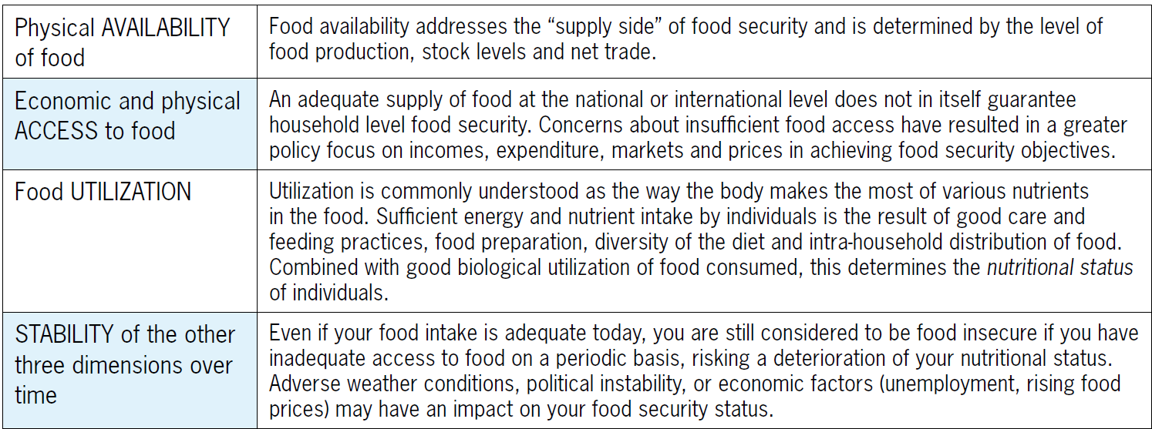
*Table sourced from FAO Food Security Programme, 2008

Next, students will summarize the meaning of the passage in a way their grandparent or a person over 60 years old can understand.

Part 2: Then, students will identify the four dimensions needed for food security (found in the same passage and listed above). Students will match each term with a picture and common phrase to help increase understanding and retention of the components of food security.

Finally, students will select one of the dimensions and develop a one-minute presentation for the class so students can explore one of the dimensions in more detail and then explain their dimension to others. Use the attached rubric to evaluate the presentation.

- Follow-up: Hang the student infographics throughout the school for others to learn.

- Leveling Up: Host a “hunger awareness dinner” to allow students to experience a meal similar to those in hunger-stricken countries. Some students would get a traditional meal as they would in America and some will receive a meal as they would in a developing country. Here is the link to a free resource that could assist you in hosting a hunger awareness dinner with students: https://www.scribd.com/document/390538867/World-Hunger-Simulation-FAF331EDF3DD9.

- Exit Ticket: Have students answer the following question on their exit ticket worksheet (Appendix 2): What is undernourishment and why is it so wide spread?

World Snapshot
Aligned to the following standards:
FFA.PL-A; FFA.PG-G; FFA.PG-I; FFA.PG-J; FFA.CS-M; FFA.CS-N; CCSS.ELA.RI.9-10.4; CCSS.ELA.RI.9-10.8; CCSS.ELA.SL.9-10.1; CCSS.ELA.SL.9-10.2; CCSS.ELA.SL.9-10.4; CCSSS.ELA.RST.9-10.7; CCSS.ELA.WHST.9.10.4; MP1; MP3; MP5; MP6: CRP.02; CRP.04; CRP.07; CRP.11
Directions:
You have $500 to spend. You MUST purchase food, clothes and shelter. Once you are done making your selections, answer the follow-up questions at the bottom. Select a spokesperson that will share with the class. You will have 10 minutes to make your selections and answer the conclusion questions.

Circle the country you were assigned: United States Ireland Indonesia

Food
United States | $32.76
Ireland | $98.41
Indonesia | $247.61

Clothing
Tuxedos and ballgowns | $ 160.45
T-shirts and jeans | $ 127.61
Potato sacks with pockets | $ 78.52
Potato sacks without pockets | $ 50.37

Shelter
Large brick house | $ 301.21
Small brick house | $ 261.84
Straw hut | $ 197.54

- How much money did you have left over? What did you choose to do with the remaining money?

- How much money did you spend? _________________
- How much money do you have left? _________________
- Why did you make the selections you did for your food, clothing and shelter?



Who Is Hungry?
Aligned to the following standards:
FFA.PL-A; FFA.PG-G; FFA.PG-I; FFA.PG-J; FFA.CS-M; FFA.CS-N; CCSS.ELA.RI.9-10.4; CCSS.ELA.RI.9-10.8; CCSS.ELA.SL.9-10.1; CCSS.ELA.SL.9-10.2; CCSS.ELA.SL.9-10.4; CCSSS.ELA.RST.9-10.7; CCSS.ELA.WHST.9.10.4; MP1; MP3; MP5; MP6: CRP.02; CRP.04; CRP.07; CRP.11
Part 1
Directions:
Using the infographic available at https://docs.wfp.org/api/documents/WFP-0000071530/download/?_ga=2.90932957.634527746.1537992219-54342706.1534776277, complete the activity below to better understand world hunger.

What does undernourishment mean? _________________________________________________________________________________________________________________________________________________________________________________________________________________________________

The number of people that do not get enough to eat.

Using the map provided, color, label and place a on three countries in each of the following undernourishment categories: very low, moderately low, moderately high, high and very high.

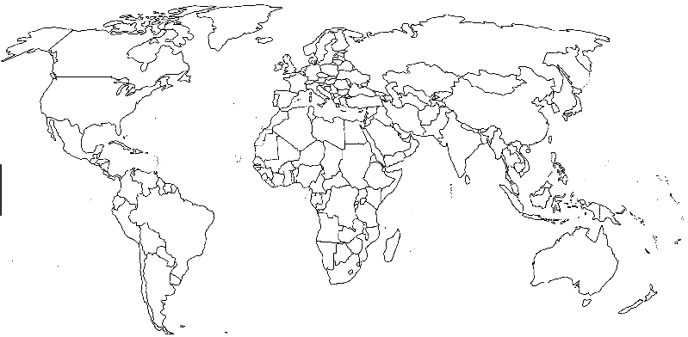
Create a key/legend for your map here:

How do you think undernourishment affects students in these countries? _________________________________________________________________________________________________________________________________________________________________________________________________________________________________
HINT: A key/legend tells you what everything means on a map. (Ex. colors and country name.)

Aligned to the following standards:
FFA.PL-A; FFA.PG-G; FFA.PG-I; FFA.PG-J; FFA.CS-M; FFA.CS-N; CCSS.ELA.RI.9-10.4; CCSS.ELA.RI.9-10.8; CCSS.ELA.SL.9-10.1; CCSS.ELA.SL.9-10.2; CCSS.ELA.SL.9-10.4; CCSSS.ELA.RST.9-10.7; CCSS.ELA.WHST.9.10.4; MP1; MP3; MP5; MP6: CRP.02; CRP.04; CRP.07; CRP.11
Part 2
Directions:
Using the paper provided, create an infographic about world hunger that you can share in your school to educate others about the global problem. Go on a webquest to research the following information to include in your infographic:
- What is hunger?
- What causes hunger?
- Where does hunger exist?
- Who experiences hunger?

**Remember that infographics are mostly pictures, are brightly colored and are informative for those that do not know anything about the topic. Use the space below to brainstorm ideas and take notes before developing your final product.
Notes and Ideas:

Infographic Rubric
Criteria | Below Average  (0–1 points) | Average  (2–3 points) | Above Average  (4–5 points)
Knowledge | Work shows little to no understanding of the topic. | Work shows some understanding of the topic. | Work shows excellent understanding of the topic.
Quality | Work is very low quality with little evidence of effort. | Work shows some effort and is mostly neat. | Work shows excellent effort and is of high quality.
Instructions | Student did not follow instructions for the task. | Student followed some of the instructions. | Student followed all instructions for the task.
Timeliness | Work was submitted more than one day late. | Work was one day late. | Work was submitted on time.
Total

Hunger Infographic
Aligned to the following standards:
FFA.PL-A; FFA.PG-G; FFA.PG-I; FFA.PG-J; FFA.CS-M; FFA.CS-N; CCSS.ELA.RI.9-10.4; CCSS.ELA.RI.9-10.8; CCSS.ELA.SL.9-10.1; CCSS.ELA.SL.9-10.2; CCSS.ELA.SL.9-10.4; CCSSS.ELA.RST.9-10.7; CCSS.ELA.WHST.9.10.4; MP1; MP3; MP5; MP6: CRP.02; CRP.04; CRP.07; CRP.11

With such a large percentage of the world being hungry, what suggestions do you now have to help feed the growing population? Describe your thoughts in three or more sentences. ________________________________________________________________________________________________________________________________________________________________________________________________
________________________________________________________________________________________________________________________________________________________________________________________________________________________________________________________________________________________________________________________________________________________________________________________________________________________________________________________________________________________________________________________________________________________________________________________________________________________________________________________________________________________________________________________________________________________________________________________________________________________________________________________________________________________________________________________________________________________________________________________________

Why Are People Hungry?
Aligned to the following standards:
FFA.PL-A; FFA.PG-G; FFA.PG-I; FFA.PG-J; FFA.CS-M; FFA.CS-N; CCSS.ELA.RI.9-10.4; CCSS.ELA.RI.9-10.8; CCSS.ELA.SL.9-10.1; CCSS.ELA.SL.9-10.2; CCSS.ELA.SL.9-10.4; CCSSS.ELA.RST.9-10.7; CCSS.ELA.WHST.9.10.4; MP1; MP3; MP5; MP6: CRP.02; CRP.04; CRP.07; CRP.11
Part 1
Directions:
Read the following passage and then choose the best answer for each multiple choice question.
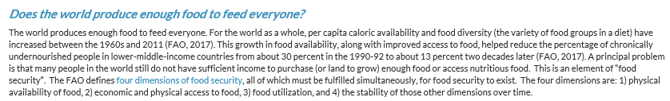
**Passage from Hunger Notes: 2018 World Hunger and Poverty Facts and Statistics

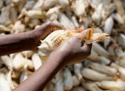
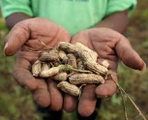
1. In the second sentence the word “caloric” means what?
a. The number of calories of heat available
b. The number of calories available for consumption
c. The number of cows available to consume
2. What does the phrase “chronically undernourished” mean?
a. They have a lot of food.
b. They have a large amount of nutrition.
c. They severely lack the nutrition required for their diet.
In one to three sentences, write exactly how you would explain the above passage to your grandma or grandpa, or someone more than 60 years old, so he or she could understand. _______________________________________________________________________________________________________________________________________________________________________________________________________________________________________________________________________________________________________________________________________________________________________________________________________________________________________________________________________________________________________________
4. “The FAO defines the four dimensions of food security, all of which must be fulfilled simultaneously, for food security to exist.” What does the underlined portion mean in this sentence?
a. The four dimensions must be listed together when reading.
b. The four dimensions must all be met for food security.
c. Food security can exist with only one of the dimensions.
3. If a person has “sufficient income” what does that mean?
a. A person has enough money coming in to meet their needs.
b. A person does not have enough money coming in to meet their needs.
c. A person does not spend their money thoughtfully.
Part 2
Aligned to the following standards:
FFA.PL-A; FFA.PG-G; FFA.PG-I; FFA.PG-J; FFA.CS-M; FFA.CS-N; CCSS.ELA.RI.9-10.4; CCSS.ELA.RI.9-10.8; CCSS.ELA.SL.9-10.1; CCSS.ELA.SL.9-10.2; CCSS.ELA.SL.9-10.4; CCSSS.ELA.RST.9-10.7; CCSS.ELA.WHST.9.10.4; MP1; MP3; MP5; MP6: CRP.02; CRP.04; CRP.07; CRP.11
Directions:
Identify the four dimensions of food security below.
What are the four dimensions needed for food security to exist?

- ____________________________
- ____________________________
- ____________________________
- ____________________________

Directions:
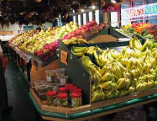

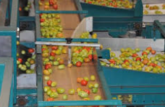





By drawing a line, match the term with the appropriate picture and common phrasing.
Physical Availability of Food

Economic and Physical Access to Food

Food Utilization

Stability Over Time
Having consistent access, funds and ability to purchase healthy and nutritious food

Having the money and ability to purchase food

Sufficient production of food

How the body uses nutrition and having good diet diversity
Aligned to the following standards:
FFA.PL-A; FFA.PG-G; FFA.PG-I; FFA.PG-J; FFA.CS-M; FFA.CS-N; CCSS.ELA.RI.9-10.4; CCSS.ELA.RI.9-10.8; CCSS.ELA.SL.9-10.1; CCSS.ELA.SL.9-10.2; CCSS.ELA.SL.9-10.4; CCSSS.ELA.RST.9-10.7; CCSS.ELA.WHST.9.10.4; MP1; MP3; MP5; MP6: CRP.02; CRP.04; CRP.07; CRP.11
Select one of the four dimensions of food security and create a one-minute speech to describe that dimension to the class. Write what you are going to say in this box so you are prepared. Be sure to answer the following questions in your speech: (1) What is the area you are covering? (2) why does this dimension need to be fulfilled to ensure food security? and (3) what does this look like in the U.S.?
KEY — Who Is Hungry?
Aligned to the following standards:
FFA.PL-A; FFA.PG-G; FFA.PG-I; FFA.PG-J; FFA.CS-M; FFA.CS-N; CCSS.ELA.RI.9-10.4; CCSS.ELA.RI.9-10.8; CCSS.ELA.SL.9-10.1; CCSS.ELA.SL.9-10.2; CCSS.ELA.SL.9-10.4; CCSSS.ELA.RST.9-10.7; CCSS.ELA.WHST.9.10.4; MP1; MP3; MP5; MP6: CRP.02; CRP.04; CRP.07; CRP.11
Part 1
Directions:
Using the infographic available at https://docs.wfp.org/api/documents/WFP-0000071530/download/?_ga=2.90932957.634527746.1537992219-54342706.1534776277, complete the following activity to better understand world hunger.

What does undernourishment mean?
”The condition in which an individual’s habitual food consumption is insufficient to provide the amount of dietary energy required to maintain a normal, active, healthy life.” — World Food Programme

815 million
The number of people that do not get enough to eat.

Using the map provided, color, label and place a on three countries in each of the following undernourishment categories: very low, moderately low, moderately high, high and very high.

Create a key/legend for your map here: Answers will vary. Five colors should be identified.
Answers will vary. Fifteen stars and labels should be marked. Five different colors should be used.

HINT: A key/legend tells you what everything means on a map. (Ex. colors and country name)

How do you think undernourishment affects students in these countries? Answers will vary. _________________________________________________________________________________________________________________________________________________________________________________________________________________________________

KEY — Why Are People Hungry?
Aligned to the following standards:
FFA.PL-A; FFA.PG-G; FFA.PG-I; FFA.PG-J; FFA.CS-M; FFA.CS-N; CCSS.ELA.RI.9-10.4; CCSS.ELA.RI.9-10.8; CCSS.ELA.SL.9-10.1; CCSS.ELA.SL.9-10.2; CCSS.ELA.SL.9-10.4; CCSSS.ELA.RST.9-10.7; CCSS.ELA.WHST.9.10.4; MP1; MP3; MP5; MP6: CRP.02; CRP.04; CRP.07; CRP.11
Part 1
Directions:
Read the following passage and then choose the best answer for each multiple choice question.

**Passage from Hunger Notes: 2018 World Hunger and Poverty Facts and Statistics
2. What does the phrase “chronically undernourished” mean?
a. They have a lot of food.
b. They have a large amount of nutrition.
c. They severely lack the nutrition required for their diet.
4. “The FAO defines the four dimensions of food security, all of which must be fulfilled simultaneously, for food security to exist.” What does the underlined portion mean in this sentence?
a. The four dimensions must be listed together when reading.
b. The four dimensions must all be met for food security.
c. Food security can exist with only one of the dimensions.
3. If a person has “sufficient income” what does that mean?
a. A person has enough money coming in to meet their needs.
b. A person does not have enough money coming in to meet their needs.
c. A person does not spend their money thoughtfully.
1. In the second sentence the word “caloric’ means what?
a. The number of calories of heat available
b. The number of calories available for consumption
c. The number of cows available to consume

In one to three sentences, write exactly how you would explain the above passage to your grandma or grandpa, or someone more than 60 years old, so he or she could understand. Answers will vary.
_______________________________________________________________________________________________________________________________________________________________________________________________________________________________________________________________________________________________________________________________________________________________________________________________________________________________________________________________________________________________________________

Part 2
Aligned to the following standards:
FFA.PL-A; FFA.PG-G; FFA.PG-I; FFA.PG-J; FFA.CS-M; FFA.CS-N; CCSS.ELA.RI.9-10.4; CCSS.ELA.RI.9-10.8; CCSS.ELA.SL.9-10.1; CCSS.ELA.SL.9-10.2; CCSS.ELA.SL.9-10.4; CCSSS.ELA.RST.9-10.7; CCSS.ELA.WHST.9.10.4; MP1; MP3; MP5; MP6: CRP.02; CRP.04; CRP.07; CRP.11
Directions:
Identify the four dimensions of food security below.

**Passage from Hunger Notes: 2018 World Hunger and Poverty Facts and Statistics
What are the four dimensions needed for food security to exist?

- Physical availability of food
- Food utilization
- Economic and physical access to food
- Stability of the other dimensions over time

Physical Availability of Food

Economic and Physical Access to Food

Food Utilization

Stability Over Time
Having consistent access, funds and ability to purchase healthy and nutritious food

Having the money and ability to purchase food

Sufficient production of food

How the body uses nutrition and having good diet diversity
Directions:
By drawing a line, match the term with the appropriate picture and common phrasing.
Aligned to the following standards:
FFA.PL-A; FFA.PG-G; FFA.PG-I; FFA.PG-J; FFA.CS-M; FFA.CS-N; CCSS.ELA.RI.9-10.4; CCSS.ELA.RI.9-10.8; CCSS.ELA.SL.9-10.1; CCSS.ELA.SL.9-10.2; CCSS.ELA.SL.9-10.4; CCSSS.ELA.RST.9-10.7; CCSS.ELA.WHST.9.10.4; MP1; MP3; MP5; MP6: CRP.02; CRP.04; CRP.07; CRP.11
Select one of the four dimensions of food security and create a one-minute speech to describe that dimension to the class. Write what you are going to say in this box so you are prepared. Be sure to answer the following questions in your speech: (1) What is the area you are covering? (2) why does this dimension need to be fulfilled to ensure food security? and (3) what does this look like in the U.S.?

For full credit, students must select one of the four dimensions and then answer all three questions in their speeches.

Rubric — Why Are People Hungry?
Qualification | Very strong evidence of skill is present  (5–4 pts) | Moderate evidence of skill is present  (3–2 pts) | Weak evidence of skill is present  (1–0 pts) | Total Points  (20 possible)
Presentation Skills | Thorough and maintains eye contact | Somewhat professional and some preparation shown. | No evidence of preparation
Three Questions Covered | All three questions were covered thoroughly. | At least two questions were covered. | One question was covered.
Time | One minute or more | Between 30 seconds and one minute | Under 30 seconds
Overall Impression | Presentation was complete and well thought out. | Presentation was organized but lacked polish. | The presentation was not well-developed.
 |  |  | Total

Appendix 1: Bell Ringers & Exit Tickets Worksheet
Name: _________________________________________ Period: ____________
Week of: _________________________________________ Class: _________________

Bell Ringer Activity
Monday, ___________  Question:  Answer: | Tuesday, ____________  Question:  Answer:
Wednesday, ____________  Question:  Answer: | Thursday, _____________  Question:  Answer:
Friday, _____________  Question:  Answer: | 
EXIT TICKETS
Week of _____________________

Monday, ___________  Question:  Answer: | Tuesday, ____________  Question:  Answer:
Wednesday, ____________  Question:  Answer: | Thursday, _____________  Question:  Answer:
Friday, _____________  Question:  Answer: | Summarize the learning objectives for the week.
*Worksheet modified from a resource created by Chasten Bear, Indianapolis Classical School, Indianapolis, Ind.

