Understanding Demonstrations
Aligned to the following standards:
FFA.PL-B; FFA.PL-D; FFA.PL-E; FFA.PL-F; FFA.PG-I; FFA.CS-M; CCSS.W.9-10.2; CCSS.W.9-10.4; CCSS.W.9-10.5; CCSS.W.9-10.6; CCSS.W.9-10.8; CCSS.SL.9-10.1; CCSS.SL.9-10.2; CCSS.SL.9-10.4; CCSS.SL.9-10.5; CCSS.SL.9-10.6; CRP.02; CRP.04; CRP.11; CRP.12
Part 1
Directions:
While watching the video titled “How to Do a 4-H Presentation,” fill in the graphic organizer below.

- Fill in the boxes with the three types of presentations:

- There are three main parts of a presentation. Label the sandwich with the three main parts, as explained in the video:

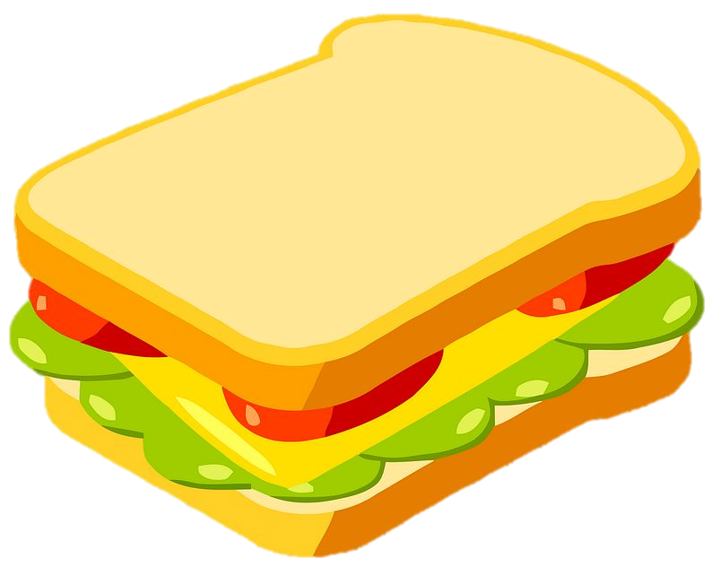

- What is one detail from the introduction that you can incorporate into your own introduction?

- Based on the body of the presentation, which type of presentation did she do?

- What is one detail from the conclusion that you can incorporate into your own conclusion?

Part 2
Directions:
Working with a partner, create a demonstration that you will present to the class. This demonstration can be a true demonstration, an informative demonstration or a persuasive demonstration. Use the guidelines below when developing your demonstration.

Demonstration assignment guidelines:
- The demonstration should be three to five minutes in length.
- The subject can inform, persuade, or demonstrate a skill or activity.
- This cannot be a speech that is recited; it must have visual aids such as posters or slides, physical items, etc.
- There must be a clear introduction, middle/body and conclusion.
- Each pair will present their demonstration, and all students must speak during the demonstration.
- Your classmates will have the opportunity to ask questions at the end of your demonstration.

Tips for this assignment:
- Topic: Choose a topic that you and/or your partner are very knowledgeable or passionate about.
- Remember, there are three main parts to a demonstration (see below).
Body: This is when you demonstrate your topic or you present two or three main ideas or facts about your topic, depending on the kind of demonstration you are giving. Details are great, especially for real demonstrations.
Introduction: This part gives a brief introduction of your topic to your audience. Create a hook, or an attention grabber, to do at the very beginning.
Conclusion: This is the part that wraps up your demonstration. Give a brief review of what you have taught the audience. Ending with a few final thoughts is a great idea too.

- When presenting your demonstration, connect with the audience by making eye contact, using vocabulary that is easy to follow and allowing your passion for the topic to show.
- Know how to use your props well while speaking or demonstrating.
- Establish credibility by explaining during your demonstration your connection to the topic. For example, explain why the topic was picked. (Maybe you learned to make fishing lures from your grandpa or learned to bake dog treats with your friends when volunteering for the shelter.)

Demonstration: A type of public speaking that demonstrates to the audience how to do something. This will include steps and details.

Informative: A type of public speaking that is meant to educate an audience on a particular topic or message with facts, data, statistics and researched content.

Persuasive: A type of public speaking that is used to help convince an audience that the speaker has the right opinion on a particular topic based on concrete evidence.

On the next page, use the planning sheet to help you and your partner develop your demonstration.

Demonstration Planning

Circle the type of demonstration you will be giving: Demonstrative Informative Persuasive

Describe your topic:

Hook or attention grabber:

Introduction overview:

Body (main points or steps):

Conclusion overview:

Props/visual aids needed:

Demonstration Rubric

Appropriate Length  The demonstration should be three to five minutes long. | /5 points
Organization  There is a clear introduction, middle/body and conclusion within the demonstration. | /15 points
Speaking Skills  This includes loud and clear voice, eye contact with audience, enthusiasm, etc. | /10 points
Content  The content presented is interesting, original, detailed and easy to follow. | /10 points
Visual Aid  The visual aid(s) used are helpful for the demonstration, not distracting. | /10 points

Total Points: /50 points

FEEDBACK/COMMENTS:

