Sustainable Development Goals
Created: 09/2023 by the National FFA Organization
Sustainability is a HUGE buzzword these days. But what does it actually mean? Through this lesson series, students will consider that question as they discover the core principles of sustainability, engage with global sustainable development goals, examine sustainable practices at work in the field of agriculture and commit to actions they can take to
live and work more sustainably in their own lives.

Thank you to our current partners in sustainability:



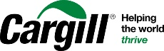
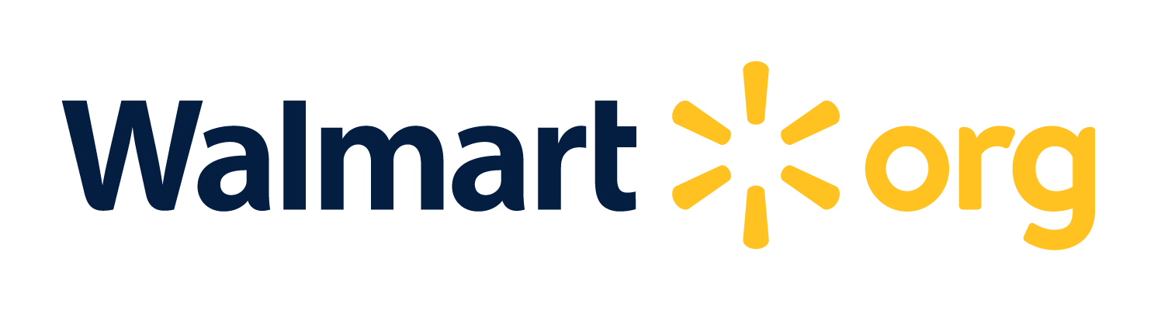

Student Learning Objectives:
After completing these activities, students will …
- Research the United Nations Sustainable Development Goals (SDGs).
- Create a short public service announcement/social media video centered around one SDG.

Suggested Grade Level:
Grades 9 and 10 (This lesson is written so instructors can scale up or down based on class needs.)

Suggested Time: Approximately 125 minutes (*Time requirements may vary based upon student understanding and class schedule.)

Resources/References:
- Video: UNICEF Georgia, “UN Sustainable Development Goals — Overview,” https://www.youtube.com/watch?v=M-iJM02m_Hg
- Website: United Nations Sustainable Development Goals — Fast Facts and Infographics, https://www.un.org/sustainabledevelopment/sdg-fast-facts/
- Website: United Nations Sustainable Development Goals, https://www.un.org/sustainabledevelopment/sustainable-development-goals/
- Video: “Understand Goal 1: No Poverty (Secondary),” https://youtu.be/A2O1HU6FMfk
- Video: “SDG 1: Poverty — Sustainable Development Goals,” https://youtu.be/OPnZ43Q8GbY
- Video: “SDG 1: No Poverty,” https://youtu.be/gmeuXD2qze0
- Video: “SDG 1: Eradicate Poverty Globally,” https://youtu.be/3sBkvn0Ayy8
- Video: “Why Is SDG 1 Important to You?” https://youtu.be/t8wS9_K_aqg

Related Resources:
- AgExplorer Sustainability Systems Focus Area, AgExplorer.FFA.org/focus/sustainability-systems/
- Darling Ingredients Educational Resources, https://FFA.box.com/s/3ko8e9w6zygohv1ewfsnc8byobjzeuxa
- Valent — Sustainability in Agriculture Lesson Series, https://FFA.box.com/v/sustainabilityinagriculture

Equipment and Supplies Needed:
- A copy of the “Global Goals for the Future” worksheet OR a copy of the “Sustainable Development Goals Passport” handout for each student
- A copy of the “Getting the Word Out” worksheet for each student
- A class copy of the “Fast Facts” and “Infographic” for each SDG
- Internet access to play videos in real time or embed them in a PowerPoint ahead of time
- Student devices to record/produce SDG videos

Vocabulary:
- Climate
- Consumption
- Equality
- Infrastructure
- Innovation
- Poverty
- Public Service Announcement
- Sustainable Development Goals

Cross-Curricular Connections:
English/Language Arts | Technology | Social Studies
Students will research, brainstorm and write a script for their public service announcement or social media video. | Students will use technology tools to produce a short public service announcement or social media video. | Students will explore global goals that were developed in collaboration with 193 unique governments.

Virtual Instruction Ideas:
- For Activity 1, instead of printing out the “Why It Matters” sheets, give students this link (https://www.un.org/sustainabledevelopment/why-the-sdgs-matter/) and a digital version of the worksheet to fill out on their own.
- For Activity 2, students could use online tools to create their videos and then post/share them to your online learning management system for other students to view and comment on.

Student Activity Sheets:
Direct access to student activity sheets without lesson plan or answer key for easy upload to a learning management system or printing for classwork.

https://ffa.box.com/s/78tb297jmr86fhdrugiqqu301skw04hz (Word)
https://ffa.box.com/s/zllnxk0efaiu649gy13m6r9yoml5bwhx (Non-Designed Word)
https://ffa.box.com/s/jv24798thgmk207gib9zqmg51e856ddd (PDF)
https://docs.google.com/document/d/1I-UWc3UKPBZNtZC0mNqwwcGz7Ini9dHeUyJDdSPw4oM/copy (Google)
https://docs.google.com/document/d/1RED19mPl8f1H65zQtlWo85dE_j4IajN2tH10WIW1tvU/copy (Non-Designed Google)
https://ffa.box.com/s/4umq66yis8evqeljjrvu6dozwstdqk6u (PDF Passport Activity)

These Activities Are Aligned to the Following Standards:
AFNR Performance Element
- CS.01. Analyze how issues, trends, technologies and public policies impact systems in the Agriculture, Food & Natural Resources Career Cluster.
- CS.04. Demonstrate stewardship of natural resources in AFNR activities.
FFA Precept
- FFA.PL-A.Action: Assume responsibility and take the necessary steps to achieve the desired results, no matter what the goal or task at hand.
- FFA.PG-J.Mental Growth: Embrace cognitive and intellectual development relative to reasoning, thinking and coping.
- FFA.CS-M.Communication: Effectively interact with others in personal and professional settings.
- FFA.CS-N.Decision Making: Analyze a situation and execute an appropriate course of action.
Common Career Technical Core
- AG1 Analyze how issues, trends, technologies and public policies impact systems in the Agriculture, Food & Natural Resources Career Cluster.
- AG4 Demonstrate stewardship of natural resources in AFNR activities.
NASDCTEc
- AGC02.02 Employ the use of technical information effectively to maintain and communicate records and reporting procedures commonly used in the AFNR cluster.
Common Core – Reading: Informational Text
- CCSS.ELA-Literacy.RI.9-10.1 Cite strong and thorough textual evidence to support analysis of what the text says explicitly as well as inferences drawn from the text.
Common Core – Writing
- CCSS.ELA-Literacy.W.9-10.2 Write informative/explanatory texts to examine and convey complex ideas, concepts, and information clearly and accurately through the effective selection, organization, and analysis of content.
Common Core – Speaking and Listening
- CCSS.ELA-Literacy.SL.9-10.1 Initiate and participate effectively in a range of collaborative discussions (one-on-one, in groups, and teacher-led) with diverse partners on grades 9-10 topics, texts, and issues, building on others’ ideas and expressing their own clearly and persuasively.
- CCSS.ELA-Literacy.SL.9-10.2 Integrate multiple sources of information presented in diverse media or formats (e.g., visually, quantitatively, orally) evaluating the credibility and accuracy of each source.
- CCSS.ELA-Literacy.SL.9-10.4 Present information, findings, and supporting evidence clearly, concisely, and logically such that listeners can follow the line of reasoning and the organization, development, substance, and style are appropriate to purpose, audience, and task.
Common Core – Science & Technical Subjects
- CCSS.ELA-Literacy.RST.9-10.1 Cite specific textual evidence to support analysis of science and technical texts, attending to the precise details of explanations or descriptions.
- CCSS.ELA-Literacy.RST.9-10.7 Translate quantitative or technical information expressed in words in a text into visual form (e.g., a table or chart) and translate information expressed visually or mathematically (e.g., in an equation) into words.
Common Core – Literacy in Science & Technical Subjects: Writing
- CCSS.ELA-Literacy.WHST.9.10.1 Write arguments focused on discipline-specific content.
- CCSS.ELA-Literacy.WHST.9.10.2 Write informative/explanatory texts, including the narration of historical events, scientific procedures/ experiments, or technical processes.
- CCSS.ELA-Literacy.WHST.9.10.4 Produce clear and coherent writing in which the development, organization, and style are appropriate to task, purpose, and audience.
- CCSS.ELA-Literacy.WHST.9.10.6 Use technology, including the Internet, to produce, publish, and update individual or shared writing products, taking advantage of technology's capacity to link to other information and to display information flexibly and dynamically.
Green/Sustainability Knowledge and Skill Statements
- AFNR Career Cluster, Statement 2 Analyze community practice or policy development related to sustainability in AFNR.
- AFNR Career Cluster, Statement 3 Communicate the impact of green and sustainability principles on agriculture, food and natural resource systems.
- AFNR Career Cluster, Statement 7 Demonstrate an understanding of green and sustainability trends that are impacting processes and markets in AFNR.
AFNR Career Ready Practices
- CRP.02. Apply appropriate academic and technical skills. Career-ready individuals readily access and use the knowledge and skills acquired through experience and education to be more productive.
- CRP.04. Communicate clearly, effectively, and with reason. Career-ready individuals communicate thoughts, ideas and action plans with clarity, whether using written, verbal and/or visual methods.
- CRP.05. Consider the environmental, social and economic impact of decisions. Career-ready individuals understand the interrelated nature of their actions and regularly make decisions that positively impact and/or mitigate negative impact on other people, organizations and the environment.
- CRP.06. Demonstrate creativity and innovation. Career-ready individuals regularly think of ideas that solve problems in new and different ways, and they contribute those ideas in a useful and productive manner to improve their organization.
- CRP.11. Use technology to enhance productivity. Career-ready individuals find and maximize the productive value of existing and new technology to accomplish workplace tasks and solve workplace problems.
Partnership for 21st Century Skills
- Communication
- Critical Thinking and Problem Solving
- Environmental Literacy
- Information, Communications, and Technology Literacy
- Global Awareness
- Think Creatively

Lesson Plan:
- Bell Ringer: What are the biggest problems people around the world are facing today?

- Introduction: (10 minutes) Give students three to five minutes to individually list out the biggest problems people around the world are facing today. Have them list at least 10 that they can think of. Hold a class discussion and allow students to share their responses out loud. As students share, record their responses (particularly those that can be tied to any of the 17 sustainable development goals) on the board or on a document on screen at the front of the room for all students to see.
  - Ask students discussion questions about these problems:
    - Why did these problems come to mind?
    - Do these problems affect everyone? Or only some locations, countries or demographics?
    - Are all of these problems of equal importance?
    - Are these problems solvable?
Say: Did you know that there is currently a worldwide effort to solve many of these problems? The United Nations (or the UN) is an international collection of world governments who cooperate to develop friendly relations amongst the different governments of the world. There are currently 193 countries who are members of the UN. These countries have put together an agenda that includes 17 goals for sustainable development that they intend to achieve by the year 2030! They call them the sustainable development goals (or SDGs) and many of the problems you all identified today are related to one of these 17 goals. Let’s watch this video to take a look at the goals.

Play the video “UN Sustainable Development Goals — Overview” (https://www.youtube.com/watch?v=M-iJM02m_Hg).
Say: Now that we have had a quick introduction to the sustainable development goals, let’s dig a little deeper and get to know more about the SDGs now!

- Activity 1: (40 minutes) Each student needs a copy of the worksheet “Global Goals for the Future” OR the “Sustainable Development Goals Passport” handout (https://ffa.box.com/s/4umq66yis8evqeljjrvu6dozwstdqk6u).
  - Teacher Note: Prior to this activity, print out the “Fast Facts” and “Infographic” PDFs for each of the SDGs available from the United Nations (https://www.un.org/sustainabledevelopment/sdg-fast-facts/) to station around the room for students to visit throughout the activity. You can either station these individually or group them together depending on how much room you have available.
  - Have students visit the different SDG stations around the room to fill out their SDG Passport on the “Global Goals for the Future” worksheet or the “Sustainable Development Goals Passport” handout. Depending on how many stations you have, determine how much time you will give students at each station (two to three minutes for each SDG). Students will record the goal, a short description based on the information they read and sketch a drawing of the SDG icon associated with each goal.
  - Have students answer the three questions at the end of the worksheet. Have students share in a class discussion if desired. (Question 1 could be used as a jumping off point for Activity 2).

- Activity 2: (75 minutes) Each student needs a copy of the worksheet “Getting the Word Out.”
  - Depending on your preferences, have students either pair up for this activity or complete it independently.
  - Students will select one of the 17 SDGs about which to create a short (90- to 120-second) public service announcement (PSA) or social media video. (Students should select SDGs they have a particular interest in but take consideration to ensure that there is variety within the class and not all students/groups are using the same SDG).
  - It may be helpful to show students some examples of what these could look like. You could play any of the following videos that cover SDG 1: No Poverty to give students an idea of what they could produce.
    - “Understand Goal 1: No Poverty (Secondary)”: https://youtu.be/A2O1HU6FMfk
    - “SDG 1: Poverty —Sustainable Development Goals”: https://youtu.be/OPnZ43Q8GbY
    - “SDG 1: No Poverty”: https://youtu.be/gmeuXD2qze0
    - “SDG 1: Eradicate Poverty Globally”: https://youtu.be/3sBkvn0Ayy8
    - “Why Is SDG 1 Important to You?” https://youtu.be/t8wS9_K_aqg
  - Once students have selected their SDGs, they will use the “Getting the Word Out” worksheet and the provided rubric to plan their PSAs. Each PSA should meet the following criteria:
    - Name and number of the SDG must be included.
    - Six to eight supporting facts, statistics, stories or anecdotes.
    - A “call to action” for viewers and next steps for what they should do.
    - A list of sources for your information.
  - Provide students with the “Why It Matters” sheet from the previous activity for their chosen SDG. Also provide them with the link to the UN’s Sustainable Development Goals website with more detailed information on each of the goals (https://www.un.org/sustainabledevelopment/sustainable-development-goals/) to aid in their research. They can also use additional resources they find on the internet.
  - Provide students with time to plan and produce their public service announcements. Students can use whichever tools your classroom has access to for creation and editing. Some ideas are listed below for graphics creation, slide creation and video editing; however, feel free to recommend or use whatever your students might have the most familiarity or comfortability with.
    - Canva: https://www.canva.com/
    - Prezi: https://prezi.com/
    - Animoto: https://animoto.com/
    - Kizoa: https://www.kizoa.com/video-maker-for-education
    - Wondershare Filmora: https://filmora.wondershare.com/video-editor/
    - Flip: https://info.flip.com/en-us.html
  - Alternate Activity: If technology is limited, consider having students create and present a skit or news report to the class.

- Follow-up: Play the completed SDG public service announcements for the entire class. Have students record at least one thing they learned related to each goal the class created a video for. Discuss the videos together as a class.

- Exit Ticket: Select one of the sustainable development goals that has particular importance to you. Write three to five sentences about why that goal resonates with you and why you are passionate about seeing it accomplished.

Global Goals for the Future
Aligned to the following standards:
CS.01; CS.04; FFA.PL-A; FFA.PG-J; FFA.CS-M; FFA.CS-N; AG1; AG4; AGC02.02; CCSS-RI.9-10.1; CCSS.ELA-W.9-10.2; CCSS.ELA.SL.9-10.1; CCSS.ELA.SL.9-10.2; CCSS.ELA.SL.9-10.4; CCSS.ELA.RST.9-10.1; CCSS.ELA.RST.9-10.7; CCSS.ELA.WHST.9-10.1; CCSS.ELA.WHST.9-10.2; CCSS.ELA.WHST.9-10.4; CCSS.ELA.WHST.9-10.6; AFNR Career Cluster, Statement 2; AFNR Career Cluster, Statement 3; AFNR Career Cluster, Statement 7; CRP.02; CRP.04; CRP.05; CRP.06; CRP.11
Directions:
Visit each of the SDGs according to the directions given by your teacher. In your Sustainable Development Goals Passport, for each SDG, record the full goal, a two- to three-sentence description from the information you’ve read on the “Fast Facts” sheet and a drawing of the icon associated with that SDG.
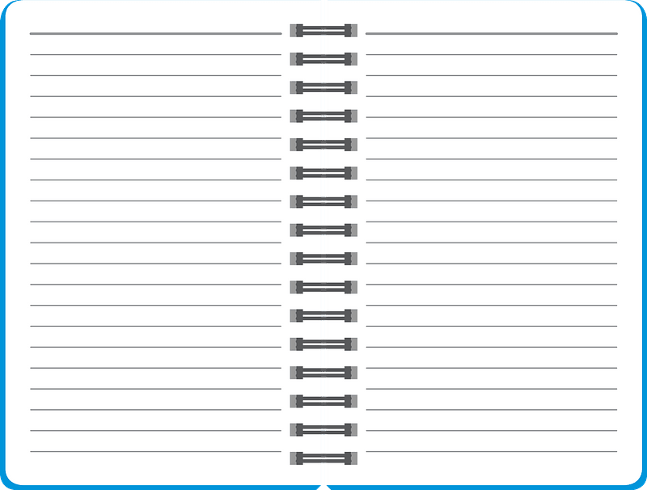


SDG 1:
Goal:
Description:
SDG Icon:
SDG 2:
Goal:
Description:
SDG Icon:
PASSPORT
Sustainable Development Goals

SDG 3:
Goal:
Description:
SDG Icon:
SDG 4:
Goal:
Description:
SDG Icon:
SDG 5:
Goal:
Description:
SDG Icon:

SDG 7:
Goal:
Description:
SDG Icon:
SDG 8:
Goal:
Description:
SDG Icon:
SDG 6:
Goal:
Description:
SDG Icon:

SDG 9:
Goal:
Description:
SDG Icon:
SDG 10:
Goal:
Description:
SDG Icon:
SDG 11:
Goal:
Description:
SDG Icon:

SDG 13:
Goal:
Description:
SDG Icon:
SDG 14:
Goal:
Description:
SDG Icon:
SDG 12:
Goal:
Description:
SDG Icon:

SDG 15:
Goal:
Description:
SDG Icon:
SDG 16:
Goal:
Description:
SDG Icon:
SDG 17:
Goal:
Description:
SDG Icon:

- Which SDG would you particularly like to see accomplished? Why?

- If you were to add an 18th SDG, what would you add? Explain why you would add it, then draw an icon for your new SDG.

- How is your new SDG different from the existing ones?

Getting the Word Out
Aligned to the following standards:
CS.01; CS.04; FFA.PL-A; FFA.PG-J; FFA.CS-M; FFA.CS-N; AG1; AG4; AGC02.02; CCSS-RI.9-10.1; CCSS.ELA-W.9-10.2; CCSS.ELA.SL.9-10.1; CCSS.ELA.SL.9-10.2; CCSS.ELA.SL.9-10.4; CCSS.ELA.RST.9-10.1; CCSS.ELA.RST.9-10.7; CCSS.ELA.WHST.9-10.1; CCSS.ELA.WHST.9-10.2; CCSS.ELA.WHST.9-10.4; CCSS.ELA.WHST.9-10.6; AFNR Career Cluster, Statement 2; AFNR Career Cluster, Statement 3; AFNR Career Cluster, Statement 7; CRP.02; CRP.04; CRP.05; CRP.06; CRP.11
Directions:
Use this sheet to brainstorm for the PSA (public service announcement) on your chosen SDG.

Which sustainable development goal will your PSA be about?

Supporting facts, statistics, stories or anecdotes for your video:

My “call to action” statement for viewers:

Additional Notes:

List all sources you used in your research:

Directions:
Use this side of the sheet to write the script for your public service announcement/video. Be sure your video meets all requirements outlined in the rubric on the next page.

Public Service Announcement Rubric
Area | 4 Points | 3 Points | 2 Points | 1 Point
Video Content  (2x multiplier) | All content is accurate. There are no factual errors.  (8 points total) | Most of the content is accurate, but there is one piece of information that seems inaccurate.  (6 points total) | The content is generally accurate and interview based, but one piece of information is clearly inaccurate.  (4 points total) | Content is confusing or contains more than one factual error.  (2 points total)
Clarity and Creativity | The video is easy to understand, and all elements are clearly written or spoken. Creativity was used. | The video is easy to understand, and most elements are clearly written or spoken. Some creativity was used. | The video is hard to understand with very quiet speaking or very hard to read writing. Little creativity was used. | The video is hard to understand, and one cannot follow the thought process. No creativity was used.
Quality of  Product | The video is clearly produced and presented with no mistakes.  All elements of the video (clips, graphics, text, voice) show quality and professionalism. | One or two mistakes are evident in the video.  Most elements of the video (clips, graphics, text, voice) show quality and professionalism. | Three or more mistakes are evident in the video.  Some elements of the video (clips, graphics, text, voice) show quality and professionalism. | The video is not well-produced and presents several mistakes.  Few elements of the video (clips, graphics, text, voice) show quality and professionalism.
Call to Action | There is a clear and compelling call to action for viewers to take next steps related to the goal. | The call to action is unclear or not compelling. Next steps are weak. | The call to action is confusing and weakly presented. No next steps are given. | There is no call to action present in the video.
Time | Video was 90 to 120 seconds in length. |  |  | Video was either under or over the allotted time frame.

Comments: Total: ________/24

KEY: Global Goals for the Future
Aligned to the following standards:
CS.01; CS.04; FFA.PL-A; FFA.PG-J; FFA.CS-M; FFA.CS-N; AG1; AG4; AGC02.02; CCSS-RI.9-10.1; CCSS.ELA-W.9-10.2; CCSS.ELA.SL.9-10.1; CCSS.ELA.SL.9-10.2; CCSS.ELA.SL.9-10.4; CCSS.ELA.RST.9-10.1; CCSS.ELA.RST.9-10.7; CCSS.ELA.WHST.9-10.1; CCSS.ELA.WHST.9-10.2; CCSS.ELA.WHST.9-10.4; CCSS.ELA.WHST.9-10.6; AFNR Career Cluster, Statement 2; AFNR Career Cluster, Statement 3; AFNR Career Cluster, Statement 7; CRP.02; CRP.04; CRP.05; CRP.06; CRP.11
Directions:
Visit each of the SDGs according to the directions given by your teacher. In your Sustainable Development Goals Passport, for each SDG, record the full goal, a two- to three-sentence description from the information you’ve read on the “Why It Matters” sheet and a drawing of the icon associated with that SDG.
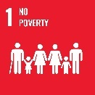
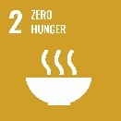
SDG 1:
Goal: No Poverty — To end poverty in all its forms everywhere by 2030
Description:
Answers will vary.
SDG Icon:
SDG 2:
Goal: Zero Hunger — To end hunger, achieve food security and improved nutrition and promote sustainable agriculture
Description:
Answers will vary.
SDG Icon:
PASSPORT
Sustainable Development Goals

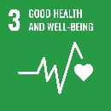
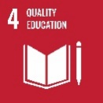
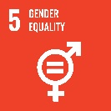
SDG 3:
Goal: Good Health and Well-Being — To ensure healthy lives and promote well-being for all at all ages
Description:
Answers will vary.
SDG Icon:
SDG 4:
Goal: Quality Education — Ensure inclusive and quality education for all and promote lifelong learning
Description:
Answers will vary.
SDG Icon:
SDG 5:
Goal: Gender Equality — To achieve gender equality and empower all women and girls
Description:
Answers will vary.
SDG Icon:

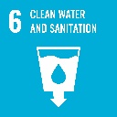
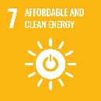
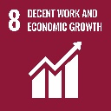
SDG 6:
Goal: Clean Water and Sanitation — To ensure access to safe water sources and sanitation for all
Description:
Answers will vary.
SDG Icon:
SDG 7:
Goal: Affordable and Clean Energy — To ensure access to affordable, reliable, sustainable and modern energy for all
Description:
Answers will vary.
SDG Icon:
SDG 8:
Goal: Decent Work and Economic Growth — To promote inclusive and sustainable economic growth, employment and decent work for all
Description:
Answers will vary.
SDG Icon:

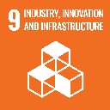
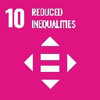
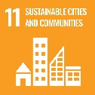
SDG 9:
Goal: Industry, Innovation and Infrastructure — To build resilient infrastructure, promote inclusive and sustainable industrialization and foster innovation
Description:
Answers will vary.
SDG Icon:
SDG 10:
Goal: Reduced Inequalities — To reduce inequalities within and among countries
Description:
Answers will vary.
SDG Icon:
SDG 11:
Goal: Sustainable Cities — To make cities inclusive, safe, resilient and sustainable
Description:
Answers will vary.
SDG Icon:

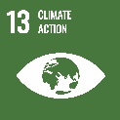
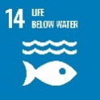
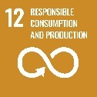
SDG 13:
Goal: Climate Action — Taking urgent action to tackle climate change and its impacts
Description:
Answers will vary.
SDG Icon:
SDG 14:
Goal: Life Below Water — To conserve and sustainably use the world’s ocean, seas and marine resources
Description:
Answers will vary.
SDG Icon:
SDG 12:
Goal: Responsible Consumption and Production — To ensure sustainable consumption and production patterns
Description:
Answers will vary.
SDG Icon:

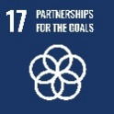
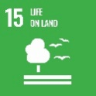
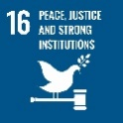
SDG 17:
Goal: Partnerships — To revitalize the global partnership for sustainable development
Description:
Answers will vary.
SDG Icon:
SDG 15:
Goal: Life on Land — To sustainably manage forests, combat desertification, halt and reverse land degradation and halt biodiversity loss.
Description:
Answers will vary.
SDG Icon:
SDG 16:
Goal: Peace, Justice and Strong Institutions —Promote peaceful and inclusive societies for sustainable development, provide access to justice for all, and build effective, accountable and inclusive institutions at all levels.
Description:
Answers will vary.
SDG Icon:

- Which SDG would you particularly like to see accomplished? Why?
Answers will vary.
- If you were to add an 18th SDG, what would you add?
Answers will vary.

- How is your new SDG different from the existing ones?
Answers will vary.

KEY: Getting the Word Out
Aligned to the following standards:
CS.01; CS.04; FFA.PL-A; FFA.PG-J; FFA.CS-M; FFA.CS-N; AG1; AG4; AGC02.02; CCSS-RI.9-10.1; CCSS.ELA-W.9-10.2; CCSS.ELA.SL.9-10.1; CCSS.ELA.SL.9-10.2; CCSS.ELA.SL.9-10.4; CCSS.ELA.RST.9-10.1; CCSS.ELA.RST.9-10.7; CCSS.ELA.WHST.9-10.1; CCSS.ELA.WHST.9-10.2; CCSS.ELA.WHST.9-10.4; CCSS.ELA.WHST.9-10.6; AFNR Career Cluster, Statement 2; AFNR Career Cluster, Statement 3; AFNR Career Cluster, Statement 7; CRP.02; CRP.04; CRP.05; CRP.06; CRP.11
Directions:
Use this sheet to brainstorm for the PSA (public service announcement) on your chosen SDG.

Which sustainable development goal will your PSA be about?
Answers will vary.

Supporting facts, statistics, stories or anecdotes for your video:
- Answers will vary.
- Answers will vary.
- Answers will vary.
- Answers will vary.
- Answers will vary.
- Answers will vary.
- Answers will vary.
- Answers will vary.
My “call to action” statement for viewers:

Answers will vary.

Additional Notes:

Answers will vary.

List all sources you used in your research:

Answers will vary.

Directions:
Use this side of the sheet to write the script for your public service announcement/video. Be sure your video meets all requirements outlined in the rubric on the next page.

Answers will vary.

