
Staying Safe in the Field
Created: 04/2026 by the National FFA Organization
Description of Lesson: Students will practice selecting and promoting effective sun protection strategies to reduce ultraviolet (UV) exposure in agricultural work settings.

Student Learning Objectives:
After completing these activities, students will …
- Explain the High Five Sun-Safe Practices.
- Determine the proper sun safety clothing, accessories and measures for agriculturists based on their careers.
- Create a message that promotes sun safety in agricultural communities.

Suggested Grade Level:
Grades 9 and 10 (This lesson is written so instructors can scale up or down based on class needs.)

Suggested Time: 60 minutes (*Time requirements may vary based upon student understanding and class schedule.)

Resources/References:
- Video: Sun Safety PSA/Outrun the Sun, https://www.youtube.com/watch?v=rsQQy-o30NU

Related Resources:
- 2022 Fall FFA New Horizons Teaching Guide: Appendix 7: Six Important Farm Safety Tips, https://FFA.box.com/s/xpbzyu620bddw37o9pcc3nyf2ak1jija

Equipment and Supplies Needed:
- A copy of the “High Five Sun-Safe Practices” student activity sheet for each student
- A copy of the “Flat Agriculturist” student activity sheet for each pair
- A copy of the “Sun Safe PSA” student activity sheet for each group
- A copy of the “Appendix 1: Sun Safety Graphic” handout display (Optional: a copy for each student)
- A copy of the “Appendix 2: Flat Agriculturist” handout for each pair (Tip: Print on cardstock.)
- Materials for students to decorate their Flat Agriculturist
  - Coloring items
  - Construction paper
  - Magazines
  - Fabric
  - Other craft items
  - Scissors
  - Glue or tape
- Internet access to play the video in real time or embed it in a PowerPoint ahead of time
- Devices to record the commercial, or permission for students to use their own devices
- Optional: Take what you teach in the classroom and allow students to plan an outreach project about sun safety in agriculture using this tailored guide - Outreach Guide: Sun Safety in Agriculture

Vocabulary:
- Advocacy
- Agriculturist
- High Five Sun-Safe Practices
- Occupational Risk
- Public Service Announcement
- Preventative Behavior
- Sunscreen
- Sun Safety
- Ultraviolet (UV) Radiation

Cross-Curricular Connections:
Science | English/Language Arts | Technology
Connect UV radiation exposure to biological impacts on the skin and eyes and apply preventative strategies based on environmental conditions. | Develop persuasive messaging through storyboard creation and PSA scripts, clearly communicating a call to action. | Use digital tools to plan, record and present a PSA commercial video.

SAE and FFA Connections
SAE: Have students create a sun safety checklist unique for each setting in their SAEs.

FFA: Share the sun safety PSA commercials during an FFA meeting or on the FFA chapter’s social media platforms during National Farm Safety Week (typically the third week of September).

Student Activity Sheets:
Direct access to student activity sheets without lesson plan or answer key for easy upload to a learning management system or printing for classwork.

https://ffa.box.com/s/vcq5avz4k43yl3qp5kkiripphipz5bnc (Word | PDF)
https://docs.google.com/document/d/1E02wSKS0gp7Ouy8lbvLt2hkEPX21nGyVlgjQDjP9i5g/view (Google)

These Activities Are Aligned to the Following Standards:
AFNR Performance Element
- FPS.03. Examine and summarize the importance of health, safety and environmental management systems in AFNR workplaces.
- FPS.14. Evaluate opportunities to develop leadership, citizenship and career skills.
FFA Precept
- FFA.PL-A.Action A1. Work independently and in groups to get things done.
- FFA.PL-A.Action A3. Plan effectively.
- FFA.PL-A.Action A5. Communicate effectively with others.
- FFA.PL-A.Action A8. Evaluate and reflect on actions taken and make appropriate modifications.
- FFA.PG-G.Physical Growth G2. Respect one’s body.
- FFA.PG-J.Mental Growth J1. Think critically.
- FFA.PG-J.Mental Growth J2. Think creatively.
- FFA.PG-J.Mental Growth J3. Practice sound decision-making.
Common Core – Reading: Informational Text
- CCSS.ELA-LITERACY.RI.9-10.1. Cite strong and thorough textual evidence to support analysis of what the text says explicitly as well as inferences drawn from the text.
- CCSS.ELA-LITERACY.RI.9-10.2. Determine a central idea of a text and analyze its development over the course of the text, including how it emerges and is shaped and refined by specific details; provide an objective summary of the text.
- CCSS.ELA-LITERACY.RI.9-10.4. Determine the meaning of words and phrases as they are used in a text, including figurative, connotative and technical meanings; analyze the cumulative impact of specific word choices on meaning and tone (e.g., how the language of a court opinion differs from that of a newspaper).
- CCSS.ELA-LITERACY.RI.9-10.7. Analyze various accounts of a subject told in different mediums (e.g., a person's life story in both print and multimedia), determining which details are emphasized in each account.
Common Core – Writing
- CCSS.ELA-LITERACY.W.9-10.2. Write informative/explanatory texts to examine and convey complex ideas, concepts and information clearly and accurately through the effective selection, organization and analysis of content.
- CCSS.ELA-LITERACY.W.9-10.4. Produce clear and coherent writing in which the development, organization and style are appropriate to task, purpose and audience.
- CCSS.ELA-LITERACY.W.9-10.6. Use technology, including the internet, to produce, publish and update individual or shared writing products, taking advantage of technology’s capacity to link to other information and to display information flexibly and dynamically.
- CCSS.ELA-LITERACY.W.9-10.10. Write routinely over extended time frames (time for research, reflection and revision) and shorter time frames (a single sitting or a day or two) for a range of tasks, purposes and audiences.
Common Core – Speaking and Listening
- CCSS.ELA-LITERACY.SL.9-10.1. Initiate and participate effectively in a range of collaborative discussions (one-on-one, in groups and teacher-led) with diverse partners on grades 9-10 topics, texts and issues, building on others’ ideas and expressing their own clearly and persuasively.
- CCSS.ELA-LITERACY.SL.9-10.4. Present information, findings and supporting evidence clearly, concisely and logically such that listeners can follow the line of reasoning and the organization, development, substance and style are appropriate to purpose, audience and task.
- CCSS.ELA-LITERACY.SL.9-10.5. Make strategic use of digital media (e.g., textual, graphical, audio, visual and interactive elements) in presentations to enhance understanding of findings, reasoning and evidence and to add interest.
Common Core – Language
- CCSS.ELA-LITERACY.L.9-10.6. Acquire and use accurately general academic and domain-specific words and phrases, sufficient for reading, writing, speaking and listening at the college and career-readiness level; demonstrate independence in gathering vocabulary knowledge when considering a word or phrase important to comprehension or expression.
AFNR Career Ready Practices
- CRP.01. Act as a responsible and contributing citizen and employee.
- CRP.02. Apply appropriate academic and technical skills.
- CRP.03. Attend to personal health and financial well-being.
- CRP.04. Communicate clearly, effectively and with reason.
- CRP.08. Utilize critical thinking to make sense of problems and persevere in solving them.
- CRP.11. Use technology to enhance productivity.
- CRP.12. Work productively in teams while using cultural/global competence.
Partnership for 21st Century Skills
- Collaboration
- Communication
- Critical Thinking and Problem Solving
- Health Literacy
- Media Literacy
- Technology Literacy
- Think Creatively

Lesson Plan:
- Bell Ringer: Why do you think some agricultural workers choose not to protect themselves from the sun, even when they know the risks?

- Introduction:
Project or print/pass out the image found in the “Appendix 1: Sun Safety Graphic” handout. Each student needs a copy of the “High Five Sun-Safe Practices” student activity sheet.

Discuss the High Five Sun-Safe Practices found on the handout. As you cover each practice, students will complete the questions for each tip on their activity sheets. Below is important content information to include when teaching the class about the High Five Sun-Safe Practices.
- Sunscreen
- SPF means Sun Protection Factor.
- Sunscreen should be an SPF of 30 or higher, applied 20 minutes before going outside so it can sink in, reapplied every two hours or after getting out of the pool or sweating.
- One ounce of sunscreen lotion should be used each time sunscreen is applied.
- Sunscreen sprays are not as effective as sunscreen lotion or sticks.
- Hat
- The wider the brim on a hat, the better protection that is provided.
- Shirt
- The more skin that is covered with fabric, the less skin that is exposed to get sunburned.
- The sun’s rays can pass through sheer and thin clothing as well as light colors.
- Sunglasses
- Eyes can be damaged by the sun with a cancer called ocular melanoma.
- Sunglasses can help prevent this disease.
- Shade
- Shade is important, even on cloudy days.
- The sun’s rays can reflect off sand, water and snow, which increases the chance of getting sunburned.

After all tips have been discussed, have students share their answers out loud for the following two questions from their activity sheets:
- Which of these tips is followed most in agriculture?
- Which is often ignored in agriculture?

Say: While spending the day at the beach requires just as much sun safety as working in agriculture, there are often more moments in agriculture when sun safety is often ignored or misunderstood. Today, we are going to discuss protective clothing and accessories and create a sun safety public service announcement geared toward the agricultural community.

- Activity:

Part 1: Students will work in pairs. Each pair needs a copy of the “Flat Agriculturist” student activity sheet and a copy of the “Appendix 2: Flat Agriculturist” handout (printed on cardstock, if possible).

Say: Now, we are going to take the High Five Sun-Safe Practices and apply them like real agricultural professionals. Your job is to design a worker in the industry of agriculture who is protected from the sun for a specific agriculture task. This is not a beach or amusement park outfit; this should be real work gear.

Pair up students to work together. Each pair will choose one of the agriculture tasks on the activity sheet. Then they will create their flat agriculturist to represent someone completing that task while also being sun safe. Freedom can be given for this activity such as cutting the person outline out or leaving it as a whole page to add to. Provide materials for students to use when creating their protective additions such as clothing, accessories, behaviors, etc. Suggested materials include construction paper, magazines to cut, fabric, coloring items, scissors, glue, tape, etc.

Each Flat Agriculturist must include:
- At least one item for each of the High Five Sun-Safe Practices
- At least eight total protective additions (clothing/accessories/behaviors)
- Labels showing which practice each item represents
- A short justification on why this works for this task

After each pair has completed their Flat Agriculturist, allow them to stand and share. Give each pair 30 seconds to share the task they picked, one specific item they added, why they added it and which High Five Sun-Safe Practice it matches.

Say: Notice how each pair matched sun protection to the specific task that their person was going to do. Often, in agriculture, being safe relies heavily on what is happening at that moment. Now, you are going to take what you’ve practiced so far and turn it into a message that could influence someone in agriculture to be more sun conscious.

(Teacher Note: If you wish to change delivery of this activity, the “flat agriculturist” could also be drawn and decorated outside on concrete with chalk.)

Part 2: Students will be working in groups. Each group needs a copy of the “Sun Safe PSA” student activity sheet. Assigning roles to each member of the group is optional but can be beneficial.

Say: Now, you will work with your group to create a sun safety commercial for agriculture. This is about influence, not acting or directing talent. If your audience watches it, they should know exactly what to do next to be safe. Let’s watch an example of a sun safety public service announcement (PSA).

Show the “Sun Safety PSA/Outrun the Sun” video (https://www.youtube.com/watch?v=rsQQy-o30NU). After showing the video, ask students:
- What was the message of the video?
- What made you want to pay attention?

Separate students into small groups of three or four. Assign each group one of the following agriculture settings:
- Crop field (row crops, vegetables, etc.)
- Livestock pasture or grazing area
- Livestock handling facilities (pens, chutes, corrals)
- Greenhouse or high tunnel
- Equipment yard or machinery lot
- Farm shop with open bay doors
- Hay field
- Orchard or vineyard
- Landscaping or turf management site (school grounds, park, sports field)
- Agricultural education outdoor lab or school farm

Each group will create a detailed storyboard before filming the PSA video. Once their commercials are planned out, they will record the commercial using either a school device or a personal device. Showcase two or three of the commercials in class (you can show them all if you have time).

Say: What you just practiced is called advocacy. Advocacy is not just education, but it also brings awareness to a topic or issue that is often misunderstood. Sun dangers are often misunderstood and looked at as just part of the job in agriculture. Now, you’re better equipped to help advocate for the realities of sun safety in agriculture.

- Follow-up:
Write the two questions below on the board. Students will answer these questions on a sheet of paper, without including their names. Then they will ball the paper up. When you say “go,” have students throw their balled-up paper across the room. When you say “go” again, students will then find a paper that is not theirs. Give them one or two minutes to read through the answers on the paper and decide if they agree with them. Call on five or six students to share the answers and either agree or defend their opposing opinion of the answers.

Questions:
- Which of the High Five Sun-Safe Practices are ignored most in agriculture? Why?
- Which protection strategy is the easiest to adopt immediately in agriculture?

- Optional – Extended Learning Opportunities (Not factored into time requirement):
  - Students will create a sun safety checklist for one of the following: an upcoming FFA event, an SAE activity or another school-related event. Their checklists must include at least four of the High Five Sun-Safe Practices and a commitment to one sun-safe thing they will model.

- Exit Ticket: What is one sun safety behavior you can realistically commit to during an agriculture class, an FFA activity or your SAE?

High Five Sun-Safe Practices
Aligned to the following standards: FPS.03, FPS.14, FFA.PL-A, FFA.PG-G, FFA.PG-J, CCSS.RI.9-10.1, CCSS.RI.9-10.2, CCSS.RI.9-10.4, CCSS.RI.9-10.7, CCSS.W.9-10.2, CCSS.W.9-10.4, CCSS.W.9-10.6, CCSS.W.9-10.10, CCS.SL.9-10.1, CCSS.SL.9-10.4, CCSS.SL.9-10.5, CCSS.L.9-10.6, CRP.01, CRP.02, CRP.03, CRP.04, CRP.08, CRP.11, CRP12
Directions: As the High Five Sun-Safe Practices are covered in class, answer the prompts below for each tip.

1. Sunscreen | Write a one-sentence description of this tip in your own words.  Describe one agriculture-specific example where this tip would be helpful.
2. Hat | Write a one-sentence description of this tip in your own words.  Describe one agriculture-specific example where this tip would be helpful.
3. Shirt | Write a one-sentence description of this tip in your own words.  Describe one agriculture-specific example where this tip would be helpful.
4. Sunglasses | Write a one-sentence description of this tip in your own words.  Describe one agriculture-specific example where this tip would be helpful.
5. Shade | Write a one-sentence description of this tip in your own words.  Describe one agriculture-specific example where this tip would be helpful.

- Which of these tips is followed the most in agriculture? Explain.

- Which is often ignored in agriculture? Explain.

Flat Agriculturist
Aligned to the following standards: FPS.03, FPS.14, FFA.PL-A, FFA.PG-G, FFA.PG-J, CCSS.RI.9-10.1, CCSS.RI.9-10.2, CCSS.RI.9-10.4, CCSS.RI.9-10.7, CCSS.W.9-10.2, CCSS.W.9-10.4, CCSS.W.9-10.6, CCSS.W.9-10.10, CCS.SL.9-10.1, CCSS.SL.9-10.4, CCSS.SL.9-10.5, CCSS.L.9-10.6, CRP.01, CRP.02, CRP.03, CRP.04, CRP.08, CRP.11, CRP12

Directions: You and your partner are going to decorate a “Flat Stanley” outline with sun-safe apparel, accessories and behaviors that match the agricultural task you choose.
Reminder:
- Sunscreen
- Hat
- Shirt
- Sunglasses
- Shade

Specific Instructions:
- Cut out the person outline from the appendix handout.
- Using the craft materials provided, add protective clothing and accessories.
- Label each addition with the item name and which High Five Sun-Safe Practice it matches (sunscreen/hat/shirt/sunglasses/shade).
- Add at least one behavior strategy, such as reapply sunscreen, water breaks, seek shade during lunch, etc.

- Circle the agricultural task for your Flat Agriculturist:
Moving cattle | Planting in a field | Irrigation setup | Landscaping/mowing | Tractor operator
Greenhouse worker | Hay baling/stacking | Fence repair | Forestry trail work | Horse training
- Describe the setting that your Flat Agriculturist is typically working in.

- What are 10 sun protection additions this person could use for their task? This could be clothing, accessories and/or behaviors.

- Match at least one protection addition from the list above with each of the High Five Sun-Safe Practices.

Sunscreen:

Hat:

Shirt:

Sunglasses:

Shade:

- Why will these protections work for this agricultural task?

Sun Safe PSA
Aligned to the following standards: FPS.03, FPS.14, FFA.PL-A, FFA.PG-G, FFA.PG-J, CCSS.RI.9-10.1, CCSS.RI.9-10.2, CCSS.RI.9-10.4, CCSS.RI.9-10.7, CCSS.W.9-10.2, CCSS.W.9-10.4, CCSS.W.9-10.6, CCSS.W.9-10.10, CCS.SL.9-10.1, CCSS.SL.9-10.4, CCSS.SL.9-10.5, CCSS.L.9-10.6, CRP.01, CRP.02, CRP.03, CRP.04, CRP.08, CRP.11, CRP12

Directions: Your group has been hired by a marketing firm to create a 30- to 45-second public service announcement commercial showcasing sun-safety tips for agriculturists based on the setting you are assigned.

Commercial Requirements  - Length: 30-45 seconds  - Audience: Agriculture workers/FFA members  - Must include at least three of the High Five Sun-Safe Practices.  - Must include things from your specific agricultural setting.  - Must include a clear call to action (what should the viewer do?). | Group Roles – Although you are working as a team, sometimes it is helpful to assign roles.  - Director (keeps project on task)  - Writer (script/storyboard)  - Actors/voices  - Prop/visual designer

- Your assigned setting: ____________________________________________________________________

- Describe this setting:

- List the High Five Sun-Safe Practices you plan to cover and explain why for each of them.

- What is your call to action?

- What are two or three things from your specific agricultural setting that you plan to include or show?

- What is your creative hook or attention getter?

STORY BOARD – Sketch the scenes from your commercial and fill out the prompts. Use as many scenes as needed.

Scene 1: | Description of This Scene:  Music/Sound Effects:  Script:
Scene 2: | Description of This Scene:  Music/Sound Effects:  Script:
Scene 3: | Description of This Scene:  Music/Sound Effects:  Script:
Scene 4: | Description of This Scene:  Music/Sound Effects:  Script:
Scene 5: | Description of This Scene:  Music/Sound Effects:  Script:

Commercial Checklist – Be sure you have the following in your commercial:
- Clear agriculture setting shown
- At least three of the High Five Sun-Safe Practices highlighted
- Call to action that is obvious
- Message that is believable for agriculture
- Something that makes it memorable

Key: High Five Sun-Safe Practices
Aligned to the following standards: FPS.03, FPS.14, FFA.PL-A, FFA.PG-G, FFA.PG-J, CCSS.RI.9-10.1, CCSS.RI.9-10.2, CCSS.RI.9-10.4, CCSS.RI.9-10.7, CCSS.W.9-10.2, CCSS.W.9-10.4, CCSS.W.9-10.6, CCSS.W.9-10.10, CCS.SL.9-10.1, CCSS.SL.9-10.4, CCSS.SL.9-10.5, CCSS.L.9-10.6, CRP.01, CRP.02, CRP.03, CRP.04, CRP.08, CRP.11, CRP12
Directions: As the High Five Sun-Safe Practices are covered in class, answer the prompts below for each tip.

1. Sunscreen | Write a one-sentence description of this tip in your own words.  Answers will vary.  Describe one agriculture-specific example where this tip would be helpful.  Answers will vary.
2. Hat | Write a one-sentence description of this tip in your own words.  Answers will vary.  Describe one agriculture-specific example where this tip would be helpful.  Answers will vary.
3. Shirt | Write a one-sentence description of this tip in your own words.  Answers will vary.  Describe one agriculture-specific example where this tip would be helpful.  Answers will vary.
4. Sunglasses | Write a one-sentence description of this tip in your own words.  Answers will vary.  Describe one agriculture-specific example where this tip would be helpful.  Answers will vary.
5. Shade | Write a one-sentence description of this tip in your own words.  Answers will vary.  Describe one agriculture-specific example where this tip would be helpful.  Answers will vary.

- Which of these tips is followed the most in agriculture? Explain.
Answers will vary.

- Which is often ignored in agriculture? Explain.
Answers will vary.

Key: Flat Agriculturist
Aligned to the following standards: FPS.03, FPS.14, FFA.PL-A, FFA.PG-G, FFA.PG-J, CCSS.RI.9-10.1, CCSS.RI.9-10.2, CCSS.RI.9-10.4, CCSS.RI.9-10.7, CCSS.W.9-10.2, CCSS.W.9-10.4, CCSS.W.9-10.6, CCSS.W.9-10.10, CCS.SL.9-10.1, CCSS.SL.9-10.4, CCSS.SL.9-10.5, CCSS.L.9-10.6, CRP.01, CRP.02, CRP.03, CRP.04, CRP.08, CRP.11, CRP12

Directions: You and your partner are going to decorate a “Flat Stanley” outline with sun safe apparel, accessories and behaviors to match the agricultural task that you choose.
Reminder:
- Sunscreen
- Hat
- Shirt
- Sunglasses
- Shade

Specific Instructions:
- Cut out the person outline from the appendix handout.
- Using the craft materials provided, add protective clothing and accessories.
- Label each addition with the item name and which High Five Sun-Safe Practice it matches (sunscreen/hat/shirt/sunglasses/shade).
- Add at least one behavior strategy such as reapply sunscreen, water breaks, seek shade during lunch, etc.

- Circle the agricultural task for your Flat Agriculturist: Answers will vary.
Moving cattle | Planting in a field | Irrigation setup | Landscaping/mowing | Tractor operator
Greenhouse worker | Hay baling/stacking | Fence repair | Forestry trail work | Horse training
- Describe the setting that your Flat Agriculturist is typically working in.
Answers will vary.

- What are 10 sun protection additions this person could use for their task? This could be clothing, accessories and/or behaviors.

- Answers will vary.

- Match at least one protection addition from the list above with each of the High Five Sun-Safe Practices.

Sunscreen: Answers will vary.

Hat:

Shirt:

Sunglasses:

Shade:

- Why will these protections work for this agricultural task?
Answers will vary.

Key: Sun Safe PSA
Aligned to the following standards: FPS.03, FPS.14, FFA.PL-A, FFA.PG-G, FFA.PG-J, CCSS.RI.9-10.1, CCSS.RI.9-10.2, CCSS.RI.9-10.4, CCSS.RI.9-10.7, CCSS.W.9-10.2, CCSS.W.9-10.4, CCSS.W.9-10.6, CCSS.W.9-10.10, CCS.SL.9-10.1, CCSS.SL.9-10.4, CCSS.SL.9-10.5, CCSS.L.9-10.6, CRP.01, CRP.02, CRP.03, CRP.04, CRP.08, CRP.11, CRP12

Directions: Your group has been hired by a marketing firm to create a 30- to 45-second public service announcement commercial showcasing sun-safety tips for agriculturists based on the setting you are assigned.

Commercial Requirements  - Length: 30-45 seconds  - Audience: Agriculture workers/FFA members  - Must include at least three of the High Five Sun-Safe Practices.  - Must include things from your specific agricultural setting.  - Must include a clear call to action (what should the viewer do?). | Group Roles – Although you are working as a team, sometimes it is helpful to assign roles.  - Director (keeps project on task)  - Writer (script/storyboard)  - Actors/voices  - Prop/visual designer

- Your assigned setting: Answers will vary.

- Describe this setting: Answers will vary.

- List the High Five Sun-Safe Practices you plan to cover and explain why for each of them.
Answers will vary.

- What is your call to action?
Answers will vary.

- What are two or three things from your specific agricultural setting that you plan to include or show?
Answers will vary.

- What is your creative hook or attention getter?
Answers will vary.

STORY BOARD – Sketch the scenes from your commercial and fill out the prompts. Use as many scenes as needed.

Scene 1: Answers will vary. | Description of This Scene:  Music/Sound Effects:  Script:
Scene 2: Answers will vary. | Description of This Scene:  Music/Sound Effects:  Script:
Scene 3: Answers will vary. | Description of This Scene:  Music/Sound Effects:  Script:
Scene 4: Answers will vary. | Description of This Scene:  Music/Sound Effects:  Script:
Scene 5: Answers will vary. | Description of This Scene:  Music/Sound Effects:  Script:

Commercial Checklist – Be sure you have the following in your commercial:
- Clear agriculture setting shown
- At least three of the High Five Sun-Safe Practices highlighted
- Call to action that is obvious
- Message that is believable for agriculture
- Something that makes it memorable

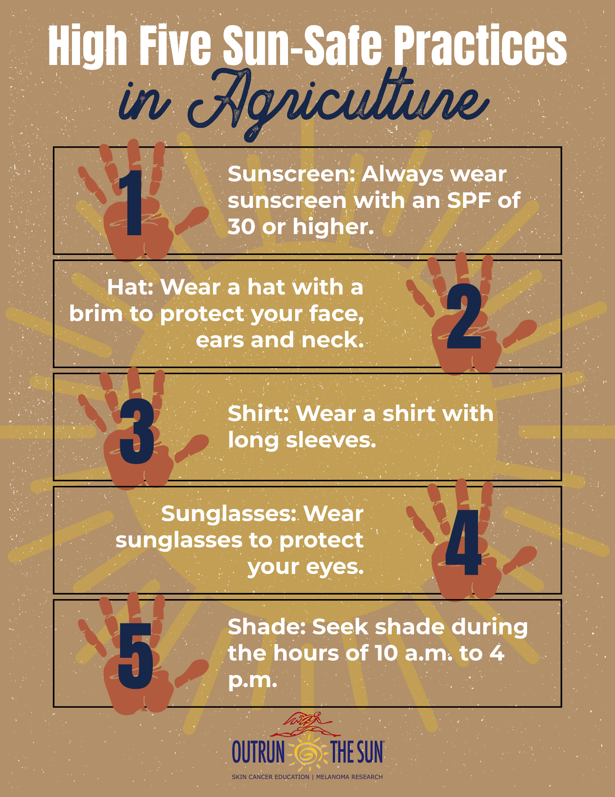
Appendix 1: Sun Safety Graphic

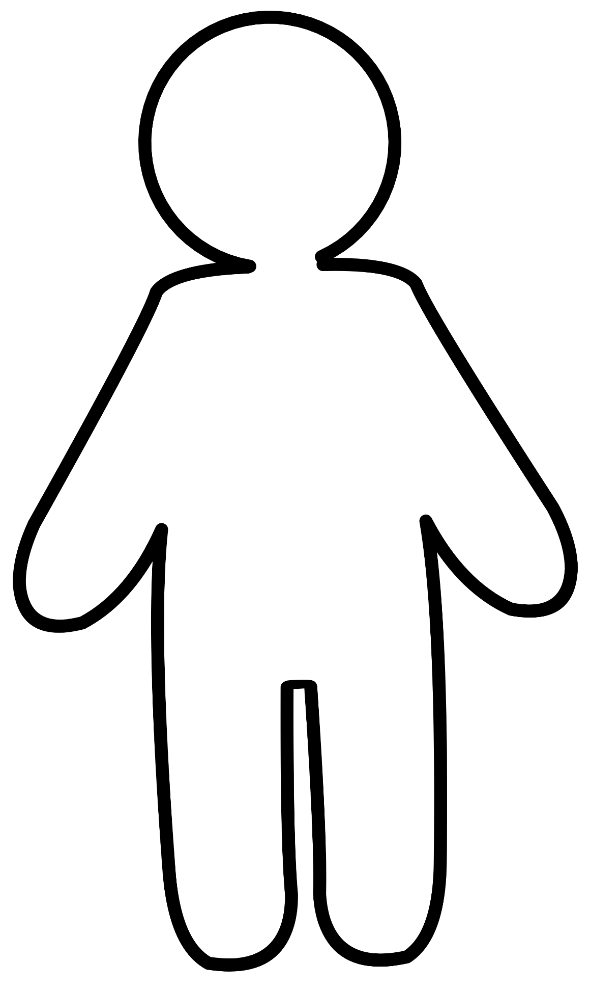
Appendix 2: Flat Agriculturist

