Developing and Marketing a New Food Product
Created: 08/2022 by the National FFA Organization
By the end of this lesson, students will be able to develop and market a new food product. This lesson aligns with the “Product Development” portion of the National FFA Food Science and Technology CDE.
Student Learning Objectives:
After completing these activities, students will …
- Develop a new food product.
- Market a new food product.
- Design packaging for a new food product.

Suggested Grade Level:
Grades 9 and 10 (This lesson is written so instructors can scale up or down based on class needs.)

Suggested Time: Three to five 60-minute class periods. Length of lesson will depend on pace of student progress. This lesson could take up to five full 60-minute class periods. (*Time requirements may vary based upon student understanding and class schedule.)

Resources/References:
- PDF: Arkansas FFA, http://www.arkansasffa.org/docs/FFA_CDE_Workbook%20Updated%20Feb%2013.pdf
- Textbook: Principles of Food Science, 4th Edition, Janet D. Ward (Facts/information in this lesson were obtained from the textbook.)
- May need to reference previous lessons on creating food nutritional labels: Unit 6, Lesson 1

Related Resources:
- Example ideal presentation video, https://www.youtube.com/watch?v=s-DqmURK0SU
- Optional Activity resource, https://www.youtube.com/watch?v=9ZLlGhMqPKo
- Textbook used for Nutritional Calculation Example, https://edisciplinas.usp.br/pluginfile.php/5516437/course/section/6014434/2017_Book_FoodAnalysisLaboratoryManual.pdf
- Follow-up activity video, https://www.youtube.com/watch?v=xOXnrKy17s0

Equipment and Supplies Needed:
- Projector and computer or chalk/dry erase board
- Activity 1:
  - “Activity 1: Steps to Creating a New Food Product” worksheet
  - “Activity 1: Nutritional Label Calculations” worksheet, one per student
- Activity 2: basic craft supplies — markers, construction paper, plastic wrap, crayons, plastic food storage containers, specific student requests for packaging options (pizza box, cereal box, etc.)
- Exit Ticket (optional): sticks of various lengths (can be straws, popsicle sticks, etc.), one per student or group
  - Used for determining order of presentations. Students/groups take one stick (do not allow them to see length). Student/group with the shortest stick goes first and continues in order of stick length.
- Exit Ticket: Teacher needs “Grading Rubric for Product Development Verbal Presentation,” one per student or group

Vocabulary:
- Innovation
- Retail
- Wholesale
- Food service
- Convenience store
- Frozen
- Refrigerated
- Shelf-stable
- Convenience
- Ready to eat
- Heat and serve

Cross-Curricular Connections:
Science | English/Language Arts | Engineering | Mathematics
- All components of this lesson (primarily Activity 1) will utilize science as a component of the lesson in creating a new food product. The overall goal of this lesson is to create a new food product that is appealing, safe and realistic. | - Exit Ticket: Students are challenged to give a verbal presentation on their food product design. | - Activity 2: Students will construct food packaging using designated materials. | - Activity 2: Students will complete calculations to create a food nutritional label for their new food products.

Virtual Instruction Ideas:
All of this lesson could be taught virtually and/or online. Students would need access to craft materials in order to complete the design activity. Communication with the course instructor is key for teaching this lesson virtually or online.

Student Activity Sheets:
Direct access to student activity sheets without lesson plan or answer key for easy upload to a learning management system or printing for classwork.

https://ffa.box.com/s/h6thv9kzn17xvl5kd78hauefjlw3hzt3 (Word)
https://ffa.box.com/s/ll6vauk3m2ts4yl345cpouwq85vjizmb (PDF)
https://ffa.box.com/s/igl1ofaeivt5q7tpdq0ffd7uwlbyff3u (Non-Designed)
https://docs.google.com/document/d/1nHnugKbuV3JxiamM6ZjhIMgWXo5-Ul_9xod-g2--BLE/copy (Google)

These Activities are Aligned to the Following Standards:
AFNR Performance Element
- FPP.01. Develop and implement procedures to ensure safety, sanitation, and quality in food product and processing facilities.
- FPP.04. Explain the scope of the food industry and the historical and current developments of food products and processing.
FFA Precept
- FFA.PL-A.Action: Assume responsibility and take the necessary steps to achieve the desired results, no matter what the goal or task at hand.
- FFA.PG-G.Physical Growth: Take care of one’s health by eating well, exercising, getting enough sleep, respecting one’s body, and setting personal goals for long-term health.
- FFA.PG-J.Mental Growth: Embrace cognitive and intellectual development relative to reasoning, thinking, and coping.
- FFA-CS-M.Communication: Effectively interact with others in personal and professional settings.
- FFA.CS-N.Decision Making: Analyze a situation and execute an appropriate course of action.
Common Career Technical Core
- AG-FD2 Apply principles of nutrition, biology, microbiology, chemistry and human behavior to the development of food products.
- AG-FD4 Explain the scope of the food industry and the historical and current developments of food products and processing.
NASDCTEc
- AGPA01.01 Design and implement procedures and plans that demonstrate application of food processing principles to manage quality control in the food product and processing industry.
- AGPA01.02 Conduct food product development and research activities that demonstrate application of food science principles to enhance products.
- AGAP01.03 Plan, implement, manage, and/or provide services associated with the preservation and packaging of food and food products to prepare products for distribution.
- AGPA01.04 Identify and apply food processing, handling, and storage factors to demonstrate their impact on product quality and safety.
AFNR Cluster Skills
- CS.03. Examine and summarize the importance of health, safety and environmental management systems in AFNR workplaces.
- CS.01. Analyze how issues, trends, technologies and public policies impact systems in the Agriculture, Food & Natural Resources Career Cluster.
Common Core – Writing
- CCSS.ELA-Literacy.W.9-10.2 Write informative/explanatory texts to examine and convey complex ideas, concepts, and information clearly and accurately through the effective selection, organization, and analysis of content.
Common Core – Speaking and Listening
- CCSS.ELA-Literacy.SL.9-10.1.C Propel conversations by posing and responding to questions that relate the current discussion to broader themes or larger ideas; actively incorporate others into the discussion; and clarify, verify, or challenge ideas and conclusions.
- CCSS.ELA-Literacy.SL.9-10.4 Present information, findings, and supporting evidence clearly, concisely, and logically such that listeners can follow the line of reasoning and the organization, development, substance, and style are appropriate to purpose, audience, and task.
Common Core – Science & Technical Subjects
- CCSS.ELA-Literacy.RST.9-10.3 Follow precisely a complex multistep procedure when carrying out experiments, taking measurements, or performing technical tasks, attending to special cases or exceptions defined in the text.
- CCSS.ELA-Literacy.RST.9-10.9 Compare and contrast findings presented in a text to those from other sources (including their own experiments), noting when the findings support or contradict previous explanations or accounts.
Common Core – Literacy in Science & Technical Subjects: Writing
- CCSS.ELA-Literacy.WHST.9-10.2 Write informative/explanatory texts, including the narration of historical events, scientific procedures/experiments, or technical processes.
- CCSS.ELA-Literacy.WHST.9-10.4 Produce clear and coherent writing in which the development, organization, and style are appropriate to task, purpose, and audience.
- CCSS.ELA-Literacy.WHST.9-10.5 Develop and strengthen writing as needed by planning, revising, editing, rewriting, or trying a new approach, focusing on addressing what is most significant for a specific purpose and audience.
Common Core – Math Practices
- CCSS.MATH.PRACTICE.MP1 Make sense of problems and persevere in solving them.
- CCSS.MATH.PRACTICE.MP3 Construct viable arguments and critique the reasoning of others.
- CCSS.MATH.PRACTICE.MP6 Attend to precision.
Green/Sustainability Knowledge and Skill Statements
- AFNR Career Cluster, Statement 6 Use green technologies and sustainability practices to maintain safe and healthful working environments that sustain the natural environment and promote well being in the AFNR workplaces.
- AFNR Career Cluster- Food Products and Processing Systems Pathway, Statement 1 Design and implement procedures and plans that demonstrate application of sustainability principles and policies to increase efficiency and reduce environmental impact of the food production and processing industry.
- AFNR Career Cluster-Food Products and Processing Systems Pathway, Statement 2 Analyze the impact of various food production and processing practices and policies on ecological and public health.
National Standards for Financial Literacy
- Buying Goods and Services, Benchmarks: Grade 12, Statement 1 Consumer decisions are influenced by the price of a good or service, the price of alternatives, and the consumer’s income as well as his or her preferences.
- Buying Goods and Services, Benchmarks: Grade 12, Statement 2 When people consume goods and services, their consumption can have positive and negative effects on others.
- Buying Goods and Services, Benchmarks: Grade 12, Statement 7 Governments establish laws and institutions to provide consumers with information about goods or services being purchased and to protect consumers from fraud.
AFNR Career Ready Practices
- CRP.02. Apply appropriate academic and technical skills. Career-ready individuals readily access and use the knowledge and skills acquired through experience and education to be more productive.
- CRP.04. Communicate clearly, effectively, and with reason. Career-ready individuals communicate thoughts, ideas and action plans with clarity, whether using written, verbal and/or visual methods.
- CRP.05. Consider the environmental, social and economic impact of decisions. Career-ready individuals understand the interrelated nature of their actions and regularly make decisions that positively impact and/or mitigate negative impact on other people, organizations and the environment.
- CRP.06. Demonstrate creativity and innovation. Career-ready individuals regularly think of ideas that solve problems in new and different ways, and they contribute those ideas in a useful and productive manner to improve their organization.
- CRP.07. Employ valid and reliable research strategies. Career-ready individuals are discerning in accepting and using new information to make decisions, change practices or inform strategies.
- CRP.08. Utilize critical thinking to make sense of problems and persevere in solving them. Career-ready individuals readily recognize problems in the workplace, understand the nature of the problem, and
- devise effective plans to solve the problem.
- CRP.11 Use technology to enhance productivity. Career-ready individuals find and maximize the productive value of existing and new technology to accomplish workplace tasks and solve workplace problems.
Partnership for 21st Century Skills
- Critical Thinking and Problem Solving
- Flexibility and Adaptability
- Implement Innovations
- Information Literacy
- Productivity and Accountability
- Think Creatively

Lesson Plan:
- Bell Ringer:
  - Have the following question on the board or projected on the screen: “If you could create any new food product, what would it be and why?” You may consider using your computer to project pictures of foods, or tape pictures to the board, to help foster ideas for students. Picture ideas: apple, boxed cereal, packaged food, cookies, bread, sports drink, pasta, ice cream
  - Direct students to answer the question on a piece of scrap paper while they are entering the room. Be sure to have an idea for yourself on a food product you would like to see to share with students.
  - Once class starts, take turns allowing students to share their ideas. Did students struggle to come up with ideas? Is there a common food product theme?
  - Transition into the lesson. Tell students: Today, you will get to take your ideas and put them on paper and into practice! We are going to create new food product ideas, make the packaging for them and learn how to market them! This is part of the National FFA Food Science and Technology CDE known as “Team Product Development.”

- Introduction:
- Ask students, “Why is it important for food scientists to continually develop new food products?” (Answer: Innovation is key to survival in any business. Food companies must continually strive to meet the changing demands of consumers. Think about how popular organic and pasture-raised, cage-free products have become. Consider “ready-to-eat” products and “fast food chain” products. Demands and needs are continually changing, and companies must keep up or they will go out of business).
- Ask students, “What restaurants or food-related businesses have gone out of business that you can think of?” (Be ready with examples if they do not think of any. Teachers may need to Google for specific examples.)
- Ask students, “Why do you think these examples went out of business? Was it something they were doing or not doing?” (Answer: possibly lack of business due to poor food quality, poor service, bad location, funding, etc.)
- Ask students, “How do you think we should start developing a new food product? What are the steps we should follow or what should we know before we begin?” Allow students to brainstorm and provide ideas; record ideas on the board, making a list. (Answers to add to the list: target audience, ingredients needed for the food product, source of ingredients, cost to make the product, selling price, profit margins, packaging options/requirements, marketing strategies, selling location — grocery, restaurant, fast food, gas station, school, etc., quality control/GMP (good manufacturing practices), HACCP (Hazard Analysis and Critical Control Point), brand/catchy name for the product, nutritional information for the product
- Move into Activity 1. Plan for this activity to take one or two class periods unless it is assigned as homework. It is crucial that students complete every step of this activity in depth. This activity sets them up to make their food packaging and create their verbal presentation.

- Activity 1: Steps to Creating a New Food Product
- Provide each student with a copy of “Activity 1: Steps to Creating a New Food Product” worksheet.
- Read over the directions and each step with students. Be sure to read the examples provided on the worksheet; help students brainstorm together as a class.
- For Step 11 of the worksheet, give each student a copy of the “Activity 1: Nutritional Label Calculations” worksheet. Go over the example worksheet together as a class. It may be helpful to reference the website provided on the worksheet. The address provides a textbook link for a detailed explanation of the worksheet example.
- Allow students ample time to complete the design worksheet. Students may need assistance or guidance.
- Move on to Activity 2.

- Activity 2: Designing a Food Package
- Write the following on the board or verbally tell students: “Directions for this activity: Using the craft supplies provided to you (or the ones you provided), create a realistic package for your food product. Reference back to Activity 1 from this lesson on how you sketched your original package design. Also, reference the nutritional information. You must include the nutritional information and all other packaging information on your package. Be sure to consider multiple layers of packaging if your product needs it.” Be sure to ask students what questions they have. This activity may take one entire class period or more.

- Follow-up:
  - This section will serve as a brief lesson review. Students will watch a video clip of students presenting a food product they designed. Tell students: As you watch this video, please record notes on how this video relates to today’s topic. List at least two concepts you had to address with your new food creation. Students must record the notes on paper (or electronically and submit online) and turn them in prior to leaving class.
  - Show the following video in class: https://www.youtube.com/watch?v=xOXnrKy17s0.

- Optional – Extended Learning Opportunities (Not factored into time requirement):
  - This video is likely too long to show in class; however, parts of it could be very beneficial to show in class. This video is also a good training tool for the teacher, https://www.youtube.com/watch?v=9ZLlGhMqPKo. Ideas on how to use this video: teacher watches prior to class and shares concepts with students. OR, teacher selects specific content to show students during class.

- Exit Ticket: Students will do a presentation on their product development and package designs. Students will need to use the information they recorded on Activity 1 and their product packaging from Activity 2.
  - NOTICE: This portion of the lesson will serve as the unit assessment. There is no separate unit assessment for this unit.
  - Show students the following video clip on how to give a presentation: https://www.youtube.com/watch?v=s-DqmURK0SU.
  - Give each student/group a copy of the “Grading Rubric for Food Product Development Verbal Presentation.”
  - Discuss the requirements and expectations on the handout with the class. Ask students, “What questions do you have?”
  - Allow groups to volunteer to present OR have them draw sticks. The student/group with the shortest stick presents first, followed by the remaining sticks based on length.
  - Teacher may choose to collect product package and all information from students for a separate grade on the package alone. A grading rubric for just the packaging has been provided; it mimics the National FFA grading rubric the food science CDE.
  - **NOTE: This Exit Ticket activity can take up to an entire class period (60 minutes) or more.**

Aligned to the following standards: FPP.01; FPP.04; FFA.PL-A; FFA.PG-G; FFA.PG-J; FFA-CS-M; FFA.CS-N; AG-FD2; AG-FD4; AGPA01.01; AGPA01.02; AGAP01.03; AGPA01.04; CS.03; CS.01; CCSS.ELA.W.9-10.2; CCSS.ELA.SL.9-10.1.C; CCSS.ELA.SL.9-10.4; CCSS.ELA.RST.9-10.3; CCSS.ELA.RST.9-10.9; CCSS.ELA.WHST.9-10.2; CCSS.ELA.WHST.9-10.4; CCSS.ELA.WHST.9-10.5; MP1; MP3; MP6; AFNR Career Cluster, Statement 6; AFNR Career Cluster- Food Products and Processing Systems Pathway, Statement 1; AFNR Career Cluster-Food Products and Processing Systems Pathway, Statement 2; Buying Goods and Services, Benchmarks: Grade 12, Statement 1; Buying Goods and Services, Benchmarks: Grade 12, Statement 2; Buying Goods and Services, Benchmarks: Grade 12, Statement 7; CRP.02; CRP.04; CRP.05; CRP.06; CRP.07; CRP.08; CRP.11.

Activity 1: Steps to Creating a New Food Product
Directions:
Follow each step to begin the creation of your NEW food product! Read each step carefully and complete requirements as directed. Record your thoughts in the spaces provided. You may work with 1 partner if desired. You do not have to complete the steps in order if you find it easier to jump around.

STEP 1: Select and CIRCLE your Food Category, Platform and Market below:
“Product development scenarios will describe a category, platform and market. These may include but are not limited to the following categories, platforms and markets listed below:”

Category: (Circle 1)
i. Cereal
ii. Snacks (trail mix, etc.)
iii. Meals (frozen, ready to eat, etc.)
iv. Side dishes (macaroni, pasta salad, etc.)
v. Beverages (sodas, sport drinks, etc.)
vi. Supplements (vitamin/mineral based or supplemental meal bar)
vii. Condiments (ketchup, mustard, etc.)
viii. Desserts (cookies, pies, cakes, etc.)

Platform: (Circle 1)
i. Frozen
ii. Refrigerated
iii. Shelf-stable: food that can be kept at room temperature without spoiling. (Rice, canned goods, etc.)
iv. Convenience: food that saves time when preparing and cleaning up. (cake/baking mixes, instant potatoes, etc.)
v. Ready to eat: food that does not require preparation and is ready to eat. (cold meats, cheeses, precooked meals designed to eat cold, etc.)
vi. Heat and serve: food that has been prepared and frozen, which can then be heated and served. (frozen TV dinners, frozen pizza, frozen pies, frozen breakfast burritos, etc.)

Market (Domestic and International): (Circle 1)
i. Retail: selling of goods directly to a consumer (grocery stores such as Kroger, Walmart or small/locally owned grocery stores)
ii. Wholesale: buying of large quantities of items and reselling to customers or other retail stores (large stores such as Costco, Sam’s Club)
iii. Food service (used in a food service program cafeterias — school, college, government)
iv. Convenience store (gas station)

STEP 2: Processing of your product. Answer the following questions about how you plan to process/make your food product.
- Provide a description of how to make your product. (Think recipe style here.)
________________________________________________________________________________________________________________________________________________________________________________________________________________________________________________________________________________________________________________________________________________________________________________________________________________________________________________________________________________________________

- What equipment is needed? (meat processor, oven, dehydrator, etc.)
________________________________________________________________________________________________________________________________________________________________________________________________________________________________________________________________________________________________________________________________________________________________________________________________________________________________________________________________________________________________

- Flow diagram of how your processing will be set up.
Examples:
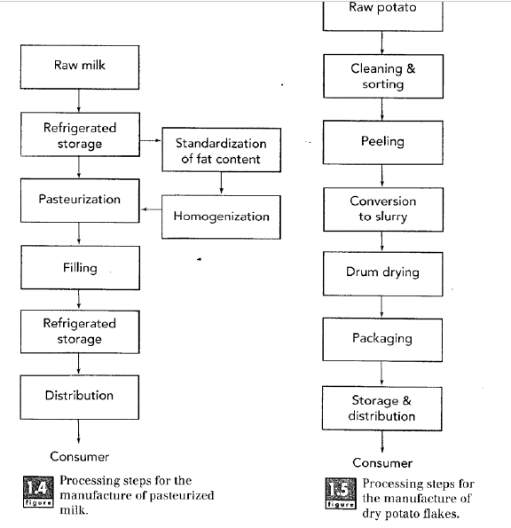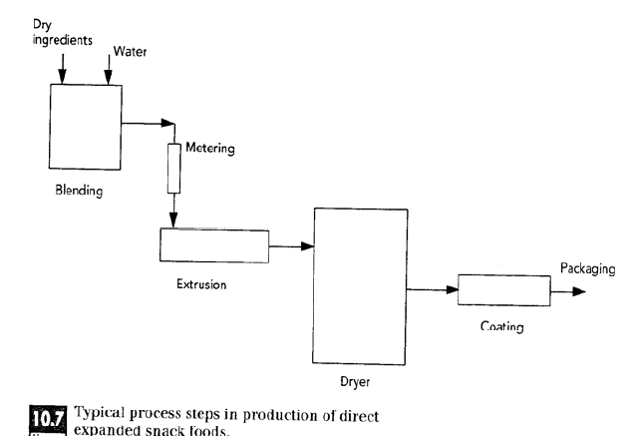

Use the space below to draw YOUR processing flow chart/plan:

- How many people and what type of people do you need working at your processing facility? (managers, machine operators, HR, quality control, packaging, etc.) Your response here will depend on how large you want your company to be. It can be as big or as small as you wish; just be sure to state the number of people required for each job you list.
Job Title/Role Number of People Needed for Role
____________________________________________________________________________________________________________________________________________________________________________________________________________________________________________________________________________________________________________________________________________________________________________________________________________________________________________________________________________________________________________________________________________________________________________________________________________________________________________________________________________________________________________________________________________________________________________________________________________________________________________________________________________________________________________________________________

STEP 3: Identify your target audience. Who do you want to purchase your product? (youth ages x to y; young adults ages x to y; middle-aged adults ages x to y; elderly, etc.) Is your target audience athletic? Parents of young children? Busy, working adults?
Target Audience is ________________________________________________________________.
Why this target audience? ________________________________________________________________________________________________________________________

STEP 4: Packaging. What are you going to package your item in? Consider multiple layer packaging depending on your product (like a cereal box) and what is the purpose of the multiple layers (to keep food fresh, from getting soggy, from getting firm, etc.). You must consider the materials used; be sure materials are appropriate for your food item, and be creative.
Describe your packaging plan:
________________________________________________________________________________________________________________________________________________________________________________________________________________________________________________________________________________________________________________________________________________________________________________________________________________________________________________________________________________________________________________________________________________________________________________________________________________________________________________________________________________________________________________________________________________

STEP 5: Food safety. What food safety concerns are associated with your product? Cross-contamination concerns? Over or under baking? Equipment operation concerns? Think about all phases of processing (from start to finish). How will you combat concerns?
Food Safety Concern: How to Prevent the Concern:
________________________________________________________________________________________________________________________________________________________________________________________________________________________________________________________________________________________________________________________________________________________________________________________________________________________________________________________________________________________________________________________________________________________________________________________________________________________________________________________________________________________________________________________________________________

STEP 6: Product ingredients and supplies
List all ingredients needed for your product. Consider if you will purchase items whole, like pizza dough or make your own. List all supplies needed to make your product (sticks for popsicle, boxes for pizza, etc.)
My Food Product INGREDIENTS List My Food Product SUPPLYS List
________________________________________________________________________________________________________________________________________________________________________________________________________________________________________________________________________________________________________________________________________________________________________________________________________________________________________________________________________________________________________________________________________________________________________________________________________________________________________________________________________________________________________________________________________________
________________________________________________________________________________________________________________________________________________________________________________________________________________________________________________________________________________________________________________________________________________________________________________________________________________________________________________________________________________________________________________________________________________________________________________________________________________________________________________________________________________________________________________________________________________

STEP 7: Cost of goods sold. You will need to calculate rough estimates for this portion. You must calculate using appropriate numbers and figures. This must be realistic. You may need to complete online research for pricing of raw goods. Do not forget about your packaging supplies costs. Reference Step 5 for all components to list here. List all costs here.
Item Name Cost/What Size? (oz, gram, pint?)
________________________________________________________________________________________________________________________________________________________________________________________________________________________________________________________________________________________________________________________________________________________________________________________________________________________________________________________________________________________________________________________________________________________________________________________________________________________________________________________________________________________________________________________________________________
________________________________________________________________________________________________________________________________________________________________________________________________________________________________________________________________________________________________________________________________________________________________________________________________________________________________________________________________________________________________________________________________________________________________________________________________________________________________________________________________________________________________________________________________________________

STEP 8: Quality control
What are the quality control measures you need to look for in your product? (Examples: flavor, texture, consistency, temperature, net wet, size, etc.)
List the quality control measures you need to look for in your product:
________________________________________________________________________________________________________________________________________________________________________________________________________________________________________________________________________________________________________________________________________________________________________________________________________________________________________________________________________________________________________________________________________________________________________________________________________________________________________________________________________________________________________________________________________________

STEP 9: Marketing and sales
- Use the space below to draw each side of your packaging for your product. You do not need to provide detailed nutrition or nutrition label information here.
- DO include the following areas on your packaging: name of product; net weight of product; nutrition facts panel (draw a box in the location where it would go on your packaging); ingredient list (provide space where this information will go); manufacturer information
My packaging will be made of: (plastic, cardboard, etc.) ________________________________________________________________________________________________________________________
The name of my product is: (Kreiders’ Korn, Sadis’ Sweet Syrup, etc.) Do not forget about your LOGO! (Created in “Anatomy of a Logo” worksheet) ________________________________________________________________________________________________________________________

FRONT of Packaging: Back of Packaging:

Side of Packaging? Other side of Packaging?

Where do you plan to market/sell your product? (Be specific on store location: front, back, side, etc. Free standing case? Or in another case?) ____________________________________________________________________________________________________________________________________________________________________________________

Do you plan to run promotions? If so, when and what kind? How will these promotions impact your overall profit?
____________________________________________________________________________________________________________________________________________________________________________________

STEP 10: Nutrition and nutritional labeling
Using the information you learned in our previous lesson on “Interpreting and Designing Food Labels,” design a food label for your product. All calculations must be correct.
Example Nutritional Label:
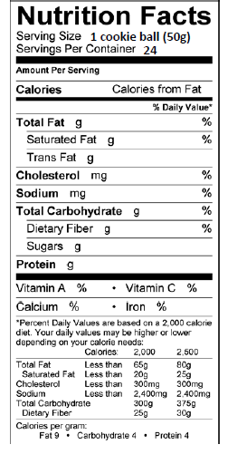

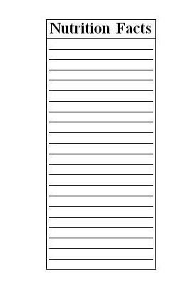
My Food Product Nutritional Label: Draw lines where needed and fill in the label below to represent your product. You may use the empty space around the label for notes, calculations, etc.

Activity 1: Nutritional Label Calculations
Aligned to the following standards: FPP.01; FPP.04; FFA.PL-A; FFA.PG-G; FFA.PG-J; FFA-CS-M; FFA.CS-N; AG-FD2; AG-FD4; AGPA01.01; AGPA01.02; AGAP01.03; AGPA01.04; CS.03; CS.01; CCSS.ELA.W.9-10.2; CCSS.ELA.SL.9-10.1.C; CCSS.ELA.SL.9-10.4; CCSS.ELA.RST.9-10.3; CCSS.ELA.RST.9-10.9; CCSS.ELA.WHST.9-10.2; CCSS.ELA.WHST.9-10.4; CCSS.ELA.WHST.9-10.5; MP1; MP3; MP6; AFNR Career Cluster, Statement 6; AFNR Career Cluster- Food Products and Processing Systems Pathway, Statement 1; AFNR Career Cluster-Food Products and Processing Systems Pathway, Statement 2; Buying Goods and Services, Benchmarks: Grade 12, Statement 1; Buying Goods and Services, Benchmarks: Grade 12, Statement 2; Buying Goods and Services, Benchmarks: Grade 12, Statement 7; CRP.02; CRP.04; CRP.05; CRP.06; CRP.07; CRP.08; CRP.11.

Directions:

Reference for this worksheet (with explanation of example): https://edisciplinas.usp.br/pluginfile.php/5516437/course/section/6014434/2017_Book_FoodAnalysisLaboratoryManual.pdf

EXAMPLE:

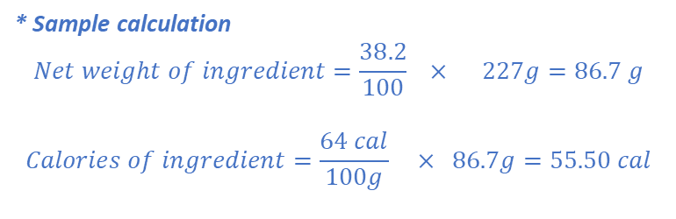

Grading Rubric for Product Development Verbal Presentation
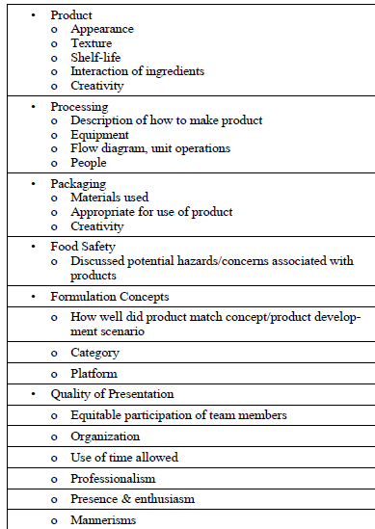
National FFA Scoring Rubric for Reference:
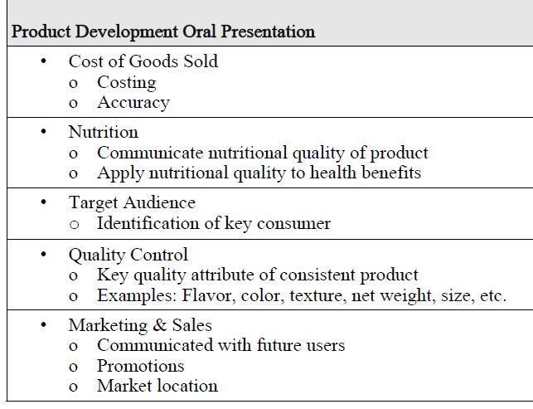

- Students declared: ___/___
  - Category (cereal, snack, etc.)
  - Platform (frozen, ready to eat, etc.)
  - Market (retail, food service, etc.)
- Clear processing plan of product shown: ___/___
  - Description of how to make product was provided:
  - Equipment needed to make product was provided: ___/___
- Target audience identified and explanation of why: ___/___
- Food safety issues addressed: ___/___
- Covered cost of goods sold: ___/___
- Discussed/shared quality control measures taken: ___/___
- Marketing and sales plan for product: ___/___
- Description of product packaging: ___/___
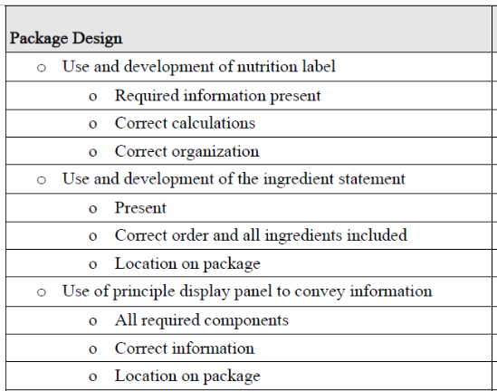

TOTAL SCORE: ______ /______

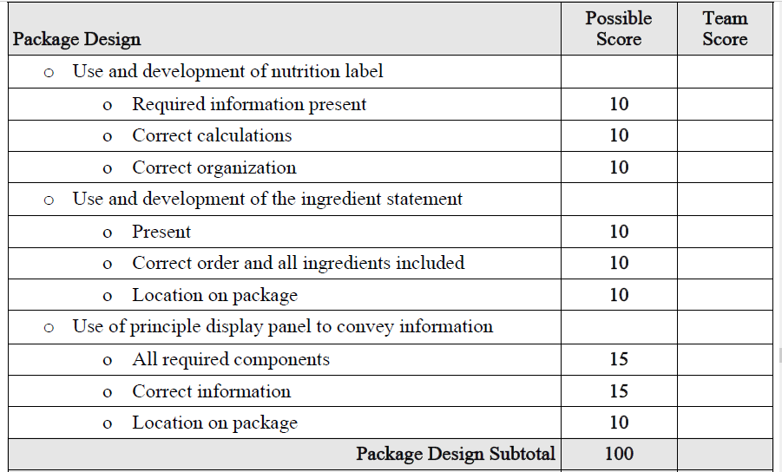
KEY: Product Development Packaging
Optional Use: National FFA Food Science and Technology CDE Grading Rubric for “Package Design”.

