Animal Production
Created: 07/2019 by the National FFA Organization

Student Learning Objectives:
After completing these activities, students will …
- Describe the main food-producing animals and how they are managed.
- Examine animal welfare concerns that accompany the production of animal-based food.
- Describe the impact of production practices on final consumer food costs.
- Describe the role of animal-based food consumption in everyday nutrition.

Time Required: 200 minutes
Resources:
- American Egg Board, https://www.incredibleegg.org/?utm_source=bing&utm_medium=cpc&utm_campaign=Int_General&utm_term=%5Bamerican%20egg%20board%5D&utm_content=American%20Egg%20Board_Exact
- American Goat Federation, https://americangoatfederation.org/
- American Lamb Board, https://lambresourcecenter.com/
- Beef Check Off, https://www.beefitswhatsfordinner.com/
- MyPlate, https://www.choosemyplate.gov/
- National Chicken Council, https://www.nationalchickencouncil.org/
- National Dairy Council, https://www.nationaldairycouncil.org/
- National Turkey Federation, https://www.eatturkey.org/
- Nutrition.gov, https://www.nutrition.gov/subject/whats-in-food
- Pork Check Off, https://www.pork.org/
- Six-Year-Old Basketball Phenom News Report, https://youtu.be/n5k7HqMUE70

Equipment and Supplies Needed:
- A copy of the “Match” worksheet for each student
- A copy of the “Teach the World” worksheet for each student
- A copy of the “Nutrition Choices” worksheet for each student
- One sticky note per student
- Internet access for research
- Colored pencils, markers or pens

This quick lesson plan would work well as AN:
- Introduction to an animal production lesson.
- Animal welfare lesson.
- Meat Science.

Student Activity Sheets
https://ffa.box.com/s/w37mmrycgxh4i9034zhx9jd1kfll6km3 (Word)
https://ffa.box.com/s/14unfrlvfne56mt5rob9sx5z1p8vss1m (PDF)

These activities are aligned to the following standards:
AFNR Performance Element
- AS.02: Utilize best-practice protocols based upon animal behaviors for animal husbandry and welfare.
- AS.05: Evaluate environmental factors affecting animal performance and implement procedures for enhancing performance and animal health.
- AS.08: Analyze environmental factors associated with animal production.
- CS.01: Analyze how issues, trends, technologies and public policies impact systems in the Agriculture, Food & Natural Resources Career Cluster.
FFA Precept
- FFA.PL-A.Action: Assume responsibility and take the necessary steps to achieve the desired results, no matter what the goal or task at hand.
- FFA.PG-J.Mental Growth: Embrace cognitive and intellectual development relative to reasoning, thinking and coping.
- FFA.CS-M.Communication: Effectively interact with others in personal and professional settings.
- FFA.CS-N.Decision Making: Analyze a situation and execute an appropriate course of action.

Common Career Technical Core
- AG1: Analyze how issues, trends, technologies and public policies impact systems in the Agriculture, Food & Natural Resources Career Cluster.
- AG.ANI2: Utilize best-practice protocols based upon animal behaviors for animal husbandry and welfare.
- AG.ANI5: Evaluate environmental factors affecting animal performance and implement procedures for enhancing performance and animal health.
- AG.ANI8: Analyze environmental factors associated with animal production.
NASDCTEc
- AGC10.03: Compare and contrast issues affecting the AFNR industry including biotechnology, employment, safety, environmental and animal welfare to demonstrate an understanding of the trends and issues important to careers in this industry.
Common Core – Reading: Informational Text
- CCSS.ELA-Literacy.RI.9-10.4: Determine the meaning of words and phrases as they are used in a text, including figurative, connotative, and technical meanings; analyze the cumulative impact of specific word choices on meaning and tone (e.g., how the language of a court opinion differs from that of a newspaper).
Common Core – Writing
- CCSS.ELA-Literacy.W.9-10.2: Write informative/explanatory texts to examine and convey complex ideas, concepts, and information clearly and accurately through the effective selection, organization, and analysis of content.
Common Core – Speaking and Listening
- CCSS.ELA-Literacy.SL.9-10.1: Initiate and participate effectively in a range of collaborative discussions (one-on-one, in groups, and teacher-led) with diverse partners on grades 9-10 topics, texts, and issues, building on others' ideas and expressing their own clearly and persuasively.
- CCSS.ELA-Literacy.SL.9-10.2: Integrate multiple sources of information presented in diverse media or formats (e.g., visually, quantitatively, orally) evaluating the credibility and accuracy of each source.
- CCSS.ELA-Literacy.SL.9-10.4: Present information, findings, and supporting evidence clearly, concisely, and logically such that listeners can follow the line of reasoning and the organization, development, substance, and style are appropriate to purpose, audience, and task.
Common Core – Literacy in Science & Technical Subjects: Writing
- CCSS.ELA-Literacy.WHST.9.10.2: Write informative/explanatory texts, including the narration of historical events, scientific procedures/ experiments, or technical processes.
- CCSS.ELA-Literacy.WHST.9.10.4: Produce clear and coherent writing in which the development, organization, and style are appropriate to task, purpose, and audience.
Common Core – Math Practices
- CCSS.MP1: Make sense of problems and persevere in solving them.
- CCSS.MP3: Construct viable arguments and critique the reasoning of others.
- CCSS.MP5: Use appropriate tools strategically.
- CCSS.MP6: Attend to precision.
Next Generation Science
- HS-ETS1-3: Evaluate a solution to a complex real-world problem based on prioritized criteria and trade-offs that account for a range of constraints, including cost, safety, reliability, and aesthetics as well as possible social, cultural, and environmental impacts.
AFNR Career Ready Practices
- CRP.02: Apply appropriate academic and technical skills. Career-ready individuals readily access and use the knowledge and skills acquired through experience and education to be more productive.
- CRP.04: Communicate clearly, effectively, and with reason. Career-ready individuals communicate thoughts, ideas and action plans with clarity, whether using written, verbal and/or visual methods.
- CRP.05: Consider the environmental, social and economic impact of decisions. Career-ready individuals understand the interrelated nature of their actions and regularly make decisions that positively impact and/or mitigate negative impact on other people, organizations and the environment.
- CRP.06: Demonstrate creativity and innovation. Career-ready individuals regularly think of ideas that solve problems in new and different ways, and they contribute those ideas in a useful and productive manner to improve their organization.
- CRP.07: Employ valid and reliable research strategies. Career-ready individuals are discerning in accepting and using new information to make decisions, change practices or inform strategies.
- CRP.08: Utilize critical thinking to make sense of problems and persevere in solving them. Career-ready individuals readily recognize problems in the workplace, understand the nature of the problem, and devise effective plans to solve the problem.
Partnership for 21st Century Skills
- Communication
- Critical Thinking and Problem Solving
- Flexibility and Adaptability
- Initiative and Self-Direction
- Leadership and Responsibility
- Think Creatively

Lesson Plan:
- Bell Ringer: Hand out a sticky note to each student. Have students watch the video available at https://youtu.be/n5k7HqMUE70. On a sticky note, students should write down three positive qualities of the news broadcast. Have students set their sticky notes aside temporarily. If technology or YouTube is unavailable, have students answer the question “What is a news broadcast?” Have students share responses. Then, have students brainstorm with their neighbors the things they should look for in a quality news broadcast. Create a list on the board.

- Introduction: Hand out the “Match” worksheet to each student. Match the meals to the species that produced the food. There may be multiple species per food dish. Students should also complete the question on the worksheet. After all students have finished, share the answers and discuss why we should care about where our food comes from.

- Activity 1:
Part 1: Explain that it is important to learn about the animal production industry to better understand where our food comes from. Describe how we utilize many different by-products from animals for thousands of different resources. This lesson will focus on food-based animals. Students will create a news broadcast about one of the main food-producing animal species. Have students share their sticky note responses for what makes a good news broadcast. Create a list on the board that can be referenced during the activity. After a list has been developed and discussed, split students into seven equal groups and assign a species on which to focus. Hand out the “Teach the World” worksheet to each student. Students will use the resources provided and the outline template to guide their research and help organize their news broadcasts. Encourage students to be as creative as possible and use only valid sources if they move beyond those provided. Presentations should be five minutes long and include all group members. Once students have finished preparing for their presentation (recommended: 45 minutes), have students practice (recommended: 20 minutes). At the conclusion of the preparation and practice time, randomly draw groups to present. Use the attached rubric to evaluate each presentation.

Part 2: Once all presentations have concluded, students should find two classmates that have different species than what they presented. They should use the diagram to compare and contrast the three species. The questions on the worksheet should then be answered individually. After students are done, have a discussion with the class about the biggest misconceptions regarding food production animals. End by answering any final questions that may exist about production.

Part 3: Students will learn how the differences in production impacts the cost of the foods they purchase. Students will utilize different grocery websites to look up and record the different products listed (Ex. store-brand large grade A eggs vs. cage-free eggs). Students will then answer the conclusion question on the worksheet. Have students think-pair-share with a neighbor and then share with the class.

Activity 2:
Part 1: Hand out the “Nutrition Choices” worksheet to each student. Students will learn about the important parts of the MyPlate model and the nutritional needs they each have. Using their knowledge of the different food categories in the MyPlate model (more information can be found at https://www.choosemyplate.gov/), have students use colored writing utensils to circle each food with the color that matches the nutritional category. When a student has completed the circling portion of the activity, they should complete the accompanying questions. Have students share the food product they selected with a neighbor.

Part 2: Using the Nutrition.gov website, https://www.nutrition.gov/subject/whats-in-food, have students complete the chart in Part 2 of the “Nutrition Choices” worksheet to learn about the different nutritional needs. Have students answer the question when they are finished.

Part 3: Now students will take the nutritional knowledge they have just gained and apply it to food products. Using the three nutrition labels, have students find and record the carbohydrates and protein on the labels as well as one element they found interesting about the label. Next, have students critically think about why animal-based food is so important to the diet (animal-based nutrition is important to maintain a healthy diet, reduce the risk of disease and grow into an adult). Students will then answer the final question about food insecurity and link their knowledge from previous lessons to this lesson.

- Follow-up: Have students bring in food labels from their favorite food products. Lay out the food nutrition labels throughout the room. Have students go through labels and design a one-day meal plan that would satisfy the nutritional needs identified in this lesson. Also have students identify the food-producing animal that the food comes from.

- Leveling Up: Have students develop a school lunch plan (possibly by working with cafeteria staff or the family and consumer sciences class) that will satisfy the nutritional needs while incorporating animal-based foods into the menu. Have students include facts for each day to educate others about the nutrition and production of these animals.

- Exit Ticket: What role do food-producing animals play in our economy and nutritional/dietary needs?

Match
Aligned to the following standards:
AS.02; AS.05; AS.08; CS.01; FFA.PL-A; FFA.PG-J; FFA.CS-M; FFA.CS-N; AG1; AG.ANI2; AG.ANI5; AG.ANI8; AGC10.03; CCSS.ELA.RI.9-10.4; CCSS.ELA.W.9-10.2; CCSS.ELA.SL.9-10.1; CCSS.ELA.SL.9-10.2; CCSS.ELA.SL.9-10.4; CCSS.ELA.WHST.9.10.2; CCSS.ELA.WHST.9.10.4; MP1; MP3; MP5; MP6; HS-ETS1-3; CRP.02; CRP.04; CRP.05; CRP.06; CRP.07; CRP.08
Directions:
Match the meals to the species that produced the food. There may be multiple species per food dish.

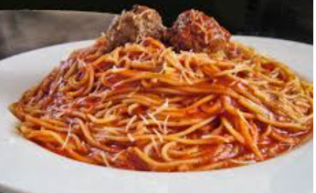
- Beef production
- Broiler (meat) chicken production
- Dairy production
- Egg production
- Pork production
- Sheep/Goats production
- Turkey production

________________________

Spaghetti and Turkey Meatballs

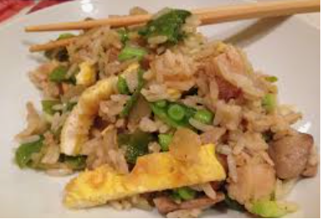

________________________

Chicken Fried Rice

Should you care about where your food comes from? Explain.
________________________

Breakfast Sandwich

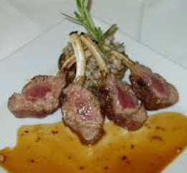
________________________

Lamb Chops

Teach the World
Aligned to the following standards:
AS.02; AS.05; AS.08; CS.01; FFA.PL-A; FFA.PG-J; FFA.CS-M; FFA.CS-N; AG1; AG.ANI2; AG.ANI5; AG.ANI8; AGC10.03; CCSS.ELA.RI.9-10.4; CCSS.ELA.W.9-10.2; CCSS.ELA.SL.9-10.1; CCSS.ELA.SL.9-10.2; CCSS.ELA.SL.9-10.4; CCSS.ELA.WHST.9.10.2; CCSS.ELA.WHST.9.10.4; MP1; MP3; MP5; MP6; HS-ETS1-3; CRP.02; CRP.04; CRP.05; CRP.06; CRP.07; CRP.08
Part 1
Directions:
Today, you and your partners will be placed in the role of a news broadcaster. You will report to the rest of the class about the production of a specific food-animal species: (1) beef, (2) broiler (meat) chickens, (3) dairy, (4) egg production, (5) pork, (6) turkey and (7) sheep/goats. During this news report, you need to be sure to only use reliable sources (sources have been provided). You will report about the farm-to-fork production process as well the welfare management practices that are in place for the species. Follow the template below to complete your research. Once you have completed your research, you will put together your broadcast. Be sure to implement the positive elements of a broadcast you discussed during the bell ringer activity. Your news broadcast should be 5 minutes long and have equal participation from all group members. Be creative and have fun!
Beef
Beef Check Off: Beef, It’s What’s for Dinner: https://www.beefitswhatsfordinner.com/

Hot topic: Grass fed vs. Feed lot production
Dairy
National Dairy Council: https://www.nationaldairycouncil.org/

Hot topic: Usage of rBST (artificial growth hormone) vs. no use of rBST
Pork

Pork Check Off: https://www.pork.org/

Hot topic: gestation crate usage vs. no gestation crates
Sheep/Goats
American Goat Federation: https://americangoatfederation.org/
American Lamb Board: https://lambresourcecenter.com/

Hot topic: Docking tails vs. not docking tails
Turkey

National Turkey Federation: https://www.eatturkey.org/

Hot topic: GMO feed vs. Non-GMO feed
Eggs
American Egg Board: https://www.incredibleegg.org/?utm_source=bing&utm_medium=cpc&utm_campaign=Int_General&utm_term=%5Bamerican%20egg%20board%5D&utm_content=American%20Egg%20Board_Exact

Hot topic: cage-free eggs vs. caged
Broiler (meat) Chickens
National Chicken Council: https://www.nationalchickencouncil.org/

Hot topic: Antibiotic use vs. no antibiotics
Additional Resources for All Species

American Humane Association: https://www.americanhumane.org/program/farms/

Animal Health Institute: https://www.ahi.org/issues-advocacy/animal-antibiotics/

Department of Agriculture’s Animal and Plant Health Inspection Service: http://www.aphis.usda.gov/animal_welfare/

Department of Agriculture’s National Agriculture Library Animal Care Guidelines: https://www.nal.usda.gov/awic/standards-and-guidelines

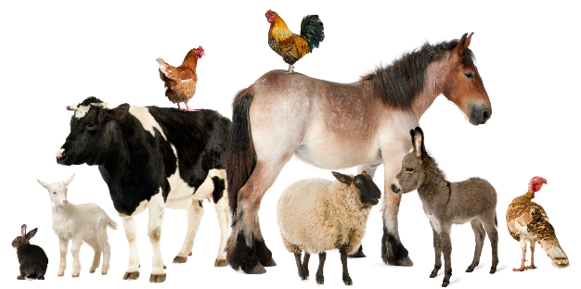

Directions:
Aligned to the following standards:
AS.02; AS.05; AS.08; CS.01; FFA.PL-A; FFA.PG-J; FFA.CS-M; FFA.CS-N; AG1; AG.ANI2; AG.ANI5; AG.ANI8; AGC10.03; CCSS.ELA.RI.9-10.4; CCSS.ELA.W.9-10.2; CCSS.ELA.SL.9-10.1; CCSS.ELA.SL.9-10.2; CCSS.ELA.SL.9-10.4; CCSS.ELA.WHST.9.10.2; CCSS.ELA.WHST.9.10.4; MP1; MP3; MP5; MP6; HS-ETS1-3; CRP.02; CRP.04; CRP.05; CRP.06; CRP.07; CRP.08
Record information in each box to help you prepare your news broadcast.
What is the purpose of your species for food production?
Hot topic research: What are both sides of the issue? Why is this issue a concern? What is the industry doing to address this issue?
Describe the housing and management practices of your species. Where do they live? How do they live (cages, etc.)? What considerations have to be made for their housing?
How is good animal welfare (the way an animal is treated) maintained during production? Give specific examples of how and why.
What is the impact on the environment by this species? Ex. water usage
Part 2
Aligned to the following standards:
AS.02; AS.05; AS.08; CS.01; FFA.PL-A; FFA.PG-J; FFA.CS-M; FFA.CS-N; AG1; AG.ANI2; AG.ANI5; AG.ANI8; AGC10.03; CCSS.ELA.RI.9-10.4; CCSS.ELA.W.9-10.2; CCSS.ELA.SL.9-10.1; CCSS.ELA.SL.9-10.2; CCSS.ELA.SL.9-10.4; CCSS.ELA.WHST.9.10.2; CCSS.ELA.WHST.9.10.4; MP1; MP3; MP5; MP6; HS-ETS1-3; CRP.02; CRP.04; CRP.05; CRP.06; CRP.07; CRP.08
Directions:
Now that you have learned about the different food-producing species, compare and contrast your species with two others to visually see how they are similar and different.
What surprised you the most about the similarities and differences among the three species you compared and contrasted?
Which species/production practices surprised you the most overall? Why?
Which production practices could be the most misunderstood by the general consumer? Why?

Part 3
Aligned to the following standards:
AS.02; AS.05; AS.08; CS.01; FFA.PL-A; FFA.PG-J; FFA.CS-M; FFA.CS-N; AG1; AG.ANI2; AG.ANI5; AG.ANI8; AGC10.03; CCSS.ELA.RI.9-10.4; CCSS.ELA.W.9-10.2; CCSS.ELA.SL.9-10.1; CCSS.ELA.SL.9-10.2; CCSS.ELA.SL.9-10.4; CCSS.ELA.WHST.9.10.2; CCSS.ELA.WHST.9.10.4; MP1; MP3; MP5; MP6; HS-ETS1-3; CRP.02; CRP.04; CRP.05; CRP.06; CRP.07; CRP.08
Directions:
You have learned how food-animal species are produced, why they are produced the way that they are and hot topic issues. Now, let’s look at some products you would purchase locally. Using a local grocery store (ex. Kroger, Walmart, etc.), research the costs of the products below.
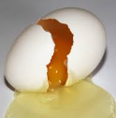
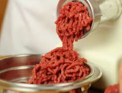

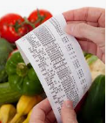
$______________

Store-Brand Large Grade A Eggs
$______________

Cage-Free Large Grade A Eggs
vs.
vs.
$______________

1 lb Store-Brand 80% Ground Beef
$______________

1 lb Grass-Fed 80% Ground Beef
$______________

1 Gallon Store-Brand 2% Milk
$______________

1 Gallon Organic 2% Milk
vs.
What impact did the production practices have on the price you would pay at the grocery store for a food product? Why?
What is the difference in production between cage-free and store-brand eggs?
What is the difference in production between grass-fed and store-brand ground beef?
What is the difference in production between organic and store-brand milk?

Nutrition Choices
Aligned to the following standards:
AS.02; AS.05; AS.08; CS.01; FFA.PL-A; FFA.PG-J; FFA.CS-M; FFA.CS-N; AG1; AG.ANI2; AG.ANI5; AG.ANI8; AGC10.03; CCSS.ELA.RI.9-10.4; CCSS.ELA.W.9-10.2; CCSS.ELA.SL.9-10.1; CCSS.ELA.SL.9-10.2; CCSS.ELA.SL.9-10.4; CCSS.ELA.WHST.9.10.2; CCSS.ELA.WHST.9.10.4; MP1; MP3; MP5; MP6; HS-ETS1-3; CRP.02; CRP.04; CRP.05; CRP.06; CRP.07; CRP.08
Part 1
Directions:
Circle the following foods according to the nutritional category they fall into. Some may have multiple categories, so add multiple circles in their assigned color. You can use the MyPlate website for help: https://www.choosemyplate.gov/.
- Protein = Purple
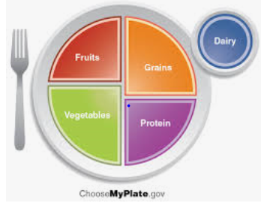
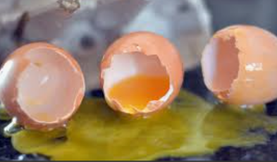
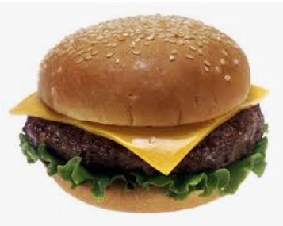
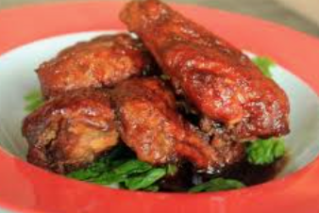
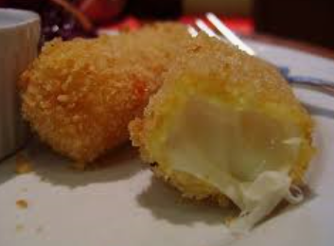
- Vegetable = Green
Eggs
Cheeseburger
Buffalo Wings
Mozzarella Stick
What role do food animals play in the nutrition we consume?
Select your favorite main course (ex. French toast) and identify the food animals involved in the production of that food.
- Grain = Orange
- Fruits = Red
- Blue = Dairy

Part 2
Aligned to the following standards:
AS.02; AS.05; AS.08; CS.01; FFA.PL-A; FFA.PG-J; FFA.CS-M; FFA.CS-N; AG1; AG.ANI2; AG.ANI5; AG.ANI8; AGC10.03; CCSS.ELA.RI.9-10.4; CCSS.ELA.W.9-10.2; CCSS.ELA.SL.9-10.1; CCSS.ELA.SL.9-10.2; CCSS.ELA.SL.9-10.4; CCSS.ELA.WHST.9.10.2; CCSS.ELA.WHST.9.10.4; MP1; MP3; MP5; MP6; HS-ETS1-3; CRP.02; CRP.04; CRP.05; CRP.06; CRP.07; CRP.08
Directions:
Now that we know the impact food animals have in our daily meal consumption, let’s determine how much we should be eating to maintain proper health and nutrition! Using the Nutrition.gov website, https://www.nutrition.gov/subject/whats-in-food, determine what the essential dietary components are, how much you should consume each day and where they come from.

Component | Why is it important? | How much do I need? | Examples
Protein
Carbohydrates
Fat
Vitamins and Minerals
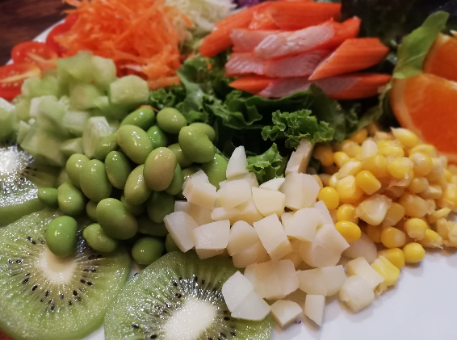
What could happen if you do not consume the needed nutrition? Give specific examples.
Part 3
Aligned to the following standards:
AS.02; AS.05; AS.08; CS.01; FFA.PL-A; FFA.PG-J; FFA.CS-M; FFA.CS-N; AG1; AG.ANI2; AG.ANI5; AG.ANI8; AGC10.03; CCSS.ELA.RI.9-10.4; CCSS.ELA.W.9-10.2; CCSS.ELA.SL.9-10.1; CCSS.ELA.SL.9-10.2; CCSS.ELA.SL.9-10.4; CCSS.ELA.WHST.9.10.2; CCSS.ELA.WHST.9.10.4; MP1; MP3; MP5; MP6; HS-ETS1-3; CRP.02; CRP.04; CRP.05; CRP.06; CRP.07; CRP.08
Directions:
Using the nutritional information we just learned about, evaluate the nutrition for each of the following foods.
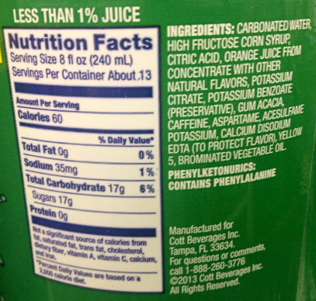
Why is it so important to include food-animal products in your everyday diet?
What is the role of food-animal products in meeting the needs of those who are food insecure?
If a person is unable to consume animal-based products due to health concerns, how can they ensure a healthy diet?
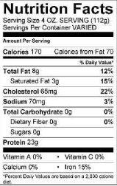
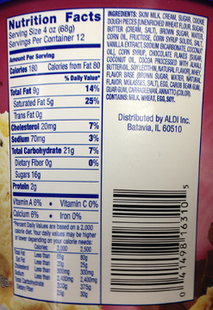
Identify the amounts of the following:
Ice Cream
Ground Beef
Mountain Dew Soda

Carbohydrates: _______

Protein: _______

Write down another fact you find
interesting about this food label.
Identify the amounts of the following:

Carbohydrates: _______

Protein: _______

Write down another fact you find
interesting about this food label.
Identify the amounts of the following:

Carbohydrates: _______

Protein: _______

Write down another fact you find
interesting about this food label.
Key: Match
Aligned to the following standards:
AS.02; AS.05; AS.08; CS.01; FFA.PL-A; FFA.PG-J; FFA.CS-M; FFA.CS-N; AG1; AG.ANI2; AG.ANI5; AG.ANI8; AGC10.03; CCSS.ELA.RI.9-10.4; CCSS.ELA.W.9-10.2; CCSS.ELA.SL.9-10.1; CCSS.ELA.SL.9-10.2; CCSS.ELA.SL.9-10.4; CCSS.ELA.WHST.9.10.2; CCSS.ELA.WHST.9.10.4; MP1; MP3; MP5; MP6; HS-ETS1-3; CRP.02; CRP.04; CRP.05; CRP.06; CRP.07; CRP.08
Directions:
Match the meals to the species that produced the food. There may be multiple species per food dish.

- Beef production
- Broiler (meat) chicken production
- Dairy production
- Egg production
- Pork production
- Sheep/Goats production
- Turkey production

G

Spaghetti and Turkey Meatballs

B, D

Chicken Fried Rice
Should you care about where your food comes from? Explain.

Answers will vary. Example: Food animals provide protein in the diet.
C, D, E

Breakfast Sandwich

F

Lamb Chops

Teach the World Rubric
Aligned to the following standards:
AS.02; AS.05; AS.08; CS.01; FFA.PL-A; FFA.PG-J; FFA.CS-M; FFA.CS-N; AG1; AG.ANI2; AG.ANI5; AG.ANI8; AGC10.03; CCSS.ELA.RI.9-10.4; CCSS.ELA.W.9-10.2; CCSS.ELA.SL.9-10.1; CCSS.ELA.SL.9-10.2; CCSS.ELA.SL.9-10.4; CCSS.ELA.WHST.9.10.2; CCSS.ELA.WHST.9.10.4; MP1; MP3; MP5; MP6; HS-ETS1-3; CRP.02; CRP.04; CRP.05; CRP.06; CRP.07; CRP.08

Indicator | Strong  (5–4 points) | Moderate  (3–2 points) | Weak  (1–0 points) | Points Earned
Species Purpose | Included | Included, but difficult to understand | Not included
Describe the Housing and Management Practices | Demonstrates thorough research and understanding of accurate production practices by giving 3 or more examples | Demonstrates moderate research and understanding of accurate production practices by giving 2 examples | Demonstrates limited research and understanding of accurate production practices by giving less than 2 examples
Hot Topic Research | Demonstrates thorough research and understanding of the hot topic by giving 3 or more examples | Demonstrates moderate research and understanding of the hot topic by giving 2 examples | Demonstrates limited research and understanding of the hot topic by giving less than 2 examples
Animal Welfare | Demonstrates thorough research and understanding of animal welfare | Demonstrates moderate research and understanding of animal welfare | Demonstrates limited research and understanding of animal welfare
Environmental  Concerns | Demonstrates thorough research and understanding of the environmental concerns by giving 3 or more examples | Demonstrates moderate research and understanding of the environmental concerns by giving 2 examples | Demonstrates limited research and understanding of the environmental concerns by giving less than 2 examples
Used Valid Sources | All sources were valid. | Half of the resources were valid. | Less than half of the resources were valid.
Demonstrates Knowledge of Topic | Presentation shows strong knowledge of the subject with good evidence of support. | Presentation shows some knowledge of the subject with fair evidence of support. | Presentation shows little knowledge of the subject with poor evidence of support.
Team Participation | All team members took an active role in the presentation. | One to two team members did not participate. | Less than three team members took an active role in the presentation.

Total: __________
Comments:
Part 3
Aligned to the following standards:
AS.02; AS.05; AS.08; CS.01; FFA.PL-A; FFA.PG-J; FFA.CS-M; FFA.CS-N; AG1; AG.ANI2; AG.ANI5; AG.ANI8; AGC10.03; CCSS.ELA.RI.9-10.4; CCSS.ELA.W.9-10.2; CCSS.ELA.SL.9-10.1; CCSS.ELA.SL.9-10.2; CCSS.ELA.SL.9-10.4; CCSS.ELA.WHST.9.10.2; CCSS.ELA.WHST.9.10.4; MP1; MP3; MP5; MP6; HS-ETS1-3; CRP.02; CRP.04; CRP.05; CRP.06; CRP.07; CRP.08
Directions:
You have learned how food-animal species are produced, why they are produced the way that they are and hot topic issues. Now, let’s look at some products you would purchase locally. Using a local grocery store, research the costs of the products below (ex. Kroger, Walmart, etc.). Answers will vary. However, the cage-free eggs, grass-fed beef and organic milk should have a higher cost.
$______________

Store-Brand Large Grade A Eggs
$______________

Cage-Free Large Grade A Eggs
vs.
vs.
$______________

1 lb Store-Brand 80% Ground Beef
$______________

1 lb Grass-Fed 80% Ground Beef
$______________

1 Gallon Store-Brand 2% Milk
$______________

1 Gallon Organic 2% Milk
vs.
What impact did the production practices have on the price you would pay at the grocery store for a food product? Why? With products that are produced with variances to the traditional production practices (Examples: grass-fed beef, cage-free eggs, organic milk) there are additional costs and requirements related to production, certifications (organic program), management of the animals, etc. This increases the final cost to the customer when purchasing the product.
What is the difference in production between cage-free and store-brand eggs? Cage-free eggs and conventionally produced eggs are both raised in traditional chicken houses. However, chickens in cage-free production are allowed to move about freely in the alleyways of the chicken house whereas chickens in traditional production are held in cages to decrease bullying and eggs from being broken or destroyed by chickens.
What is the difference in production between grass-fed and store-brand ground beef? Grass-fed cattle are those raised on a primarily forage and grass-based diet from wean to finish. Traditionally raised have grain incorporated into their diet.
What is the difference in production between organic and store-brand milk? Organically produced milk comes from cows that have only been fed organic feedstuffs and follows all USDA organic requirements. Traditionally raised milk cows follow standard animal care guidelines and regulations and can be fed non-organic feed.

Nutrition Choices
Aligned to the following standards:
AS.02; AS.05; AS.08; CS.01; FFA.PL-A; FFA.PG-J; FFA.CS-M; FFA.CS-N; AG1; AG.ANI2; AG.ANI5; AG.ANI8; AGC10.03; CCSS.ELA.RI.9-10.4; CCSS.ELA.W.9-10.2; CCSS.ELA.SL.9-10.1; CCSS.ELA.SL.9-10.2; CCSS.ELA.SL.9-10.4; CCSS.ELA.WHST.9.10.2; CCSS.ELA.WHST.9.10.4; MP1; MP3; MP5; MP6; HS-ETS1-3; CRP.02; CRP.04; CRP.05; CRP.06; CRP.07; CRP.08
Part 1
Directions:
Circle the following foods according to the nutritional category they fall into. Some may have multiple categories, so add multiple circles in their assigned color. You can use the MyPlate website for help: https://www.choosemyplate.gov/.
- Protein = Purple
- Vegetable = Green
Eggs
Cheeseburger
Buffalo Wings
Mozzarella Stick
What role do food animals play in the nutrition we consume? Food animals play an important role in our nutrition as they are a primary source of protein and dairy, which are identified as essential components to the diet by the MyPlate nutrition model.
Select your favorite main course (ex. French toast) and identify the food animals involved in the production of that food. Answers will vary.
- Grain = Orange
- Fruits = Red
- Blue = Dairy

Part 2
Aligned to the following standards:
AS.02; AS.05; AS.08; CS.01; FFA.PL-A; FFA.PG-J; FFA.CS-M; FFA.CS-N; AG1; AG.ANI2; AG.ANI5; AG.ANI8; AGC10.03; CCSS.ELA.RI.9-10.4; CCSS.ELA.W.9-10.2; CCSS.ELA.SL.9-10.1; CCSS.ELA.SL.9-10.2; CCSS.ELA.SL.9-10.4; CCSS.ELA.WHST.9.10.2; CCSS.ELA.WHST.9.10.4; MP1; MP3; MP5; MP6; HS-ETS1-3; CRP.02; CRP.04; CRP.05; CRP.06; CRP.07; CRP.08
Directions:
Now that we know the impact that food animals have in our daily meal consumption, let’s determine how much we should be eating to maintain proper health and nutrition! Using the Nutrition.gov website, https://www.nutrition.gov/subject/whats-in-food, determine what the essential dietary components are, how much you should consume each day and where they come from.

Component | Why is it important? | How much do I need? | Examples
Protein | Important for growth, strength and muscle | Answer depends on age and gender. | Lean red meat, chicken, turkey, seafood, eggs, dairy products
Carbohydrates | Energy source that provides sugar (glucose) and power for the brain | Answer depends on age and gender. | Whole grain, milk products, vegetables, fruit
Fat | Healthy fats assist with cognitive development. | Answer depends on age and gender. | Nut butters, different oils (vegetable, purified fish, soybean, algal, flaxseed), nuts and seeds
Vitamins and Minerals | Assists in overall health and body function | Answer depends on age and gender. | Calcium from dairy products, seafood, iodized salt, iron from meat, etc.
What could happen if you do not consume the needed nutrition? Give specific examples. Different diseases and health conditions can arise from poor nutritional balance. These deficiencies can lead to long-term health implications in the future, such as high cholesterol.
Part 3
Aligned to the following standards:
AS.02; AS.05; AS.08; CS.01; FFA.PL-A; FFA.PG-J; FFA.CS-M; FFA.CS-N; AG1; AG.ANI2; AG.ANI5; AG.ANI8; AGC10.03; CCSS.ELA.RI.9-10.4; CCSS.ELA.W.9-10.2; CCSS.ELA.SL.9-10.1; CCSS.ELA.SL.9-10.2; CCSS.ELA.SL.9-10.4; CCSS.ELA.WHST.9.10.2; CCSS.ELA.WHST.9.10.4; MP1; MP3; MP5; MP6; HS-ETS1-3; CRP.02; CRP.04; CRP.05; CRP.06; CRP.07; CRP.08
Directions:
Using the nutritional information we just learned about, evaluate the nutrition for each of the following foods.
Identify the amounts of the following:

Why is it so important to include food-animal products in your everyday diet? Food-animal products are important to ensure that all essential nutrients are being consumed. For example, in ice cream plenty of carbohydrates are being consumed with a small amount of protein. However, including ground beef in the diet increases the amount of protein consumed, increasing the ability to meet the daily nutrition needs.
What is the role of food-animal products in meeting the needs of those who are food insecure? Food-animal products are important to ensure all people are receiving the proper nutrition that they need.
If a person is unable to consume animal-based products due to health concerns, how can they ensure a healthy diet? Include other protein and nutrition sources. Example: legumes
Ice Cream
Ground Beef
Mountain Dew Soda

Carbohydrates: 17g/serving

Protein: 0g/serving
Identify the amounts of the following:

Carbohydrates: 21g/serving

Protein: 3g/serving

Write down another fact you find
interesting about this food label.
Answers will vary.

Write down another fact you find
interesting about this food label.
Answers will vary.
Identify the amounts of the following:

Carbohydrates: 0g/serving

Protein: 23g/serving

Write down another fact you find
interesting about this food label.
Answers will vary.

