Series vs. Parallel Circuits
Created: 08/2025 by the National FFA Organization
Description of Lesson: This lesson introduces students to parallel and series circuits and is a supplement to the National FFA Agricultural Technology and Mechanical Systems Career Development Event (CDE). These lessons are designed to be used in order.
Student Learning Objectives:
After completing these activities, students will …
- Identify the differences between series and parallel circuits.
- Explain how electricity flows in both series and parallel circuits.
- Compare the advantages and disadvantages of series and parallel circuits.
Suggested Grade Level:
Grades 9 and 10 (This lesson is written so instructors can scale up or down based on class needs.)

Suggested Time: 60 minutes (*Time requirements may vary based upon student understanding and class schedule.)
Resources/References:
- Website: http://www.rivertonmiddleschool.com/

Related Resources:
- SAE Idea Cards, https://FFA.box.com/s/0j0438zo941eymcncgpqabh5iqzzlrpg

Equipment and Supplies Needed:
- A copy of the “Circuit Showdown” worksheet for each student

Vocabulary:
- Circuit
- Parallel Circuit
- Series Circuit
- Switch

Cross-Curricular Connections:
Science | English
Label parallel and series circuit diagrams. | Compare and contrast using a Venn diagram.

SAE and FFA Connections
- Agricultural Technology and Mechanical Systems CDE, https://FFA.box.com/s/lm54vln05kzwexi6nx5rzajzrc1d5dxx
- Agricultural Proficiency Area: Agricultural Mechanics Design and Fabrication, FFA.org/participate/awards/proficiencies/
- Foundational SAE Connections: Agricultural Literacy

Student Activity Sheets:
Direct access to student activity sheets without lesson plan or answer key for easy upload to a learning management system or printing for classwork.

https://ffa.box.com/s/9gp5e9ouxw816aa6paj2jra6rz25971i (Word)
https://ffa.box.com/s/hz5l80y59fkou0qxouuyn4ns7zgr35z8 (PDF)
https://docs.google.com/document/d/126EayR1-2LXlmvHFhh5NNBt9AC_tjsc8U3GYQ6DMoHA/copy (Google)

These Activities Are Aligned to the Following Standards:
AFNR Performance Element
- PST.04. Plan, build and maintain AFNR structures.
FFA Precept
- FFA.PL-A.Action: Assume responsibility and take the necessary steps to achieve the desired results, no matter what the goal or task at hand.
- FFA.PG-J.Mental Growth: Embrace cognitive and intellectual development relative to reasoning, thinking and coping.
Common Career Technical Core
- AG-PST4 Plan, build and maintain AFNR structures.
Common Core – Reading: Informational Text
- CCSS.ELA-Literacy.RI.9-10.1 Cite strong and thorough textual evidence to support analysis of what the text says explicitly as well as inferences drawn from the text.
Common Core – Speaking and Listening
- CCSS.ELA-Literacy.SL.9-10.1 Initiate and participate effectively in a range of collaborative discussions (one-on-one, in groups and teacher-led) with diverse partners on grades 9-10 topics, texts and issues, building on others' ideas and expressing their own clearly and persuasively.
- CCSS.ELA-Literacy.SL.9-10.4 Present information, findings and supporting evidence clearly, concisely and logically such that listeners can follow the line of reasoning and the organization, development, substance and style are appropriate to purpose, audience and task.
Common Core – Science & Technical Subjects
- CCSS.ELA-Literacy.RST.9-10.2 Determine the central ideas or conclusions of a text; trace the text's explanation or depiction of a complex process, phenomenon or concept; provide an accurate summary of the text.
- CCSS.ELA-Literacy.RST.9-10.4 Determine the meaning of symbols, key terms and other domain-specific words and phrases as they are used in a specific scientific or technical context relevant to grades 9-10 texts and topics.
- CCSS.ELA-Literacy.RST.9-10.9 Compare and contrast findings presented in a text to those from other sources (including their own experiments), noting when the findings support or contradict previous explanations or accounts.
AFNR Career Ready Practices
- CRP.02. Apply appropriate academic and technical skills. Career-ready individuals readily access and use the knowledge and skills acquired through experience and education to be more productive.
- CRP.04. Communicate clearly, effectively and with reason. Career-ready individuals communicate thoughts, ideas and action plans with clarity, whether using written, verbal and/or visual methods.
- CRP.07. Employ valid and reliable research strategies. Career-ready individuals are discerning in accepting and using new information to make decisions, change practices or inform strategies.
- CRP.08. Utilize critical thinking to make sense of problems and persevere in solving them. Career-ready individuals readily recognize problems in the workplace, understand the nature of the problem and devise effective plans to solve the problem.
Partnership for 21st Century Skills
- Information Literacy
- Initiative and Self-Direction
- Productivity and Accountability

Lesson Plan:
- Bell Ringer: If you could design your room’s lights, would you want them all to turn on with one switch or each to have its own? Why would you choose that?

- Introduction: Have you ever noticed how the lights in your home can be turned on and off individually? Or how one broken bulb in holiday lights sometimes turns off the whole strand? That’s because there are two different ways to set up circuits, series and parallel. In today’s lesson, you’ll explore the differences between the two, figure out how electricity flows in each and discover which setup works best in different real-world situations. *Teacher Note: Consider bringing in holiday lights to demonstrate this concept.*

- Activity: Each student needs a copy of the worksheet “Circuit Showdown.”
  - Part 1: Have students read about series and parallel circuits, then fill in the Venn diagram comparing and contrasting the two.
  - Part 2: Direct students to learn more about series and parallel circuits on their student activity sheets and complete the activities along with each picture.
  - Part 3: Direct students to read each scenario or feature on their student activity sheets. Next, they’ll decide whether it describes a series or parallel circuit. Then, students will write a brief explanation to justify their answers. Finally, they’ll answer the reflection questions.

- Follow-up: Have students walk through a room at home or school and find two examples of circuits. For each, they will identify whether it’s a series or parallel circuit and explain their reasoning.

- Optional – Extended Learning Opportunities (Not factored into time requirement):
  - Research a real-life example of circuit failure (e.g., holiday lights, a power outage or an electrical malfunction). Write a short summary and explain how the circuit type may have contributed to the failure or could have prevented it.

- Exit Ticket: Which type of circuit, series or parallel, do you think is more practical for everyday use? Why?

Circuit Showdown
Aligned to the following standards:
PST.04; PL-A.; PG-J.; CCSS.RI.9-10.1; CCSS.SL.9-10.1; CCSS.SL.9-10.4; CCSS.RST.9-10.2; CCSS.RST.9-10.4; CCSS.RST.9-10.9; CRP.02; CRP.04; CRP.07; CRP.08

Part 1
Directions:
Read about series and parallel circuits, then fill in the Venn diagram comparing and contrasting the two.

Series and Parallel Circuits
- There are two types of circuits we can make, called series and parallel. The components in a circuit are joined by wires. If there are no branches, then it is a series circuit. If there are branches, it’s a parallel circuit
Series Circuits
- In a television series, you get several episodes, one after the other. A series circuit is similar. You get several components one after the other. If you follow the circuit diagram from one side of the cell to the other, you should pass through all the different components, one after the other, without any branches.
- If you put more lamps into a series circuit, the lamps will be dimmer than before.
- In a series circuit, if a lamp breaks or a component is disconnected, the circuit is broken and all the components stop working.
- Series circuits are useful if you want a warning that one of the components in the circuit has failed. They also use less wiring than parallel circuits.
Parallel Circuits
- In parallel circuits, different components are connected on different branches of the wire. If you follow the circuit diagram from one side of the cell to the other, you can only pass through all the different components if you follow all the branches.
- In a parallel circuit, if a lamp breaks or a component is disconnected from one parallel wire, the components on different branches keep working.
- Unlike a series circuit, the lamps stay bright if you add more lamps in parallel.
- Parallel circuits are useful if you want everything to work, even if one component has failed. This is why our homes are wired up with parallel circuits.
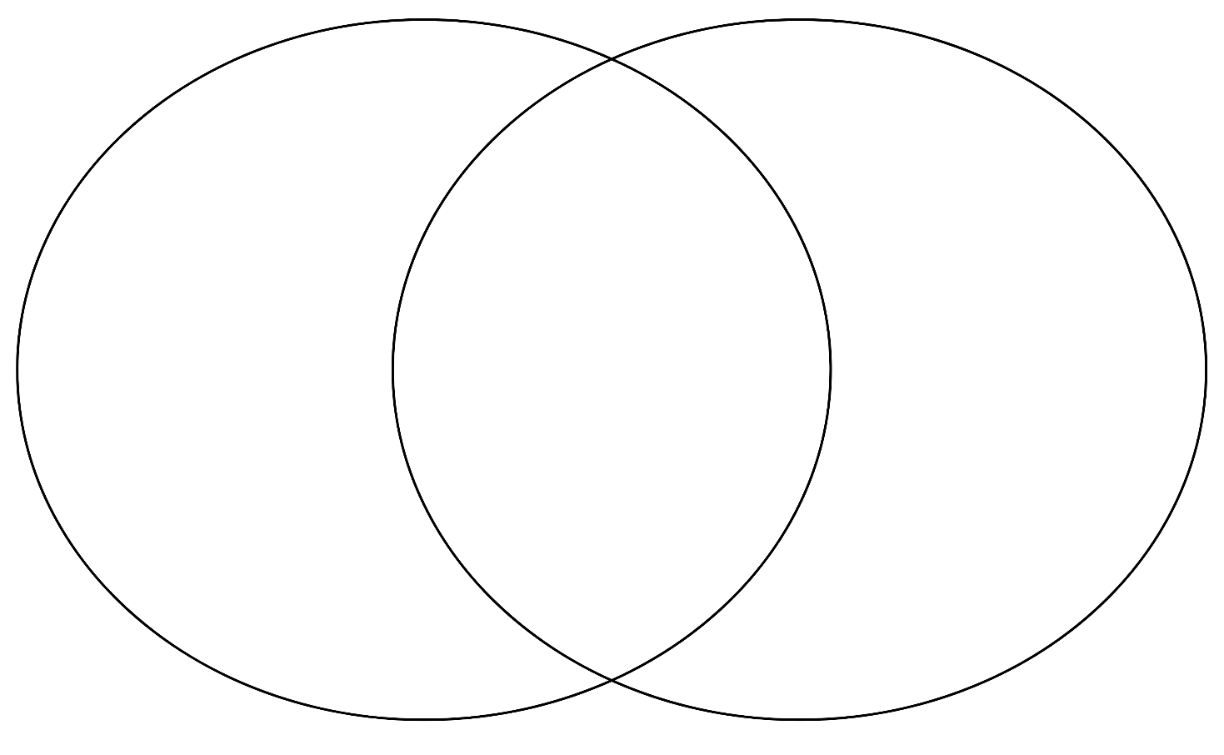

Part 2
Directions:
Learn more about series and parallel circuits below and complete the activities along with each picture.
In a series circuit, electric current has only one path to follow. All parts are connected one after another. Electric current flows from the negative side of the battery around in a loop to the positive side. Draw arrows to show the path of electric current in this series circuit.
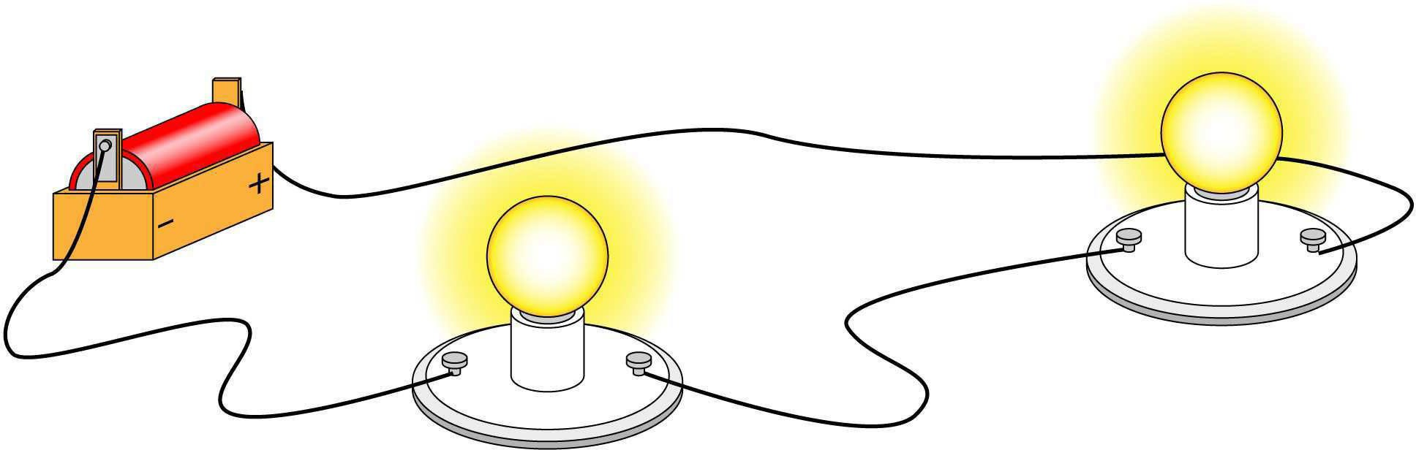

In a parallel circuit, electric current has more than one path to follow. The electric current can follow different paths as it flows from the negative side of the battery to the positive side. Draw arrows to show the different paths electric current can travel in this parallel circuit.
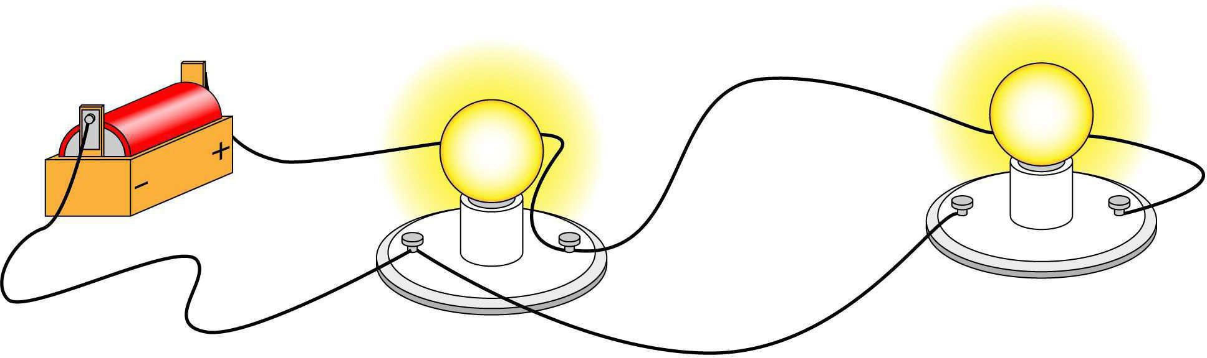

Indicate whether the light bulb or bulbs will light or will not light based on the circuit.
1. 2.


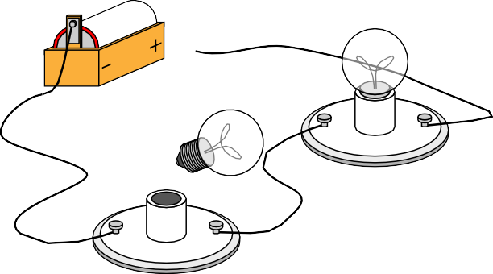

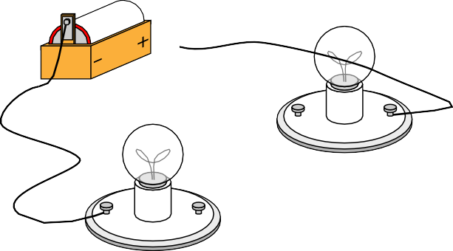



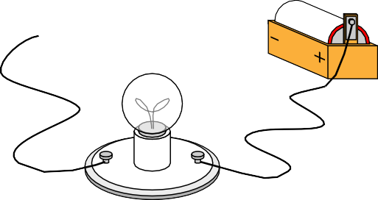

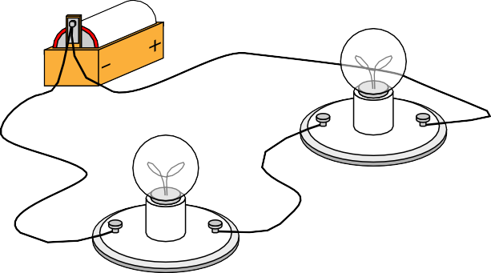

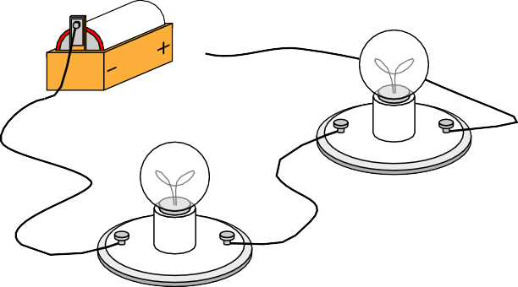

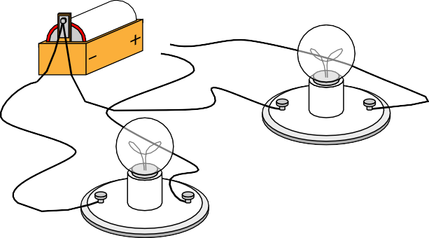

3. 4.

5. 6.


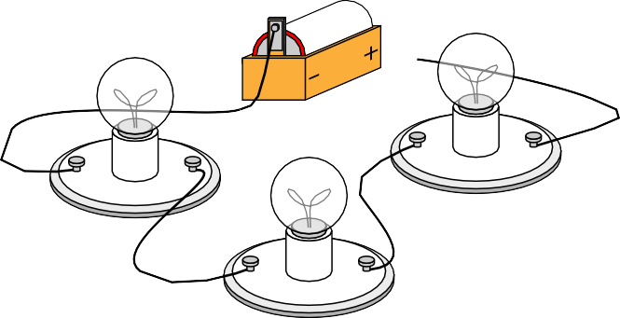

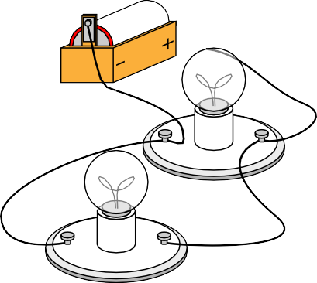
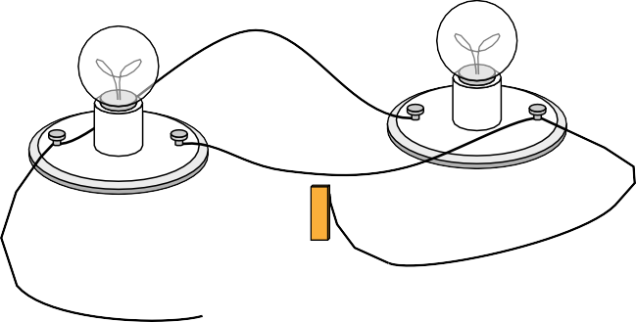

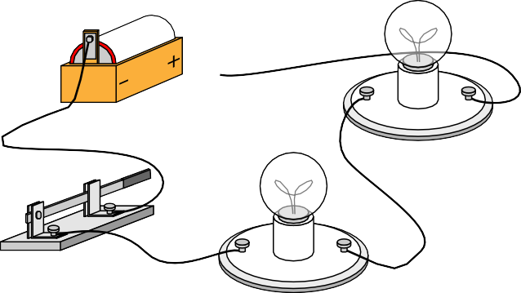



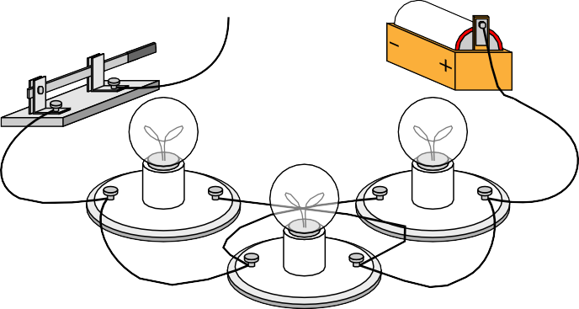





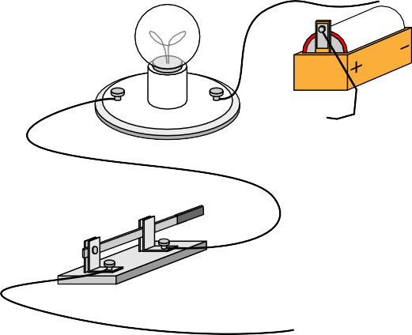
Indicate whether each picture shows a series circuit or parallel circuit by labeling the circuit below each picture and writing an explanation of how you know.

Type: _______________________________________________ Type: _________________________________________________

Type: _______________________________________________ Type: _________________________________________________

Type: _______________________________________________ Type: _________________________________________________
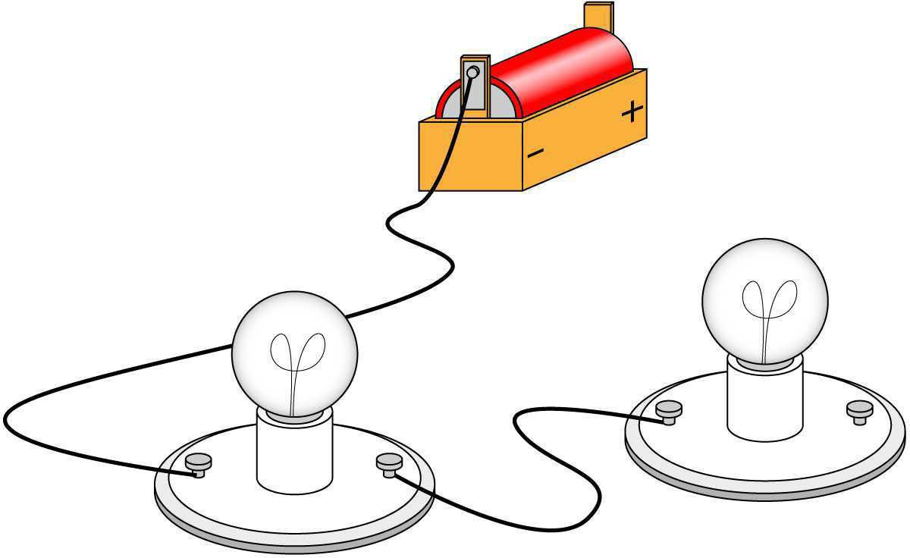
- Explain why the light bulbs won’t light in the circuit pictured on the right.

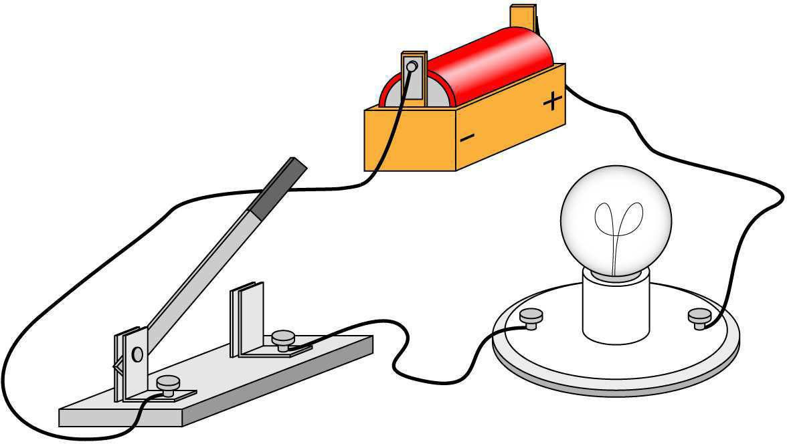
- Explain why the light bulb won’t light in the circuit pictured on the right

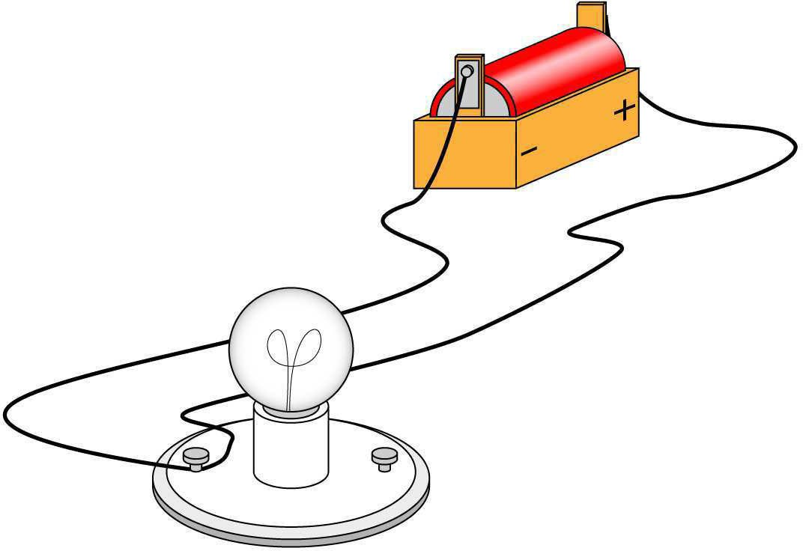
- Explain why the light bulb won’t light in the circuit pictured on the right.

Part 3
Directions:
Read each scenario or feature below. Decide whether it describes a series or parallel circuit. Then, write a brief explanation to justify your answer. Finally, answer the reflection questions.

Scenario or Feature | Series or Parallel? | Why?
1. Holiday lights that go out when one bulb breaks
2. A home’s electrical wiring system
3. A circuit with one continuous path for current and three bulbs
4. Each light in the circuit has its own switch.
5. If one bulb is removed, the others stay lit.
6. A single break causes the entire circuit to stop working.
7. Used to alert you if a component fails
8. Lights stay the same brightness when more are added.
9. Used in most household applications
10. Requires less wiring but is more likely to fail if one part breaks

Reflection Questions:

- In your own words, explain the biggest difference between a series and a parallel circuit.

- Which circuit type would you rather use in your bedroom and why?

KEY: Circuit Showdown
Aligned to the following standards:
PST.04; PL-A.; PG-J.; CCSS.RI.9-10.1; CCSS.SL.9-10.1; CCSS.SL.9-10.4; CCSS.RST.9-10.2; CCSS.RST.9-10.4; CCSS.RST.9-10.9; CRP.02; CRP.04; CRP.07; CRP.08

Part 1
Directions:
Read about series and parallel circuits, then fill in the Venn diagram comparing and contrasting the two.

Series and Parallel Circuits
- There are two types of circuits we can make, called series and parallel. The components in a circuit are joined by wires. If there are no branches, then it is a series circuit. If there are branches, it’s a parallel circuit
Series Circuits
- In a television series, you get several episodes, one after the other. A series circuit is similar. You get several components one after the other. If you follow the circuit diagram from one side of the cell to the other, you should pass through all the different components, one after the other, without any branches.
- If you put more lamps into a series circuit, the lamps will be dimmer than before.
- In a series circuit, if a lamp breaks or a component is disconnected, the circuit is broken and all the components stop working.
- Series circuits are useful if you want a warning that one of the components in the circuit has failed. They also use less wiring than parallel circuits.
Parallel Circuits
- In parallel circuits, different components are connected on different branches of the wire. If you follow the circuit diagram from one side of the cell to the other, you can only pass through all the different components if you follow all the branches.
- In a parallel circuit, if a lamp breaks or a component is disconnected from one parallel wire, the components on different branches keep working.
- Unlike a series circuit, the lamps stay bright if you add more lamps in parallel.
- Parallel circuits are useful if you want everything to work, even if one component has failed. This is why our homes are wired up with parallel circuits.

Series Circuits:
One path for current
All components connected one after another
If one part fails, the entire circuit stops working.
Lamps get dimmer as more are added.
Less wiring

Parallel Circuits:
Multiple paths for current
Components connected across branches
If one part fails, others keep working.
Brightness of lamps stays the same
More wiring needed

Use wires to connect components.
Carry electric current.
Require a power source.
Can include switches, bulbs and resistors.

Part 2
Directions:
Learn more about series and parallel circuits below and complete the activities along with each picture.
In a series circuit, electric current has only one path to follow. All parts are connected one after another. Electric current flows from the negative side of the battery around in a loop to the positive side. Draw arrows to show the path of electric current in this series circuit.

In a parallel circuit, electric current has more than one path to follow. The electric current can follow different paths as it flows from the negative side of the battery to the positive side. Draw arrows to show the different paths electric current can travel in this parallel circuit.

Tell whether the light bulb or bulbs will light or will not light based on the circuit.
1. 2.

Will not light Will not light

3. 4.

Will light Will not light

5. 6.

Will light Will not light

Tell whether each picture shows a series circuit or parallel circuit by labeling the circuit below each picture and writing an explanation of how you know.

Type: _Series____________________________________________ Type: _Parallel________________________________________

Type: _Series___________________________________________ Type: __Parallel_______________________________________

Type: ___Series__________________________________________ Type: ______Parallel___________________________________
- Explain why the light bulbs won’t light in the circuit pictured on the right.

The circuit won’t work because one component is disconnected,
breaking the loop.

- Explain why the light bulb won’t light in the circuit pictured on the right

A break in a series circuit means the whole current is stopped.

- Explain why the light bulb won't light in the circuit pictured on the right.

In a parallel circuit, even if one path breaks, others can carry the current.

Part 3
Directions:
Read each scenario or feature below. Decide whether it describes a series or parallel circuit. Then, write a brief explanation to justify your answer. Finally, answer the reflection questions.

Scenario or Feature | Series or Parallel? | Why?
1. Holiday lights that go out when one bulb breaks | Series | One break stops the flow of current.
2. A home’s electrical wiring system | Parallel | Each device operates independently.
3. A circuit with one continuous path for current and three bulbs | Series | One single loop, no branches
4. Each light in the circuit has its own switch. | Parallel | Each component can operate on its own.
5. If one bulb is removed, the others stay lit. | Parallel | Multiple paths allow current to continue.
6. A single break causes the entire circuit to stop working. | Series | Break in loop stops all current.
7. Used to alert you if a component fails | Series | All components fail if one does.
8. Lights stay the same brightness when more are added. | Parallel | Each gets full current
9. Used in most household applications | Parallel | More practical for independent use
10. Requires less wiring but is more likely to fail if one part breaks | Series | Simpler but less reliable

Reflection Questions:

- In your own words, explain the biggest difference between a series and a parallel circuit.
Answers will vary.
- Which circuit type would you rather use in your bedroom and why?

Answers will vary.

