Introduction to Soil Health
Created: 07/2025 by the National FFA Organization
Description of Lesson: This lesson introduces students to the concept of soil health and its importance in agriculture and ecosystems. Students will explore the physical, chemical and biological components of soil and analyze real soil samples to observe variations in texture, composition and organic matter. Through hands-on activities and discussions, they will develop an understanding of what makes soil healthy and why maintaining soil quality is essential for food production and environmental sustainability.
Thank you to our current partners in sustainability:






Student Learning Objectives:
After completing these activities, students will …
- Define soil biodiversity and explain its importance to overall soil health.
- Identify major types of soil organisms and their roles in soil ecosystems.
- Investigate soil life through direct observation and classroom activities.
- Analyze how human practices influence soil biodiversity.
Suggested Grade Level:
Grades 9 and 10 (This lesson is written so instructors can scale up or down based on class needs.)

Suggested Time: 90-100 minutes (*Time requirements may vary based upon student understanding and class schedule.)
Resources/References:
- Website: USDA NRCS, Soil Page, https://www.nrcs.usda.gov/conservation-basics/natural-resource-concerns/soil
- Website: Britannica, Soil Organisms, https://www.britannica.com/science/soil-organism
- Website: USDA ARS, Soil and Organisms, https://www.ars.usda.gov/plains-area/sidney-mt/northern-plains-agricultural-research-laboratory/nparl-docs/just-for-kids/soils-organisms/
- Document: USDA NRCS, Soil Biology Classroom Activities, https://www.nrcs.usda.gov/sites/default/files/2022-10/Three_Soil_Biology_Classroom_Activities.pdf
Related Resources:
- AgExplorer Sustainability Systems Focus Area, AgExplorer.FFA.org/focus/sustainability-systems/
- Introduction to Sustainability Lesson Series, https://FFA.box.com/v/introtosustainability
- Darling Ingredients Educational Resources, https://FFA.box.com/s/3ko8e9w6zygohv1ewfsnc8byobjzeuxa
- Valent — Sustainability in Agriculture Lesson Series, https://FFA.box.com/v/sustainabilityinagriculture

Equipment and Supplies Needed:
- A copy of the “Who’s in My Soil” student activity sheet for each student
- A copy of the “Signs of Life” student activity sheet for each student
- A copy of the “Soil City Detective” student activity sheet for each student
- A copy of the “Appendix 1: Soil Organisms” cards cut apart (One class set)
- Two soil samples (healthy and unhealthy)
- Microscopes, hand lenses or magnifying glasses (One per student if possible or share amongst class)
- Microscope slides
- Plastic containers for soil
- Student devices with internet access

Vocabulary:
- Actinomycetes
- Bacteria
- Earthworms
- Mites
- Mycorrhizal Fungi
- Nematodes
- Organism
- Protozoa
- Soil Health
- Springtails
Cross-Curricular Connections:
Science | English/Language Arts
Conduct a lab to evaluate and compare two soil samples. | Write a creative story about soil organisms missing from a soil ecosystem.

SAE and FFA Connections:
- Agronomy CDE, FFA.org/participate/cdes/agronomy/
- Environmental and Natural Resources CDE, FFA.org/participate/cdes/environmental-and-natural-resources/
- Proficiency Areas: Environmental Science and Natural Resources Management, FFA.org/participate/awards/proficiencies/
- Foundational SAE Connections: Agricultural Literacy

Student Activity Sheets:
Direct access to student activity sheets without lesson plan or answer key for easy upload to a learning management system or printing for classwork.

https://ffa.box.com/s/m1v3alsowpz4afuf0hntyx8us00fxfft (Word)
https://ffa.box.com/s/oeqd35hai87t2kbyi9uaqnznmfu1vn4f (PDF)
https://docs.google.com/document/d/14OdX96bBrdQ-fVuTA96bu6kf4sOQ8RlQ0l6-0bHKCH8/copy (Google)

These Activities Are Aligned to the Following Standards:
AFNR Performance Element
- CS.03. Examine and summarize the importance of health, safety and environmental management systems in AFNR workplaces.
- CS.04. Demonstrate stewardship of natural resources in AFNR activities.
- CS.06. Analyze the interaction among AFNR systems in the production, processing and management of food, fiber and fuel and the sustainable use of natural resources.
- NRS.02. Analyze the interrelationships between natural resources and humans.
- NRS.04. Demonstrate responsible management procedures and techniques to protect, maintain, enhance, and improve natural resources.
FFA Precept
- FFA.PL-A.Action: Assume responsibility and take the necessary steps to achieve the desired results, no matter what the goal or task at hand.
- FFA.CS-N.Decision Making: Analyze a situation and execute an appropriate course of action.
Common Career Technical Core
- AG3 Examine and summarize the importance of health, safety, and environmental management systems in AFNR businesses.
- AG4 Demonstrate stewardship of natural resources in AFNR activities.
- AG6 Analyze the interaction among AFNR systems in the production, processing, and management of food, fiber, and fuel and the sustainable use of natural resources.
- AG-NR2 Analyze the interrelationships between natural resources and humans.
- AG-NR4 Demonstrate responsible management procedures and techniques to protect or maintain natural resources.
Common Core – Reading: Informational Text
- CCSS.ELA-Literacy.RI.9-10.2 Determine a central idea of a text and analyze its development over the course of the text, including how it emerges and is shaped and refined by specific details; provide an objective summary of the text.
Common Core – Writing
- CCSS.ELA-LITERACY.W.9-10.2 Write informative/explanatory texts to examine and convey complex ideas, concepts, and information clearly and accurately through the effective selection, organization, and analysis of content.
- CCSS.ELA-LITERACY.W.9-10.4 Produce clear and coherent writing in which the development, organization, and style are appropriate to task, purpose, and audience.
- CCSS.ELA-LITERACY.W.9-10.5 Develop and strengthen writing as needed by planning, revising, editing, rewriting, or trying a new approach, focusing on addressing what is most significant for a specific purpose and audience.
- CCSS.ELA-LITERACY.W.9-10.8 Gather relevant information from multiple authoritative print and digital sources, using advanced searches effectively; assess the usefulness of each source in answering the research question; integrate information into the text selectively to maintain the flow of ideas, avoiding plagiarism and following a standard format for citation.
Common Core – Science & Technical Subjects
- CCSS.ELA-Literacy.RST.9.10.3 Follow precisely a complex multistep procedure when carrying out experiments, taking measurements, or performing technical tasks, attending to special cases or exceptions defined in the text.
Next Generation Science
- HS-ESS3-1 Construct an explanation based on evidence for how the availability of natural resources, occurrence of natural hazards, and changes in climate have influenced human activity.
Green/Sustainability Knowledge and Skill Statements
- AFNR Career Cluster, Statement 1 - Apply understanding of ecosystems and systems thinking to the management of natural resources to maximize the health and productivity of the environment, agriculture, communities, and society.
- AFNR Career Cluster, Statement 3 - Communicate the impact of green and sustainability principles on agriculture, food and natural resource systems.
- AFNR Career Cluster, Statement 7 - Demonstrate an understanding of green and sustainability trends that are impacting processes and markets in AFNR.
AFNR Career Ready Practices
- CRP.02. Apply appropriate academic and technical skills. Career-ready individuals readily access and use the knowledge and skills acquired through experience and education to be more productive.
- CRP.04. Communicate clearly, effectively, and with reason. Career-ready individuals communicate thoughts, ideas and action plans with clarity, whether using written, verbal and/or visual methods.
- CRP.05. Consider the environmental, social and economic impact of decisions. Career-ready individuals understand the interrelated nature of their actions and regularly make decisions that positively impact and/or mitigate negative impact on other people, organizations and the environment.
Partnership for 21st Century Skills
- Environmental Literacy
- Global Awareness
- Information, Communications, and Technology Literacy
- Think Creatively

Lesson Plan:
- Bell Ringer: Is soil alive? What might you find if you zoomed in on a handful of healthy soil?

- Introduction: (10-15 minutes) Post the sheets from “Appendix 1: Soil Organisms” around the room and have students visit them. Provide students with copies of the student activity sheet “Who’s in My Soil?” for them to record information on as they visit each sheet.

- Activity 1: (25 Minutes) Each student needs a copy of the worksheet “Signs of Life.” For this activity, students will need two soil samples, one healthy and teeming with life and the other from a compacted or unhealthy area (do not let them know which is which; simply call them “Sample A” and “Sample B”). Students will use microscopes, hand lenses or magnifying glasses to observe the soil for any signs of life. On their student activity sheets, they will record and draw any organisms or signs of life that they can see and try to identify them as best they can. Students will also compare the two samples against each other and make observations about which one is healthier and contains more biodiversity than the other. They will then answer the analysis questions on their student activity sheets.
- Activity 2: (45-60 minutes) Each student needs a copy of the worksheet “Soil City Detective.” For this activity, students will be writing a short story about “Soil City,” a civilization that is thriving and working together in harmony until one day one of the organisms goes missing. Each student will randomly draw one of the organisms from the “Who’s in My Soil” activity to be their missing organism. They will then write their story about a “missing organisms’ detective” trying to find out what happened to this organism and how to recover it. Students can and should be creative with these stories. They may choose to include interviews with the other organisms, pieces of evidence found or anything else they might find in a good crime drama story. Students should also include a narrative about how other organisms are affected by this one’s disappearance. While it is a fun and fictional story, they should base it on fact, so they may need to do additional research on how soil organisms live and work together, what might lead to a decline in their particular organism and what might restore their organism. A rubric is provided for grading.

- Follow-up: (5-10 minutes) Have a few student volunteers share their stories (or summaries of their stories) with the class. Discuss how different organisms thrive in different conditions and how they all interact with each other.
- Optional – Extended Learning Opportunities (Not factored into time requirement):
  - If you would like to extend your students’ learning about soil biology and biodiversity, you may check out these activities from the USDA NRCS: https://www.nrcs.usda.gov/sites/default/files/2022-10/Three_Soil_Biology_Classroom_Activities.pdf.

- Exit Ticket: Name two types of soil organisms and describe how each contributes to soil health.

Who’s in My Soil?
Aligned to the following standards:
CS.03; CS.04; CS.06; NRS.02; NRS.04; FFA.PL-A; FFA.CS-M; FFA.CS-N; AG3; AG4; AG6; AG-NR2; AG-NR4; CCSS.ELA-RI.9-10.2; CCSS.ELA-W.9-10.2; CCSS.ELA-W.9-10.4; CCSS.ELA-W.9-10.5; CCSS.ELA-W.9-10.8; CCSS.ELA.RST.9-10.3; HS-ESS3-1; CRP.02; CRP.04; CRP.05

Directions:
Record information on each of the soil organisms as you visit their information sheets around the room.

Earthworms | Mycorrhizal Fungi
Springtails | Nematodes
Actinomycetes | Mites
Protozoa | Ants
Grubs (Larval Beetles) | Bacteria

What organism did you find most interesting? Why?

What organism surprised you most with its role in soil health? Why?
What do you think would happen if one of these organisms was not present in the soil?
Signs of Life
Aligned to the following standards:
CS.03; CS.04; CS.06; NRS.02; NRS.04; FFA.PL-A; FFA.CS-M; FFA.CS-N; AG3; AG4; AG6; AG-NR2; AG-NR4; CCSS.ELA-RI.9-10.2; CCSS.ELA-W.9-10.2; CCSS.ELA-W.9-10.4; CCSS.ELA-W.9-10.5; CCSS.ELA-W.9-10.8; CCSS.ELA.RST.9-10.3; HS-ESS3-1; CRP.02; CRP.04; CRP.05

Directions:
Record your observations as you examine each of the soil samples.
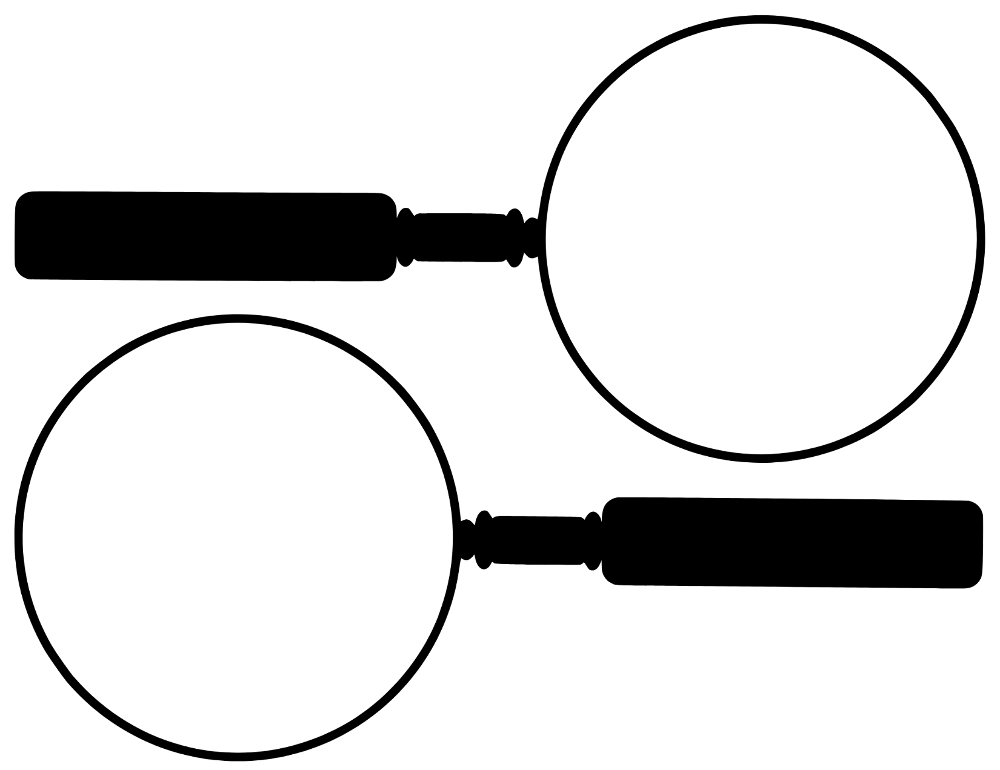
- In the magnifying glasses below, draw the organism you observed in each sample.
Soil Sample A
Soil Sample B

- What other observations did you make about each soil sample? (texture, color, etc.)
Soil Sample A | Soil Sample B
Analysis Questions:
- Which organism was the easiest to find or identify? Why do you think that is?
- Were you surprised by the variety or number of organisms you found? Why or why not?
- Why is soil biodiversity important for plant growth and agriculture?
- What kinds of human actions might harm the organisms you found today?
- How might the presence or absence of certain organisms be a clue to overall soil health?
- What additional questions do you have about soil organisms or soil ecosystems after this activity?
Soil City Detective
Aligned to the following standards:
CS.03; CS.04; CS.06; NRS.02; NRS.04; FFA.PL-A; FFA.CS-M; FFA.CS-N; AG3; AG4; AG6; AG-NR2; AG-NR4; CCSS.ELA-RI.9-10.2; CCSS.ELA-W.9-10.2; CCSS.ELA-W.9-10.4; CCSS.ELA-W.9-10.5; CCSS.ELA-W.9-10.8; CCSS.ELA.RST.9-10.3; HS-ESS3-1; CRP.02; CRP.04; CRP.05

Directions:
Soil City is a thriving community with many organisms working together in harmony. Suddenly, however, one of its valuable residents has gone missing. Randomly draw one of the organisms from the “Who’s in My Soil” activity and write a short story about a “missing organisms’ detective” trying to find out what happened to this organism and how to recover it. Be creative with your story! You may choose to include interviews with the other organisms, pieces of evidence found or anything else that might be found in a good crime drama story. You should also be sure to include a narrative about how other organisms are affected by this one’s disappearance.
While this is a fun and fictional story, you must also base it on fact, so you may need to do additional research on how soil organisms live and work together, what might lead to a decline in your selected organism and what might restore that organism.
Use the space below for brainstorming characters, plot lines, etc.

Use these pages to write your story (or use a word processing software if preferred and available). Use additional pages as necessary.
________________________________________________________________________________________________________________________________________________________________________________________________________________________________________________________________________________________________________________________________________________________________________________________________________________________________________________________________________________________________________________________________________________________________________________________________________________________________________________________________________________________________________________________________________________________________________________________________________________________________________________________________________________________________________________________________________________________________________________________________________________________________________________________________________________________________________________________________________________________________________________________________________________________________________________________________________________________________________________________________________________________________________________________________________________________________________________________________________________________________________________________________________________________________________________________________________________________________________________________________________________________________________________________________________________________________________________________________________________________________________________________________________________________________________________________________________________________________________________________________________________________________________________________________________________________________________________________________________________________________________________________________________________________________________________________________________________________________________________________________________________________________________________________________________________________________________________________________________________________________________________________________________________________________________________________________________________________________________________________________________________________________________________________________________________________________________________________________________________________________________________________________________________________________________________________________________________________________________________________________________________________________________________________________________________________________________________________________________________________________________________________________________________________________________________________________________________________________________________________________________________________________________________________________________________________________________________________________________________________________________________________________________________________________________________________________________________________________________________________________________________________________________________________________________________________________________________________________________________________________________________________________________________________________________________________________________________________________________________________________________________________________________________________________________________________________________________________________________________________________________________________________________________________________________________________________________________________________________________________________________________________________________________________________________________________________________________________________________________________________________________________________________________________________________________________________________________________________________________________________________________________________________________________________________________________________________________________________________________________________________________________________________________________________________________________________________________________________________________________________________________________________________________________________________________________________________________________________________________________________________________________________________________________________________________________________________________________________________________________________________________________________________________________________________________________________________________________________________________________________________________________________________________________________________________________________________________________________________________________________________________________________________________________________________________________________________________________________________________________________________________________________________________________________________________________________________________________________________________________________________________________________________________________________________________________________________________________________________________________________________________________________________________________________________________________________________________________________________________________________________________________________________________________________________________________________________________________________________________________________________________________________________________________________________________________________________________________________________________________________________________________________________________________________________________________________________________________________________________________________________________________________________________________________________________________________________________________________________________________________________________________________________________________________________________________________________________________________________________________________________________________________________________________________________________________________________________________________________________________________________________________________________________________________________________________________________________________________________________________________________________________________________________________________________________________________________________________________________________________________________________________________________________________________________________________________________________________________________________________________________________________________________________________________________________________________________________________________________________________________________________________________________________________________________________________________________________________________________________________________________________________________________________________________________________________________________________________________________________________________________________________________________________________________________________________________________________________________________________________________________________________________________________________________________________________________________________________________________________________________________________________________________________________________________________________________________________________________________________________________________________________________________________________________________________________________________________________________________________________________________________________________________________________________________________________________________________________________________________________________________________________________________________________________________________________________________________________________________________________________________________________________________________________________________________________________________________________________________________________________________________________________________________________________________________________________________________________________________________________________________________________________________________________________________________________________________________________________________________________________________________________________________________________________________________________________________________________________________________________________________________________________________________________________________________________________________________________________________________________________________________________________________________________________________________________________________________________________________________________________________________________________________________________________________________________________________________________________________________________________________________________________________________________________________________________________________________________________________________________________________________________________________________________________________________________________________________________________________________________________________________________________________________________________________________________________________________________________________________________________
What was the most challenging part of writing your story? Explain in one or two sentences.
Soil City Detective Story Rubric
Category | Excellent  (4 pts) | Good  (3 pts) | Developing  (2 pts) | Needs Improvement  (1 pt)
Accuracy | Includes accurate, detailed information about the selected soil organism’s role, needs, decline factors and recovery All facts are clearly supported. | Information mostly accurate and relevant; minor factual errors or gaps in detail | Some factual inaccuracies or misunderstandings of organism roles or conditions | Little to no factual accuracy; content is vague or incorrect.
Creative Storytelling | Story is highly engaging, original, and creatively presents the mystery. Characters, setting and dialogue are imaginative and well-developed. | Story is engaging and shows creativity. Some characters or story elements could be more developed. | Story has basic structure but lacks creative elements or detail. | Minimal effort in storytelling. Lacks clarity, organization or creativity
Connection to Soil Ecosystem | Clearly explains how the organism’s disappearance affects the broader soil ecosystem; other organisms' reactions are meaningful and based on ecological facts. | Some explanation of ecosystem impact is present; other organisms are mentioned with partial relevance. | Limited or unclear connection to other organisms or the soil system | No meaningful connection to ecosystem dynamics
Use of Evidence | Includes at least two realistic pieces of “evidence” (e.g., signs of habitat loss, soil conditions) that tie into the mystery | Includes at least one relevant piece of “evidence”  Some connections to the mystery may be weak. | Includes vague or generic “evidence” Connections to story logic or science are unclear. | No use of evidence, or evidence is irrelevant and unconnected to science.
Organization and Writing | Writing is clear, well-organized and free of errors. Follows a logical structure with a strong beginning, middle and end | Mostly organized; few errors  Logical structure is mostly followed. | Some confusion in organization or multiple errors in grammar/spelling | Writing lacks structure or is difficult to follow due to many errors.
Effort and Completion | All parts of the story are completed with care and attention to detail. | Most components are complete. | Some components are incomplete or rushed. | Incomplete or very minimal effort
Total Score |  |  |  | /24
Notes:
________________________________________________________________________________________________________________________________________________________________________________________________________________________________________________________________________________________________________________________________________________________________________________________________________________________________________________________________________________________________
KEY: Who’s in My Soil?
Aligned to the following standards:
CS.03; CS.04; CS.06; NRS.02; NRS.04; FFA.PL-A; FFA.CS-M; FFA.CS-N; AG3; AG4; AG6; AG-NR2; AG-NR4; CCSS.ELA-RI.9-10.2; CCSS.ELA-W.9-10.2; CCSS.ELA-W.9-10.4; CCSS.ELA-W.9-10.5; CCSS.ELA-W.9-10.8; CCSS.ELA.RST.9-10.3; HS-ESS3-1; CRP.02; CRP.04; CRP.05

Directions:
Record information on each of the soil organisms as you visit their information sheets around the room.

Earthworms | Mycorrhizal Fungi
Role in Soil Health:  Break down organic matter, improve soil structure and porosity and enhance nutrient cycling through their castings  Thrive In:  - Moist, aerated soils rich in organic matter  - Neutral pH (6-8)  - Undisturbed environments (no-till or reduced-till systems)  Decline In:  - Frequent or deep tillage  - Soil compaction  - Drought or poor drainage  - Heavy pesticide use | Role in Soil Health:  Form symbiotic relationships with plant roots to increase water and nutrient uptake (especially phosphorus); help build soil aggregates  Thrive In:  - Soils with living plants and root exudates  - Low phosphorus inputs  - Stable, undisturbed environments  Decline In:  - Overuse of synthetic fertilizers  - Tillage (disrupts fungal networks)  - Monocultures  - Bare soils with no root hosts
Springtails | Nematodes
Role in Soil Health:  Feed on fungi, decaying organic matter and bacteria, helping with decomposition and nutrient cycling  Thrive In:  - Moist, organically rich soils  - Mulched or forested areas  - Leaf litter and compost piles  Decline In:  - Dry or compacted soils  - Chemical pesticide exposure  - Tillage or loss of organic matter | Role in Soil Health:  Some species help decompose organic matter or prey on pests; others feed on plant roots (not all are beneficial).  Thrive In:  - Diverse microbial populations  - Moist soil with moderate temperatures  - Adequate organic matter  Decline In:  - Soil fumigation or chemical treatments  - Excessive drought or flooding  - Lack of microbial life or plant diversity
Actinomycetes | Mites
Role in Soil Health:  A type of bacteria that helps decompose tough materials like cellulose and lignin; contributes to the earthy smell of healthy soil.  Thrive In:  - Warm, aerated soils with moderate moisture  - High organic matter  - Near-neutral pH  Decline In:  - Poor drainage or saturated soils  - Soil compaction  - Acidic pH  - Lack of plant residues | Role in Soil Health:  Include decomposers, predators of pests and contributors to microbial activity; play multiple roles depending on the type  Thrive In:  - Mulched or forested soils  - Moisture-stable environments  - Organic residues or compost  Decline In:  - Disturbed soils (tillage or compaction)  - Dry, bare or nutrient-poor soil  - Chemical exposure
Protozoa | Ants
Role in Soil Health:  Feed on bacteria, regulating microbial populations and releasing nutrients for plants (especially nitrogen).  Thrive In:  - Moist, well-aerated soils  - Abundant bacterial populations  - Stable temperatures  Decline In:  - Drought or waterlogged soils  - Low microbial activity  - Pesticide exposure | Role in Soil Health:  Aerate soil through tunneling, assist in decomposition and redistribute nutrients and seeds  Thrive In:  - Loamy or sandy soils  - Warm climates  - Undisturbed environments  Decline In:  - Flooded or compacted soils  - High pesticide use  - Loss of ground cover or food sources
Grubs (Larval Beetles) | Bacteria
Role in Soil Health:  Decompose organic material and break down plant matter; some are pests of roots.  Thrive In:  - Moist soils with decaying roots or mulch  - Presence of vegetation (especially turf and pasture)  - Moderate temperatures  Decline In:  - Tillage and soil disruption  - Cold or dry conditions  - Predator populations (e.g., birds, beneficial nematodes) | Role in Soil Health:  Decompose organic matter, fix nitrogen, suppress diseases and support plant health in countless ways  Thrive In:  - High organic matter  - Moist, oxygenated soils  - pH near neutral (6.5-7.5)  Decline In:  - Acidic, compacted or extremely dry soils  - Pesticide exposure  - Lack of food sources like root exudates

What organism did you find most interesting? Why?

Answers will vary.

What organism surprised you most with its role in soil health? Why?
Answers will vary.
What do you think would happen if one of these organisms was not present in the soil?
Answers will vary.

KEY: Signs of Life
Aligned to the following standards:
CS.03; CS.04; CS.06; NRS.02; NRS.04; FFA.PL-A; FFA.CS-M; FFA.CS-N; AG3; AG4; AG6; AG-NR2; AG-NR4; CCSS.ELA-RI.9-10.2; CCSS.ELA-W.9-10.2; CCSS.ELA-W.9-10.4; CCSS.ELA-W.9-10.5; CCSS.ELA-W.9-10.8; CCSS.ELA.RST.9-10.3; HS-ESS3-1; CRP.02; CRP.04; CRP.05

Directions:
Record your observations as you examine each of the soil samples.
- In the magnifying glasses below, draw the organism you observed in each sample.
Soil Sample A
Soil Sample B

- What other observations did you make about each soil sample? (texture, color, etc.)
Soil Sample A | Soil Sample B
Answers will vary. | Answers will vary.
Analysis Questions:
- Which organism was the easiest to find or identify? Why do you think that is?
Answers will vary.
- Were you surprised by the variety or number of organisms you found? Why or why not?
Answers will vary.
- Why is soil biodiversity important for plant growth and agriculture?
Answers will vary.
- What kinds of human actions might harm the organisms you found today?
Answers will vary.
- How might the presence or absence of certain organisms be a clue to overall soil health?
Answers will vary.
- What additional questions do you have about soil organisms or soil ecosystems after this activity?
Answers will vary.

Appendix 1: Soil Organisms
1. Earthworms  Role in Soil Health:  Break down organic matter, improve soil structure and porosity and enhance nutrient cycling through their castings  Thrive In:  - Moist, aerated soils rich in organic matter  - Neutral pH (6-8)  - Undisturbed environments (no-till or reduced-till systems)  Decline In:  - Frequent or deep tillage  - Soil compaction  - Drought or poor drainage  - Heavy pesticide use | 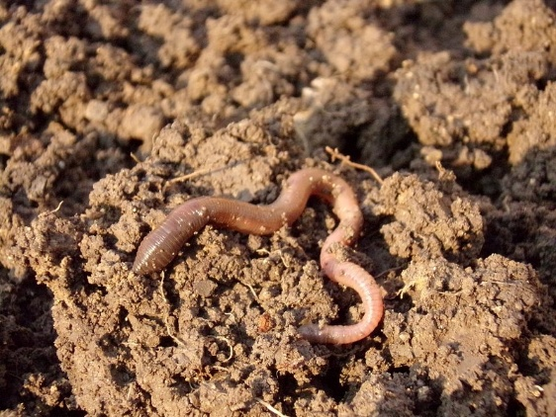
2. Mycorrhizal Fungi  Role in Soil Health:  Form symbiotic relationships with plant roots to increase water and nutrient uptake (especially phosphorus); help build soil aggregates  Thrive In:  - Soils with living plants and root exudates  - Low phosphorus inputs  - Stable, undisturbed environments  Decline In:  - Overuse of synthetic fertilizers  - Tillage (disrupts fungal networks)  - Monocultures  - Bare soils with no root hosts | 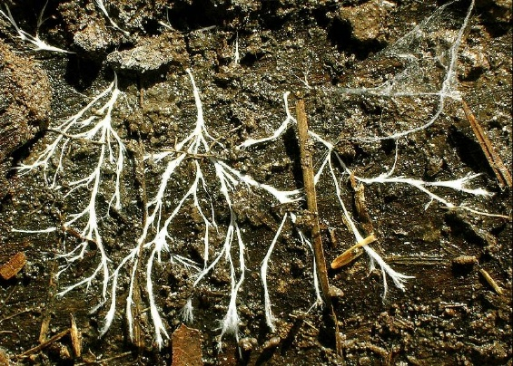

3. Springtails  Role in Soil Health:  Feed on fungi, decaying organic matter and bacteria, helping with decomposition and nutrient cycling  Thrive In:  - Moist, organically rich soils  - Mulched or forested areas  - Leaf litter and compost piles  Decline In:  - Dry or compacted soils  - Chemical pesticide exposure  - Tillage or loss of organic matter | 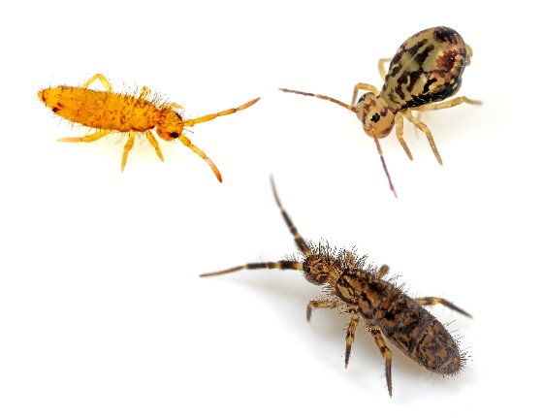
4. Nematodes  Role in Soil Health:  Some species help decompose organic matter or prey on pests; others feed on plant roots (not all are beneficial)  Thrive In:  - Diverse microbial populations  - Moist soil with moderate temperatures  - Adequate organic matter  Decline In:  - Soil fumigation or chemical treatments  - Excessive drought or flooding  - Lack of microbial life or plant diversity | 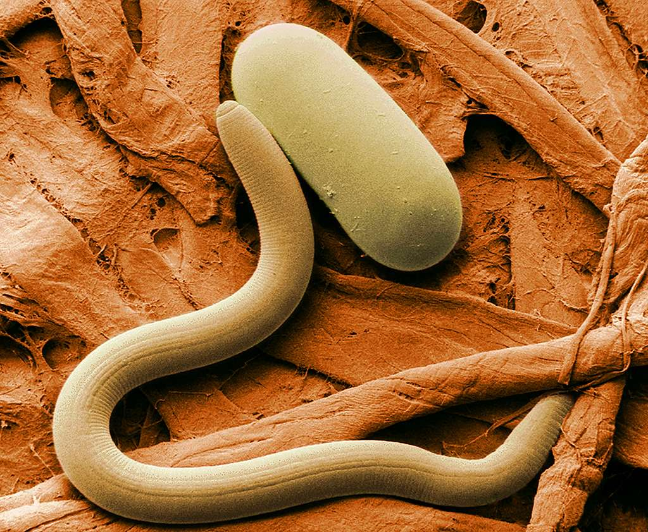

5. Actinomycetes  Role in Soil Health:  A type of bacteria that helps decompose tough materials like cellulose and lignin; contributes to the earthy smell of healthy soil  Thrive In:  - Warm, aerated soils with moderate moisture  - High organic matter  - Near-neutral pH  Decline In:  - Poor drainage or saturated soils  - Soil compaction  - Acidic pH  - Lack of plant residues | 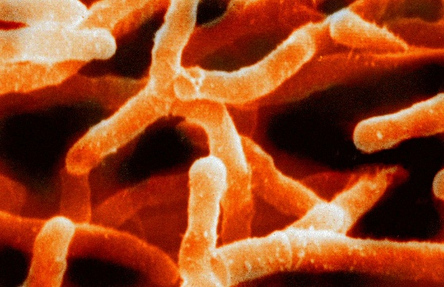
6. Mites  Role in Soil Health:  Include decomposers, predators of pests and contributors to microbial activity; play multiple roles depending on the type  Thrive In:  - Mulched or forested soils  - Moisture-stable environments  - Organic residues or compost  Decline In:  - Disturbed soils (tillage or compaction)  - Dry, bare or nutrient-poor soil  - Chemical exposure | 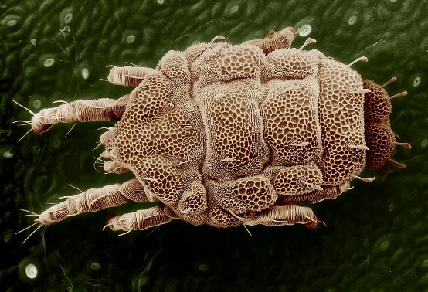

7. Protozoa  Role in Soil Health:  Feed on bacteria, regulating microbial populations and releasing nutrients for plants (especially nitrogen)  Thrive In:  - Moist, well-aerated soils  - Abundant bacterial populations  - Stable temperatures  Decline In:  - Drought or waterlogged soils  - Low microbial activity  - Pesticide exposure | 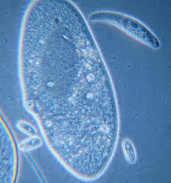
8. Ants  Role in Soil Health:  Aerate soil through tunneling, assist in decomposition and redistribute nutrients and seeds  Thrive In:  - Loamy or sandy soils  - Warm climates  - Undisturbed environments  Decline In:  - Flooded or compacted soils  - High pesticide use  - Loss of ground cover or food sources | 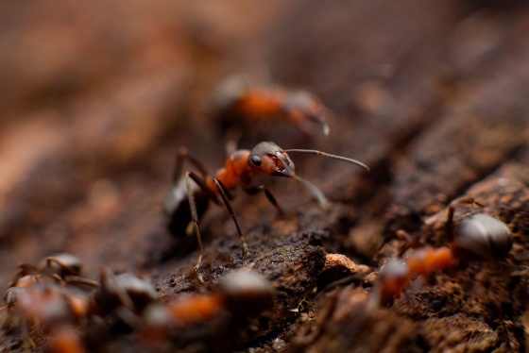

9. Grubs (Larval Beetles)  Role in Soil Health:  Decompose organic material and break down plant matter; some are pests of roots.  Thrive In:  - Moist soils with decaying roots or mulch  - Presence of vegetation (especially turf and pasture)  - Moderate temperatures  Decline In:  - Tillage and soil disruption  - Cold or dry conditions  - Predator populations (e.g., birds, beneficial nematodes) | 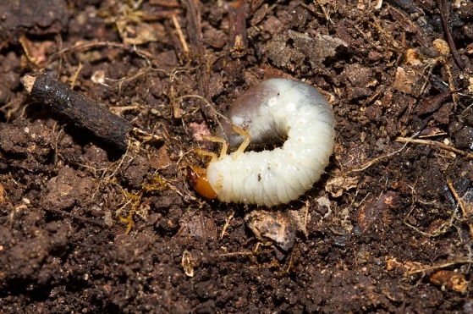
10. Bacteria  Role in Soil Health:  Decompose organic matter, fix nitrogen, suppress diseases and support plant health in countless ways  Thrive In:  - High organic matter  - Moist, oxygenated soils  - pH near neutral (6.5-7.5)  Decline In:  - Acidic, compacted or extremely dry soils  - Pesticide exposure  - Lack of food sources like root exudates | 