Sustainable Production
Created: 02/2020 by the National FFA Organization

Description: Valent USA is a leader in sustainable solutions for a changing world, and maintaining the ability to continue feeding the growing population requires sustainability. Through this lesson series, students will have the opportunity to learn about the importance of sustainability throughout the Agriculture, Food and Natural Resources Value Chain.
Student Learning Objectives:
After completing these activities, students will …
- Explain how a producer earns “sustainably grown” recognition for their food products.
- Compare and contrast sustainable and non-sustainable food production practices.
- Develop an agricultural issues forum presentation about sustainable agriculture.

Time Required: 200 minutes
Resources:
- National FFA Agricultural Issues Forum LDE Portfolio (Pages 2 and 3), https://FFA.app.box.com/s/v1hqdkm9ubaqfel5d9osgvq6hrl72oiw/file/411948144154
- National FFA Agricultural Issues Forum Resources, https://web.ics.purdue.edu/~peters/HTML/ag-issues-forum/ag-issues-forum.html
- Sustainably Grown Standard, https://www.scsglobalservices.com/stakeholder-review-of-scs-standards
- “Producing Enough Sustainable Food,” https://youtu.be/FxMHl5Gr2Yg

Equipment and Supplies Needed:
- A copy of the “Sustainably Grown Standard” worksheet for each student
- “Sustainably Grown Standard” PowerPoint
- A copy of the “Ingredient Sustainability” worksheet for each student
- A copy of the “Agricultural Issues Forum: Summary and Resources” worksheet for each student
- A copy of the “Agricultural Issues Forum: Sample Script” worksheet for each student
- Internet access to play the video in real time or embed it in a PowerPoint ahead of time

This quick lesson plan would work well as:
- A lesson in an agricultural production regulations unit.
- An introduction to the agricultural issues forum leadership development event (LDE).

These activities are aligned to the following standards:

AFNR Performance Element
- CS.01. Analyze how issues, trends, technologies and public policies impact systems in the Agriculture, Food & Natural Resources Career Cluster.
FFA Precept
- FFA.PL-A.Action: Assume responsibility and take the necessary steps to achieve the desired results, no matter what the goal or task at hand.
- FFA.PL-E.Awareness: Understand personal vision, mission and goals.
- FFA.PL-F.Continuous Improvement: Accept responsibility for learning and personal growth.
- FFA.PG-I.Professional Growth: Assume responsibility for attaining and improving upon the skills needed for career success.
- FFA.PG-J.Mental Growth: Embrace cognitive and intellectual development relative to reasoning, thinking and coping.
- FFA.CS-M.Communication: Effectively interact with others in personal and professional settings.
- FFA.CS-N.Decision Making: Analyze a situation and execute an appropriate course of action.
Common Career Technical Core
- AG1: Analyze how issues, trends, technologies and public policies impact systems in the Agriculture, Food & Natural Resources Career Cluster.
NASDCTEc
- AGC10.03: Compare and contrast issues affecting the AFNR industry including biotechnology, employment, safety, environmental and animal welfare to demonstrate an understanding of the trends and issues important to careers in this industry.
Common Core – Reading: Informational Text
- CCSS.ELA-Literacy.RI.9-10.1: Cite strong and thorough textual evidence to support analysis of what the text says explicitly as well as inferences drawn from the text.
- CCSS.ELA-Literacy.RI.9-10.2: Determine a central idea of a text and analyze its development over the course of the text, including how it emerges and is shaped and refined by specific details; provide an objective summary of the text.
- CCSS.ELA-Literacy.RI.9-10.8: Delineate and evaluate the argument and specific claims in a text, assessing whether the reasoning is valid and the evidence is relevant and sufficient; identify false statements and fallacious reasoning.
Common Core – Writing
- CCSS.ELA-Literacy.W.9-10.1: Write arguments to support claims in an analysis of substantive topics or texts, using valid reasoning and relevant and sufficient evidence.
- CCSS.ELA-Literacy.W.9-10.2: Write informative/explanatory texts to examine and convey complex ideas, concepts, and information clearly and accurately through the effective selection, organization, and analysis of content.
Common Core – Speaking and Listening
- CCSS.ELA-Literacy.SL.9-10.1: Initiate and participate effectively in a range of collaborative discussions (one-on-one, in groups, and teacher-led) with diverse partners on grades 9-10 topics, texts, and issues, building on others' ideas and expressing their own clearly and persuasively.
- CCSS.ELA-Literacy.SL.9-10.2: Integrate multiple sources of information presented in diverse media or formats (e.g., visually, quantitatively, orally) evaluating the credibility and accuracy of each source.
- CCSS.ELA-Literacy.SL.9-10.4: Present information, findings, and supporting evidence clearly, concisely, and logically such that listeners can follow the line of reasoning and the organization, development, substance, and style are appropriate to purpose, audience, and task.
Common Core – Science & Technical Subjects
- CCSS.ELA-Literacy.RST.9.10.4: Determine the meaning of symbols, key terms, and other domain-specific words and phrases as they are used in a specific scientific or technical context relevant to grades 9-10 texts and topics.
- CCSS.ELA-Literacy.RST.9.10.8: Assess the extent to which the reasoning and evidence in a text support the author's claim or a recommendation for solving a scientific or technical problem.
- CCSS.ELA-Literacy.RST.9-10.9: Compare and contrast findings presented in a text to those from other sources (including their own experiments), noting when the findings support or contradict previous explanations or accounts.
Common Core – Literacy in Science & Technical Subjects: Writing
- CCSS.ELA-Literacy.WHST.9.10.1: Write arguments focused on discipline-specific content.
- CCSS.ELA-Literacy.WHST.9.10.2: Write informative/explanatory texts, including the narration of historical events, scientific procedures/experiments, or technical processes.
- CCSS.ELA-Literacy.WHST.9.10.4: Produce clear and coherent writing in which the development, organization, and style are appropriate to task, purpose, and audience.
Next Generation Science
- HS-ETS1-3: Evaluate a solution to a complex real-world problem based on prioritized criteria and trade-offs that account for a range of constraints, including cost, safety, reliability, and aesthetics as well as possible social, cultural, and environmental impacts.
Green/Sustainability Knowledge and Skill Statements
- AFNR Career Cluster, Statement 2: Analyze community practice or policy development related to sustainability in AFNR.
- AFNR Career Cluster, Statement 3: Communicate the impact of “green” and sustainability principles on agriculture, food and natural resource systems.
- AFNR Career Cluster, Statement 7: Demonstrate an understanding of green and sustainability trends that are impacting processes and markets in AFNR.
AFNR Career Ready Practices
- CRP.02: Apply appropriate academic and technical skills. Career-ready individuals readily access and use the knowledge and skills acquired through experience and education to be more productive.
- CRP.04: Communicate clearly, effectively, and with reason. Career-ready individuals communicate thoughts, ideas and action plans with clarity, whether using written, verbal and/or visual methods.
- CRP.05: Consider the environmental, social and economic impact of decisions. Career-ready individuals understand the interrelated nature of their actions and regularly make decisions that positively impact and/or mitigate negative impact on other people, organizations and the environment.
- CRP.06: Demonstrate creativity and innovation. Career-ready individuals regularly think of ideas that solve problems in new and different ways, and they contribute those ideas in a useful and productive manner to improve their organization.
- CRP.07: Employ valid and reliable research strategies. Career-ready individuals are discerning in accepting and using new information to make decisions, change practices or inform strategies.
- CRP.08: Utilize critical thinking to make sense of problems and persevere in solving them. Career-ready individuals readily recognize problems in the workplace, understand the nature of the problem, and devise effective plans to solve the problem.
- CRP.11: Use technology to enhance productivity. Career-ready individuals find and maximize the productive value of existing and new technology to accomplish workplace tasks and solve workplace problems.

Partnership for 21st Century Skills
- Communication
- Critical Thinking and Problem Solving
- Flexibility and Adaptability
- Initiative and Self-Direction
- Leadership and Responsibility
- Think Creatively

Lesson Plan:
- Bell Ringer: (5 minutes) Watch the video “Producing Enough Sustainable Food” (https://youtu.be/FxMHl5Gr2Yg) and answer the question “What are scientists doing to help feed a growing population?”

- Introduction: (5 minutes) Have students take out pencil and paper. Instruct students that they are going to write for one minute about what they have learned or what they know about sustainability in the agriculture industry. Once one minute has concluded, have students share their thoughts with their neighbors. Open the floor for discussion about what has been learned so far about sustainability.

- Activity 1: (20 minutes) Sustainability Standards: What Are They?
  - For a producer to earn the badge of “Sustainably Grown” products, they must submit to announced and unannounced compliance reviews. During these reviews, a third-party auditor utilizes the Sustainability Framework to audit the operation. The focus of this framework is on environmental, social and economic factors.
  - Hand out the “Sustainably Grown Standard” worksheet to each student. Have students complete the crossword as you go through the “Sustainably Grown Standard” PowerPoint. Provide students with direct instruction regarding how a producer earns the “Sustainably Grown” badge using the PowerPoint. Note: This PowerPoint is meant to be a brief overview that covers the Sustainability Framework from a 500-foot view. For more detail, review the Sustainably Grown Standard, https://www.scsglobalservices.com/stakeholder-review-of-scs-standards.
  - To deliver this material in a more engaging way, consider using the “Little Professor E-Moment,” https://FFA.box.com/s/qk84mkgfg8w5j4eqdwpulybd492u1qiy.
  - Once you have finished instruction, have students design and draw a stamp to be placed on a product to indicate to a consumer that the product follows the sustainably grown practices. This stamp should be indicative of its meaning and be understandable to multiple age levels.

- Activity 2: (20 minutes) Ingredient Sustainability
  - Have students choose three of the ingredients they selected in Lesson 3. During this activity, students will go into more detail to learn how each product has been sourced and the sustainability practices associated with it.

- Activity 3: (60 minutes) Agricultural Issues Forum Research and Summary — “Sustainable Agriculture: What Does It Mean and Is It Viable for Long-Term Food Production?”
  - Explain to students that they will participate in a mock contest today. They will watch a short video of a portion of the competition from the National FFA Convention & Expo.
  - Show a clip from the National FFA Agricultural Issues Forum LDE National Finals Contest (https://youtu.be/z5QyBX05hZo). Start at the 4:00-minute mark and end when you feel students have gained an understanding of the activity.
  - Students will work in groups. It is recommended that they work in the same groups that they developed their trail mix product with.
  - The issue students will be researching is “Sustainable agriculture: What does it mean and is it viable for long-term food production?” (Note: The instructor may choose to have each group research a separate issue related to sustainable agriculture or have every group research the same issue.)
    - Other potential topics: compare and contrast sustainable and non-sustainable food production practices; ensuring food safety while employing sustainably grown practices, etc.
  - Provide students with a copy of the “Agricultural Issues Forum: Summary Questions and Resources” worksheet.
  - Students will research a variety of topics related to sustainable agriculture and create a two-page summary of the issue. Note: The instructor may choose to have each group research a separate issue related to sustainable agriculture or have every group research the same issue.
    - Samples of summaries can be found at https://FFA.app.box.com/s/v1hqdkm9ubaqfel5d9osgvq6hrl72oiw/file/411948144154.
    - Direct students to Pages 2 and 3 of this resource. For the purposes of this activity, they will only complete the summary portion of the portfolio.

- Activity 4: (90 minutes) Agricultural Issues Forum Script and Presentation — “Sustainable Agriculture: What Does It Mean and Is It Viable for Long-Term Food Production?”
  - Students will utilize the research and summary they created from Activity 3 to develop a script for presenting their issue in a forum format. Students will need the “Agricultural Issues Forum: Sample Script” handout.
  - Each group will be given 10 minutes to present their topic to the class.

- Follow-up: Have students write a reflection regarding sustainability practices and long-term food production using what they learned from the forum presentations.

- Leveling Up: Have students give their forum presentation to an outside group such as the local Farm Bureau or the school board.

- Exit Ticket: Students will turn in their reflective writing from the forum presentations.

Sustainably Grown Standard
Aligned to the following standards:
CS.01; FFA.PL-A; FFA.PL-E; FFA.PL-F; FFA.PG-I; FFA.PG-J; FFA.CS-M; FFA.CS-N; AG1; AGC10.03; CCSS.ELA.RI.9-10.1; CCSS.ELA.RI.9-10.2; CCSS.ELA.RI.9-10.8; CCSS.ELA.W.9-10.1; CCAA.ELA.W.9-10.2; CCSS.ELA.SL.9-10.1; CCSS.SL.9-10.2; CCSS.SL.9-10.4; CCSS.RST.9.10.4; CCSS.ELA.RST.9.10.8; CCSS.ELA.RST.9-10.9; CCSS.WHST.9.10.1; CCSS.WHST.9.10.2; CCSS.ELA.WHST. 9.10.4; HS-ETS1-3; AFNR Career Cluster, Statement 2; AFNR Career Cluster, Statement 3; AFNR Career Cluster, Statement 7; CRP.02; CRP.04; CRP.05; CRP.06; CRP.07; CRP.08; CRP.11
Directions:
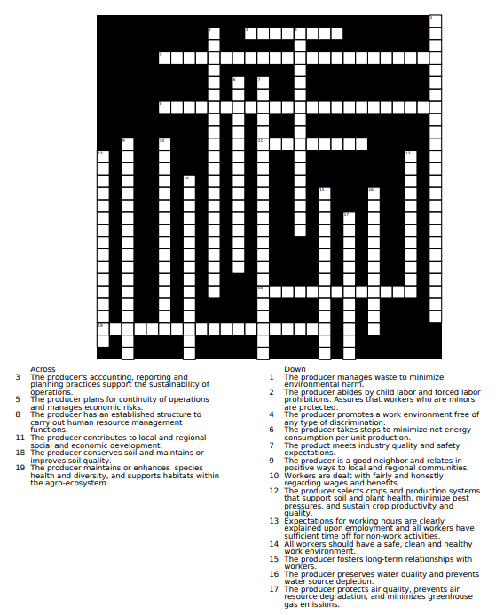
While following along with your teacher and the PowerPoint, complete the following activities.

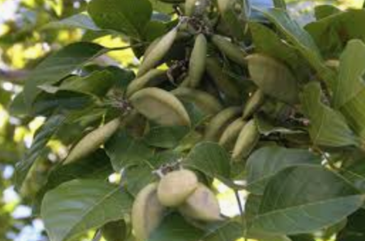
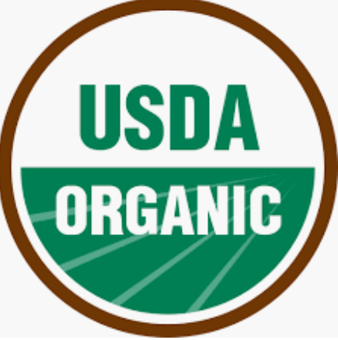
How do all of these different standards/practices work together to help ensure a better, more sustainably produced food product?
Design and draw a stamp to be placed on a product to indicate to a consumer that the product follows the sustainable practices you just learned about. This stamp should be indicative of its meaning and be understandable to multiple age levels.
How is food safety ensured throughout the production process?
What impact do these labeling and certification practices have on the salability of the final product?
Ingredient Sustainability
Aligned to the following standards:
CS.01; FFA.PL-A; FFA.PL-E; FFA.PL-F; FFA.PG-I; FFA.PG-J; FFA.CS-M; FFA.CS-N; AG1; AGC10.03; CCSS.ELA.RI.9-10.1; CCSS.ELA.RI.9-10.2; CCSS.ELA.RI.9-10.8; CCSS.ELA.W.9-10.1; CCAA.ELA.W.9-10.2; CCSS.ELA.SL.9-10.1; CCSS.SL.9-10.2; CCSS.SL.9-10.4; CCSS.RST.9.10.4; CCSS.ELA.RST.9.10.8; CCSS.ELA.RST.9-10.9; CCSS.WHST.9.10.1; CCSS.WHST.9.10.2; CCSS.ELA.WHST. 9.10.4;HS-ETS1-3; AFNR Career Cluster, Statement 2; AFNR Career Cluster, Statement 3; AFNR Career Cluster, Statement 7; CRP.02; CRP.04; CRP.05; CRP.06; CRP.07; CRP.08; CRP.11
Directions:
In the last lesson, you identified ingredients to include in your trail mix product. Now, you are going to select three of those ingredients that you identified (on the map) and learn more about the sustainability practices that are utilized when producing those three products. Using what you have learned, research each ingredient and the sustainable production process each goes through. Be sure to call out the specific sustainability practices, standards, certifications and/or regulations the ingredient goes through. Some resources to help you get started:
- SCS Global, https://www.scsglobalservices.com/food-and-agriculture-products
- Valent Sustainable Solutions, https://www.valentsustainablesolutions.com/

Ingredient 1: _______________
Country sourced from: __________________________

Growing/harvesting practices:

Processing and labeling practices:

Transportation practices:
Ingredient 2: _______________
Country sourced from: __________________________

Growing/harvesting practices:

Processing and labeling practices:

Transportation practices:
Ingredient 3: _______________
Country sourced from: __________________________

Growing/harvesting practices:

Processing and labeling practices:

Transportation practices:
What sustainability practices do these ingredients have in common?
Why are these sustainability practices utilized and considered so important?

Aligned to the following standards:
CS.01; FFA.PL-A; FFA.PL-E; FFA.PL-F; FFA.PG-I; FFA.PG-J; FFA.CS-M; FFA.CS-N; AG1; AGC10.03; CCSS.ELA.RI.9-10.1; CCSS.ELA.RI.9-10.2; CCSS.ELA.RI.9-10.8; CCSS.ELA.W.9-10.1; CCAA.ELA.W.9-10.2; CCSS.ELA.SL.9-10.1; CCSS.SL.9-10.2; CCSS.SL.9-10.4; CCSS.RST.9.10.4; CCSS.ELA.RST.9.10.8; CCSS.ELA.RST.9-10.9; CCSS.WHST.9.10.1; CCSS.WHST.9.10.2; CCSS.ELA.WHST. 9.10.4; HS-ETS1-3; AFNR Career Cluster, Statement 2; AFNR Career Cluster, Statement 3; AFNR Career Cluster, Statement 7; CRP.02; CRP.04; CRP.05; CRP.06; CRP.07; CRP.08; CRP.11
Agricultural Issues Forum: Summary Questions and Resources
Directions:
Your teacher will provide you with the agriculture issue you will be researching with your team. Let the questions below guide your research, and answer these questions to the best of your ability. Be sure to use credible sources, and provide a list of the sources you used in APA format.

- Why is this issue important now?

- What is the nature of the issue?

- Who is involved?

- How can the issue be defined?

- What is the historical background of the issue?

- What caused this issue?

- What are the risks?

- What are the benefits?

- Are there any strong disagreements on the issue?


Aligned to the following standards:
CS.01; FFA.PL-A; FFA.PL-E; FFA.PL-F; FFA.PG-I; FFA.PG-J; FFA.CS-M; FFA.CS-N; AG1; AGC10.03; CCSS.ELA.RI.9-10.1; CCSS.ELA.RI.9-10.2; CCSS.ELA.RI.9-10.8; CCSS.ELA.W.9-10.1; CCAA.ELA.W.9-10.2; CCSS.ELA.SL.9-10.1; CCSS.SL.9-10.2; CCSS.SL.9-10.4; CCSS.RST.9.10.4; CCSS.ELA.RST.9.10.8; CCSS.ELA.RST.9-10.9; CCSS.WHST.9.10.1; CCSS.WHST.9.10.2; CCSS.ELA.WHST. 9.10.4; HS-ETS1-3; AFNR Career Cluster, Statement 2; AFNR Career Cluster, Statement 3; AFNR Career Cluster, Statement 7; CRP.02; CRP.04; CRP.05; CRP.06; CRP.07; CRP.08; CRP.11
Agricultural Issues Forum: Sample Script
Directions:
Use this sample script to plan your opening and closing remarks for your presentation.

Here is a sample script for use in planning your opening remarks:

“Good evening! I am (name), and this is (name) , (name) , (name) and (name) . We are from the (organization).”

“We’re here this evening to talk to you about an agricultural issue that we feel is of great importance.”

“Our objective is not to try to persuade you to take a stand on this issue, but we would like to present both sides of the issue to you in order to better educate the public on a very important agricultural concern.”

“We want to take this opportunity to thank you for allowing us to come before the (name of organization) for this agricultural issues forum. Our topic today is (title of the agricultural issue being presented).”

(The opening remarks may be made by the teacher or the leader of the group making the presentation.)

From this point, you’ll want to begin introducing the agricultural issue. From a verbal analysis, the listener should not be able to tell whether the presenter is for or against the issue.

Here is a sample script for use in closing your presentation:

“As we bring our agricultural issues forum to a close, we once again thank you for allowing us to be here this evening, and we hope this activity has given you a much clearer understanding of (restate the agricultural issue that was presented).”

“We would welcome the opportunity to return with another group of students to present a different agricultural issues forum topic in the near future.”

KEY: Sustainably Grown Standard
Aligned to the following standards:
CS.01; FFA.PL-A; FFA.PL-E; FFA.PL-F; FFA.PG-I; FFA.PG-J; FFA.CS-M; FFA.CS-N; AG1; AGC10.03; CCSS.ELA.RI.9-10.1; CCSS.ELA.RI.9-10.2; CCSS.ELA.RI.9-10.8; CCSS.ELA.W.9-10.1; CCAA.ELA.W.9-10.2; CCSS.ELA.SL.9-10.1; CCSS.SL.9-10.2; CCSS.SL.9-10.4; CCSS.RST.9.10.4; CCSS.ELA.RST.9.10.8; CCSS.ELA.RST.9-10.9; CCSS.WHST.9.10.1; CCSS.WHST.9.10.2; CCSS.ELA.WHST. 9.10.4; HS-ETS1-3; AFNR Career Cluster, Statement 2; AFNR Career Cluster, Statement 3; AFNR Career Cluster, Statement 7; CRP.02; CRP.04; CRP.05; CRP.06; CRP.07; CRP.08; CRP.11
Directions:
While following along with your teacher and the PowerPoint, complete the following activities.
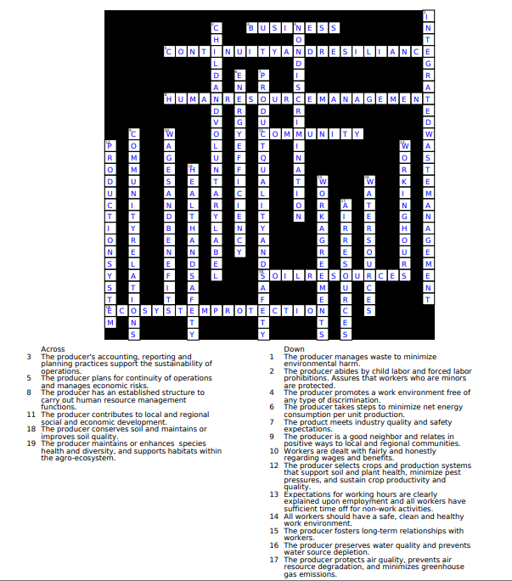

Presentation Rubric
