Crop Production
Created: 07/2019 by the National FFA Organization

Student Learning Objectives:
After completing these activities, students will …
- Examine how crops are produced.
- Describe genetically modified organisms (GMOs).
- Examine the use of genetically modified organisms (GMOs).
- Describe the role of crop consumption in everyday nutrition.

Time Required: 180 minutes
Resources:
- AgExplorer, https://agexplorer.ffa.org/
- “How to Make a Paper Slideshow,” https://youtu.be/E5RXynA_D3I
- Michigan State University: GMO 101, https://msutoday.msu.edu/feature/2018/gmos-101/
- Purdue University: What are GMOs?, https://youtu.be/QiHreVTjS58
- Public Service Announcement: Stop Smoking, https://youtu.be/7LkuSm9kUEI
- USDA State Facts, https://www.ers.usda.gov/StateFacts/

Equipment and Supplies Needed:
- A copy of the “Growing the Future” worksheet for each student
- A copy of the “Public Service Announcement” worksheet for each student
- A copy of the “The Science Behind My Food …” worksheet for each student
- A copy of the “Crops and Me” worksheet for each student
- Internet access to play the video in real time or embed it in a PowerPoint ahead of time
- Internet access for students
- Colored pencils, markers or pens
- White paper
- A device to record on (ex. phone, tablet, etc.)

This quick lesson plan would work well as:
- A plant science lesson.
- An introduction to crop production.
- A biotechnology lesson.

Student Activity sheets
https://ffa.box.com/s/uceas7u8k0ulddxw14frtmm188ksz8b4 (Word)
https://ffa.box.com/s/j2fq9ma6cl0496ppexhlbjkokioyfv9k (PDF)
These activities are aligned to the following standards:

AFNR Performance Element
- BS.01 NCAE Standard: Assess factors that have influenced the evolution of biotechnology in agriculture (e.g., historical events, societal trends, ethical and legal implications, etc.).
- CS.01: Analyze how issues, trends, technologies and public policies impact systems in the Agriculture, Food & Natural Resources Career Cluster
FFA Precept
- FFA.PL-A.Action: Assume responsibility and take the necessary steps to achieve the desired results, no matter what the goal or task at hand.
- FFA.PL-E.Awareness: Understand personal vision, mission and goals.
- FFA.PL-F.Continuous Improvement: Accept responsibility for learning and personal growth.
- FFA.PG-I.Professional Growth: Assume responsibility for attaining and improving upon the skills needed for career success.
- FFA.PG-J.Mental Growth: Embrace cognitive and intellectual development relative to reasoning, thinking and coping.
- FFA.CS-M.Communication: Effectively interact with others in personal and professional settings.
- FFA.CS-N.Decision Making: Analyze a situation and execute an appropriate course of action.
Common Career Technical Core
- AG1: Analyze how issues, trends, technologies and public policies impact systems in the Agriculture, Food & Natural Resources Career Cluster.
NASDCTEc
- AGC10.03: Compare and contrast issues affecting the AFNR industry including biotechnology, employment, safety, environmental and animal welfare to demonstrate an understanding of the trends and issues important to careers in this industry.
- AGC10.04: Envision emerging technology and globalization and project its influence on widespread markets to demonstrate an understanding of technologies and trends that will impact the AFNR industry.
Common Core – Reading: Informational Text
- CCSS.ELA-Literacy.RI.9-10.2: Determine a central idea of a text and analyze its development over the course of the text, including how it emerges and is shaped and refined by specific details; provide an objective summary of the text.
- CCSS.ELA-Literacy.RI.9-10.4: Determine the meaning of words and phrases as they are used in a text, including figurative, connotative, and technical meanings; analyze the cumulative impact of specific word choices on meaning and tone (e.g., how the language of a court opinion differs from that of a newspaper).
- CCSS.ELA-Literacy.RI.9-10.8: Delineate and evaluate the argument and specific claims in a text, assessing whether the reasoning is valid and the evidence is relevant and sufficient; identify false statements and fallacious reasoning.
Common Core – Speaking and Listening
- CCSS.ELA-Literacy.SL.9-10.1: Initiate and participate effectively in a range of collaborative discussions (one-on-one, in groups, and teacher-led) with diverse partners on grades 9-10 topics, texts, and issues, building on others' ideas and expressing their own clearly and persuasively.
- CCSS.ELA-Literacy.SL.9-10.2: Integrate multiple sources of information presented in diverse media or formats (e.g., visually, quantitatively, orally) evaluating the credibility and accuracy of each source.
- CCSS.ELA-Literacy.SL.9-10.4: Present information, findings, and supporting evidence clearly, concisely, and logically such that listeners can follow the line of reasoning and the organization, development, substance, and style are appropriate to purpose, audience, and task.
Common Core – Science & Technical Subjects
- CCSS.ELA-Literacy.RST.9.10.8: Assess the extent to which the reasoning and evidence in a text support the author's claim or a recommendation for solving a scientific or technical problem.
- CCSS.ELA-Literacy.RST.9.10.9: By the end of grade 10, read and comprehend science/technical texts in the grades 9-10 text complexity band independently and proficiently.
Common Core – Math Practices
- CCSS.MP1: Make sense of problems and persevere in solving them.
- CCSS.MP3: Construct viable arguments and critique the reasoning of others.
- CCSS.MP5: Use appropriate tools strategically.
- CCSS.MP6: Attend to precision.
Next Generation Science
- HS-ETS1-3: Evaluate a solution to a complex real-world problem based on prioritized criteria and trade-offs that account for a range of constraints, including cost, safety, reliability, and aesthetics as well as possible social, cultural, and environmental impacts.
AFNR Career Ready Practices
- CRP.02: Apply appropriate academic and technical skills. Career-ready individuals readily access and use the knowledge and skills acquired through experience and education to be more productive.
- CRP.04: Communicate clearly, effectively, and with reason. Career-ready individuals communicate thoughts, ideas and action plans with clarity, whether using written, verbal and/or visual methods.
- CRP.05: Consider the environmental, social and economic impact of decisions. Career-ready individuals understand the interrelated nature of their actions and regularly make decisions that positively impact and/or mitigate negative impact on other people, organizations and the environment.
- CRP.06: Demonstrate creativity and innovation. Career-ready individuals regularly think of ideas that solve problems in new and different ways, and they contribute those ideas in a useful and productive manner to improve their organization.
- CRP.07: Employ valid and reliable research strategies. Career-ready individuals are discerning in accepting and using new information to make decisions, change practices or inform strategies.
- CRP.08: Utilize critical thinking to make sense of problems and persevere in solving them. Career-ready individuals readily recognize problems in the workplace, understand the nature of the problem, and devise effective plans to solve the problem.
- CRP.11: Use technology to enhance productivity. Career-ready individuals find and maximize the productive value of existing and new technology to accomplish workplace takes and solve workplace problems.
Partnership for 21st Century Skills
- Communication
- Critical Thinking and Problem Solving
- Flexibility and Adaptability
- Initiative and Self-Direction
- Leadership and Responsibility
- Think Creatively

Lesson Plan:
- Bell Ringer: What are five crops/foods grown in your state?

- Introduction: The production of crops has many similarities and differences throughout the United States and the world. Understanding how these commodities are produced becomes important in light of the goal of meeting the food needs of the growing population. Today, we will learn about the production of different crop commodities and the technology being used.

- Activity 1: Each student needs a copy of the worksheet “Growing the Future.”

  - Part 1: In this part of the activity, students will draw their favorite meal, including all sides they might have with that meal. Once they have completed their drawings, they will identify the crops used to make the foods they have drawn. Students will then use resources in their classroom or on the internet to determine where each of these crops are grown.
  - Part 2: Now that students have had time to think about their favorite meal, pair students up with a partner. Students need to use the map to color and label their state. Next, using the USDA state facts documents found at https://www.ers.usda.gov/StateFacts/, have students select one of the top five crops produced in your state that they have interest in learning about. On the map, students will then color and label, in a different color, a second state of interest (students should not select a neighboring state or one that someone else in the class has selected) and record it in the associated box. Have students record their selected states on the board so that there are not any duplicates. Again, students will use the USDA website, https://www.ers.usda.gov/StateFacts/, and select one of the top five crops produced in their selected state and record the crop in the box provided.
  - Part 3: After students have selected their crops, students will watch the video “How to Make a Paper Slideshow.” The URL is https://youtu.be/E5RXynA_D3I. Students will create a paper-slide video explaining the selected crop from outside of your state. Videos should last between 45 and 90 seconds. Students should utilize the space provided in the worksheet to script their videos. (Illustrations will go in the boxes and narration on the lines.)

Slide 1: Describe the crop, its purpose and use.
Slide 2: Include information about planting, growth and care of the crop (i.e. watering, nutrition, pest management).
Slide 3: Explain how to harvest the crop, including techniques and machinery.
Slide 4: Describe the processing of the crop and foods created from the crop.
Slide 5: Include a list of five additional states that grow this crop.

Allow students time to complete their paper-slide video, including recording, (approximately 45 minutes). When they are done, have students share their videos with the class. If technology is not available to record, students can present the paper slide without recording.
  - Part 4: As pairs are presenting, have students draw a picture of a crop from each state shared by their classmates on the new map provided (separate from the previous two). If a state is not large enough, have students draw a line and create their picture to the side. Students will then answer the follow-up questions. Have students share their responses with the class.

- Activity 2: Each student needs a copy of the worksheet “The Science Behind My Food ...”

  - To meet the growing population’s need for food across the globe, the need to find ways to grow more nutritious and abundant supplies of food has also increased. Watch the “What Are GMOs?” video from Purdue University to find out how agriculture is working to meet this need. Have students complete the video questions on the worksheet as they watch. The video URL is https://youtu.be/QiHreVTjS58. If YouTube is unavailable, use this website, https://ag.purdue.edu/GMOs/Pages/WhatareGMOs.aspx.
  - Have students use the infographic from Purdue University to learn about the use of GMOs. After students have answered the questions, hold a discussion about the importance GMOs play in both medicine and crop production. More information can be found at https://ag.purdue.edu/GMOs/Pages/WhatareGMOs.aspx. Overall, students should understand that GMOs play a vital role in crop production and even medicine. GMOs are important in meeting the needs of the growing population.
  - Have students read the passage from Michigan State University and underline the four most important statements. Students should then answer the questions based on the passage. Overall, it is important for students to understand there are many misconceptions that currently exist regarding the safety of GMOs. However, many organizations and years of research have concluded that at this time there are no health concerns associated with the use of GMOs in our food supply. The use of GMOs adds to the food supply by allowing an increased production of food to meet global demands.
  - Students will create a one- to two-minute public service announcement (PSA) to explain GMOs and their use in society. A PSA is an announcement that is delivered to the public free of charge to educate them about an important topic. Public service announcements are beneficial in that they are short, educational and attract the attention of their audience. Have students watch the PSA available at https://youtu.be/7LkuSm9kUEI to see the components of a PSA and to help students generate ideas for their GMO PSAs. Students should use the guidelines and template provided to plan. Give students time to brainstorm, develop, practice and record their PSA (approximately 45 minutes). Students should then share their PSAs with the class. If recording is not an option, have students present to the class live.

- Activity 3: Each student needs a copy of the worksheet “Crops and Me.” Crops come in many varieties and are found in our everyday nutrition regardless of diet preferences (i.e. gluten free, vegan, vegetarian, etc.). The government has determined the appropriate dietary guidelines can be represented visually using the MyPlate model. Utilizing the crops identified throughout the country in the “Growing the Future” activity, students will create a balanced meal for their family for dinner. They will create a recipe card for three dishes: one side dish (ex. mixed salad), one main course (ex. turkey meatloaf) and one dessert (ex. pudding). When crafting their recipe card, have students write the ingredients in the corresponding color as found on the MyPlate model (i.e., fruit = red, vegetable = green, protein = purple, grains = orange, blue = dairy). Additionally, have students put an asterisk (*) next to the food that could be from a GMO source. Remind students that a recipe card has ingredients with amounts needed as well as precise directions to make the dish. Overall, students should gain an understanding of the role and importance that crops play in the diet. From fruits and vegetables to cereal and peanut butter, crops and GMOs are present and play a large role in meeting our nutritional needs.

- Follow-up: Have students share their paper-slide videos and PSA videos in other classes. If you have access to TVs in the school hallways, have these informational videos play so that other students can also learn.

- Leveling Up:
  - Reach out to a local plant breeder and ask them to speak to the class. If you do not have access to a local plant breeder, video chat with one from a company or university in your state. Additionally, you could plan a visit to a plant breeding facility or have students start a plant breeding supervised agricultural experience (SAE) program.
  - Use https://agexplorer.ffa.org/ to learn more about plant breeders in the Biotechnology or Plant Systems Career Focus Areas.

- Exit Ticket: What role do crops and GMOs play in our daily lives? How could GMOs be used to help create a more food secure population?

Growing the Future
Aligned to the following standards:
BS.01; CS.01; FFA.PL-A; FFA.PL-E; FFA.PL-F; FFA.PG-I; FFA.PG-J; FFA.CS-M; FFA.CS-N; AG1; AGC10.03; AGC10.04; CCSS.ELA.RI.9-10.2; CCSS.ELA.RI.9-10.4; CCSS.ELA.RI.9-10.8; CCSS.SL.9-10.1; CCSS.ELA.SL.9-10.2; CCSS.ELA.SL.9-10.4; CCSS.ELA.RST.9.10.8; CCSS.EL.RST.9.10.9; MP1; MP3; MP5; MP6;HS-ETS1-3; CRP.02; CRP.04; CRP.05; CRP.06; CRP.07; CRP.08; CRP.11
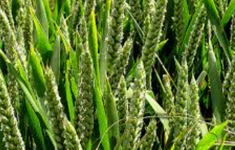
Part 1
Directions:
Draw and label a picture of your favorite meal below. Be sure to include the sides (ex. mashed potatoes). Use food labels or the internet to complete the questions below your picture.

Create a list of all of the raw crops used to make the meal you drew above (ex. corn, apples).

Where are each of the crops grown in the United States?

Aligned to the following standards:
NRS.01; AGPE01.01; CCSS.RI.9-10.3; CCSS.SL.9-10.1; RST.9.10.1; RST.9.10.2; RST.9.10.4; RST.9.10.5; RST.9.10.6; RST.9.10.8; RST.9.10.9; WHST.9.10.7; WHST.9.10.9; MP3; MP6; AG-NR2; HS-LS2-6; HS-LS2-7

Part 2
Directions:
As you can see from Part 1, our food comes from commodities found all over the U.S. and sometimes the world! You and a partner are going to become an expert on the production of one of the major commodities in your state and somewhere else in the U.S.

- Using the map below, color and label your state.
- Using the USDA website, https://www.ers.usda.gov/StateFacts/, select one of the top five crops produced in your state. Record the crop in the box provided.
- Using the map below, in a different color, color and label a second state of interest (do not select a neighboring state or one that someone else in the class has selected) and record it in the associated box.
- Using the USDA website, https://www.ers.usda.gov/StateFacts/, select one of the top five crops produced in the selected state. Record the crop in the box provided.
Crop selected in your state:
Crop selected in other state:
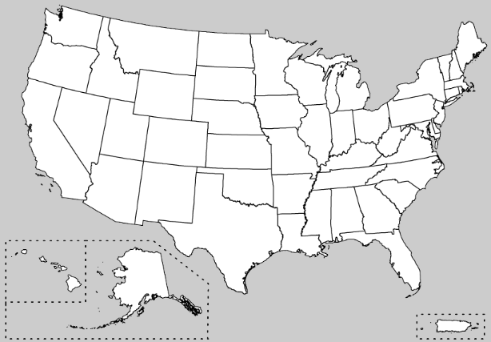
Why did you select this crop? What interests you about this crop?
Why did you select this crop? What interests you about this crop?

Part 3
Directions:
Watch the video “How to Make a Paper Slideshow,” available at https://youtu.be/E5RXynA_D3I. You will create a paper-slide video explaining your selected crop from outside of your state. Videos should last between 45 and 90 seconds. Use the space below to script your video. (Illustrations will go in the boxes and your narration on the lines.)
Slide 1: Describe the crop, its purpose and use.
Slide 2: Include information about planting, growth and care of the crop (i.e. watering, nutrition, pest management).
Slide 3: Explain how to harvest the crop, including techniques and machinery.
Slide 4: Describe the processing of the crop and foods created from the crop.
Slide 5: Include a list of five additional states that grow this crop.

Crop Name:

Slide One:
Narration:

__________________________________________

__________________________________________

__________________________________________

__________________________________________

__________________________________________

Slide Two:

Narration: Narration:

__________________________________________

__________________________________________

__________________________________________

__________________________________________

__________________________________________

Slide Three:
Narration:

__________________________________________

__________________________________________

__________________________________________

__________________________________________

__________________________________________

Slide Four:
Narration:

__________________________________________

__________________________________________

__________________________________________

__________________________________________

__________________________________________

Narration:
Slide Five:

__________________________________________

__________________________________________

__________________________________________

__________________________________________

__________________________________________

Part 4
Directions:
In each state on the map below, draw a picture of the crop based on information shared by your classmates. If a state is not large enough, draw a line and create your picture to the side in the gray space or on the back.
What role does crop production play in your everyday life?
Using what you learned today, identify three pieces of information that you consider new and interesting about crop production.

1.

2.

3.

The Science Behind My Food …
Aligned to the following standards:
BS.01; CS.01; FFA.PL-A; FFA.PL-E; FFA.PL-F; FFA.PG-I; FFA.PG-J; FFA.CS-M; FFA.CS-N; AG1; AGC10.03; AGC10.04; CCSS.ELA.RI.9-10.2; CCSS.ELA.RI.9-10.4; CCSS.ELA.RI.9-10.8; CCSS.SL.9-10.1; CCSS.ELA.SL.9-10.2; CCSS.ELA.SL.9-10.4; CCSS.ELA.RST.9.10.8; CCSS.EL.RST.9.10.9; MP1; MP3; MP5; MP6;HS-ETS1-3; CRP.02; CRP.04; CRP.05; CRP.06; CRP.07; CRP.08; CRP.11
Directions:
To meet the growing population’s food requirements across the globe, the need to find ways to grow more nutritious and abundant supplies of food has also increased. Watch the “What are GMOs?’ video from Purdue University to find out how agriculture is working to meet this need. Answer the questions as you watch the video. The video URL is https://youtu.be/QiHreVTjS58. If YouTube is unavailable, use this website: https://ag.purdue.edu/GMOs/Pages/WhatareGMOs.aspx.



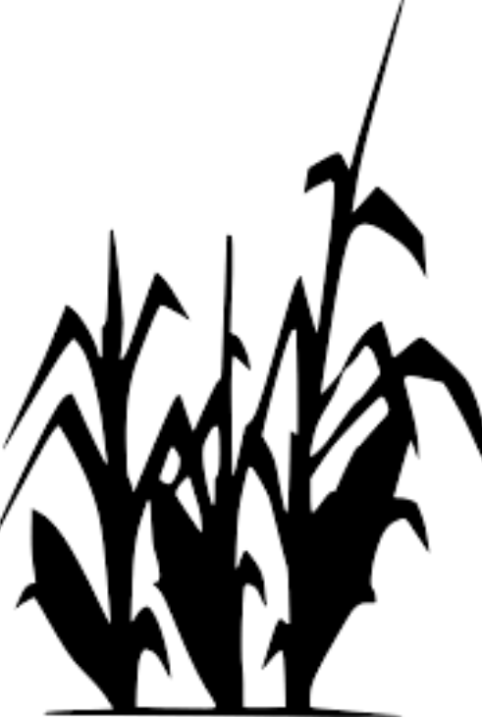
What does GMO stand for?

G____________________ M____________________ O____________________
The term “organism” refers to …

- what we eat.
- what we plant.
- any living thing.
How has this technology improved medical treatment?
What is an example of a pharmaceutical product that comes from GMOs?

_____________________
How has this development improved the lives of those with diabetes?
Which of the following vaccines have been developed utilizing GMO technology?

- Diabetes, Hepatitis B
- Cholera, Hepatitis B
- Cholera, Diabetes
- Hepatitis A, Cholera

What is the difference between conventional plant breeding and GMOs?
What are the top 4 GMO agronomic crops in the United States?

What does the term agronomic mean?

- Agricultural crops
- Only plants that are GMO.
- The transfer of information to get desired traits.

Directions:
Using this infographic from Purdue University, answer the following questions.
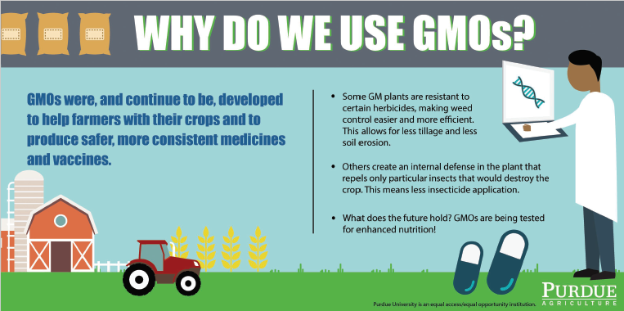
What are three ways that GMOs are used every day?

- ______________________________________________
- ______________________________________________
- ______________________________________________
With the need to feed a growing population and maintain its health, what role will GMOs have in the future?


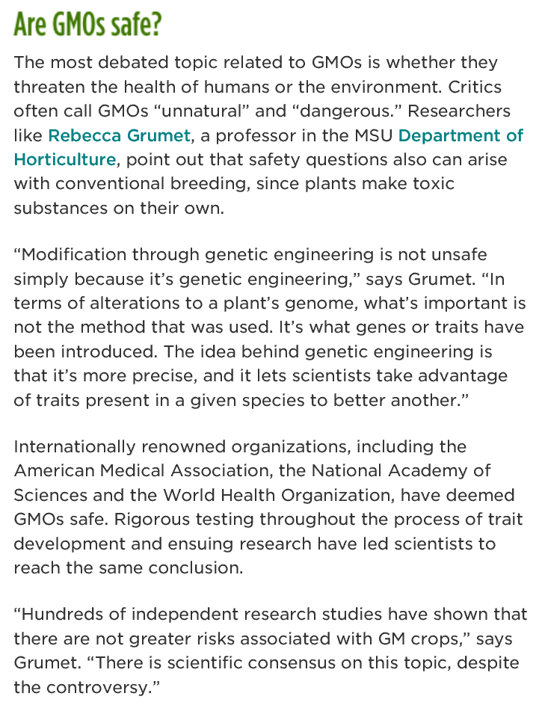
Directions:
Remembering that we have a great need to grow a more abundant and nutritious supply of food, read the passage below from Michigan State University. While reading, underline the four most important statements and answer the questions.
Why might people think GMOs are unsafe?
What evidence supports the safety of GMOs?
What would you say to a person who says GMOs are unsafe for consumption? Use what you have learned in your explanation.
Public Service Announcement
Aligned to the following standards:
BS.01; CS.01; FFA.PL-A; FFA.PL-E; FFA.PL-F; FFA.PG-I; FFA.PG-J; FFA.CS-M; FFA.CS-N; AG1; AGC10.03; AGC10.04; CCSS.ELA.RI.9-10.2; CCSS.ELA.RI.9-10.4; CCSS.ELA.RI.9-10.8; CCSS.SL.9-10.1; CCSS.ELA.SL.9-10.2; CCSS.ELA.SL.9-10.4; CCSS.ELA.RST.9.10.8; CCSS.EL.RST.9.10.9; MP1; MP3; MP5; MP6;HS-ETS1-3; CRP.02; CRP.04; CRP.05; CRP.06; CRP.07; CRP.08; CRP.11
Directions:
A public service announcement (PSA) is an announcement that is delivered to the public free of charge to educate them about an important topic. Public service announcements are beneficial in that they are short, educational and attract the attention of their audience. Today you are going to create a 1- to 2-minute public service announcement about GMOs. Watch this PSA, https://youtu.be/7LkuSm9kUEI, to help you generate ideas for your GMO PSA. Use the guidelines and template below to plan.

- Watch the PSA video, https://youtu.be/7LkuSm9kUEI.
- Brainstorm how to make your PSA creative.
- Complete any additional research needed. Be sure to use only valid resources. Examples: USDA, university websites, state grain grower associations (ex. Iowa Corn Producers).
- Practice!
- Record your PSA.


What is a GMO?
Why do we use GMOs?
Where can we find GMOs every day?
What impact do GMOs have on the ability to meet the food needs of a growing population?
Three additional facts about GMOs.
Crops and Me
Aligned to the following standards:
BS.01; CS.01; FFA.PL-A; FFA.PL-E; FFA.PL-F; FFA.PG-I; FFA.PG-J; FFA.CS-M; FFA.CS-N; AG1; AGC10.03; AGC10.04; CCSS.ELA.RI.9-10.2; CCSS.ELA.RI.9-10.4; CCSS.ELA.RI.9-10.8; CCSS.SL.9-10.1; CCSS.ELA.SL.9-10.2; CCSS.ELA.SL.9-10.4; CCSS.ELA.RST.9.10.8; CCSS.EL.RST.9.10.9; MP1; MP3; MP5; MP6;HS-ETS1-3; CRP.02; CRP.04; CRP.05; CRP.06; CRP.07; CRP.08; CRP.11
Directions:
Crops come in many varieties and are found in our everyday nutrition regardless of diet preferences (i.e. gluten free - for people that cannot eat gluten, vegan - people that do not consume animal or animal-based products/foods, vegetarian - for individuals that do not consume animal products, etc.). The government has determined the appropriate dietary guidelines can be represented visually using the MyPlate model. Utilizing the crops identified throughout the country in the “Growing the Future” activity, create a balanced meal for your family for dinner. You will create a recipe card for 3 dishes: one side dish (ex. mixed salad), one main course (ex. turkey meatloaf) and one dessert (ex. pudding). When crafting your recipe card, write the ingredients in the corresponding color as found on the MyPlate model (i.e., fruit = red, vegetable = green, protein = purple, grains = orange, blue = dairy). Additionally, based on what you have learned about GMOs, put an asterisk (*) next to the food that could be from a GMO source. Remember that a recipe card has ingredients with amounts needed as well as precise directions to make the dish.
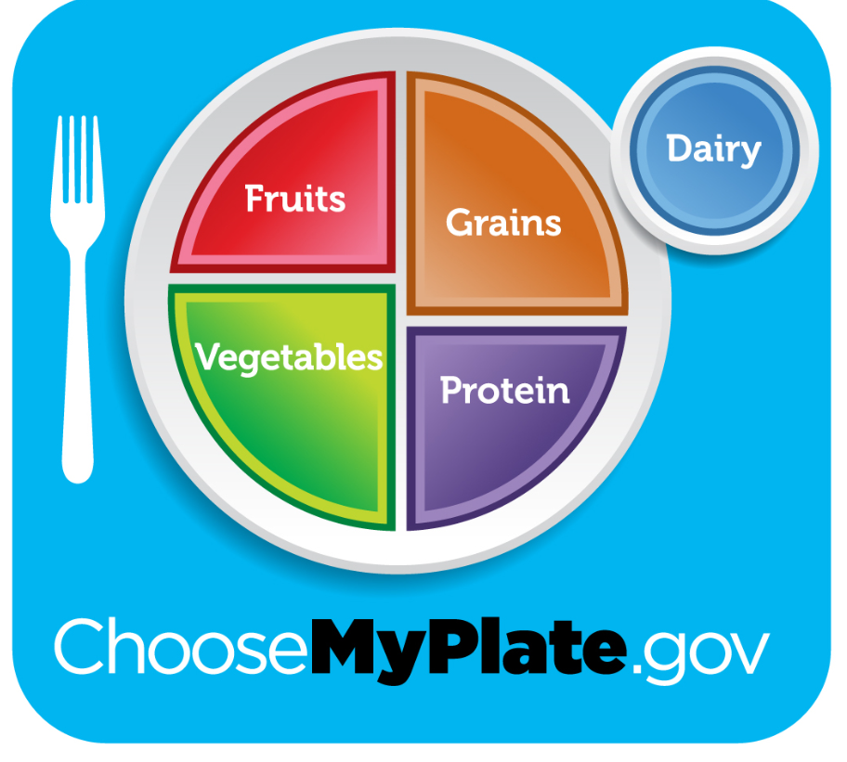
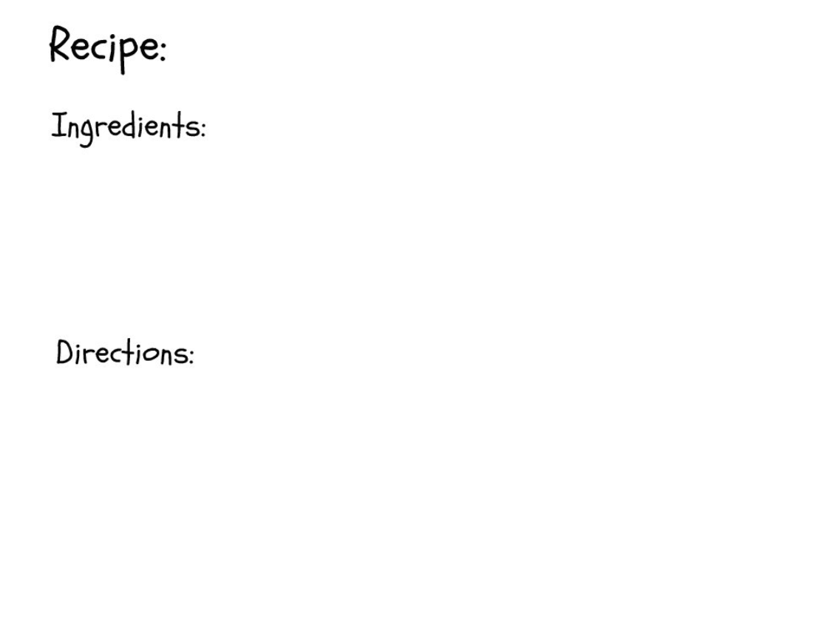

What is the role and importance of crops in your diet and for your nutritional needs?
Paper-Slide Video Rubric
Aligned to the following standards:
BS.01; CS.01; FFA.PL-A; FFA.PL-E; FFA.PL-F; FFA.PG-I; FFA.PG-J; FFA.CS-M; FFA.CS-N; AG1; AGC10.03; AGC10.04; CCSS.ELA.RI.9-10.2; CCSS.ELA.RI.9-10.4; CCSS.ELA.RI.9-10.8; CCSS.SL.9-10.1; CCSS.ELA.SL.9-10.2; CCSS.ELA.SL.9-10.4; CCSS.ELA.RST.9.10.8; CCSS.EL.RST.9.10.9; MP1; MP3; MP5; MP6;HS-ETS1-3; CRP.02; CRP.04; CRP.05; CRP.06; CRP.07; CRP.08; CRP.11
Area | 4 Points | 3 Points | 2 Points | 1 Point
Content | All content is accurate. There are no factual errors. | Most of the content is accurate, but there is one piece of information that seems inaccurate. | The content is generally accurate, but one piece of information is clearly inaccurate. | Content is confusing or contains more than one factual error.
Clarity and Neatness | The paper slide is easy to read, and all elements are clearly written, labeled and drawn. Creativity was used. | The paper slide is easy to read, and most elements are clearly written, labeled and drawn. Some creativity was used. | The paper slide is hard to read with rough drawings, labels and color. Little creativity was used. | The paper slide is hard to read, and one cannot tell what goes where or what the illustrations represent. No creativity was used.
Narration and Preparedness | The paper slide is clearly rehearsed and narrated with no mistakes.  Student spoke slowly and clear. | One mistake is heard in the paper-slide video. | Two mistakes are heard in the paper-slide video. | Three or more mistakes are heard in the paper-slide video.  Student spoke very fast and was unclear.
Time | Student stayed in the 45 to 90 seconds time frame. |  |  | Student was either under or over the allotted time frame.

Total: _____________
Comments:

___________________________________________________________________________________________________

___________________________________________________________________________________________________

___________________________________________________________________________________________________

___________________________________________________________________________________________________

___________________________________________________________________________________________________

___________________________________________________________________________________________________

___________________________________________________________________________________________________

___________________________________________________________________________________________________

Key: The Science Behind My Food …
Aligned to the following standards:
BS.01; CS.01; FFA.PL-A; FFA.PL-E; FFA.PL-F; FFA.PG-I; FFA.PG-J; FFA.CS-M; FFA.CS-N; AG1; AGC10.03; AGC10.04; CCSS.ELA.RI.9-10.2; CCSS.ELA.RI.9-10.4; CCSS.ELA.RI.9-10.8; CCSS.SL.9-10.1; CCSS.ELA.SL.9-10.2; CCSS.ELA.SL.9-10.4; CCSS.ELA.RST.9.10.8; CCSS.EL.RST.9.10.9; MP1; MP3; MP5; MP6;HS-ETS1-3; CRP.02; CRP.04; CRP.05; CRP.06; CRP.07; CRP.08; CRP.11
Directions:
To meet the growing population’s food requirements across the globe, the need to find ways to grow more nutritious and abundant supplies of food has also increased. Watch the “What are GMOs?’ video from Purdue University to find out how agriculture is working to meet this need. Answer the questions as you watch the video. The video URL is https://youtu.be/QiHreVTjS58. If YouTube is unavailable, use this website: https://ag.purdue.edu/GMOs/Pages/WhatareGMOs.aspx.
The term “organism” refers to …

- What we eat.
- What we plant.
- Any living thing.
What does GMO stand for?

Genetically Modified Organism
How has this technology improved medical treatment?
GMO bacteria is used to create methods to cure and prevent some diseases. Before this technology, materials were taken from cadavers and livestock (cattle and pigs), which were then contaminated. GMOs make a pure form that is safer.

What is an example of a pharmaceutical product that comes from GMOs?

Insulin
How has this development improved the lives of those with diabetes?
We now have pure forms of insulin making it safer for those needing insulin for diabetes.
Which of the following vaccines have been developed utilizing GMO technology?

- Diabetes, Hepatitis B
- Cholera, Hepatitis B
- Cholera, Diabetes
- Hepatitis A, Cholera

What is the difference between conventional plant breeding and GMOs?

Conventional: They cross two parents based on traits and then select offspring based on desired traits. This takes a long time to get an offspring with all of the desired traits.

GMOs: We can take a given trait and alter the organism individually to get the desired traits.
What are the top 4 GMO agronomic crops in the United States?

- Corn
- Soybeans
- Cotton
- Canola
What does the term agronomic mean?

- Agricultural crops
- Only plants that are GMO.
- The transfer of information to get desired traits.

Directions:
Using this infographic from Purdue University, answer the following questions.

What are three ways that GMOs are used every day?

- Herbicide resistance
- Internal plant defense
- Help produce consistent medicines and vaccines
With the need to feed a growing population and maintain its health, what role will GMOs have in the future?
Answers will vary.
Directions:
Remembering that we have a great need to grow a more abundant and nutritious supply of food, read the passage below from Michigan State University. While reading, underline the four most important statements and answer the questions.
Why might people think GMOs are unsafe?
Misconceptions occur because some feel the products are not natural.
What evidence supports the safety of GMOs?
Years of research by well-known groups. Ex. American Medical Association
What would you say to a person who says GMOs are unsafe for consumption? Use what you have learned in your explanation.
Answers will vary.
Aligned to the following standards:
BS.01; CS.01; FFA.PL-A; FFA.PL-E; FFA.PL-F; FFA.PG-I; FFA.PG-J; FFA.CS-M; FFA.CS-N; AG1; AGC10.03; AGC10.04; CCSS.ELA.RI.9-10.2; CCSS.ELA.RI.9-10.4; CCSS.ELA.RI.9-10.8; CCSS.SL.9-10.1; CCSS.ELA.SL.9-10.2; CCSS.ELA.SL.9-10.4; CCSS.ELA.RST.9.10.8; CCSS.EL.RST.9.10.9; MP1; MP3; MP5; MP6;HS-ETS1-3; CRP.02; CRP.04; CRP.05; CRP.06; CRP.07; CRP.08; CRP.11
Public Service Announcement Rubric
Area | 4 Points | 3 Points | 2 Points | 1 Point
Content | All content is accurate. There are no factual errors. | Most of the content is accurate, but there is one piece of information that seems inaccurate. | The content is generally accurate, but one piece of information is clearly inaccurate. | Content is confusing or contains more than one factual error.
Clarity and Creativity | The PSA is easy to understand, and all elements are clearly written or spoken. Creativity was used. | The PSA is easy to understand, and most elements are clearly written or spoken. Some creativity was used. | The PSA is hard to understand with very quiet speaking or very hard to read writing. Little creativity was used. | The PSA is hard to understand, and one cannot follow the thought process. No creativity was used.
Narration and Preparedness | The PSA is clearly rehearsed and presented with no mistakes.  Student spoke slowly and clear. | One mistake is heard in the PSA video. | Two mistakes are heard in the PSA video. | Three or more mistakes are heard in the PSA video.  Student spoke very fast and was unclear.
Time | Student stayed in the one- to two-minute time frame. |  |  | Student was either under or over the allotted time frame.
Total: _____________
Comments:

___________________________________________________________________________________________________

___________________________________________________________________________________________________

___________________________________________________________________________________________________

___________________________________________________________________________________________________

___________________________________________________________________________________________________

___________________________________________________________________________________________________

___________________________________________________________________________________________________

___________________________________________________________________________________________________

Key: Crops and Me
Aligned to the following standards:
BS.01; CS.01; FFA.PL-A; FFA.PL-E; FFA.PL-F; FFA.PG-I; FFA.PG-J; FFA.CS-M; FFA.CS-N; AG1; AGC10.03; AGC10.04; CCSS.ELA.RI.9-10.2; CCSS.ELA.RI.9-10.4; CCSS.ELA.RI.9-10.8; CCSS.SL.9-10.1; CCSS.ELA.SL.9-10.2; CCSS.ELA.SL.9-10.4; CCSS.ELA.RST.9.10.8; CCSS.EL.RST.9.10.9; MP1; MP3; MP5; MP6;HS-ETS1-3; CRP.02; CRP.04; CRP.05; CRP.06; CRP.07; CRP.08; CRP.11
Directions:
Crops come in many varieties and are found in our everyday nutrition regardless of diet preferences (i.e. gluten free, vegan, vegetarian, etc.). The government has determined the appropriate dietary guidelines can be represented visually using the MyPlate model. Utilizing the crops identified throughout the country in the “Growing the Future” activity, create a balanced meal for your family for dinner. You will create a recipe card for 3 dishes: one side dish (ex. mixed salad), one main course (ex. turkey meatloaf) and one dessert (ex. pudding). When crafting your recipe card, write the ingredients in the corresponding color as found on the MyPlate model (i.e., fruit = red, vegetable = green, protein = purple, grains = orange, blue = dairy). Additionally, based on what you have learned about GMOs, put an asterisk (*) next to the food that could be from a GMO source. Remember that a recipe card has ingredients with amounts needed as well as precise directions to make the dish. Answers will vary, but must include crops previously discussed in the “Growing the Future” activity and must be color coded according to the MyPlate colors.
What is the role and importance of crops in your diet and for your nutritional needs? Crops are included in what we eat every day. From fruit and vegetables to cereal and peanut butter. Without crops, our diets would be severely lacking in nutrition.

