Soil Health for the Future
Created: 07/2025 by the National FFA Organization
Description of Lesson: In this final lesson, students will connect soil health to global issues such as food security, climate change and sustainable land use. Students will be challenged to combine all the knowledge they have gained around soil heath and conservation as they research case studies on soil management from around the globe and work together to come up with innovative and sustainable solutions for their selected soil health issues.
Thank you to our current partners in sustainability:






Student Learning Objectives:
After completing these activities, students will …
- Explain connections between soil health and global challenges (climate change, food insecurity, pollution).
- Analyze real-world soil health scenarios from different regions.
- Propose sustainable solutions using systems thinking.
Suggested Grade Level:
Grades 9 and 10 (This lesson is written so instructors can scale up or down based on class needs.)

Suggested Time: 120 minutes (*Time requirements may vary based upon student understanding and class schedule.)
Related Resources:
- AgExplorer Sustainability Systems Focus Area, AgExplorer.FFA.org/focus/sustainability-systems/
- Introduction to Sustainability Lesson Series, https://FFA.box.com/v/introtosustainability
- Darling Ingredients Educational Resources, https://FFA.box.com/s/3ko8e9w6zygohv1ewfsnc8byobjzeuxa
- Valent — Sustainability in Agriculture Lesson Series, https://FFA.box.com/v/sustainabilityinagriculture

Equipment and Supplies Needed:
- A copy of the “Global Soil Health” student activity sheet for each student
- Student devices with internet access
- Appendix 1: Global Soil Health Scenarios, one set per class

Vocabulary:
- Soil Health
Cross-Curricular Connections:
Social Studies | English/Language Arts
Analyze differences in soil health across different regions, continents and countries. | Write proposed solutions for soil health issues occurring within given scenarios.

SAE and FFA Connections:
- Agronomy CDE, FFA.org/participate/cdes/agronomy/
- Environmental and Natural Resources CDE, FFA.org/participate/cdes/environmental-and-natural-resources/
- Proficiency Areas: Environmental Science and Natural Resources Management, FFA.org/participate/awards/proficiencies/
- Foundational SAE Connections: Agricultural Literacy
Student Activity Sheets:
Direct access to student activity sheets without lesson plan or answer key for easy upload to a learning management system or printing for classwork.

https://ffa.box.com/s/kznfov10eb0k1e0wbc8btbqomula6pdo (Word)
https://ffa.box.com/s/qbufl27xccez4mburhudn8mxr5jue6jn (Word, Non-designed)
https://ffa.box.com/s/amg8m92mg0mdqy8ddywf1wix8xh9vvr0 (PDF)
https://docs.google.com/document/d/1wjBb2K1Cx9FmNk7JZK4csu6iXB0PeZ_e2idSAJQX98s/copy (Google)

These Activities Are Aligned to the Following Standards:
AFNR Performance Element
- CS.03. Examine and summarize the importance of health, safety and environmental management systems in AFNR workplaces.
- CS.04. Demonstrate stewardship of natural resources in AFNR activities.
- CS.06. Analyze the interaction among AFNR systems in the production, processing and management of food, fiber and fuel and the sustainable use of natural resources.
- NRS.02. Analyze the interrelationships between natural resources and humans.
- NRS.04. Demonstrate responsible management procedures and techniques to protect, maintain, enhance, and improve natural resources.
FFA Precept
- FFA.PL-A.Action: Assume responsibility and take the necessary steps to achieve the desired results, no matter what the goal or task at hand.
- FFA.PL-B.Relationship: Build relationships, work as a team player and appreciate the talents of others.
- FFA.PL-C.Vision: Visualize the future and how to get there.
- FFA.CS-M.Communication: Effectively interact with others in personal and professional settings.
- FFA.CS-N.Decision Making: Analyze a situation and execute an appropriate course of action.
Common Career Technical Core
- AG3 Examine and summarize the importance of health, safety, and environmental management systems in AFNR businesses.
- AG4 Demonstrate stewardship of natural resources in AFNR activities.
- AG6 Analyze the interaction among AFNR systems in the production, processing, and management of food, fiber, and fuel and the sustainable use of natural resources.
- AG-NR2 Analyze the interrelationships between natural resources and humans.
- AG-NR4 Demonstrate responsible management procedures and techniques to protect or maintain natural resources.
Common Core – Reading: Informational Text
- CCSS.ELA-Literacy.RI.9-10.2 Determine a central idea of a text and analyze its development over the course of the text, including how it emerges and is shaped and refined by specific details; provide an objective summary of the text.
Common Core – Speaking and Listening
- CCSS.ELA-Literacy.SL.9-10.1 Initiate and participate effectively in a range of collaborative discussions (one-on-one, in groups, and teacher-led) with diverse partners on grades 9-10 topics, texts, and issues, building on others’ ideas and expressing their own clearly and persuasively,
- CCSS.ELA-LITERACY.SL.9-10.2 Integrate multiple sources of information presented in diverse media or formats (e.g., visually, quantitatively, orally) evaluating the credibility and accuracy of each source.
- CCSS.ELA-LITERACY.SL.9-10.4 Present information, findings, and supporting evidence clearly, concisely, and logically such that listeners can follow the line of reasoning and the organization, development, substance, and style are appropriate to purpose, audience, and task.
Common Core – Science & Technical Subjects
- CCSS.ELA-Literacy.RST.11-12.1 Cite specific textual evidence to support analysis of science and technical texts, attending to important distinctions the author makes and to any gaps or inconsistencies in the account.
- CCSS.ELA-Literacy.RST.11-12.7 Integrate and evaluate multiple sources of information presented in diverse formats and media (e.g., quantitative data, video, multimedia) in order to address a question or solve a problem.
Green/Sustainability Knowledge and Skill Statements
- AFNR Career Cluster, Statement 1 - Apply understanding of ecosystems and systems thinking to the management of natural resources to maximize the health and productivity of the environment, agriculture, communities, and society.
- AFNR Career Cluster, Statement 3 - Communicate the impact of green and sustainability principles on agriculture, food and natural resource systems.
- AFNR Career Cluster, Statement 7 - Demonstrate an understanding of green and sustainability trends that are impacting processes and markets in AFNR
AFNR Career Ready Practices
- CRP.02. Apply appropriate academic and technical skills. Career-ready individuals readily access and use the knowledge and skills acquired through experience and education to be more productive.
- CRP.04. Communicate clearly, effectively, and with reason. Career-ready individuals communicate thoughts, ideas and action plans with clarity, whether using written, verbal and/or visual methods.
- CRP.05. Consider the environmental, social and economic impact of decisions. Career-ready individuals understand the interrelated nature of their actions and regularly make decisions that positively impact and/or mitigate negative impact on other people, organizations and the environment.
- CRP.06. Demonstrate creativity and innovation. Career-ready individuals regularly think of ideas that solve problems in new and different ways, and they contribute those ideas in a useful and productive manner to improve their organization.
- CRP.07. Employ valid and reliable research strategies. Career-ready individuals are discerning in accepting and using new information to make decisions, change practices or inform strategies.
- CRP.08. Utilize critical thinking to make sense of problems and persevere in solving them. Career-ready individuals readily recognize problems in the workplace, understand the nature of the problem, and
- devise effective plans to solve the problem.
- CRP.11 Use technology to enhance productivity. Career-ready individuals find and maximize the productive value of existing and new technology to accomplish workplace tasks and solve workplace problems.
Partnership for 21st Century Skills
- Communication
- Environmental Literacy
- Global Awareness
- Information, Communications, and Technology Literacy
- Think Creatively

Lesson Plan:
- Bell Ringer: What might happen if farmland soil became too degraded to grow crops locally? Globally?

- Introduction: Say: We’ve learned a lot about soil health up to this point. We’ve covered common soil health issues, conservation methods, the impact of biodiversity on soil and several other topics. Now, it’s time for you to solve the world’s toughest soil issues!

- Activity 1: (at least 120 minutes, depending on research depth and presentation format) Each student needs a copy of the worksheet “Global Soil Health.”
  - Part 1: Students will be divided into small groups (approximately three or four students per group) and assigned one of the scenarios from “Appendix 1: Global Soil Health Scenarios.” Each of these scenarios is designed to challenge students to research the given area and their soil, think critically about the issues the regions are facing and come up with sustainable soil health solutions for their issue. Students’ teams will research and fill out the graphic organizer provided on their student activity sheets. These are key items they must be able to articulate to you and the rest of the class:
    - Geographic location (Where is their soil health issue happening?)
    - Soil health issue (What is happening to the soil?)
    - Contributing factors (What caused this situation?)
    - Who is affected? (List people, communities, industries or systems impacted.)
    - Short-term consequences (What is happening right now?)
    - Long-term consequences (What could happen if this issue continues?)
    - Proposed solutions (List two or three well-thought-out and detailed solutions that could resolve this issue and return the soil to a healthy state.)
    - Additional challenges/obstacles (What could get in the way of these solutions being implemented?)
    - Potential consequences (What are some possible unintended outcomes or negative consequences from implementing the proposed solutions?)
    - Critical first step (What needs to be done to get started now?)
  - Part 2: Students will share their scenarios, their findings and their solutions with the class. You may choose to have them do so in the form of a formal presentation with slides or a more informal, round-robin style, rotating through groups sharing from their tables. If you choose the more formal route, you may consider inviting local farmers, extension agents, scientists or other soil health professionals to sit in and provide feedback and encouragement to students on their soil health journey.
  - Part 3: Hold a class discussion about the process of attempting to solve a soil health problem. Consider the following questions:
    - What challenges did you face in the research and brainstorming process?
    - How do you think farmers and other professionals approach these issues?
    - Is soil health management ever completely done? Why or why not?

- Follow-up: (10 minutes) Discuss how soil health (both globally and locally) affects students directly. Ask them how they think they are impacted by soil health. Have students discuss how they could help monitor and improve soil health in their area.

- Exit Ticket: Why is managing our planet’s soil health so important? Why is it so challenging to get it right?

Teacher Note: This lesson’s activities depend wholly on students’ personal results, thoughts and reflections, so no answer keys are included.

Global Soil Health
Aligned to the following standards:
CS.03; CS.04; CS.06; NRS.02; NRS.04; FFA.PL-A; FFA.PL-B; FFA.PL-C; FFA.CS-M; FFA.PL-N; AG3; AG4; AG6; AG-NR2; AG-NR4; CCSS.ELA.RI.9-10.2; CCSS.ELA.SL.9-10.1; CCSS.ELA.SL.9-10.2; CCSS.ELA.SL.9-10.4; CCSS.ELA.RST.11-12.1.; CCSS.ELA.RST.11-12.7; HS.ETS 1-3; AFNR Career Cluster, Statement 1; AFNR Career Cluster, Statement 3; AFNR Career Cluster, Statement 7; CRP.02; CRP.04; CRP.05; CRP.06; CRP.07; CRP.08; CRP.11;
Directions:
Use the graphic organizer throughout these pages to research and organize your group’s thoughts in response to your global soil health scenario.
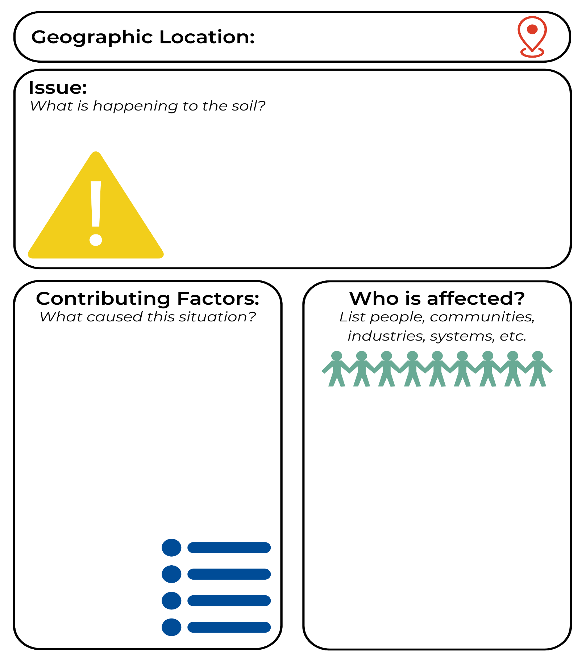
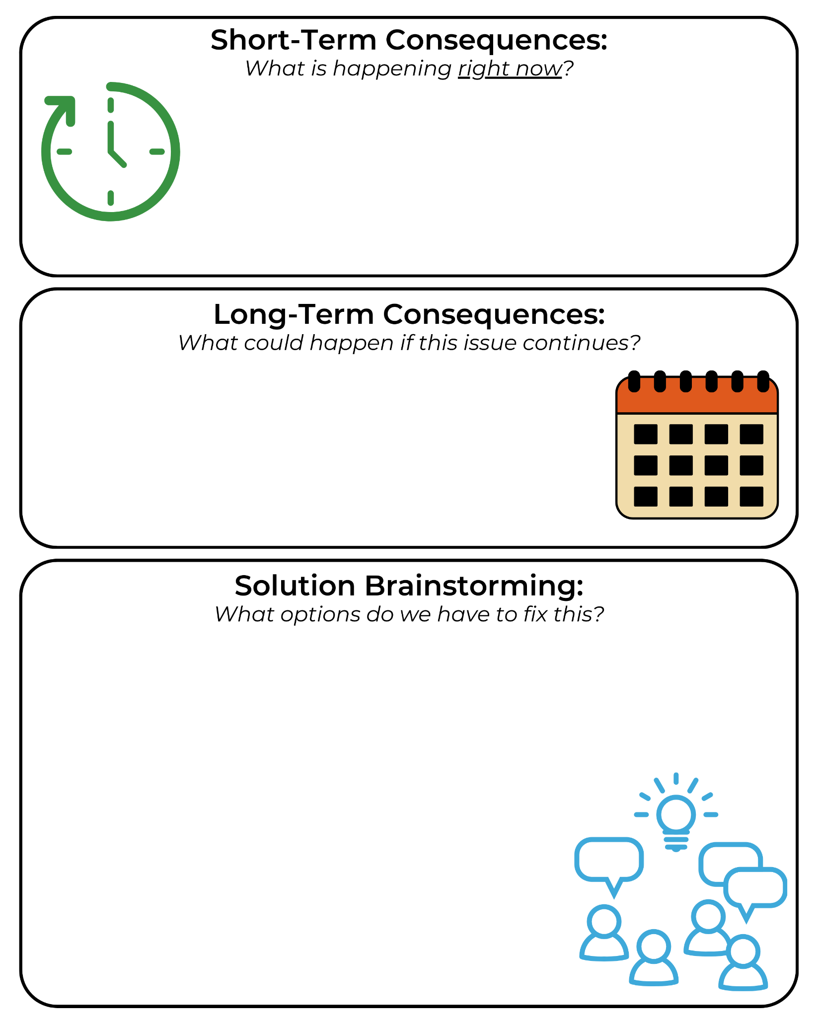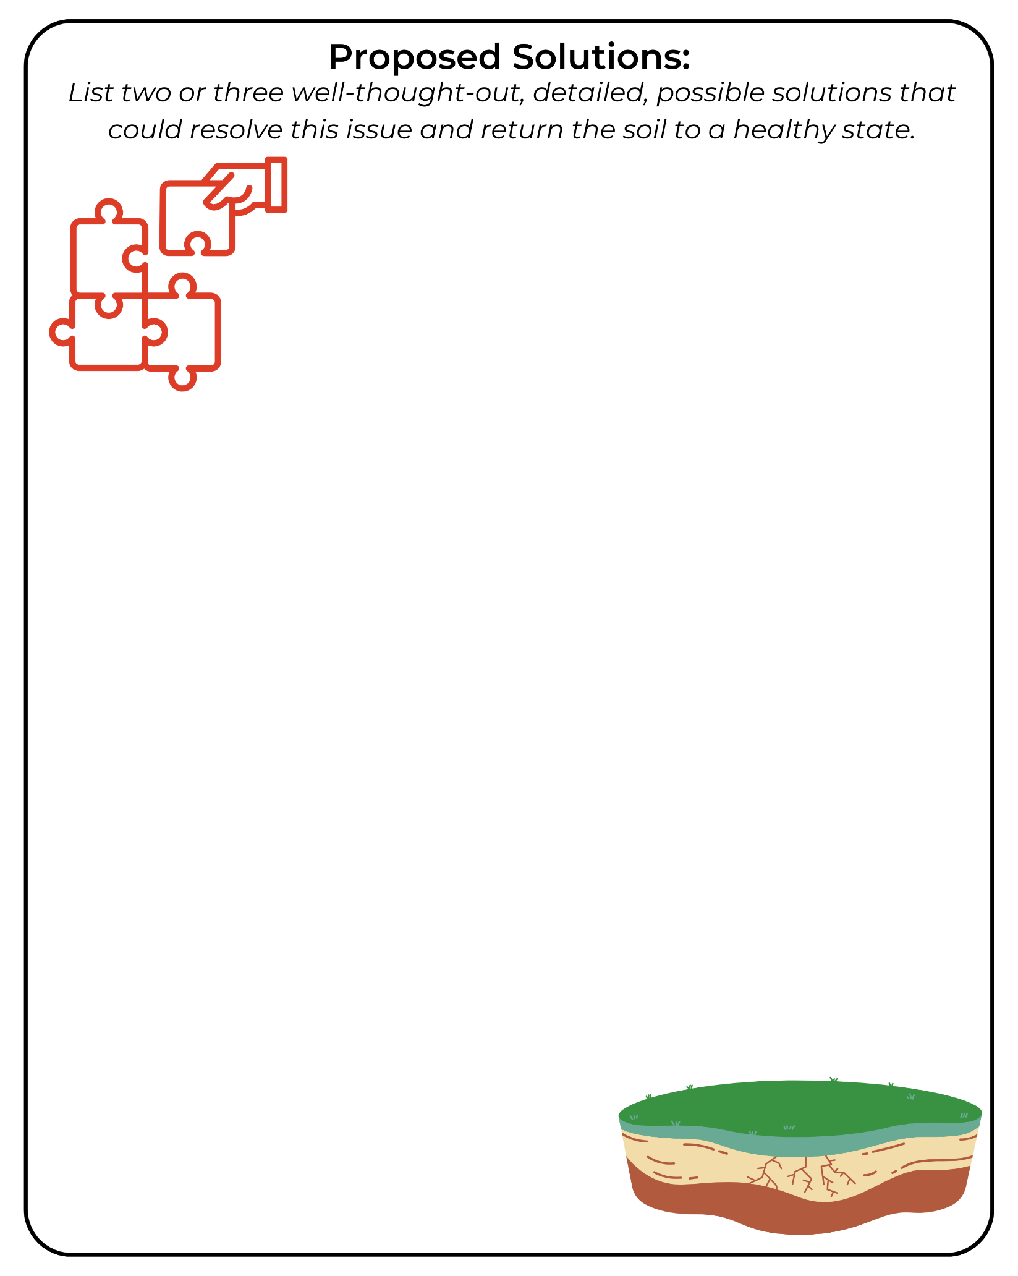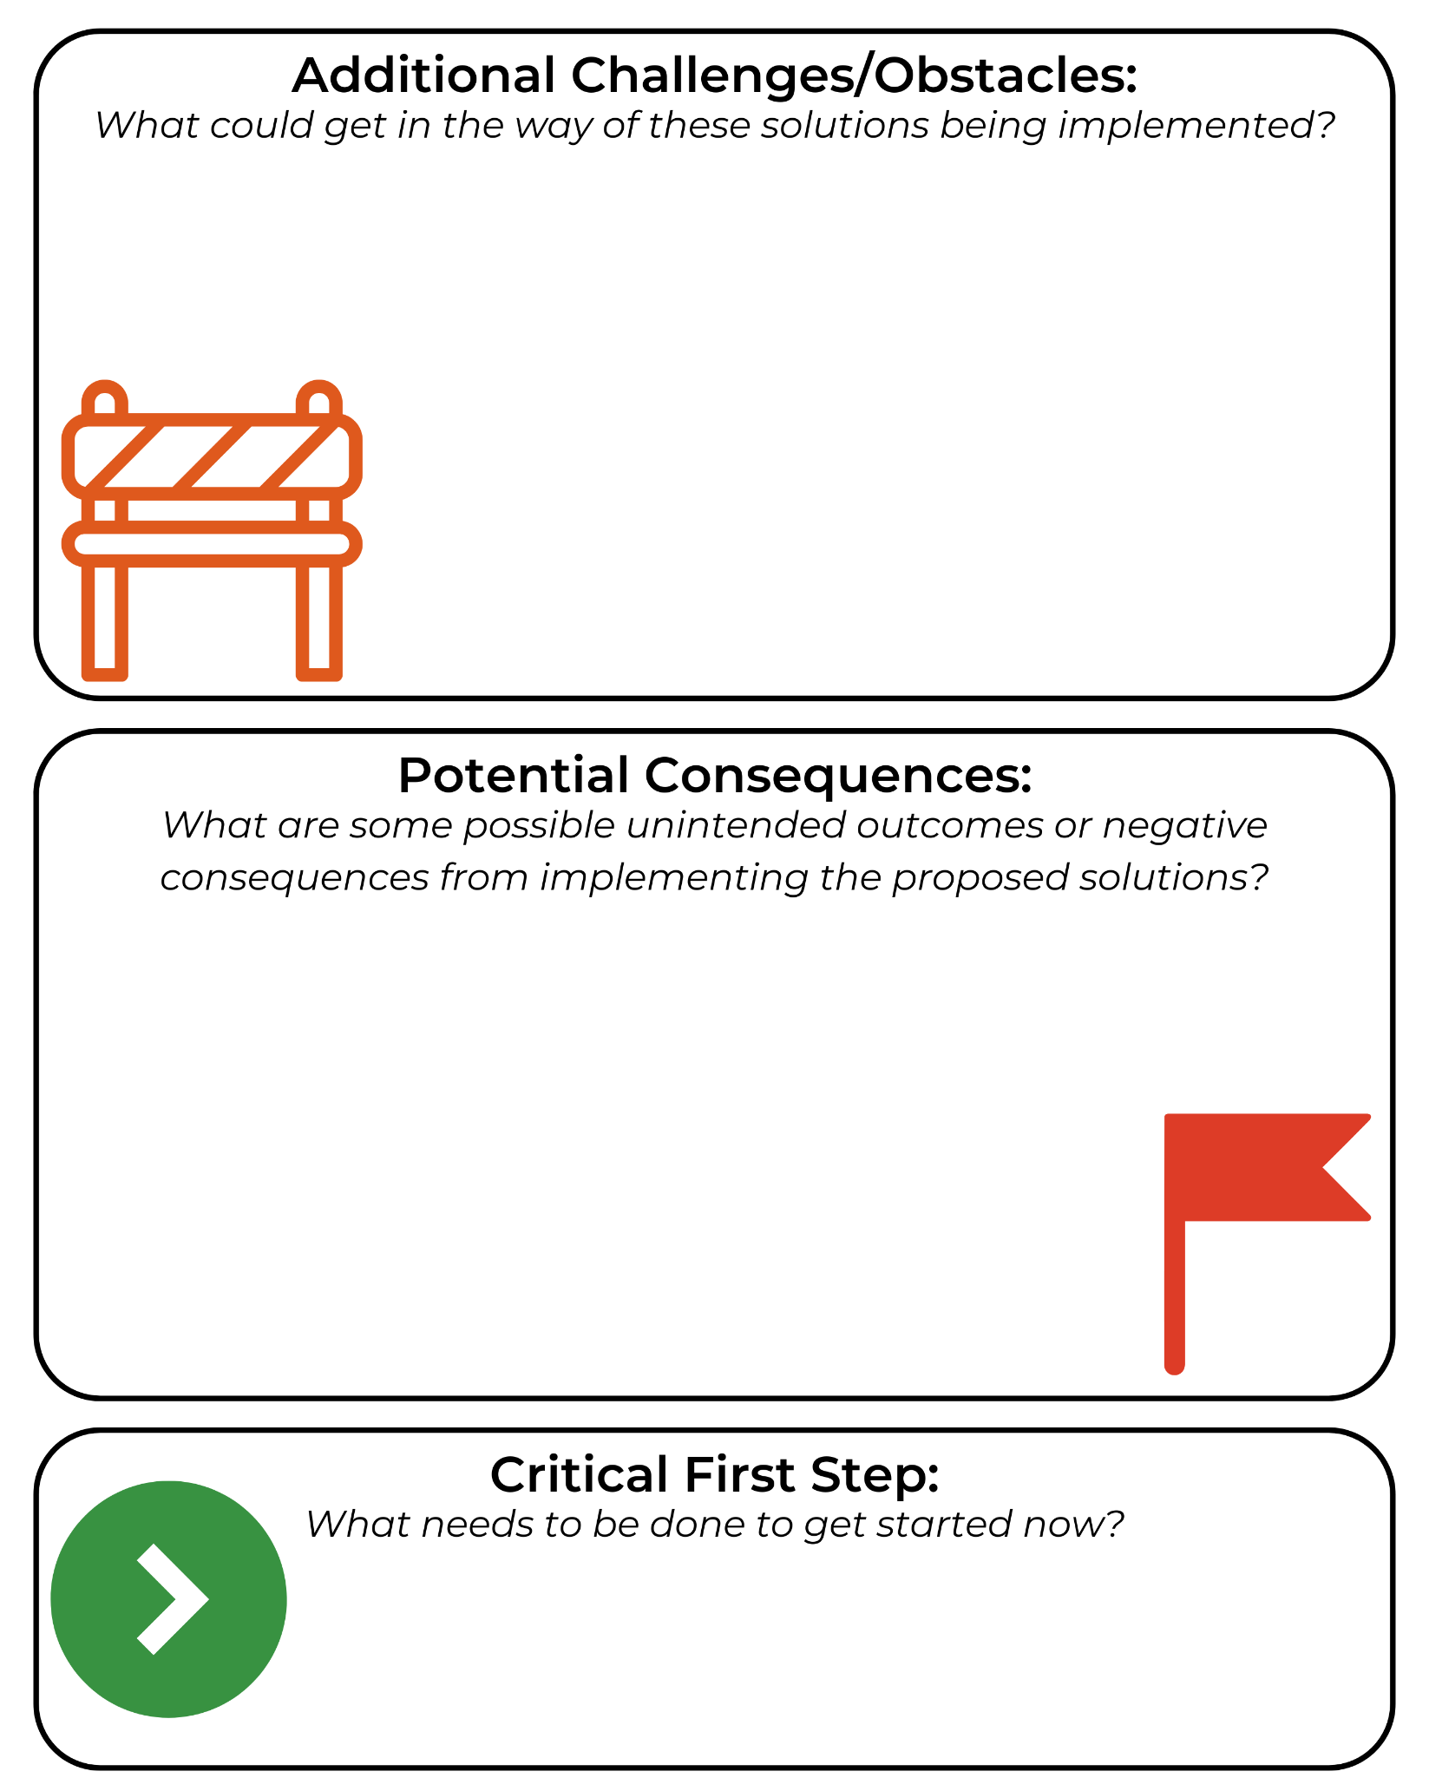

Appendix 1: Global Soil Health Scenarios
Scenario 1: Failing Farms in Sub-Saharan Africa
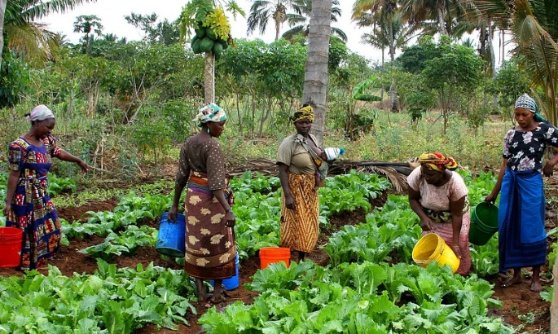
In a rural Kenyan village, most families rely on small plots of land to grow staple crops like maize and beans. These crops have been planted repeatedly without the addition of compost or fertilizer, which has led to depleted nutrients in the soil. The once dark and crumbly soil has become pale and compacted, and plant growth is stunted.
Climate change has made rainfall less predictable — sometimes flooding the fields, other times leaving them dry for weeks. As yields drop, families face food shortages, and younger generations are leaving the village in search of work. Government programs and NGOs have offered some support, but resources are limited. Community members are exploring solutions like composting, intercropping and collecting rainwater to restore soil health.
Scenario 2: Erosion on U.S. Farmland
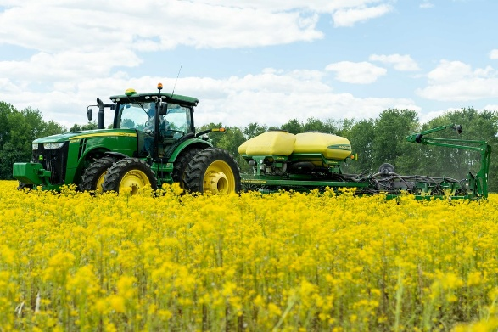
In the heart of the Midwest, a corn and soybean farmer has noticed that each year more of the topsoil is washing away. Heavy spring rains frequently occur after the soil has been tilled and left bare between plantings. This runoff not only strips the field of valuable nutrients but also carries sediment and fertilizers into nearby streams, polluting water supplies.
The once-rich soil has become shallow and less able to retain water. The farmer is considering no-till practices, cover crops and other regenerative strategies but is unsure about the financial risk or how to make the transition. They’ve begun researching support through government conservation programs and local extension services.

Scenario 3: Contaminated Soil in an Urban Garden (USA)
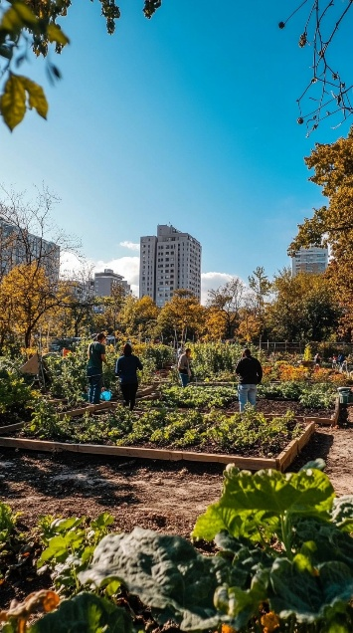
In Detroit, a local neighborhood group is transforming abandoned lots into community gardens to address food insecurity. After setting up raised beds and planting vegetables, a university soil test reveals elevated levels of lead and other heavy metals, a legacy of past industrial activity.
The group is devastated. They worry about the health risks for families and children who were excited to eat from the garden. Soil compaction from old construction materials has also made it difficult for roots to grow. Now the group must decide: Should they replace the soil, plant only in raised beds or look into phytoremediation techniques using specific plants to pull toxins from the ground?
Scenario 4: Deforestation and Nutrient Loss in Brazil
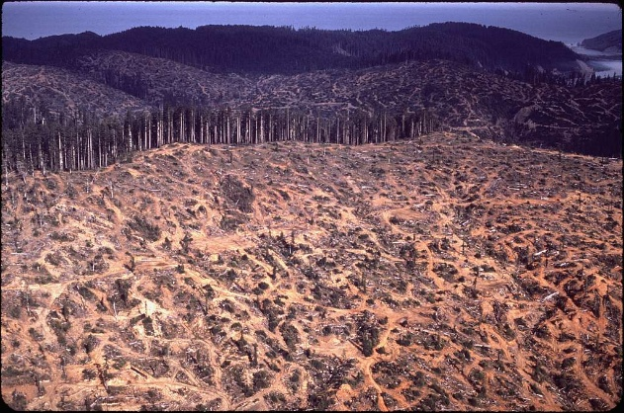
In northern Brazil, large sections of the Amazon rainforest are being cleared for soybean and cattle farming. The rich green canopy is replaced by fields of short grass or bare earth. Although the newly cleared land is initially productive, it quickly loses its fertility.
Tropical rainforest soil is surprisingly thin and relies on constant input from falling leaves and decaying plant matter. Once exposed, the soil is washed away during rains, and the carbon stored in soil and plants is released into the atmosphere, contributing to global warming. Environmental groups are calling for reforestation and more sustainable farming practices while local farmers face pressure from global commodity markets.

Scenario 5: Desertification in Northern China
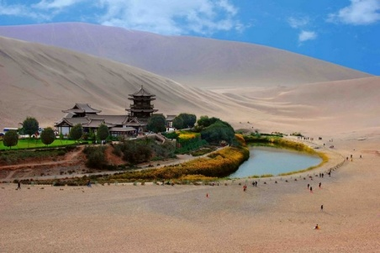
In northern China’s Loess Plateau — a region known for its powdery, yellow soil — centuries of deforestation and overgrazing have left vast areas bare. Without grasses or trees to protect the surface, strong seasonal winds carry topsoil away in massive dust storms. These storms reduce visibility, damage infrastructure and pose serious respiratory health risks for nearby communities.
Rainfall in the region is minimal and irregular. When it does fall, the lack of vegetation and compacted soil leads to flash flooding and runoff, rather than water absorption. Many villages have been abandoned due to unproductive farmland.
The Chinese government has launched large-scale reforestation projects, including the “Great Green Wall” initiative, planting millions of trees and introducing terraced farming to stabilize slopes. Results have varied. Some areas are rebounding while others remain at risk of permanent desertification due to climate pressures and poor land management.
Scenario 6: Salinization in Irrigated Fields of Pakistan
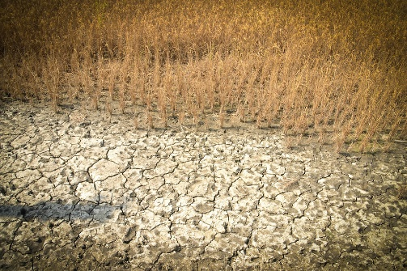
In the Sindh and Punjab regions of Pakistan, irrigation has long supported vital crops like wheat, rice and cotton. Water from the Indus River is diverted across thousands of kilometers of canals and ditches to reach distant fields. However, over the past few decades, poor drainage and repeated flooding have led to salinization, a condition where salts build up in the upper layers of soil eventually forming a crust that stunts or kills crops.
Farmers began noticing white deposits on the soil surface and reduced growth even in freshly irrigated fields. They tried flushing the fields with excess water, but this worsens water waste and raises groundwater tables, compounding the problem.
Research institutions have suggested using salt-tolerant crops like barley or quinoa, improving canal maintenance and implementing subsurface drainage systems. But many rural farmers lack the technical knowledge or funding to make these changes without outside support.

Scenario 7: Deforested Hillsides in Haiti
Haiti’s steep mountainsides were once covered in dense forests, but decades of cutting trees for charcoal and building materials have left the slopes exposed. Each rainy season, the bare hills shed massive quantities of soil in the form of mudslides and sheet erosion. Rivers swell with sediment, damaging roads and homes downstream.

This erosion not only reduces arable land but also pollutes rivers and coastal waters, harming coral reefs and reducing fish populations that coastal communities rely on for food and income.
Efforts to stabilize the land include planting fast-growing trees, training farmers in contour farming and agroforestry and introducing fuel alternatives like propane. However, economic pressures and food insecurity continue to drive deforestation in many areas.
Scenario 8: Overgrazing in Australia
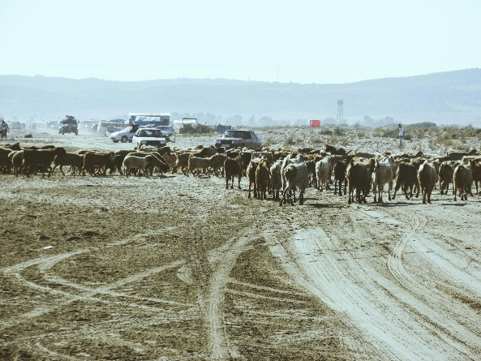
In the dry rangelands of central and western Australia, sheep and cattle roam across massive paddocks (pastures). Over time, overgrazing has worn away the native grasses and broken up soil structure. Invasive weed species often take over, and the compacted soil becomes more vulnerable to erosion.
Without enough vegetation, rainfall runs off quickly, and dust storms become more frequent, especially during hot, dry months. Indigenous communities note that traditional bush tucker plants and habitats for native wildlife are disappearing.
Some landholders are adopting rotational grazing, planting perennial grasses and working with scientists to monitor soil carbon levels. Others hesitate, concerned about reduced stocking rates and upfront costs.

Scenario 9: Urban Sprawl in India
On the outskirts of Delhi and other growing Indian cities, fertile farmland is rapidly being converted into housing developments, shopping centers and industrial sites. As concrete and asphalt spread, the underlying soil becomes sealed off, no longer able to absorb water, support roots or cycle nutrients.
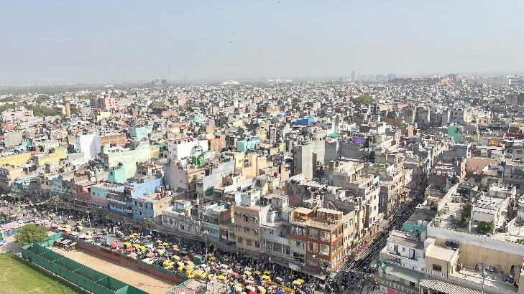
Flooding has become more common during monsoon season because the land cannot soak up excess water. Local vegetable growers are displaced, and food must travel farther to reach urban markets, increasing cost and carbon emissions.
Some urban planners and activists are pushing for green infrastructure (like parks, rain gardens and green roofs), protected farmland zones and peri-urban farming initiatives, but these are difficult to implement in the face of rising land prices and lack of regulation.
Scenario 10: Peatland Destruction in Indonesia
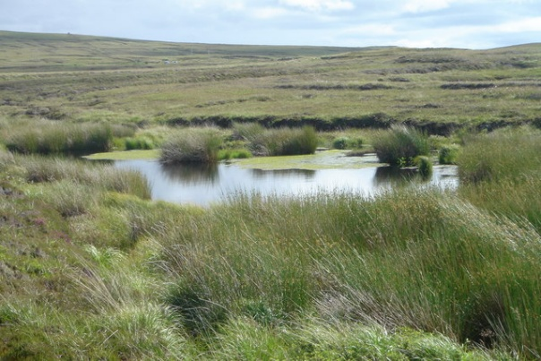
Indonesia is home to vast tropical peatlands, wetlands made of thick layers of partially decayed plant matter. These ecosystems are among the world’s largest carbon sinks, storing massive amounts of greenhouse gases. But over the past 20 years, many have been drained for palm oil plantations.
Once drained, peat dries out, shrinks and becomes highly flammable. Fires often spread uncontrollably, sending choking smoke across Southeast Asia. These fires not only release huge quantities of carbon dioxide but also disrupt local health and schooling.
Conservation groups are promoting peatland restoration through rewetting and blocking drainage canals while others push for stronger enforcement of sustainable palm oil certification standards. However, palm oil remains a major economic driver for both corporations and smallholders, making change politically and economically complex.

