A Helping Hand
Created: 07/2019 by the National FFA Organization

Student Learning Objectives:
After completing these activities, students will …
- Describe philanthropy.
- Identify philanthropic options for food insecurity and food access in the United States.
- Illustrate the impact of philanthropy in the United States.

Time Required: 120 minutes
Resources:
- AgExplorer, https://agexplorer.ffa.org/
- Feeding America Annual Report, https://www.feedingamerica.org/sites/default/files/about-us/financials/2017-feeding-america-annual-report.pdf
- Supplemental Nutrition Assistance Program (SNAP) and Women, Infants and Children (WIC), https://www.fns.usda.gov/snap/supplemental-nutrition-assistance-program-snap
- Food Bank, https://www.feedingamerica.org/our-work/food-bank-network
- Food Bank Finder, https://www.feedingamerica.org/find-your-local-foodbank
- “Philanthropy and Service: Learning: Why Do They Matter?,” https://youtu.be/MIf-Em7dmvw
- “Cayden, a Philanthropist,” https://youtu.be/UDe1xuQFwPE

Equipment and Supplies Needed:
- A copy of the “Addressing Hunger” worksheet for each student
- A copy of the “Philanthropy” worksheet for each student
- A copy of the “What Does It All Mean?” worksheet for each student
- Internet access to play the videos in real time or embed them in a PowerPoint ahead of time

This quick lesson plan would work well as:
- A leadership lesson.
- A lesson on philanthropy.
- A community service lesson.

Student Activity sheets
https://ffa.box.com/s/dj7r02o8ij0ln1wq1qnp348a9hcdi5wb (Word)
https://ffa.box.com/s/uedpdoukbmbql31yqwm3vti4b1m6igwf (PDF)

These activities are aligned to the following standards:

AFNR Performance Element
- CS.05: Describe career opportunities and means to achieve those opportunities in each of the Agriculture, Food & Natural Resources career pathways.
FFA Precept
- FFA.PL-A.Action: Assume responsibility and take the necessary steps to achieve the desired results, no matter what the goal or task at hand.
- FFA.PL-E.Awareness: Understand personal vision, mission and goals.
- FFA.PL-F.Continuous Improvement: Accept responsibility for learning and personal growth.
- FFA.PG-I.Professional Growth: Assume responsibility for attaining and improving upon the skills needed for career success.
- FFA.PG-J.Mental Growth: Embrace cognitive and intellectual development relative to reasoning, thinking and coping.
- FFA.CS-N.Decision Making: Analyze a situation and execute an appropriate course of action.
Common Career Technical Core
- AG5: Describe career opportunities and means to achieve those opportunities in each of the Agriculture, Food & Natural Resources Career Pathways.
Common Core – Reading: Informational Text
- CCSS.ELA-Literacy.RI.9-10.4: Determine the meaning of words and phrases as they are used in a text, including figurative, connotative, and technical meanings; analyze the cumulative impact of specific word choices on meaning and tone (e.g., how the language of a court opinion differs from that of a newspaper).
Common Core – Speaking and Listening
- CCSS.ELA-Literacy.SL.9-10.2: Integrate multiple sources of information presented in diverse media or formats (e.g., visually, quantitatively, orally) evaluating the credibility and accuracy of each source.
Common Core – Literacy in Science & Technical Subjects: Writing
- CCSS.ELA-Literacy.WHST.9.10.4: Produce clear and coherent writing in which the development, organization, and style are appropriate to task, purpose, and audience.
Common Core – Math Practices
- CCSS.MP1: Make sense of problems and persevere in solving them.
- CCSS.MP5: Use appropriate tools strategically.
- CCSS.MP6: Attend to precision.
AFNR Career Ready Practices
- CRP.02: Apply appropriate academic and technical skills. Career-ready individuals readily access and use the knowledge and skills acquired through experience and education to be more productive.
- CRP.04: Communicate clearly, effectively, and with reason. Career-ready individuals communicate thoughts, ideas and action plans with clarity, whether using written, verbal and/or visual methods.
- CRP.06: Demonstrate creativity and innovation. Career-ready individuals regularly think of ideas that solve problems in new and different ways, and they contribute those ideas in a useful and productive manner to improve their organization.
- CRP.07: Employ valid and reliable research strategies. Career-ready individuals are discerning in accepting and using new information to make decisions, change practices or inform strategies.
- CRP.08: Utilize critical thinking to make sense of problems and persevere in solving them. Career-ready individuals readily recognize problems in the workplace, understand the nature of the problem, and devise effective plans to solve the problem.
Partnership for 21st Century Skills
- Critical Thinking and Problem Solving
- Flexibility and Adaptability
- Initiative and Self-Direction
- Leadership and Responsibility
- Think Creatively

Lesson Plan:
- Bell Ringer: Who is responsible for solving food insecurity and hunger in the United States?

- Introduction: Philanthropy is an important factor at all levels of society: public, civic and private. Through philanthropy, at these different levels, we are working to combat food insecurity and lessen hunger in society.

- Activity 1: There are three levels of responsibility that work to address hunger and food insecurity: public, private and civic. Students will learn about each and identify opportunities in your local community. Have students read the three definitions on the worksheet “Addressing Hunger” and respond. Once students have completed the questions, have a class conversation to ensure understanding.
  - Private Responsibility: This type of responsibility falls to private business corporations. (Example: annual fundraisers for a cause put on by a private business.)
  - Public Responsibility: This type of responsibility falls to the federal, state or local government. (Example: Supplemental Nutrition Assistance Program [SNAP] and Women, Infants and Children [WIC], https://www.fns.usda.gov/snap/supplemental-nutrition-assistance-program-snap)
  - Civic Responsibility: This type of responsibility falls to each individual person and the desire to make our communities better. (Example: roadside clean-up)

Activity 2: Hand out the worksheet “Philanthropy”. Philanthropy is a crucial component in any country. Watch the video “Philanthropy and Service-Learning: Why Do They Matter?,” https://youtu.be/MIf-Em7dmvw, to learn more about philanthropy and its importance in society. While watching the video, have students complete the associated questions. After students have recorded the needed information, students will then apply what they have learned by creating a flow chart of a philanthropic activity they have seen or participated in. Have students use the example to guide their chart creation.
a. If YouTube is not available to watch the video, have students use a dictionary to first determine what the term “philanthropy” means. Next, have students use the picture on the worksheet to help them answer the rest of the questions. Students should determine the “3 T’s” of philanthropy (time, talent, treasure) and determine that philanthropy is important because it is helping others around them to help make the world a better place.

Activity 3:
Part 1: Have students watch the video “Cayden, a Philanthropist,” https://youtu.be/UDe1xuQFwPE, and answer the following questions on their own paper:
- What is Cayden doing? Why?
- What have you witnessed in your community that embodies the same ideals as what Cayden is doing? Have a discussion with the class.
  - If YouTube is not available to watch the video, have students describe the actions of an individual doing a good deed in the community, such as completing a roadside clean-up project, and explain the reasoning behind those actions.
- Why would someone want to clean-up the side of a road?
- Give an example of another type of community service or philanthropy project you have witnessed.

Part 2: Now that students understand the overarching meaning of philanthropy, explore what types of philanthropic options exist to address food insecurity. Have students explore the groups and organizations listed in the worksheet. Students will select two of the organizations they have the greatest interest in working more with. Explain to students that social media is a great way to connect in our personal lives but can also be utilized in the world of philanthropy. To help these organizations, each student will create a Snapchat story and two Instagram posts for each of their selected organizations using the template provided. Once students have finished, have them hang their stories and posts so that the rest of the class can learn more.

Activity 4: Hand out the “What Does It All Mean?” worksheet. Now that students know more about philanthropy and some of the philanthropic options available to decrease food insecurity, let’s take a look at the impact. Feeding America is a large organization working to lessen food insecurity. Have students access the Feeding America Annual Report and answer the questions. The URL for the Feeding America Annual report is https://www.feedingamerica.org/sites/default/files/about-us/financials/2017-feeding-america-annual-report.pdf. Have students look at Feeding America to see the work that goes into making a food bank work. Have students create their own flow chart illustrating how this process works. Students will then think critically to determine the difference between the identified food bank and one in their local community that is not sponsored through Feeding America. Next, students will use the food bank website to identify a Feeding America sponsored food bank close to them and describe its impact in their local community. Finally, students will use AgExplorer (https://agexplorer.ffa.org/) to identify three careers that could have a role in fighting hunger and food insecurity. Have students create a career list on the board to be able to see the breadth of careers that could be involved.

- Follow-up: Have students share with other classes what philanthropy is, why it is needed and what they can do to help those in need.

- Leveling Up: Either create your own or partner with an existing summer food backpack program or a food drive to support the local community.

- Exit Ticket: Why is philanthropy so important to the local community?

Aligned to the following standards:
CS.05; FFA.PL-A; FFA.PL-E; FFA.PL-F; FFA.PG-I; FFA.PG-J; FFA.CS-N; AG5; CCSS.ELA.RI.9-10.4; CCSS.ELA.SL.9-10.2; CCSS.ELA.WHST.9.10.4; MP1; MP5; MP6; CRP.02; CRP.04; CRP.06; CRP.07; CRP.08
Addressing Hunger
Directions:
There are three levels of responsibility that work to address hunger and food insecurity: public, private and civic. Read each definition and brainstorm the possible pros and cons of each type of responsibility.
Civic Responsibility

This type of responsibility falls to each individual person and the desire to make our communities better. (Example: roadside clean-up)
Private Responsibility

This type of responsibility falls to private business corporations. (Example: annual fundraisers for a cause put on by a private business.)
Public Responsibility

This type of responsibility falls to the federal, state or local government. (Example: Supplemental Nutrition Assistance Program [SNAP] and Women, Infants and Children [WIC])
*https://www.fns.usda.gov/snap/supplemental-nutrition-assistance-program-snap

How do each of these levels (private, public and civic) work together to meet the food insecurity and hunger issues that exist in the U.S.?
What are the pros and cons of this type of responsibility for meeting the hunger needs in the U.S.?
What are the pros and cons of this type of responsibility for meeting the hunger needs in the U.S.?

What are the pros and cons of this type of responsibility for meeting the hunger needs in the U.S.?

Philanthropy
Aligned to the following standards:
CS.05; FFA.PL-A; FFA.PL-E; FFA.PL-F; FFA.PG-I; FFA.PG-J; FFA.CS-N; AG5; CCSS.ELA.RI.9-10.4; CCSS.ELA.SL.9-10.2; CCSS.ELA.WHST.9.10.4; MP1; MP5; MP6; CRP.02; CRP.04; CRP.06; CRP.07; CRP.08
Part 1
Directions:
Philanthropy is a crucial component in any country. Watch the video “Philanthropy and Service-Learning: Why Do They Matter?,” https://youtu.be/MIf-Em7dmvw, and answer the questions below to learn more about philanthropy and its importance in society.
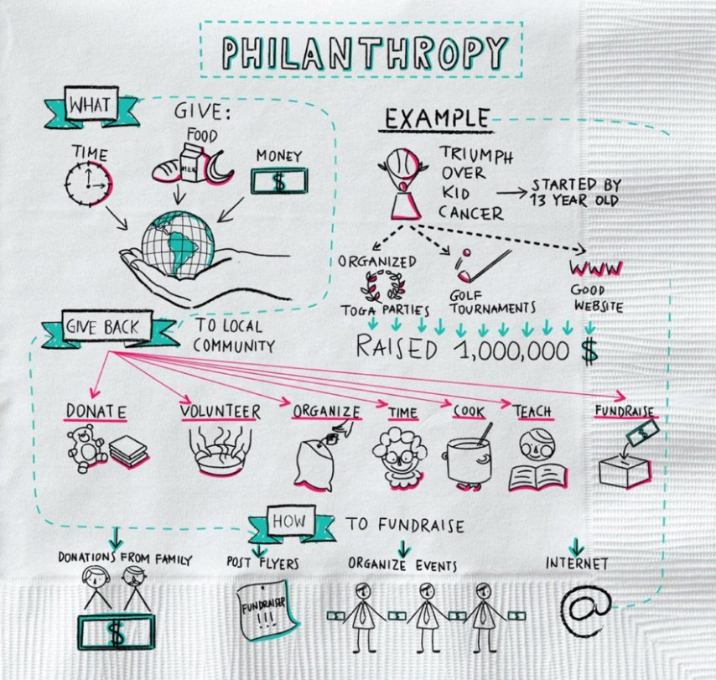

Using the example provided, draw out (like in the picture) a philanthropic activity you have participated in, witnessed or would like to start.
Philo = ________________________________________
Philanthropy is helping others by …

- T__________ Example:
- T__________ Example:
- T__________ Example:
Why should you engage in philanthropy?

Part 2
Directions:
Watch the video “Cayden, a Philanthropist,” https://youtu.be/UDe1xuQFwPE, and answer the following questions on a separate sheet of paper: (1) What is Cayden doing? Why? and (2) What have you witnessed in your community that embodies the same ideals as what Cayden is doing?

Now that we understand the overarching meaning of philanthropy, what types of philanthropic options exist to address food insecurity? Research each of the following organizations and then select two you would like to learn more about. (1) AARP and AARP Foundation, (2) Feeding America, (3) Meals on Wheels, (4) UNICEF and (5) World Food Programme.

- Select 2 organizations of most interest to you.

- _____________________________________________
- _____________________________________________
- Using the space below, record information about each organization

- Using the template below, create a Snapchat story for each organization.

- Using the template below, create an Instagram post for each organization. You will add and caption two pictures to represent the account.

(2)

Organization 2: ______________________________
Organization 1: ______________________________

(3) Each screen will be a different part of your Snapchat story for the organization listed. If you need more space for your description for each screen, you can write it under the phone image.


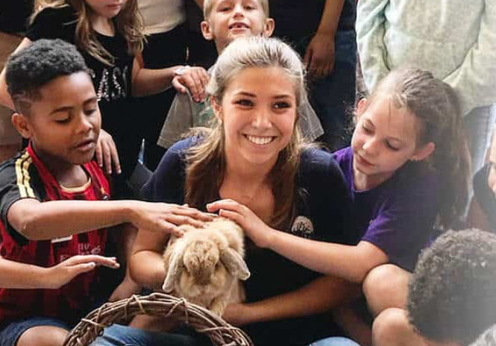
Donated dwarf goats, rabbits help FFA chapter spread happiness.
Example:

Organization 1: __________________
Organization 2: __________________________

(4) Develop two Instagram posts for each organization. Be sure to include a one- to two-sentence post to accompany your picture.



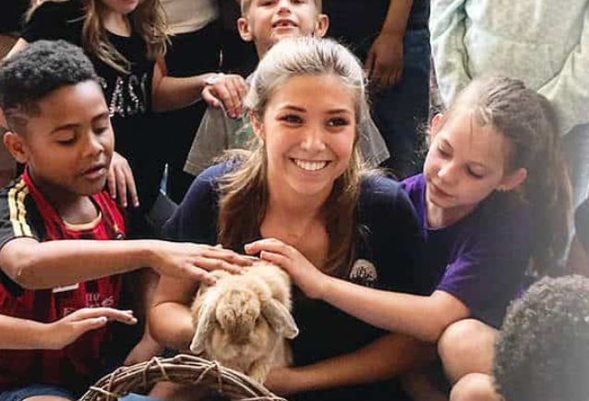
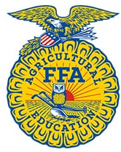

We learn best through hands-on experiences. These donated dwarf goats and rabbits help this FFA chapter spread happiness.
National FFA Organization …

Example:
Organization 1: _____________________

______________________________________________________________________________________________________________________________________________________________________________________________________________________________
_____________________ …

______________________________________________________________________________________________________________________________________________________________________________________________________________________________
_____________________ …

Organization 2: _____________________

______________________________________________________________________________________________________________________________________________________________________________________________________________________________
_____________________ …

______________________________________________________________________________________________________________________________________________________________________________________________________________________________
_____________________ …
What impact and role do these organizations have in solving food insecurity issues?

_______________________________________________________________________________________________________________________________________________________________________________________________________________________________________________________________________________________________________________________________________________________________________________________________________________________________________________________________________________________________________________________________________________________________________________________________________________________________________________________________________________________________________
_________________________________________________________________________________________________

What impact does social media have on an organization?

_______________________________________________________________________________________________________________________________________________________________________________________________________________________________________________________________________________________________________________________________________________________________________________________________________________________________________________________________________________________________________________________________________________________________________________________________________________________________________________________________________________________________________
_________________________________________________________________________________________________



What Does It All Mean?
What impact do these organizations have in solving food insecurity issues?

_______________________________________________________________________________________________________________________________________________________________________________________________________________________________________________________________________________________________________________________________________________________________________________________________________________________________________________________________________________________________________________________________________________________________________________________________________________________________________________________________________________________________________
_________________________________________________________________________________________________
Aligned to the following standards:
CS.05; FFA.PL-A; FFA.PL-E; FFA.PL-F; FFA.PG-I; FFA.PG-J; FFA.CS-N; AG5; CCSS.ELA.RI.9-10.4; CCSS.ELA.SL.9-10.2; CCSS.ELA.WHST.9.10.4; MP1; MP5; MP6; CRP.02; CRP.04; CRP.06; CRP.07; CRP.08
Directions:
Now that we know more about philanthropy and some of the philanthropic options available to decrease food insecurity, let’s take a look at the impact. Feeding America is a large organization working to lessen food insecurity.

- Using the Feeding America Annual Report, answer the following questions.
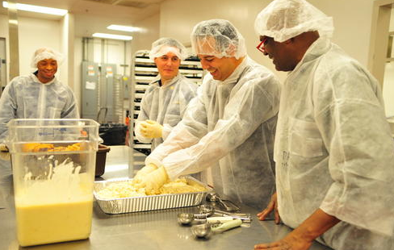

How do you think this process compares with how other food banks outside of the Feeding America network may work?
How many meals did Feeding America provide to those facing hunger and food insecurity?

_________ billion
How much food was prevented from becoming waste?

_________ billion pounds
What connection does food insecurity and hunger have with overall human health?
Overall, what impact do food banks have on local communities? Have you seen any in your local community? Explain.

- Using this website, https://www.feedingamerica.org/our-work/food-bank-network, read the information and summarize what you have read by drawing the process of how a food bank works to supply food to others. (Your illustration must look different than the website).

- Using the Feeding America food bank finder, find a food bank located near you!
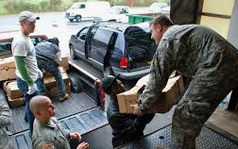

Where is the location of the closest Feeding America food bank to you?
What impact do you think this food bank has or could have on your local community?
What does your local community do to help with hunger and food insecurity?
What impact do you think your community food bank has or could have on your local community?
What can your school do to help food insecurity in your community?
What can you do to help food insecurity in your community?

- To assist in the fight against food insecurity and hunger, the U.S. will continue to need good-hearted people with a passion for service. Using AgExplorer, identify three careers
directly connected to fighting hunger and food insecurity.

- ___________________________________________
- ___________________________________________
- ___________________________________________

KEY: Addressing Hunger
Aligned to the following standards:
CS.05; FFA.PL-A; FFA.PL-E; FFA.PL-F; FFA.PG-I; FFA.PG-J; FFA.CS-N; AG5; CCSS.ELA.RI.9-10.4; CCSS.ELA.SL.9-10.2; CCSS.ELA.WHST.9.10.4; MP1; MP5; MP6; CRP.02; CRP.04; CRP.06; CRP.07; CRP.08
Directions:
There are three levels of responsibility that work to address hunger and food insecurity: public, private and civic. Learn about each and identify opportunities in your local community.
Civic Responsibility

This type of responsibility falls to each individual person and the need/want to make our communities better. (Example: roadside clean-up)

Private Responsibility

This type of responsibility falls to private business corporations. (Example: annual fundraisers for a cause put on by a private business.)
Public Responsibility

This type of responsibility falls to the federal, state, or local government. (Example: Supplemental Nutrition Assistance Program [SNAP] and Women, Infants and Children [WIC])
*https://www.fns.usda.gov/snap/supplemental-nutrition-assistance-program-snap

How do each of these levels (private, public and civic) work together to meet the food insecurity and hunger issues that exist in the U.S.? Each fulfills a different need in the fight to end hunger and food insecurity. Each has the opportunity to provide a different “T” to the issue (time, talent, treasure).
What are the pros and cons of this type of responsibility for meeting the hunger needs in the U.S.? This falls to organizations, businesses and organizations to help those in their communities. Often, there are specific times of the year in which help is given and is done in a group. (Example: Walk for the Cure)
What are the pros and cons of this type of responsibility for meeting the hunger needs in the U.S.? These types of programs help those that qualify and have strict guidelines on use of the benefit. This program greatly assists those in need at varying levels and stages of life. (Example: WIC is for infants and toddlers.)

What are the pros and cons of this type of responsibility for meeting the hunger needs in the U.S.? This relies on individual people who desire to help others. These projects can be much smaller.

KEY: Philanthropy
Aligned to the following standards:
CS.05; FFA.PL-A; FFA.PL-E; FFA.PL-F; FFA.PG-I; FFA.PG-J; FFA.CS-N; AG5; CCSS.ELA.RI.9-10.4; CCSS.ELA.SL.9-10.2; CCSS.ELA.WHST.9.10.4; MP1; MP5; MP6; CRP.02; CRP.04; CRP.06; CRP.07; CRP.08
Part 1
Directions:
Philanthropy is a crucial component in any country. Watch the video “Philanthropy and Service-Learning: Why Do They Matter?,” https://youtu.be/MIf-Em7dmvw, to learn more about philanthropy and its importance in society.
Using the example provided, draw out (like in the picture) a philanthropic activity you have participated in, witnessed or would like to start. Answers will vary.
Philo = friend, love of mankind, caring about your community
Philanthropy is helping others by …

- Time Example: Example: volunteering at the local humane society
- Treasure Example: Example: donating clothes
- Talent Example: Example: building things
Why should you engage in philanthropy? This type of responsibility falls to each individual person and the need/want to make our communities better.

Part 2
Directions:
Watch the video “Cayden, a Philanthropist,” https://youtu.be/UDe1xuQFwPE, and answer the following questions on a separate sheet of paper: (1) What is Cayden doing? Why? and (2) What have you witnessed in your community that embodies the same ideals as what Cayden is doing?

Now that we understand the overarching meaning of philanthropy, what types of philanthropic options exist to address food insecurity? Research each of the following organizations and then select two you would like to learn more about. (1) AARP and AARP Foundation, (2) Feeding America, (3) Meals on Wheels, (4) UNICEF and (5) World Food Programme.

- Select 2 organizations of most interest to you.

- _____________________________________________
- _____________________________________________
- Using the space below, record information about each organization

- Using the template below, create a Snapchat story for each organization.

- Using the template below, create an Instagram post for each organization. You will add and caption two pictures to represent the account.

(2)

Organization 2: ______________________________
Organization 1: ______________________________

(3) Each screen will be a different part of your Snapchat story for the organization listed. If you need more space for your description for each screen, you can write it under the phone image.
Donated dwarf goats, rabbits help FFA chapter spread happiness.
Example:

Organization 1: __________________
Organization 2: __________________________

(4) Develop two Instagram posts for each organization. Be sure to include a one- to two-sentence post to accompany your picture.

We learn best through hands-on experiences. These donated dwarf goats and rabbits help this FFA chapter spread happiness.
National FFA Organization …
Example:
Organization 1: _____________________

______________________________________________________________________________________________________________________________________________________________________________________________________________________________
_____________________ …

______________________________________________________________________________________________________________________________________________________________________________________________________________________________
_____________________ …

Organization 2: _____________________

______________________________________________________________________________________________________________________________________________________________________________________________________________________________
_____________________ …

______________________________________________________________________________________________________________________________________________________________________________________________________________________________
_____________________ …
What impact and role do these organizations have in solving food insecurity issues?

_______________________________________________________________________________________________________________________________________________________________________________________________________________________________________________________________________________________________________________________________________________________________________________________________________________________________________________________________________________________________________________________________________________________________________________________________________________________________________________________________________________________________________
_________________________________________________________________________________________________

What impact does social media have on an organization? Social media can be a great way to reach different audiences and share visual images of an organization. Social media can also assist in recruiting help and volunteers, organizing events and increasing attendance to events.

_______________________________________________________________________________________________________________________________________________________________________________________________________________________________________________________________________________________________________________________________________________________________________________________________________________________________________________________________________________________________________________________________________________________________________________________________________________________________________________________________________________________________________
_________________________________________________________________________________________________

What impact do these organizations have in solving food insecurity issues? These organizations help by providing a food resource that can help decrease hunger insecurity as well as help people get back on their feet.

_______________________________________________________________________________________________________________________________________________________________________________________________________________________________________________________________________________________________________________________________________________________________________________________________________________________________________________________________________________________________________________________________________________________________________________________________________________________________________________________________________________________________________
_________________________________________________________________________________________________

KEY: What Does It All Mean?
Aligned to the following standards:
CS.05; FFA.PL-A; FFA.PL-E; FFA.PL-F; FFA.PG-I; FFA.PG-J; FFA.CS-N; AG5; CCSS.ELA.RI.9-10.4; CCSS.ELA.SL.9-10.2; CCSS.ELA.WHST.9.10.4; MP1; MP5; MP6; CRP.02; CRP.04; CRP.06; CRP.07; CRP.08
Directions:
Now that we know more about philanthropy and some of the philanthropic options available to decrease food insecurity, let’s take a look at the impact. Feeding America is a large organization working to lessen food insecurity.

- Using the Feeding America Annual Report, answer the following questions.
How do you think this process compares with how other food banks outside of the Feeding America network may work? Example answer: The process is very similar. It just may be on a smaller scale.
How many meals did Feeding America provide to those facing hunger and food insecurity?

4.2 billion
How much food was prevented from becoming waste?

3.3 billion pounds
What connection does food insecurity and hunger have with overall human health? Those that are food insecure tend to have more health issues due to not having access or being able to afford better food options. (Example: diabetes)
Overall, what impact do food banks have on local communities? Have you seen any in your local community? Explain. Food banks not only provide meals to those facing food insecurity and hunger, they also help families become self-sufficient.

- Using this website, https://www.feedingamerica.org/our-work/food-bank-network, read the information and summarize what you have read by drawing the process of how a food bank works to supply food to others. (Your illustration must look different than the website). Answers will vary.

