The End Product: Packaging
Created: 02/2020 by the National FFA Organization

Description: Valent USA is a leader in sustainable solutions for a changing world, and maintaining the ability to continue feeding the growing population requires sustainability. Through this lesson series, students will have the opportunity to learn about the importance of sustainability throughout the Agriculture, Food and Natural Resources Value Chain.
Student Learning Objectives:
After completing these activities, students will …
- Analyze the purpose of food product packaging.
- Create a food product package design for their trail mix.

Time Required: 100 minutes
Resources:
- Is Food Product Packaging Getting More Deceptive?, https://youtu.be/xT9hg8jPGGU

Equipment and Supplies Needed:
- A copy of the “Product Packaging Observations” worksheet for each student
- A copy of the “What’s in a Package?” worksheet for each student
- A copy of the “Analyzing Product Packaging” worksheet for each student
- A copy of the “Designing Product Packaging” worksheet for each student
- Sticky notes for each student
- Product package examples

This quick lesson plan would work well as:
- An introductory product packaging lesson.
- An investigation of product packaging.

These activities are aligned to the following standards:
AFNR Performance Element
- CS.06: Analyze the interaction among AFNR systems in the production, processing and management of food, fiber and fuel and the sustainable use of natural resources.
- FPP.03.02: Design and apply techniques of food processing, preservation, packaging and presentation for the distribution and consumption of food products.
FFA Precept
- FFA.PL-A.Action: Assume responsibility and take the necessary steps to achieve the desired results, no matter what the goal or task at hand.
- FFA.PL-C.Vision: Visualize the future and how to get there.
- FFA.PL-E.Awareness: Understand personal vision, mission and goals.
- FFA.PL-F.Continuous Improvement: Accept responsibility for learning and personal growth.
- FFA.PG-I.Professional Growth: Assume responsibility for attaining and improving upon the skills needed for career success.
- FFA.PG-J.Mental Growth: Embrace cognitive and intellectual development relative to reasoning, thinking and coping.
- FFA-CS-M.Communication: Effectively interact with others in personal and professional settings.
- FFA.CS-N.Decision Making: Analyze a situation and execute an appropriate course of action.
Common Career Technical Core
- AG6: Analyze the interaction among AFNR systems in the production, processing and management of food, fiber and fuel and the sustainable use of natural resources.
NASDCTEc
- AGAP01.03: Plan, implement, manage, and/or provide services associated with the preservation and packaging of food and food products to prepare products for distribution.
Common Core – Speaking and Listening
- CCSS.ELA-Literacy.SL.9-10.1: Initiate and participate effectively in a range of collaborative discussions (one-on-one, in groups, and teacher-led) with diverse partners on grades 9-10 topics, texts, and issues, building on others' ideas and expressing their own clearly and persuasively.
- CCSS.ELA-Literacy.SL.9-10.2: Integrate multiple sources of information presented in diverse media or formats (e.g., visually, quantitatively, orally) evaluating the credibility and accuracy of each source.
Common Core – Literacy in Science & Technical Subjects: Writing
- CCSS.ELA-Literacy.WHST.9.10.4: Produce clear and coherent writing in which the development, organization, and style are appropriate to task, purpose, and audience.
AFNR Career Ready Practices
- CRP.02. Apply appropriate academic and technical skills. Career-ready individuals readily access and use the knowledge and skills acquired through experience and education to be more productive.
- CRP.04. Communicate clearly, effectively, and with reason. Career-ready individuals communicate thoughts, ideas and action plans with clarity, whether using written, verbal and/or visual methods.
- CRP.06. Demonstrate creativity and innovation. Career-ready individuals regularly think of ideas that solve problems in new and different ways, and they contribute those ideas in a useful and productive manner to improve their organization.
- CRP.07. Employ valid and reliable research strategies. Career-ready individuals are discerning in accepting and using new information to make decisions, change practices or inform strategies.
- CRP.08. Utilize critical thinking to make sense of problems and persevere in solving them. Career-ready individuals readily recognize problems in the workplace, understand the nature of the problem, and devise effective plans to solve the problem.
Partnership for 21st Century Skills
- Communication
- Critical Thinking and Problem Solving
- Flexibility and Adaptability
- Initiative and Self-Direction
- Leadership and Responsibility
- Think Creatively

Lesson Plan:
- Bell Ringer: (10 minutes) Food Packaging: Does It Matter?
  - Show the video “Is Food Product Packaging Getting More Deceptive?” (https://youtu.be/xT9hg8jPGGU).
  - Ask students to share their thoughts or experiences on food product packaging. Is it deceptive? Or is there a purpose and reason behind the packaging? Explain.

- Introduction: (15 minutes) What Is the Purpose of Food Packaging?
  - Have examples of food product packaging available for students to see. This can be done by bringing in real items for students to see and touch or by having images of food product packaging.
    - Recommended items: a bag of flour, a can of soup, a can or bottle of soda, bag of chips and a package that assists with cooking (such as a steamer bag, hot pocket or microwaveable soup).
  - Give students the opportunity to observe these items and notice the package features such as parts of the package, color of package, information on package, etc. Students should record their observations on the “Product Packaging Observations” worksheet.
  - After students have observed the items, ask for their observations. The teacher should record the observations on the white board (or appoint a student to record the items on the white board).
  - Note: Students should respond with observations such as holds pre-measured amounts, keeps food fresh, can re-seal for later use, has lists of ingredients, reusable, can be recycled, easy to open, etc. You will want to develop an extensive list. This list will be used for the next activity.
  - Once students have completed this activity, they will place their brainstorm to the side until Activity 2. As they work through Activity 1, they can add to their brainstorm.

- Activity 1: (15 minutes) What’s in a Package?
  - Each student will need a copy of the handout “What’s in a Package?”
  - Thinking about food products they see every day (cereal, milk, frozen pizza), students will study the different food packages pictured. Have students identify the strengths and weaknesses of the two packaging options and record their observations in the box next to the picture. Have students think about the overall packaging of the product, keeping in mind the following: product protection, keeping the product fresh/safe, cost, sustainability of the packaging, convenience, appeal and labeling, etc.

- Activity 2: (20 minutes) Analyzing Product Packaging
  - Each student will need a copy of the handout “Analyzing Product Packaging.”
  - Students will now describe the importance of product packaging needs: protection, convenience, image, fresh/safe and sustainability.
  - After sorting the list, students will consider their trail mix product package design.

- Activity 3: (30 minutes) Create Your Product Packaging
  - Each student will need a copy of the handout “Designing Product Packaging.”
  - Students will now use the four purposes of product packaging to design a package for their trail mix.
  - Students will explain their product package design.

- Follow-up: (10 minutes)
  - Have students display their product package design.
  - Give each student a few sticky notes and ask them to walk around the room, leaving a positive comment and a question about package design on each classmate’s design.

- Leveling Up: Develop a nutrition label for the food product following the USDA Food Labeling Guidelines.

- Exit Ticket: Students will turn in their product packaging design.

Product Packaging Observations
Aligned to the following standards:
CS.06; FPP.03.02; FFA.PL-A; FFA.PL-C; FFA.PL-E; FFA.PL-F; FFA.PG-I; FFA.PG-J; FFA.CS-M; FFA.CS-N; AG6; AGAP01.03; CCSS.ELA.SL.9-10.1; CCSS.ELA.SL.9-10.2; CCSS.ELA.WHST.9.10.4; CRP.04; CRP.06; CRP.07; CRP.08
Directions:
Observe the various product packages, specifically looking for items such as type of product package, colors of the package, information on the package, etc. and record your thoughts.


What’s in a Package?
Aligned to the following standards:
CS.06; FPP.03.02; FFA.PL-A; FFA.PL-C; FFA.PL-E; FFA.PL-F; FFA.PG-I; FFA.PG-J; FFA.CS-M; FFA.CS-N; AG6; AGAP01.03; CCSS.ELA.SL.9-10.1; CCSS.ELA.SL.9-10.2; CCSS.ELA.WHST.9.10.4; CRP.02; CRP.04; CRP.06; CRP.07; CRP.08
Directions:
Study the different food packages below. Identify the strengths and weaknesses of the two packaging options. Write your observations in the box next to the picture. Be sure to think about the overall packaging of the product, keeping in mind the following: product protection (we want the product to not be damaged in any way), keeping the product fresh/safe (the product should not cause any physical or biological harm to the consumer), sustainability of the packaging (meets industry standards for a sustainable package option), convenience (ease of use), and labeling/image (will I purchase this product?), etc.

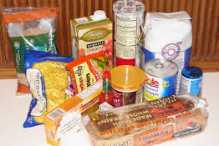
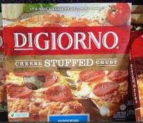
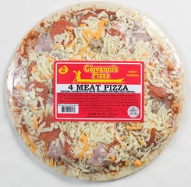
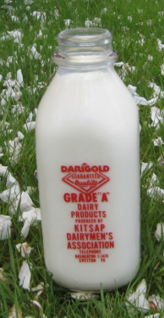
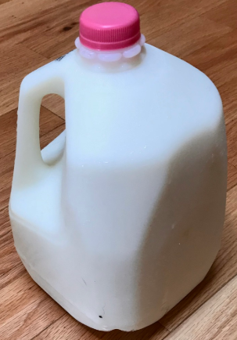
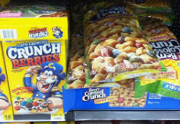
Breakfast Cereal
Strengths Weaknesses
Protection:

Convenience:

Image:

Sustainability:

Fresh and Safe:
Milk
Strengths Weaknesses
Protection:

Convenience:

Image:

Sustainability:

Fresh and Safe:

Frozen Pizza
Strengths Weaknesses
Protection:

Convenience:

Image:

Sustainability:

Fresh and Safe:
Why is selecting packaging materials, protection, labeling, sustainability, etc. so important to the food product you are trying to market and sell to the public? What impact does the packaging have?
Analyzing Product Packaging
Aligned to the following standards:
CS.06; FPP.03.02; FFA.PL-A; FFA.PL-C; FFA.PL-E; FFA.PL-F; FFA.PG-I; FFA.PG-J; FFA.CS-M; FFA.CS-N; AG6; AGAP01.03; CCSS.ELA.SL.9-10.1; CCSS.ELA.SL.9-10.2; CCSS.ELA.WHST.9.10.4; CRP.02; CRP.04; CRP.06; CRP.07; CRP.08
Directions:
Using the product packaging brainstorm that you created at the beginning of class and what you just learned about packaging importance, explain the importance of each packaging requirement. Be sure to give a specific example for each.
Sustainability
Protection
Convenience
Fresh and Safe
Image

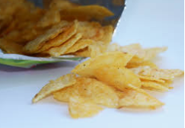
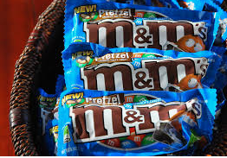
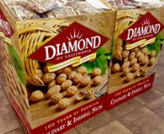
Which of the five categories above is most important to you when considering packaging for your trail mix? Explain why.
Select a food product you use often. How would you modify the packaging of the product? Explain why.

Designing Product Packaging
Aligned to the following standards:
CS.06; FPP.03.02; FFA.PL-A; FFA.PL-C; FFA.PL-E; FFA.PL-F; FFA.PG-I; FFA.PG-J; FFA.CS-M; FFA.CS-N; AG6; AGAP01.03; CCSS.ELA.SL.9-10.1; CCSS.ELA.SL.9-10.2; CCSS.ELA.WHST.9.10.4; CRP.02; CRP.04; CRP.06; CRP.07; CRP.08
Directions:
In the space below, draw the packaging you will use for your trail mix product. Consider protection, convenience, image, safety/freshness and sustainability. Label your picture with how you are going to meet each of these requirements.

Peer Review: Place your sticky note with a positive comment and a question here.

Explain the features of your product packaging.

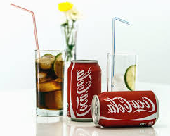
Hint: A product feature is a characteristic about your product. Examples include what it looks like, how it is used and different parts of the product.
KEY: Analyzing Product Packaging
Aligned to the following standards:
CS.06; FPP.03.02; FFA.PL-A; FFA.PL-C; FFA.PL-E; FFA.PL-F; FFA.PG-I; FFA.PG-J; FFA.CS-M; FFA.CS-N; AG6; AGAP01.03; CCSS.ELA.SL.9-10.1; CCSS.ELA.SL.9-10.2; CCSS.ELA.WHST.9.10.4; CRP.02; CRP.04; CRP.06; CRP.07; CRP.08
Directions:
Using the product packaging brainstorm that you created at the beginning of class and what you just learned about packaging importance, explain the importance of each packaging requirement. Be sure to give a specific example for each.
Protection
Answers will vary, but may include the following:

- Ships without breaking
- Keeps food fresh
- Keeps food from spoiling
- Keeps drinks carbonated
- Keeps product at certain temperature
- Keeps all pieces of product in place
Fresh and Safe
Image
Answers will vary, but may include the following:

- Looks good on shelf
- Persuades you to buy it
- Informs your choices
- List of ingredients
- Advertises the brand
- Instructions on how to use it
- Learn about company or product
- Nutritional facts
Sustainability
Answers will vary, but may include the following:

- Can be recycled
- Made from recycled products
- Resuable
- Reduces trash/waste
- Meets certain labeling requirements or certifications
√

Convenience
Answers will vary, but may include the following:

- Easier to store items
- Reseals for later use
- Easy to open
- See the item before you buy it
- Makes it easy to carry

Answers will vary, but may include the following:

- No mold or bacterial contamination
- Not stale (shelf products)
- At peak consumption freshness (fresh product, such as vegetables)
- No physical hazards

Which of the five categories above is most important to you when considering packaging for your trail mix? Explain why. Answers will vary.
Select a food product you use often. How would you modify the packaging of the product? Explain why. Answers will vary.

