Lesson Plan

Unit 1: Lesson 2 of 2
Food Science and the AFNR Value Chain

Created: 08/2022 by the National FFA Organization
This lesson will help students understand the significance food science and where it fits into the Agricultural, Food and Natural Resources (AFNR) Value Chain.
Student Learning Objectives:
After completing these activities, students will …
1. Describe how science has contributed and does contribute to the design and creation of new food products.
2. Describe the Agriculture, Food and Natural Resources (AFNR) Value Chain.
3. Create a new value-added food product.

Suggested Grade Level:
Grades 9 and 10 (This lesson is written so instructors can scale up or down based on class needs.)

Suggested Time: 60 minutes (*Time requirements may vary based upon student understanding and class schedule.)

Resources/References:
1. Website: AgExplorer (2019), AgExplorer.FFA.org
2. Textbook: Principles of Food Science, 4th Edition, Janet D. Ward (Facts/information in this lesson were obtained from the textbook.)
3. Website: FFA.org/blue365/

Related Resources:
1. FFA.org/blue365/ (for full 90-minute lesson that incorporates parts of this lesson)
2. If needed, use the Agricultural Marketed Resource Center (AMRC) website as an additional resource, https://www.agmrc.org/
3. “Value Food Chains Creating Shared Value” PDF by the USDA (see attachment)

Equipment and Supplies Needed:
1. Bell ringer: Write on the board (or otherwise make visible for students) before they enter the classroom, “Complete the ‘Role of Consumers in the Market’ worksheet as outlined in the directions on the worksheet. When finished, sit quietly.”
a. “Role of Consumers in the Market” student worksheet (found at the end of this lesson plan)
2. Introduction:
a. YouTube link, https://www.youtube.com/watch?v=YkmCQvd6_Nk b. Students need clean sheet of paper and writing utensil.
3. Activities 1 and 2: Student worksheet “Introduction to the Agriculture, Food and Natural Resources Value Chain”
4. Review/Exit Ticket: Student worksheet “Introduction to the Agriculture, Food and Natural Resources Value
Chain Review”
5. Copy of Unit 1 “Student Assessment,” one per student

Vocabulary:
1. Capitalism
2. Supply
3. Demand
4. Equilibrium prices
5. Market-clearing price
6. Marketing campaign
7. Economic campaigns
8. Personal preferences
9. Group influences
10. Purchasing power
11. Value added
12. Commodities
13. Products

Cross-Curricular Connections:

Science | English/Language Arts | Technology
• Bell ringer and Activities 1 and 2: Consideration of how science has contributed and does contribute to the design and creation of new food products | • Bell ringer: “Role of Consumers”  worksheet  • Activities 1 and 2: “Introduction to the Agriculture, Food and Natural Resources Value Chain” worksheet  Students will write responses and verbally share their findings and thoughts. | • Use of technology (computer and internet) to research information  • Consideration of how technology has  and does impact new food product production and creation

Virtual Instruction Ideas:
This entire lesson can be modified to teach online/virtually. Students need access to a computer with internet.

Student Activity Sheets:
Direct access to student activity sheets without lesson plan or answer key for easy upload to a learning management system or printing for classwork.

https://ffa.box.com/s/zlr7gynq85a7mquj5u15t9edhq0fvsub (Word) https://ffa.box.com/s/gp0yrj1qcadjex01q30gvbldmyaq5h9f (PDF) https://ffa.box.com/s/m8aabtv74iotoudrn7nb9xwout5dndgc (Non-Designed) https://docs.google.com/document/d/1Nrr48BPKxRgWxZptDsn2n2BeqP1V_gp1fqlUOCdVIs8/copy (Google)

These Activities are Aligned to the Following Standards:
AFNR Performance Element
• CS.01. Analyze how issues, trends, technologies and public policies impact systems in the Agriculture, Food &
Natural Resources Career Cluster.
FFA Precept
• FFA.PL-A.Action. Assume responsibility and take the necessary steps to achieve the desired results, no matter
what the goal or task at hand.
• FFA.PL-C.Vision. Visualize the future and how to get there.
• FFA.PL-E.Awareness. Understand personal vision, mission and goals.
• FFA.CS-M.Communication. Effectively interact with others in personal and professional settings.
• FFA.CS-N.Decision Making. Analyze a situation and execute an appropriate course of action.
Common Career Technical Core
• AG1. Analyze how issues, trends, technologies and public policies impact systems in the Agriculture, Food &
Natural Resources Career Cluster.
• AG2. Evaluate the nature and scope of the Agriculture, Food & Natural Resources Career Cluster and the role of agriculture, food, and natural resources (AFNR) in society and the economy.
NASDCTEc
• AGC05.02. Identify how key organizational systems affect organizational performance and the quality of
products and services to demonstrate an understanding of how AFNR systems are managed and improved.
Common Core – Reading: Informational Text
• CCSS.ELA-Literacy.RI.9-10.1. Cite strong and thorough textual evidence to support analysis of what the text says
explicitly as well as inferences drawn from the text.
• CCSS.ELA-Literacy.RI.9-10.2. Determine a central idea of a text and analyze its development over the course of the text, including how it emerges and is shaped and refined by specific details; provide an objective summary of the text.
• CCSS.ELA-Literacy.RI.9-10.4. Determine the meaning of words and phrases as they are used in a text, including
figurative, connotative, and technical meanings; analyze the cumulative impact of specific word choices on meaning and tone (e.g., how the language of a court opinion differs from that of a newspaper).
Common Core – Writing
• CSS.ELA-Literacy.W.9-10.2. Write informative/explanatory texts to examine and convey complex ideas, concepts,
and information clearly and accurately through the effective selection, organization, and analysis of content.
Common Core – Speaking and Listening
• CCSS.ELA-Literacy.SL.9-10.1. Initiate and participate effectively in a range of collaborative discussions (one-on-
one, in groups, and teacher-led) with diverse partners on grades 9-10 topics, texts, and issues, building on others' ideas and expressing their own clearly and persuasively.
• CCSS.ELA-Literacy.SL.9-10.4. Present information, findings, and supporting evidence clearly, concisely, and
logically such that listeners can follow the line of reasoning and the organization, development, substance, and style are appropriate to purpose, audience, and task.
Common Core – Science & Technical Subjects
• CCSS.ELA-Literacy.RST.9-10.1. Cite specific textual evidence to support analysis of science and technical texts,
attending to the precise details of explanations or descriptions.
• CCSS.ELA-Literacy.RST.9.10.4. Determine the meaning of symbols, key terms, and other domain-specific words and phrases as they are used in a specific scientific or technical context relevant to grades 9-10 texts and topics.
• CCSS.ELA-Literacy.RST.9-10.8. Assess the extent to which the reasoning and evidence in a text support the author's claim or a recommendation for solving a scientific or technical problem.
Common Core – Literacy in Science & Technical Subjects: Writing
• CCSS.ELA-Literacy.WHST.9.10.6. Use technology, including the Internet, to produce, publish, and update
individual or shared writing products, taking advantage of technology's capacity to link to other information and to display information flexibly and dynamically.
Common Core – Math Practices
• CCSS.MATH.PRACTICE.MP6 Attend to precision.
National Standards for Financial Literacy
• Buying Goods and Services, Benchmarks: Grade 12, Statement 1 Consumer decisions are influenced by the price
of a good or service, the price of alternatives, and the consumer’s income as well as his or her preferences.
• Buying Goods and Services, Benchmarks: Grade 12, Statement 2 When people consume goods and services, their consumption can have positive and negative effects on others.
AFNR Career Ready Practices
• CRP.04. Communicate clearly, effectively, and with reason. Career-ready individuals communicate thoughts,
ideas and action plans with clarity, whether using written, verbal and/or visual methods.
• CRP.05. Consider the environmental, social and economic impact of decisions. Career-ready individuals understand the interrelated nature of their actions and regularly make decisions that positively impact and/or mitigate negative impact on other people, organizations and the environment.
• CRP.06. Demonstrate creativity and innovation. Career-ready individuals regularly think of ideas that solve problems in new and different ways, and they contribute those ideas in a useful and productive manner to improve their organization.
• CRP.07. Employ valid and reliable research strategies. Career-ready individuals are discerning in accepting and using new information to make decisions, change practices or inform strategies.
• CRP.08. Utilize critical thinking to make sense of problems and persevere in solving them. Career-ready individuals readily recognize problems in the workplace, understand the nature of the problem, and devise effective plans to solve the problem.
Partnership for 21st Century Skills
• Communication
• Critical Thinking and Problem Solving
• Information, Communications, and Technology Literacy
• Initiative and Self-Direction
• Think Creatively
Lesson Plan:
1. Bell Ringer:
a. As students enter the classroom, hand each student the “Role of Consumers in the Market” worksheet. Be sure to have written on the board (or otherwise make visually available for students): “Complete the ‘Role of Consumers in the Market’ worksheet as outlined in the directions on the worksheet.”
a. Once all students are in their seats (or the bell rings), tell students they have 10 minutes to finish the questions/research. If you notice students finishing earlier, instruct them to remain quiet until everyone has finished. You may move on before 10 minutes is reached if the entire class is ready.
b. As a class, ask for volunteers to define each of the factors pertaining to the purchasing patterns of consumers in a free market — marketing campaigns, economic campaigns, personal preferences, group influence and purchasing power.
c. Ask students, “What is a consumer’s role in each of these steps?” (See the answer key located at the end of
this lesson plan.)
d. As a class, discuss the consumer’s role in free markets (see the answer key located at the end of this lesson plan).
e. Ask students, “From what we learned on this worksheet, how do you think the food we purchase and
consume fits in with consumer’s roles?” Answers will vary, but the teacher should guide students:
Consumer choices and purchases impact what food companies produce, and the amount of food
products purchased by consumers impacts the supply and demand. Farmers pledging to provide “unique” or “value-added” products opens up new choices, availability of fresh farmers markets, etc. Use this as a transition into “Introduction: Importance of the Food Value Chain.”
f. Instruct students to keep their bell ringer activity in a safe location OR collect to give a participation grade.

2. Introduction:
a. Tell students: In addition to consumer purchasing power, technology also drives what and how agricultural items are produced, this includes food. Personal health, sustainability and nutrition play key roles in driving Agriculture, Food and Natural Resources (AFNR) systems. Economics, governmental regulations and policies, environment and demographics also influence the market. Even still, the food value chain supports the transportation of goods from the producer to the consumer.
b. Show the following video clip: https://www.youtube.com/watch?v=ZkuWuK4rRxo
c. Instruct students to get out a clean sheet of paper. Tell students, On your clean sheet of paper, please answer the following (teacher may want to write these questions on the board for those students who do not hear well or are more visual learners):
a. Questions for students to answer:
i. What is the definition of “value added”? What does the process of “adding value” to a product entail?
ii. What are some ways you can add value to a product?
d. Ask students, “If this were a quiz, how would you have scored?” (Note: Students do not need to answer.) Discuss answers with students: Value added is changing something physical about a product to increase the consumer/customer base. Can you think of ways the food industry has done this? Examples: Chicken- what products are made from chicken? (chicken nuggets, cordon bleu, breaded strips, grilled strips, etc.); What products are made from corn? (cereals, muffin mixes, corn syrup, etc.)
e. Ask, “Why do we add value to raw commodities?” (Commodities are products/goods that can be interchanged (ex. Oil) regardless of who produced the item. Products are items that are specific for sale. Adding value to raw commodities can help increase sales of the product, thus offering what consumers want and will purchase/spend their money on.)

3. Activity:
a. Part 1: Give each student a copy of the worksheet “Introduction to the Agriculture, Food and Natural Resources Value Chain.” Read the directions with them. Notice Activity 1 is simply looking over the value chain and reading an example. Consider using different methods to engage students during this activity. Examples: Have different students read the components of the value chain; toss a stress ball randomly to different people to have them read aloud; count students off (1-?) and assign specific sections of the reading based on the student’s number. Before moving to Activity 2, ask if anyone has questions or needs clarification because they are going to be challenged with putting what they read into action for the next activity.
b. Part 2: Using the same worksheet, direct students to move to Activity 2. Read the directions out loud to them. Students may work with one partner on this activity (with teacher permission). Allow students to
move about in the classroom to get to a good “thinking” location. Ask if there are any questions. Let students know they have 15 minutes to complete this activity and then be ready to verbally present what they created.
i. Not to Teacher: Be sure to circulate the classroom to help clarify expectations and provide ideas if students need help.
c. After 15 minutes, check for completion. Allow more time if needed. If not, have each group/student share the following: the name of the value-added food item they came up with and why they decided to use it. (If time allows, have student share more of their creation.)
4. Follow-up:
a. Give each student a copy of the worksheet “Agriculture, Food and Natural Resources Value Chain Review.” This review will serve as both a review AND exit ticket for the day. Read the directions with students and instruct them to complete the review and to turn it in when finished.

5. Optional – Extended Learning Opportunities (Not factored into time requirement):
a. Rather than teaching this lesson plan, teachers may choose to teach a longer, more detailed lesson plan on the value chain. The following lesson plan includes components from this lesson plan. A 90- minute, more detailed lesson can be found here: FFA.org/blue365/ (Scroll down until “Lesson Plans- Value Chain” can be seen on the left side of the computer screen. Open the Word or PDF version).
*NOTE: There are other valuable resources on this page that fit with this lesson plan.

6. Exit Ticket: Use the same worksheet as used for the “review” portion of this lesson, “Agriculture, Food and
Natural Resources Value Chain Review.” Be sure to collect the worksheet when students are done.

7. Unit 1 Assessment:
a. After completion of Lesson 1 and Lesson 2 in Unit 1, distribute to students the “Unit 1 Student
Assessment.” Allow at least 30 minutes for students to complete the assessment.
Aligned to the following standards: CS.01; FFA.PL-A; FFA.PL-C; FFA.PL-E; FFA.CS-M; FFA.CS-N; AG1; AG2; AGC05.02; CCSS.ELARI.9-10.1; CCSS.ELA- RI.9-

Name:
10.2; CCSS.ELARI.9-10.4; CSS.ELAW.9-10.2; CCSS.ELA.SL.9-10.1; CCSS.ELA.SL.9-10.4; CCSS.ELA.RST.9-10.1; CCSS.ELA.RST.9.10.4; CCSS.ELA.RST.9-10.8; CCSS.ELA.WHST.9.10.6; CRP.04; CRP.05; CRP.06; CRP.07; CRP.08; Buying Goods and Services, Benchmarks: Grade 12, Statement 1; Buying Goods and Services, Benchmarks: Grade 12, Statement 2.

Bell Ringer: Role of Consumers in the Market

DIRECTIONS:
In a free market, Agriculture, Food and Natural Resources (AFNR) systems are driven by consumer demands. Consumer demands are shaped by several factors. Grasping how consumers influence the markets begins with understanding consumer purchasing power and motivations for buying agricultural products in a capitalist economy.

Complete the following:
• Visit the “Supply and Demand” and “Markets and Prices” webpages by The Library of Economics and
Liberty (n.d.), available at https://www.econlib.org/library/Topics/College/supplyanddemand.html and
“Economic Systems” by The Library of Economics and Liberty (n.d.), available at
https://www.econlib.org/library/Topics/HighSchool/EconomicSystems.html.
• Visit the “Five Common Factors Influencing Consumer Behavior” by iResearch Services (2018) website,
available at https://www.iresearchservices.com/5-common-factors-influencing-consumer-behavior/.
• Record your responses below.

Visit the “Supply and Demand,” “Markets and Prices” and “Economic Systems” webpages (links listed above) and define
the following economic terms:

Capitalism | Supply | Demand | Equilibrium Prices | Market-Clearing  Price

• Based on what you learned from these definitions, explain the role of a consumer in a capitalist economy.

• What is the role of a consumer in supply and demand?

• From what we learned on this worksheet, how do you think the food we purchase and consume fits in with
consumer’s roles?”
Visit the “Five Common Factors Influencing Consumer Behavior” by the iResearch Services (2018) website, available at
https://www.iresearchservices.com/5-common-factors-influencing-consumer-behavior/.

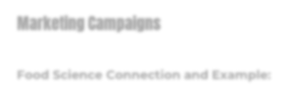Define each of the factors pertaining to the purchasing patterns of consumers in a free market. Also, describe the connection to food science and give an example.

Marketing Campaigns

Food Science Connection and Example:

Economic Campaigns

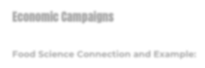Food Science Connection and Example:

Personal Preferences

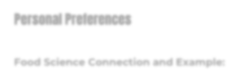Food Science Connection and Example:

Group Influence

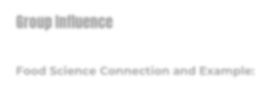Food Science Connection and Example:

Purchasing Power

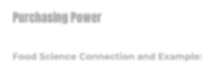Food Science Connection and Example:

• What is a consumer’s role in each of these steps?
Name:

Introduction to the Agriculture, Food and Natural
Resources Value Chain

Part 1
DIRECTIONS:
The Agriculture, Food and Natural Resources Value Chain engages several players from production to the consumer.

Complete the following:
• Review the National FFA Organization’s “Agriculture, Food and Natural Resources Value Chain”
diagram, and record your responses below.
• If needed, use the Agricultural Marketed Resource Center (AMRC) website as an additional resource
(https://www.agmrc.org/).

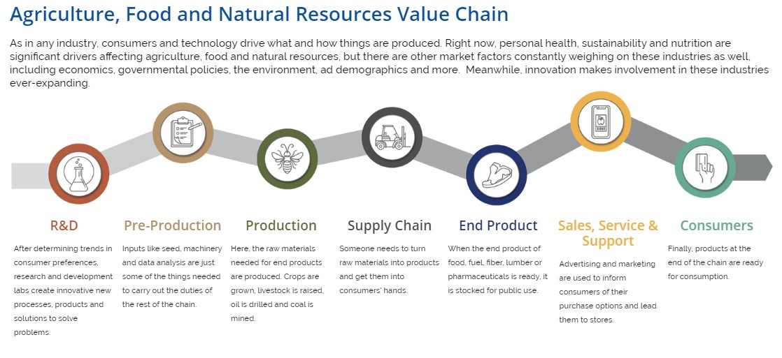To best understand value chains, it is helpful to outline how products move from production to consumer in other contexts. For example, consider the steps it would take to send a birthday card to a family member who lives in a different state. As you read each step, refer to the Agriculture, Food and Natural Resources Value Chain diagram shown above. You do not need to write anything down in this step; simply consider the steps.
1) R&D: What type of card should you buy? What does your family member like? Is there a particular
design that would appeal to your family member?
2) Pre-Production: How would the card get to the shelf? How would you travel to the store to get the card?
3) Production: What message will you write? What size stamp would it take?
4) Supply Chain: How will the letter get to your family member? How will you get it in the mail?
5) End Product: Once the letter gets to the postal service, who are the end-product players?
6) Sales, Service and Support: How will the mailperson get the letter to their mailbox?
7) Consumers: Once your family member gets the card, what will his or her reaction be?
Part 2
Using the birthday card example above, think through the value chain steps it will take to create a new value-added
food product. List the key players and questions you must consider to get a new value-added food product on the
shelves for consumers to purchase. Refer to the steps in the Agriculture, Food and Natural Resources Value Chain for ideas. Complete the following based on the new food product idea you develop.

*New, Value-Added Food Product NAME: Describe your new food product:

1) R & D:

2) Pre-Production:

3) Production:

 4) Supply Chain:

5) End Product:

6) Sales, Service and Support:

7) Consumers:
Agriculture, Food and Natural Resources Value Chain
Review + Classroom Exit Ticket

DIRECTIONS:
Review the definitions for each of the seven sectors in the Agriculture, Food and Natural Resources Value Chain diagram.
1) In your own words, label and describe each step.
2) Give an example for each step.
3) When finished, turn this worksheet in where indicated.

2 3 4
6
1 5 7

1)

2)

3)

4)

5)

6)

7)
Aligned to the following standards: CS.01; FFA.PL-A; FFA.PL-C; FFA.PL-E; FFA.CS-M; FFA.CS-N; AG1; AG2; AGC05.02; CCSS.ELARI.9-10.1; CCSS.ELA- RI.9-

Name:
10.2; CCSS.ELARI.9-10.4; CSS.ELAW.9-10.2; CCSS.ELA.SL.9-10.1; CCSS.ELA.SL.9-10.4; CCSS.ELA.RST.9-10.1; CCSS.ELA.RST.9.10.4; CCSS.ELA.RST.9-10.8; CCSS.ELA.WHST.9.10.6; CRP.04; CRP.05; CRP.06; CRP.07; CRP.08; Buying Goods and Services, Benchmarks: Grade 12, Statement 1; Buying Goods and

__
Services, Benchmarks: Grade 12, Statement 2.
KEY: Role of Consumers in the Market

Directions:
In a free market, Agriculture, Food and Natural Resources (AFNR) systems are driven by consumer demands. Consumer demands are shaped by several factors. Grasping how consumers influence the markets begins with understanding consumer purchasing power and motivations for buying agricultural products in a capitalist economy.

Complete the following:
Visit the “Supply and Demand” and “Markets and Prices” webpages by The Library of Economics and Liberty (n.d.), available at https://www.econlib.org/library/Topics/College/supplyanddemand.html and “Economic Systems” by The Library of Economics and Liberty (n.d.), available at https://www.econlib.org/library/Topics/HighSchool/EconomicSystems.html.
Visit the “Five Common Factors Influencing Consumer Behavior” by iResearch Services (2018) website, available at
https://www.iresearchservices.com/5-common-factors-influencing-consumer-behavior/. Record your responses below.

Visit the “Supply and Demand,” “Markets and Prices” and “Economic Systems” webpages (links listed above) and define
the following economic terms:

Capitalism | Supply | Demand | Equilibrium Prices | Market-Clearing
Trade/industry is not | “How much of | “How much of | “Prices that balance | Price
controlled by the | something you have” | something people | the supplies of and
state. |  | want” | demand for goods  and services.” | “There are no  shortages or  surpluses.”

• Based on what you learned from these definitions, explain the role of a consumer in a capitalist economy.
Answers will vary.

• What is the role of a consumer in supply and demand?
Answers will vary.
Name:

Visit the “Five Common Factors Influencing Consumer Behavior” by the iResearch Services (2018) website, available at
https://www.iresearchservices.com/5-common-factors-influencing-consumer-behavior/.

Define each of the factors pertaining to the purchasing patterns of consumers in a free market.

Marketing Campaigns

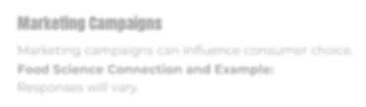Marketing campaigns can influence consumer choice.
Food Science Connection and Example:
Responses will vary.

Economic Campaigns

The market itself plays a large role in purchasing decisions made by consumers.
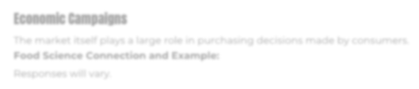Food Science Connection and Example:

Responses will vary.

Personal Preferences

A consumer's likes and dislikes will ultimately shape purchasing decisions.
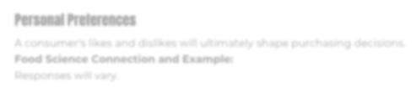Food Science Connection and Example:
Responses will vary.

Group Influence

The people that the consumer surrounds themselves with play a large role in purchasing decisions.
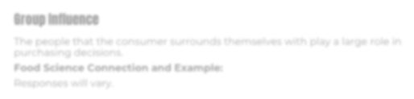Food Science Connection and Example:
Responses will vary.

Purchasing Power

Regardless of the product, if it does not fit within the purchasing power of the consumer, they cannot purchase the product.
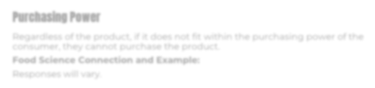Food Science Connection and Example:
Responses will vary.

• What is a consumer’s role in each of these steps?
The consumer has the ultimate final decision of what they can/cannot or will/will not purchase.
Name:
Answer KEY: Introduction to the Agriculture, Food and
Natural Resources Value Chain

*NOTE: Answers will vary depending on the food item students develop.

Helpful guide plus rubric when evaluating student participation for this activity:

Indicator | Strong  (5–4 points) | Moderate  (3–2 points) | Weak  (1–0 points) | Points  Earned
Developed a name for the new food product | Included | Included, but difficult to understand | Not included
Shared WHY the food product was developed | Included | Included, but difficult to understand and/or does not provide enough information about why the product was developed | Not included
Overall Impression  (Voice, Posture, etc.) | Voice was clear and easy to understand. Student stood up when speaking (if asked to). Student showed enthusiasm while speaking. | Voice was hard to hear/understand. Student may or may not have stood up while  presenting. Enthusiasm was not evident. | Student did not present or was not ready.
 |  |  | Total Points Possible: 15

Name:
ANSWER KEY: Introduction to the Agriculture, Food and Natural Resources Value Chain Review + Classroom Exit Ticket

*NOTE: Answers will vary depending on the food item students develop. Use the following as a resource when evaluating student work for this section:

