Why Are the Lobsters BLUE?
Aligned to the following standards:
FFA.PL-A; FFA.PL-C; FFA.PL-E; FFA.PL-F; FFA.PG-I; FFA.CS-M; CCSS.SL.9-10.1; CCSS.SL.9-10.2; CRP.04; CRP.10

Directions:
Answer the questions below as you watch the video “Lilly Richello – SAE – Blue Lobster.” The video is available at https://vimeo.com/300298592.
How many lobsters does Lilly care for?
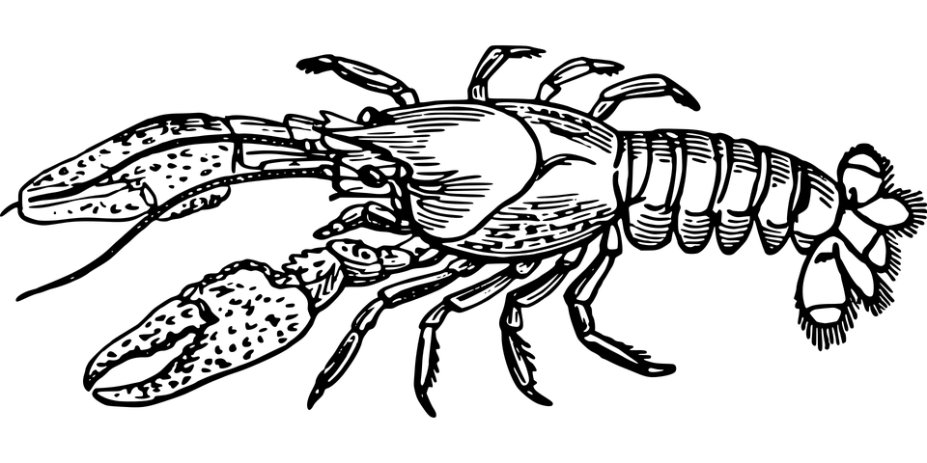
What is Lilly’s SAE?
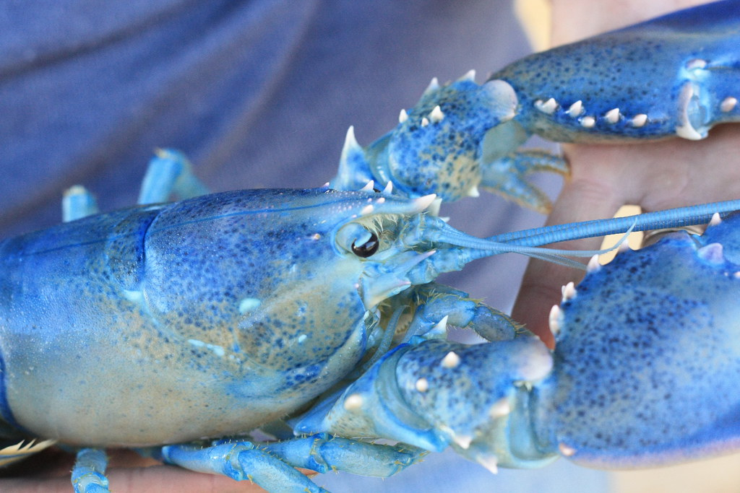
What are Lilly’s daily duties?

What is Lilly’s biggest challenge with this SAE?
How does she overcome this challenge?
Why is this so important to this SAE?

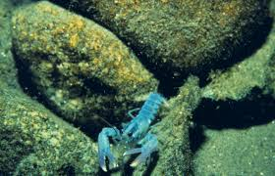
What piece of advice would Lilly give to someone looking for an SAE that suits them?
How Does It Get That Color?
Aligned to the following standards:
FFA.PL-A; FFA.PL-C; FFA.PL-E; FFA.PL-F; FFA.PG-I; FFA.CS-M; CCSS.SL.9-10.1; CCSS.SL.9-10.2; CRP.04; CRP.10

Directions:
Part 1: Work with your group members to research your given topic. Circle your topic below. Information to identify below include how it get its color and how it is grown/raised. Record your findings in the space provided.

Blue Lobsters Traditional Brown Lobsters

Purple Carrots Purple/Golden Cauliflower

RESEARCH

Part 2: You will work with your group to create a poster displaying your information. Your group can make a traditional poster or you can use Canva (www.canva.com) to create it online. Utilize the rubric below to aid you in your poster creation.

Category | 5 | 4 | 3 | 2
Required Elements | The poster includes all required elements as well as additional information. | All required elements are included on the poster. | All but 1 of the required elements are included on the poster. | Several required elements are missing.
Labels | All items of importance on the poster are clearly labeled with labels that can be read from at least 3 feet away. | Almost all items of importance on the poster are clearly labeled with labels that can be read from at least 3 feet away. | Many items of importance on the poster are clearly labeled with labels that can be read from at least 3 feet away. | Labels are too small to view or no important items are labeled.
Graphics — Relevance | All graphics are related to the topic and make it easier to understand. | All graphics are related to the topic, and most make it easier to understand. | All graphics relate to the topic. | Graphics do not relate to the topic.
Attractiveness | The poster is exceptionally attractive in terms of design, layout and neatness. | The poster is attractive in terms of design, layout and neatness. | The poster is acceptably attractive, though it may be a bit messy. | The poster is distractingly messy or very poorly designed. It is not attractive.
Grammar | There are no grammatical/mechanical mistakes on the poster. | There are 1 to 2 grammatical/mechanical mistakes on the poster. | There are 3 to 4 grammatical/mechanical mistakes on the poster. | There are more than 4 grammatical/mechanical mistakes on the poster.

Name of Student: ________________________________________________

Total Number of Points out of 25:______ x2= __________________

