Blue Lobsters
Created: 06/2019 by the National FFA Organization

SAE Video Summary: Follow Lilly as she walks us through her supervised agricultural experience (SAE) program working in the lab with blue lobsters. She shows us her daily tasks and responsibilities as well as the challenges with the lobsters.

Student Learning Objectives:
After completing these activities, students will …
- Describe the tasks in a lab-based aquatic SAE.
- Identify challenges in a partnership SAE project.
- Create a poster to display findings on how items get their color.
- Compare and contrast how animals and plants get their color.

Time Required: 60 minutes
Resources:
- “Lilly Richello – SAE – Blue Lobster,” https://vimeo.com/300298592

Equipment and Supplies Needed:
- A copy of the “Why Are the Lobsters BLUE?” worksheet for each student
- A copy of the “How Does It Get That Color?” worksheet for each student
- Internet access to play the video in real time or embed it in a PowerPoint ahead of time
- Internet access for students to conduct research
- Paper and coloring supplies for poster

This quick lesson plan would work well as Part Of:
- An SAE lesson/unit.
- An aquaculture lesson.
- A plant science lesson.

Student Activity Sheets:
Direct access to student activity sheets without lesson plan or answer key for easy upload to learning management systems or printing for classwork.
https://ffa.box.com/s/fi4enizdcr2dz457f85r4do2i6tcdq20 (Word)
https://ffa.box.com/s/4yfgff0snzxfwjwy7yi8k4679vl3ucwm (PDF)
These activities are aligned to the following standards:

FFA Precept
- FFA.PL-A.Action: Assume responsibility and take the necessary steps to achieve the desired results, no matter what the goal or task at hand.
- FFA.PL-C.Vision: Visualize the future and how to get there.
- FFA.PL-E.Awareness: Understand personal vision, mission and goals.
- FFA.PL-F.Continuous Improvement: Accept responsibility for learning and personal growth.
- FFA.PG-I.Professional Growth: Assume responsibility for attaining and improving upon the skills needed for career success.
- FFA.CS-M.Communication: Effectively interact with others in personal and professional settings.
Common Core – Speaking and Listening
- CCSS.ELA-Literacy.SL.9-10.1 Initiate and participate effectively in a range of collaborative discussions (one-on-one, in groups, and teacher-led) with diverse partners on grades 9-10 topics, texts, and issues, building on others' ideas and expressing their own clearly and persuasively.
- CCSS.ELA-Literacy.SL.9-10.2 Integrate multiple sources of information presented in diverse media or formats (e.g., visually, quantitatively, orally) evaluating the credibility and accuracy of each source.
AFNR Career Ready Practices
- CRP.04. Communicate clearly, effectively, and with reason. Career-ready individuals communicate thoughts, ideas and action plans with clarity, whether using written, verbal and/or visual methods.
- CRP.10. Plan education and career path aligned to personal goals. Career-ready individuals take personal ownership of their own educational and career goals, and they regularly act on a plan to attain these goals.
Partnership for 21st Century Skills
- Communication
- Initiative and Self-Direction
- Leadership and Responsibility

Lesson Plan:
- Bell Ringer: List as many aquatic animals as possible in one minute.

- Introduction: Review students’ answers from the bell ringer. Now that you have identified as many aquatic animals as possible, we are going to watch a short video about a student’s SAE raising a specific aquatic animal, blue lobsters.

- Activity:
  - Each student needs a copy of the worksheet “Why Are the Lobsters BLUE?” Have students watch the video “Lilly Richello – SAE – Blue Lobster” (https://vimeo.com/300298592) and answer the accompanying questions.

  - Each student needs a copy of the worksheet “How Does It Get That Color?”
Part 1: Divide students into four groups and assign them one of the following items:
- Blue lobsters
- Traditional brown lobsters
- Purple carrots
- Purple/Golden cauliflower
Groups will work together to research their given item to determine how it get its color and how it is grown/raised. Student can record their findings in the space provided on the worksheet.

Part 2: Groups will create a poster displaying their information. Groups can make a traditional poster or they can use Canva (www.canva.com) to create it online.

Part 3: Students will participate in a gallery walk around the classroom to learn about the items they were not assigned. Students will record notes on the worksheet.

- Follow Up: Upon completion of the activity, have students compare and contrast the items discussed in the activity.

- Leveling Up: To take this lesson one step further, have students try raising one of the items discussed in the activity or design an agriscience fair project around them. For more information about the agriscience fair visit, FFA.org/participate/awards/agriscience-fair/.

- Exit Ticket: Have students complete the 3-2-1 activity sheet. Students will identify three things they learned, two things they found interesting and one question they still have.

Why Are the Lobsters BLUE?
Aligned to the following standards:
FFA.PL-A; FFA.PL-C; FFA.PL-E; FFA.PL-F; FFA.PG-I; FFA.CS-M; CCSS.SL.9-10.1; CCSS.SL.9-10.2; CRP.04; CRP.10

Directions:
Answer the questions below as you watch the video “Lilly Richello – SAE – Blue Lobster.” The video is available at https://vimeo.com/300298592.
How many lobsters does Lilly care for?
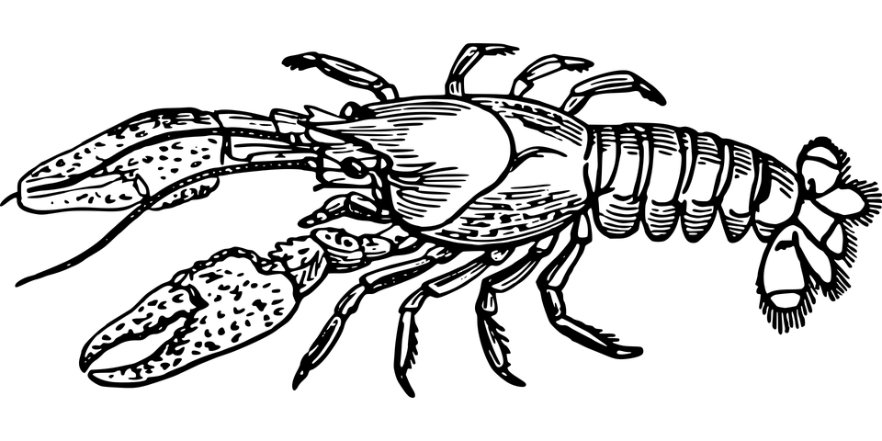
What is Lilly’s SAE?
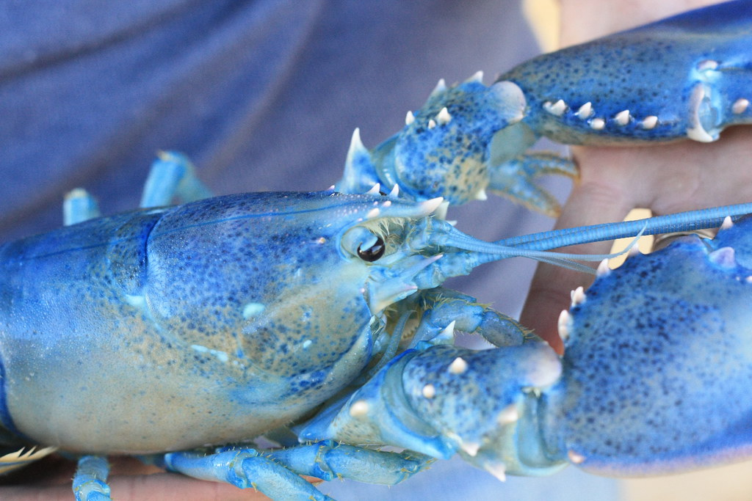
What are Lilly’s daily duties?

What is Lilly’s biggest challenge with this SAE?
How does she overcome this challenge?
Why is this so important to this SAE?

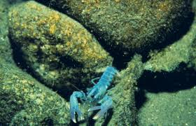
What piece of advice would Lilly give to someone looking for an SAE that suits them?
How Does It Get That Color?
Aligned to the following standards:
FFA.PL-A; FFA.PL-C; FFA.PL-E; FFA.PL-F; FFA.PG-I; FFA.CS-M; CCSS.SL.9-10.1; CCSS.SL.9-10.2; CRP.04; CRP.10

Directions:
Part 1: Work with your group members to research your given topic. Circle your topic below. Information to identify below include how it get its color and how it is grown/raised. Record your findings in the space provided.

Blue Lobsters Traditional Brown Lobsters

Purple Carrots Purple/Golden Cauliflower

RESEARCH

Part 2: You will work with your group to create a poster displaying your information. Your group can make a traditional poster or you can use Canva (www.canva.com) to create it online. Utilize the rubric below to aid you in your poster creation.

Category | 5 | 4 | 3 | 2
Required Elements | The poster includes all required elements as well as additional information. | All required elements are included on the poster. | All but 1 of the required elements are included on the poster. | Several required elements are missing.
Labels | All items of importance on the poster are clearly labeled with labels that can be read from at least 3 feet away. | Almost all items of importance on the poster are clearly labeled with labels that can be read from at least 3 feet away. | Many items of importance on the poster are clearly labeled with labels that can be read from at least 3 feet away. | Labels are too small to view or no important items are labeled.
Graphics — Relevance | All graphics are related to the topic and make it easier to understand. | All graphics are related to the topic, and most make it easier to understand. | All graphics relate to the topic. | Graphics do not relate to the topic.
Attractiveness | The poster is exceptionally attractive in terms of design, layout and neatness. | The poster is attractive in terms of design, layout and neatness. | The poster is acceptably attractive, though it may be a bit messy. | The poster is distractingly messy or very poorly designed. It is not attractive.
Grammar | There are no grammatical/mechanical mistakes on the poster. | There are 1 to 2 grammatical/mechanical mistakes on the poster. | There are 3 to 4 grammatical/mechanical mistakes on the poster. | There are more than 4 grammatical/mechanical mistakes on the poster.

Name of Student: ________________________________________________

Total Number of Points out of 25:______ x2= __________________

3-2-1 Activity Sheet

 | Three things I learned:
 | Two things I found interesting:
 | One question I still have:

KEY: Why Are the Lobsters BLUE?
Aligned to the following standards:
FFA.PL-A; FFA.PL-C; FFA.PL-E; FFA.PL-F; FFA.PG-I; FFA.CS-M; CCSS.SL.9-10.1; CCSS.SL.9-10.2; CRP.04; CRP.10

Directions:
Answer the questions below as you watch the video “Lilly Richello – SAE – Blue Lobster.” The video is available at https://vimeo.com/300298592.
How many lobsters does Lilly care for?
490
What is Lilly’s SAE?

Raising and caring for the blue lobsters
What are Lilly’s daily duties?

Feeding and basic maintenance for the lobsters

What is Lilly’s biggest challenge with this SAE?

Communication with her partner since they do not see each other on a regular basis.
How does she overcome this challenge?

They leave notes for each other in the lab to ensure all the tasks are being accomplished.
Why is this so important to this SAE?

Answers could vary.
Example: Communication is a skill you will use in your future career and when taking care of living beings it is essential to have good communication to ensure they are getting everything they need.

What piece of advice would Lilly give to someone looking for an SAE that suits them?

research

