Garden Plate
Aligned to the following standards:
FFA.PL-A; FFA.PL-C; FFA.PL-E; FFA.PL-F; FFA.PG-I; FFA.CS-M; CCSS.SL.9-10.1; CCSS.SL.9-10.2; CRP.04; CRP.10

Directions:
Part 1: Answer the questions below as you watch the video “Lindsay, Eric and Kailey Lipka – SAE – School Garden and Food Dishes.” The video URL is https://vimeo.com/300298422.
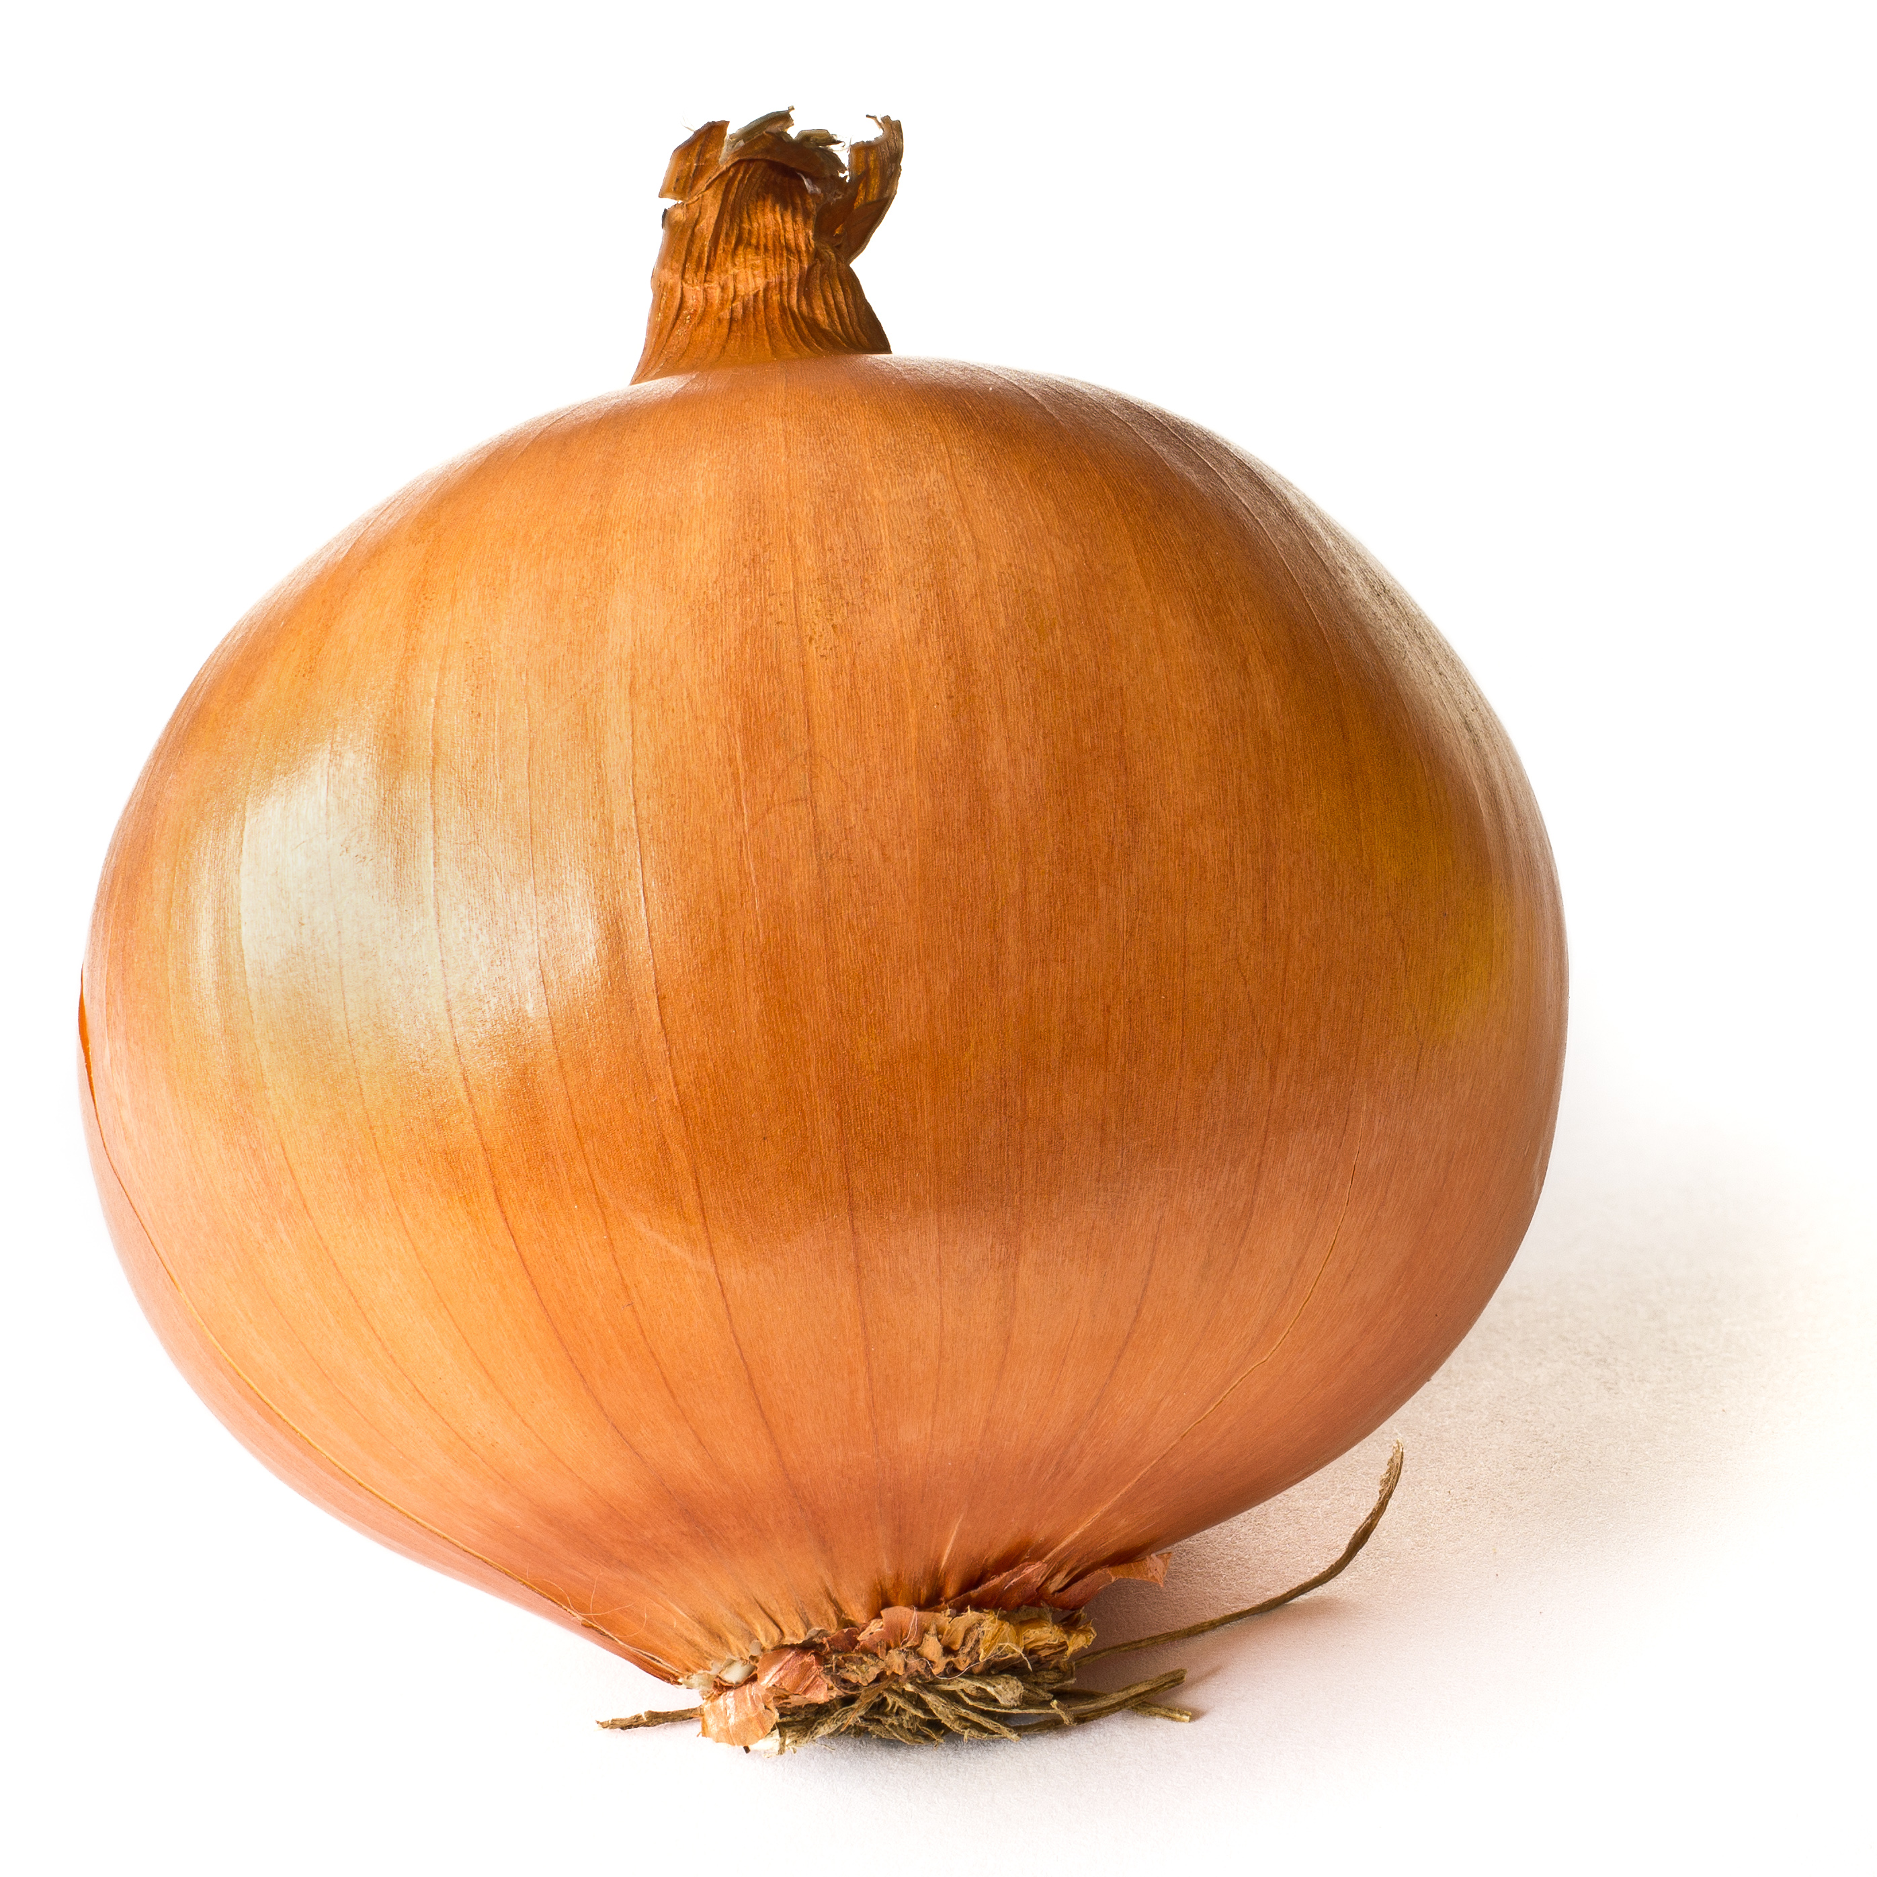
WHAT is Lindsay, Eric and Kailey’s SAE?
HOW did they get started?
WHY did they choose this project?
What is an SAE?
Biggest Challenges:
Skills Developed:

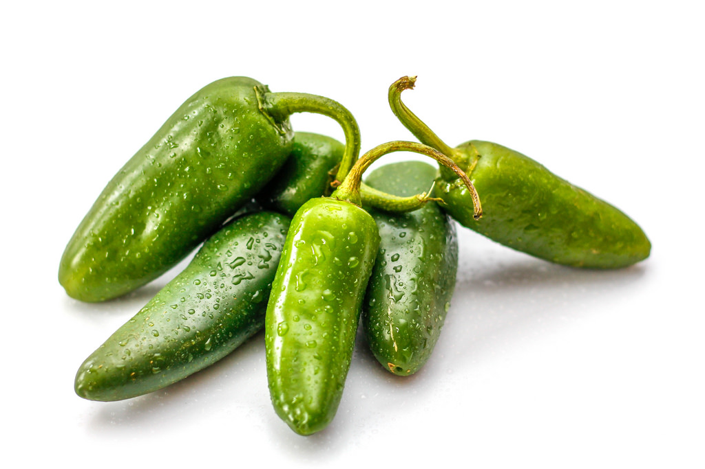

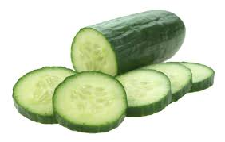

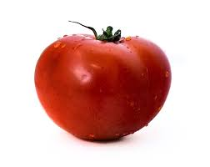

Part 2: Describe the production process Lindsay, Eric and Kailey went through to get from garden to plate.
1.
3.
2.
4.

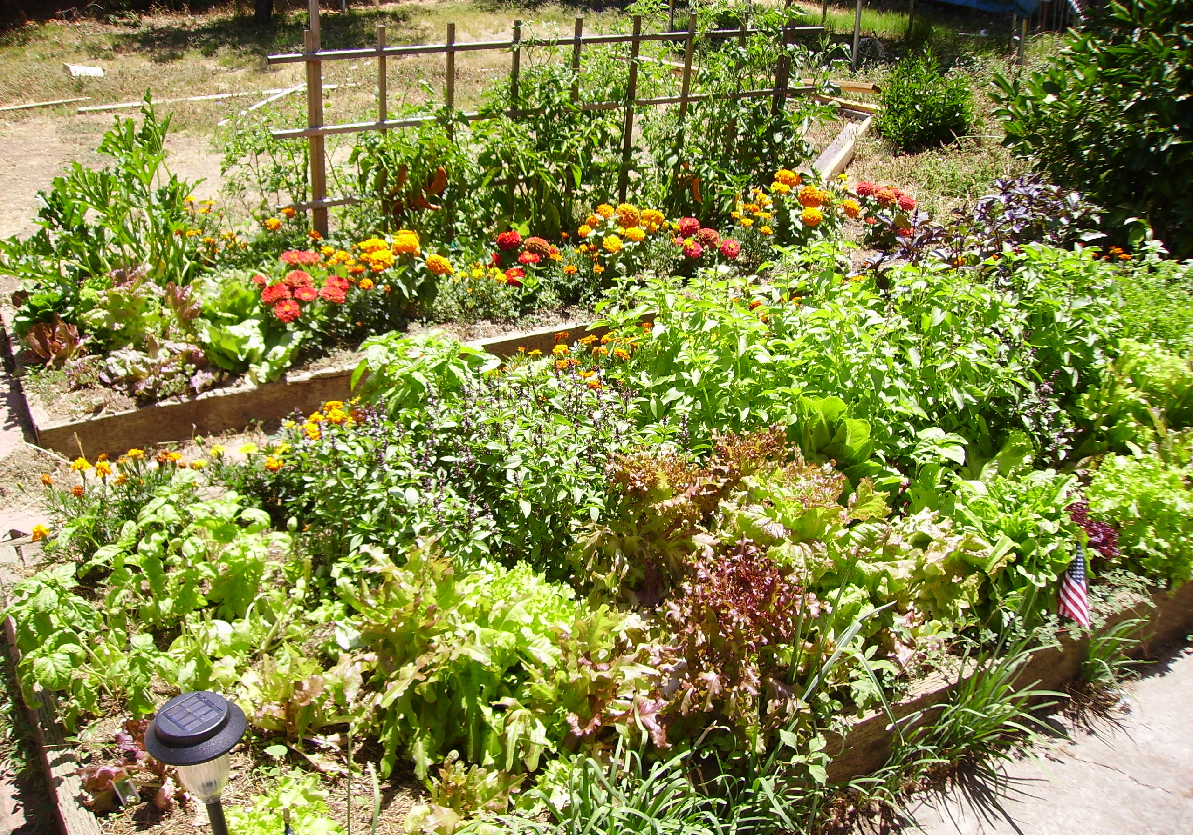

Part 3: Using the production process identified previously, design your own garden by following the prompts for each step of the process below.

PLANTING
Draw and label the vegetables you would plant in your garden in the boxes below.

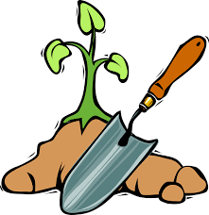

GROWING
What do your plants need for healthy growth?
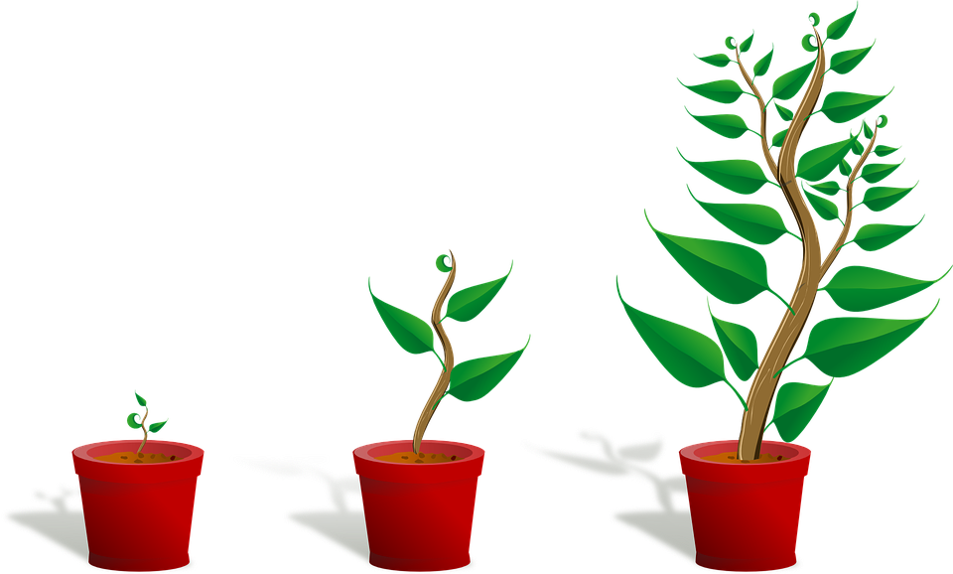

What tools and/or supplies are needed in harvesting?
HARVESTING
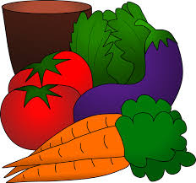

Create a recipe card using the vegetables you planted.

Directions:
________________________________________________________________________________________________________________________________________________________________________________________________________________________________________________________________________________________________________________________________________________________________________________________________________________________________________________________________________________________________________________________________________________________________________________________________________________________________________________________________________________________________

FOOD PREPARATION
Ingredients:
