Garden to Plate
Created: 02/2019 by the National FFA Organization

SAE Video Summary: Lindsay, Eric and Kailey are triplets who wanted to work together for their supervised agricultural experience (SAE) program. Follow them as they walk us through their school garden and explain how they use the produce to create food dishes such as salsa.
Student Learning Objectives:
After completing these activities, students will …
- Describe an SAE.
- Identify the steps in the production process from garden to plate.
- Design and create their own garden-to-plate enterprise.

Time Required: 45 minutes
Resources:
- Video: “Lindsay, Eric and Kailey Lipka – SAE – School Garden and Food Dishes,” https://vimeo.com/300298422

Equipment and Supplies Needed:
- A copy of the “Garden Plate” worksheet for each student
- Internet access to play the video in real time or embed it in a PowerPoint ahead of time
- Internet access for students

This quick lesson plan would work well as Part Of:
- An SAE lesson/unit.
- A food science lesson.
- A plant science lesson.

Student Activity Sheets:
Direct access to student activity sheets without lesson plan or answer key for easy upload to learning management systems or printing for classwork.
https://ffa.box.com/s/g4lb5unxh664j1ab45r3v9q31shm0yw1 (Word)
https://ffa.box.com/s/60ur9gicusgibwi98um9yh9cmejxvkmq (PDF)
These activities are aligned to the following standards:
FFA Precept
- FFA.PL-A.Action: Assume responsibility and take the necessary steps to achieve the desired results, no matter what the goal or task at hand.
- FFA.PL-C.Vision: Visualize the future and how to get there.
- FFA.PL-E.Awareness: Understand personal vision, mission and goals.
- FFA.PL-F.Continuous Improvement: Accept responsibility for learning and personal growth.
- FFA.PG-I.Professional Growth: Assume responsibility for attaining and improving upon the skills needed for career success.
- FFA.CS-M.Communication: Effectively interact with others in personal and professional settings.
Common Core – Speaking and Listening
- CCSS.ELA-Literacy.SL.9-10.1 Initiate and participate effectively in a range of collaborative discussions (one-on-one, in groups, and teacher-led) with diverse partners on grades 9-10 topics, texts, and issues, building on others' ideas and expressing their own clearly and persuasively.
- CCSS.ELA-Literacy.SL.9-10.2 Integrate multiple sources of information presented in diverse media or formats (e.g., visually, quantitatively, orally) evaluating the credibility and accuracy of each source.
AFNR Career Ready Practices
- CRP.04. Communicate clearly, effectively, and with reason. Career-ready individuals communicate thoughts, ideas and action plans with clarity, whether using written, verbal and/or visual methods.
- CRP.10. Plan education and career path aligned to personal goals. Career-ready individuals take personal ownership of their own educational and career goals, and they regularly act on a plan to attain these goals.
Partnership for 21st Century Skills
- Communication
- Initiative and Self-Direction
- Leadership and Responsibility
Lesson Plan:
- Bell Ringer: If you had a garden, what tasks might you have to complete? What goals might you have to reach to be successful?

- Introduction: Today, we are going to watch a short video where Lindsay, Eric and Kailey show us how they turned what they were learning in the classroom into a collaborative SAE program that shows the process of garden to plate.

- Activity: Each student needs a copy of the worksheet “Garden Plate.”
  - Part 1: Have students watch the video “Lindsay, Eric and Kailey Lipka – SAE – School Garden and Food Dishes” (https://vimeo.com/300298422) and answer the accompanying questions.

  - Part 2: Have students describe the production process Lindsay, Eric and Kailey went through to get from the garden to plate. Students will label the stages on the diagram.

  - Part 3: Using the production process identified previously, students will create their own garden by following the prompts for each step of the process.

- Follow Up: Upon completion of the activity, have students share their gardens and recipes with the class.

- Leveling Up: To take this lesson one step further, if you have the resources, have students design and plant a garden. If not, have students bring in the “produce” to create their recipes. Each student can “show and tell” the treat they made.

- Exit Ticket: What are the four steps in the production process from garden to plate?

Garden Plate
Aligned to the following standards:
FFA.PL-A; FFA.PL-C; FFA.PL-E; FFA.PL-F; FFA.PG-I; FFA.CS-M; CCSS.SL.9-10.1; CCSS.SL.9-10.2; CRP.04; CRP.10

Directions:
Part 1: Answer the questions below as you watch the video “Lindsay, Eric and Kailey Lipka – SAE – School Garden and Food Dishes.” The video URL is https://vimeo.com/300298422.
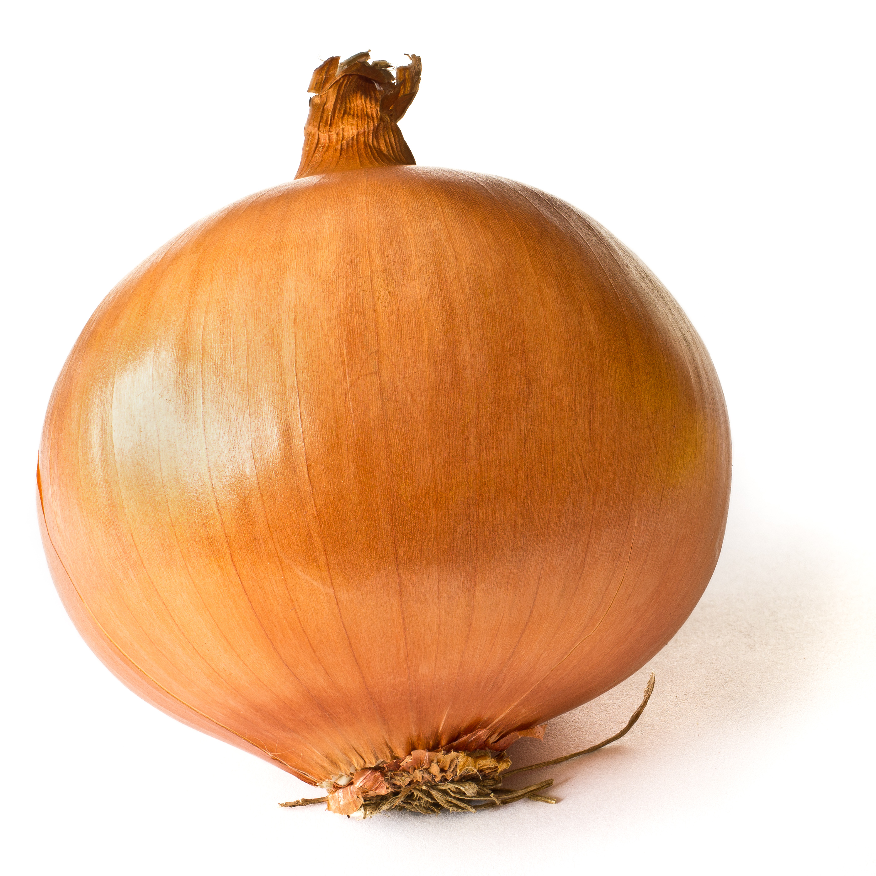
WHAT is Lindsay, Eric and Kailey’s SAE?
HOW did they get started?
WHY did they choose this project?
What is an SAE?
Biggest Challenges:
Skills Developed:

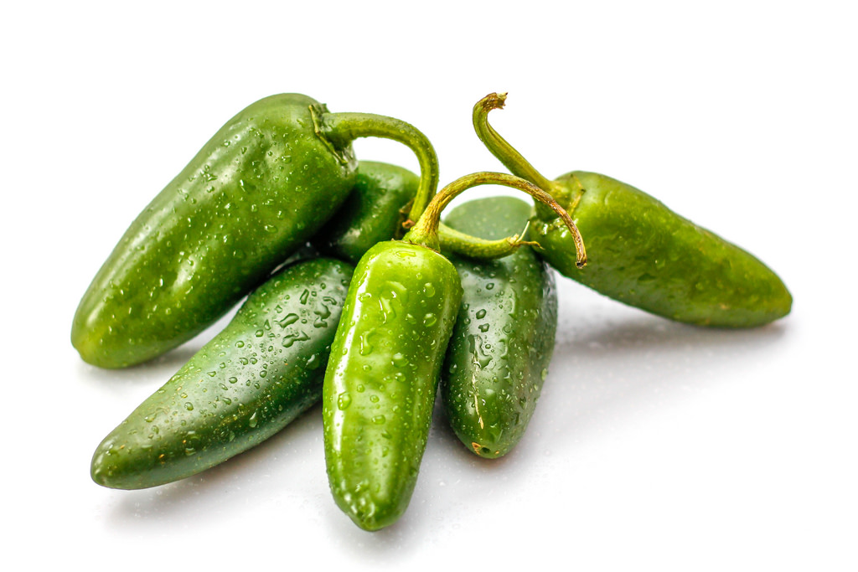

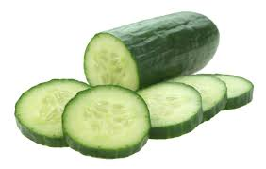

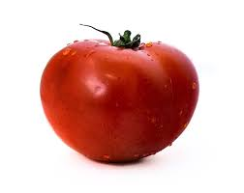

Part 2: Describe the production process Lindsay, Eric and Kailey went through to get from garden to plate.
1.
3.
2.
4.

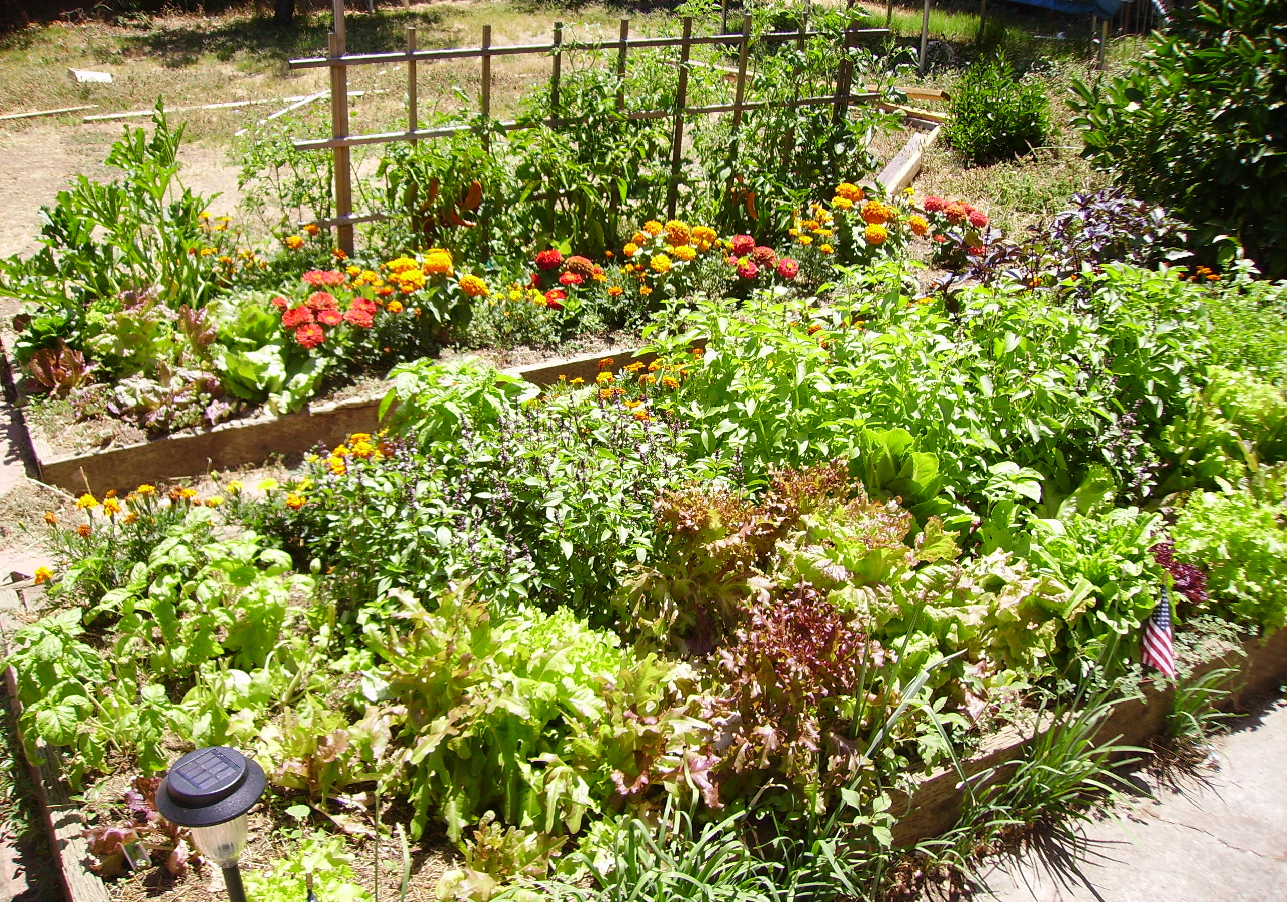

Part 3: Using the production process identified previously, design your own garden by following the prompts for each step of the process below.

PLANTING
Draw and label the vegetables you would plant in your garden in the boxes below.

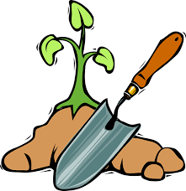

GROWING
What do your plants need for healthy growth?
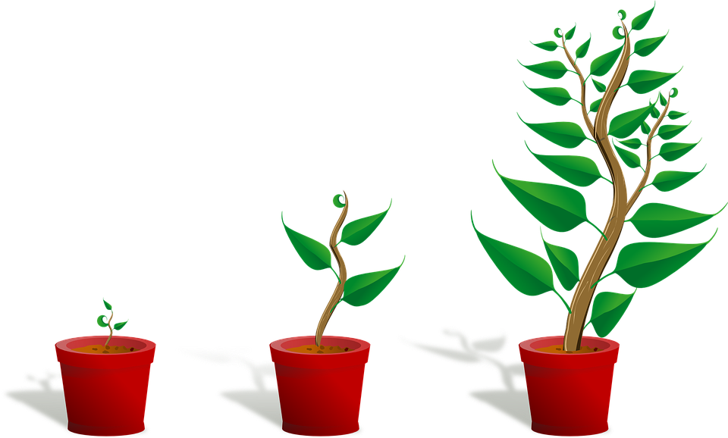

What tools and/or supplies are needed in harvesting?
HARVESTING
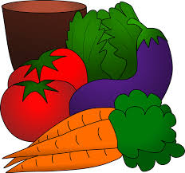

Create a recipe card using the vegetables you planted.

Directions:
________________________________________________________________________________________________________________________________________________________________________________________________________________________________________________________________________________________________________________________________________________________________________________________________________________________________________________________________________________________________________________________________________________________________________________________________________________________________________________________________________________________________

FOOD PREPARATION
Ingredients:
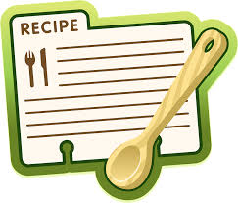

KEY: Garden Plate
Aligned to the following standards:
FFA.PL-A; FFA.PL-C; FFA.PL-E; FFA.PL-F; FFA.PG-I; FFA.CS-M; CCSS.SL.9-10.1; CCSS.SL.9-10.2; CRP.04; CRP.10

Directions:
Part 1: Answer the questions below as you watch the video “Lindsay, Eric and Kailey Lipka – SAE – School Garden and Food Dishes.” The video URL is https://vimeo.com/300298422.
WHAT is Lindsay, Eric and Kailey’s SAE?

School garden. They plant different crops to make different food dishes
HOW did they get started?

They consulted with their teacher to develop a plan/schedule.

Their teacher provided them with the equipment and supplies they needed.
WHY did they choose this project?

They wanted to work together on a project, and their teacher suggested it.
What is an SAE?
A supervised agriculture experience
Biggest Challenges:

Working in the garden in the pouring rain and weeding so the crops would have room to grow
Skills Developed:

Employability skills like cooperation and teamwork

Technical skills like identification of crops and weeds

Food safety and sanitation skills

Part 2: Describe the production process Lindsay, Eric and Kailey went through to get from garden to plate.
1.Planting
3.Harvesting
2.Growing
4.Food Production

Part 3: Using the production process identified previously, design your own garden by following the prompts for each step of the process below. Answers will vary in this section.

PLANTING
Draw and label the vegetables you would plant in your garden in the boxes below.

GROWING
What do your plants need for healthy growth?

What tools and/or supplies are needed in harvesting?
HARVESTING

Create a recipe card using the vegetables you planted.

Directions:
________________________________________________________________________________________________________________________________________________________________________________________________________________________________________________________________________________________________________________________________________________________________________________________________________________________________________________________________________________________________________________________________________________________________________________________________________________________________________________________________________________________________

FOOD PREPARATION

