Logo Activity
Directions: Match the company logo to the agricultural pathway they represent. Cut out the logos below and paste in the provided table. If you don’t have access to a printer, you can click on the logo and cut and paste in the table or write the company names in the table. (Each logo is also linked to the company website if you need more information on the company.)
*Some companies might fit in multiple pathways, so choose the one that fits best.

Logos




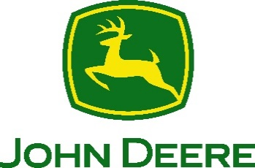



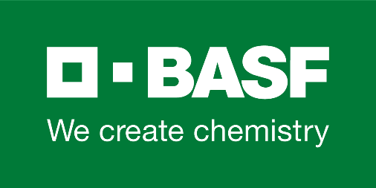




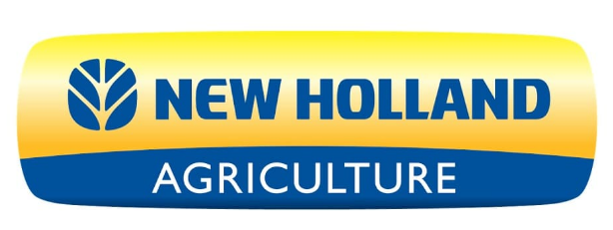
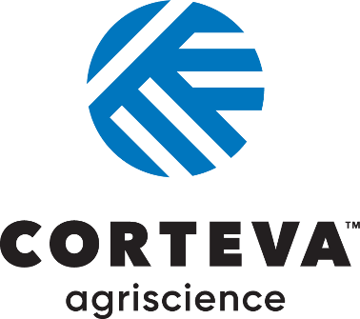

Agribusiness Systems | Animal Systems | Biotechnology Systems | Environmental Service Systems
Food Products and Processing Systems | Natural Resources Systems | Plant Systems | Power, Structural and Technical Systems

AFNR Pathway Explanation
Agribusiness Systems includes companies that connect the business world with agriculture by determining how to effectively use resources for profit and contribute to successful agriculture production. This can include crop production, farm equipment, seed supply, marketing, natural resources and animal services.

Animal Systems includes companies that work directly with animals or work with products that come from animals. Some companies treat diseased or injured animals and work to keep them healthy or study research and genetics, nutrition and the development of the animals they work with. Others develop more efficient ways of producing and processing meat, poultry, eggs and dairy products.

Biotechnology Systems includes companies that use biotechnology to enhance plants, animals and microorganisms and to solve global issues, working to increase the world’s access to safe and affordable food and clean water. These companies often investigate methods of creating fuel from agricultural byproducts and use a range of tools to better understand the basic biology of life.

Environmental Service Systems includes companies that focus on preventing the harmful effects of human activities, and they may be involved with recycling, water and air pollution control, waste disposal and public health issues. These companies use knowledge of science and engineering to meet environmental regulations and develop new methods to prevent accidents or dangerous situations.

Food Products and Processing Systems includes companies that study the physical, biological and chemical makeup of foods to improve food safety, create better processes, enhance the nutritional value and shelf-life of foods and develop new flavors. These companies may focus on diet, health and food safety by ensuring the quality of foods or work to develop new packaging, new products and new sales opportunities.

Natural Resources Systems includes companies that work to develop, maintain and manage natural environments. These companies work to protect wildlife, maintain parks, consult with research groups and keep green areas.

Plant Systems includes companies that study plants and how they impact our world. They monitor the quality and safety of our food and help consumers make sensible nutritional decisions, solve problems by developing crops that are resistant to insects and improve models to grow more food with less space. Others work to conserve our natural resources.

Power, Structural and Technical Systems includes companies that apply knowledge of engineering, hydraulics, pneumatics, electronics, power, structures and controls to the field of agriculture. These companies also create efficient processes to conserve natural resources and build solutions that impact people around the globe.

