We’re All in This Together
Aligned to the following standards:
FFA.PL-A; FFA.PL-C; FFA.PL-E; FFA.PL-F; FFA.PG-I; FFA.CS-M; CCSS.SL.9-10.1; CCSS.SL.9-10.2; CRP.04; CRP.10

Directions:
Answer the questions below as you watch the video “Maci Amaro – SAE – Goat Program,” available at https://vimeo.com/291576159.
What is Maci’s SAE project?

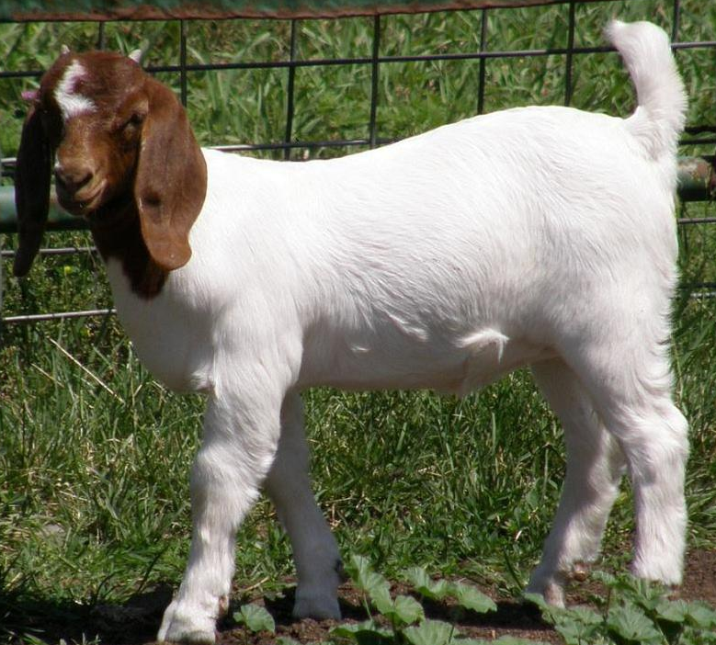
What motivated Maci in her SAE?
Skills Developed:
What challenges does Maci face?

How has this project affected Maci’s future?

What did Maci learn through her SAE?

What Can Be Done?
Aligned to the following standards:
FFA.PL-A; FFA.PL-C; FFA.PL-E; FFA.PL-F; FFA.PG-I; FFA.CS-M; CCSS.SL.9-10.1; CCSS.SL.9-10.2; CRP.04; CRP.10

Directions:
Brainstorm ideas on how each of the areas (School, Chapter, You) can be more inclusive. Record your thoughts in the area below. Use the attached bubbles for extra room.

