Come Join Us!
Created: 02/2019 by the National FFA Organization

SAE Video Summary: Follow Maci as she walks us through her supervised agricultural experience (SAE) program, managing the Mighty Honker Goat Program. In the video, she shares her passion for including others and the challenges she faces with her project.
Student Learning Objectives:
After completing these activities, students will …
- Identify skills developed through an SAE project.
- Identify and describe ways to be more inclusive.
- Develop an event or activity to foster inclusion in their FFA chapter.

Time Required: 45 minutes
Resources:
- Video: “Maci Amaro – SAE – Goat Program,” https://vimeo.com/291576159

Equipment and Supplies Needed:
- A copy of the “We’re All in This Together” worksheet for each student
- A copy of the “What Can Be Done?” worksheet for each student
- Internet access to play the video in real time or embed it in a PowerPoint ahead of time
- Internet access for students

This quick lesson plan would work well as:
- Part of an SAE lesson/unit.
- Part of an inclusion lesson.

Student Activity Sheets:
Direct access to student activity sheets without lesson plan or answer key for easy upload to learning management systems or printing for classwork.
https://ffa.box.com/s/8230wbutkgg6uyqzfziu04rklyndjv15 (Word)
https://ffa.box.com/s/18tuifxghbifnfn35t76vbppf98yh0ju (PDF)
These activities are aligned to the following standards:
FFA Precept
- FFA.PL-A.Action: Assume responsibility and take the necessary steps to achieve the desired results, no matter what the goal or task at hand.
- FFA.PL-C.Vision: Visualize the future and how to get there.
- FFA.PL-E.Awareness: Understand personal vision, mission and goals.
- FFA.PL-F.Continuous Improvement: Accept responsibility for learning and personal growth.
- FFA.PG-I.Professional Growth: Assume responsibility for attaining and improving upon the skills needed for career success.
- FFA.CS-M.Communication: Effectively interact with others in personal and professional settings.
Common Core – Speaking and Listening
- CCSS.ELA-Literacy.SL.9-10.1 Initiate and participate effectively in a range of collaborative discussions (one-on-one, in groups, and teacher-led) with diverse partners on grades 9-10 topics, texts, and issues, building on others' ideas and expressing their own clearly and persuasively.
- CCSS.ELA-Literacy.SL.9-10.2 Integrate multiple sources of information presented in diverse media or formats (e.g., visually, quantitatively, orally) evaluating the credibility and accuracy of each source.
AFNR Career Ready Practices
- CRP.04. Communicate clearly, effectively, and with reason. Career-ready individuals communicate thoughts, ideas and action plans with clarity, whether using written, verbal and/or visual methods.
- CRP.10. Plan education and career path aligned to personal goals. Career-ready individuals take personal ownership of their own educational and career goals, and they regularly act on a plan to attain these goals.
Partnership for 21st Century Skills
- Communication
- Initiative and Self-Direction
- Leadership and Responsibility
Lesson Plan:
- Bell Ringer: What does inclusion mean to you?

- Introduction: We all want to feel like we belong. Today, we are going to watch a short video about a student’s SAE project that is all about including others. After the video, we will look at ways to be more inclusive as an individual, FFA chapter and school.

- Activity:
  - Each student needs a copy of the worksheet “We’re All in This Together.” Have students watch the video “Maci Amaro – SAE – Goat Program” (https://vimeo.com/291576159) and answer the accompanying questions.

  - Each student needs a copy of the worksheet “What Can Be Done?” Have students brainstorm ideas on how each of the areas (school, chapter, you) can be more inclusive. For example, “inviting a student that is sitting alone at lunch to join me and my friends” would work well in the “You” category.

- Follow Up: Upon completion of the activity, have students discuss their ideas for a more inclusive school, chapter and personal life.

- Leveling Up: To take this lesson one step further, have students utilize the ideas from the chapter categories to design an event or activity to include students outside of FFA.

- Exit Ticket: What is one thing you can do on a daily basis to be more inclusive?

We’re All in This Together
Aligned to the following standards:
FFA.PL-A; FFA.PL-C; FFA.PL-E; FFA.PL-F; FFA.PG-I; FFA.CS-M; CCSS.SL.9-10.1; CCSS.SL.9-10.2; CRP.04; CRP.10

Directions:
Answer the questions below as you watch the video “Maci Amaro – SAE – Goat Program,” available at https://vimeo.com/291576159.
What is Maci’s SAE project?

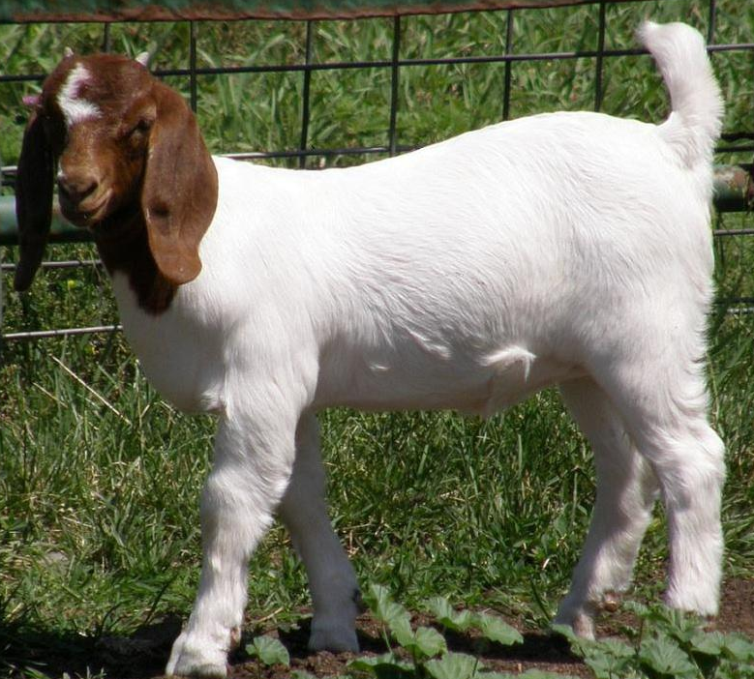
What motivated Maci in her SAE?
Skills Developed:
What challenges does Maci face?

How has this project affected Maci’s future?

What did Maci learn through her SAE?

What Can Be Done?
Aligned to the following standards:
FFA.PL-A; FFA.PL-C; FFA.PL-E; FFA.PL-F; FFA.PG-I; FFA.CS-M; CCSS.SL.9-10.1; CCSS.SL.9-10.2; CRP.04; CRP.10

Directions:
Brainstorm ideas on how each of the areas (School, Chapter, You) can be more inclusive. Record your thoughts in the area below. Use the attached bubbles for extra room.

KEY: We’re All in This Together
Aligned to the following standards:
FFA.PL-A; FFA.PL-C; FFA.PL-E; FFA.PL-F; FFA.PG-I; FFA.CS-M; CCSS.SL.9-10.1; CCSS.SL.9-10.2; CRP.04; CRP.10

Directions:
Answer the questions below as you watch the video “Maci Amaro – SAE – Goat Program,” available at https://vimeo.com/291576159.
What is Maci’s SAE project?

Mighty Honker Goat Program. A program for students with disabilities to raise, show and sell a goat at their county fair.
What motivated Maci in her SAE?

The students. She wanted to make sure they felt included in the FFA chapter.
Skills Developed:

Time management
Scheduling
Leadership
Public speaking
What challenges does Maci face?

Scheduling the mentors and pairing the mentors with the students.

How has this project affected Maci’s future?

She wants to become an agriculture teacher, so this project has helped her develop skills that will benefit her in the classroom.

What did Maci learn through her SAE?

How to work with students with special needs

