Great Service = Great Business
Created: 02/2019 by the National FFA Organization

SAE Video Summary: Follow Madalyn as she walks through her placement supervised agricultural experience (SAE) program at Bucke’s Feed & Grain. She shows us the daily tasks she completes to help in the success of the small business.
Student Learning Objectives:
After completing these activities, students will …
- Describe the tasks in a small business SAE.
- Calculate and solve sales tax and giving change problems.
- Create or update an inventory list for their agriculture class.

Time Required: 45 minutes
Resources:
- Video: “Madalyn Nissen – SAE – Bucke’s Feed & Grain,” https://vimeo.com/289989687

Equipment and Supplies Needed:
- A copy of the “All About the Small Business” worksheet for each student
- A copy of the “Inventory” worksheet for each student
- A copy of the “All About the Money” worksheet for each student
- Internet access to play the video in real time or embed it in a PowerPoint ahead of time
- Scissors
- Tape and/or glue
- Calculators

This quick lesson plan would work well as Part Of:
- An SAE lesson/unit.
- An agribusiness lesson.

Student Activity Sheets:
Direct access to student activity sheets without lesson plan or answer key for easy upload to learning management systems or printing for classwork.
https://ffa.box.com/s/7ldtindzefovn9x3jjcefo24d5jy66ug (Word)
https://ffa.box.com/s/4ypxcanvw40f1s138sm4eo0asio6bs8r (PDF)
These activities are aligned to the following standards:
FFA Precept
- FFA.PL-A.Action: Assume responsibility and take the necessary steps to achieve the desired results, no matter what the goal or task at hand.
- FFA.PL-C.Vision: Visualize the future and how to get there.
- FFA.PL-E.Awareness: Understand personal vision, mission and goals.
- FFA.PL-F.Continuous Improvement: Accept responsibility for learning and personal growth.
- FFA.PG-I.Professional Growth: Assume responsibility for attaining and improving upon the skills needed for career success.
- FFA.CS-M.Communication: Effectively interact with others in personal and professional settings.
Common Core – Speaking and Listening
- CCSS.ELA-Literacy.SL.9-10.1 Initiate and participate effectively in a range of collaborative discussions (one-on-one, in groups, and teacher-led) with diverse partners on grades 9-10 topics, texts, and issues, building on others' ideas and expressing their own clearly and persuasively.
- CCSS.ELA-Literacy.SL.9-10.2 Integrate multiple sources of information presented in diverse media or formats (e.g., visually, quantitatively, orally) evaluating the credibility and accuracy of each source.
AFNR Career Ready Practices
- CRP.04. Communicate clearly, effectively, and with reason. Career-ready individuals communicate thoughts, ideas and action plans with clarity, whether using written, verbal and/or visual methods.
- CRP.10. Plan education and career path aligned to personal goals. Career-ready individuals take personal ownership of their own educational and career goals, and they regularly act on a plan to attain these goals.

Partnership for 21st Century Skills
- Communication
- Initiative and Self-Direction
- Leadership and Responsibility

Lesson Plan:
- Bell Ringer: What tasks might you have to complete if you worked at a local store?

- Introduction: Review students’ answers from the bell ringer. Now that you have looked at tasks in a local store, what would change if we looked specifically at a grain and feed store? Today, we are going to watch a short video about a student’s SAE at a local feed and grain store.

- Activity:
  - Each student needs a copy of the worksheet “All About the Small Business.” Have students watch the video “Madalyn Nissen – SAE – Bucke’s Feed & Grain” (https://vimeo.com/289989687) and answer the accompanying questions.

  - Each student needs a copy of the worksheet “Inventory.” Students will categorize the items provided to create an inventory list. They will cut out each item and tape or glue it into its respective category. They will need to title their inventory lists.

  - Each student needs a copy of the worksheet “All About the Money.”
Part 1: Being able to correctly calculate sales tax and provide change is essential to any business. Students will calculate the sales tax and determine the total cost for the customer for each problem.

Part 2: Students will calculate the amount of change a customer is due for each problem.

- Follow Up: Upon completion of the activity, have students discuss the skills they have developed (completing an inventory and dealing with money [sales tax and change]).

- Leveling Up: To take this lesson one step further, have students complete an inventory for their specific class (shop, greenhouse, animal science, etc.)

- Exit Ticket: Why is having an accurate inventory so important to a business?

All About the Small Business
Aligned to the following standards:
FFA.PL-A; FFA.PL-C; FFA.PL-E; FFA.PL-F; FFA.PG-I; FFA.CS-M; CCSS.SL.9-10.1; CCSS.SL.9-10.2; CRP.04; CRP.10

Directions:
Answer the questions below as you watch the video “Madalyn Nissen – SAE – Bucke’s Feed & Grain.” The video URL is https://vimeo.com/289989687.

What is Madalyn’s SAE project?
Beginning Steps:



Skills Developed:


Future:


Inventory
Aligned to the following standards:
FFA.PL-A; FFA.PL-C; FFA.PL-E; FFA.PL-F; FFA.PG-I; FFA.CS-M; CCSS.SL.9-10.1; CCSS.SL.9-10.2; CRP.04; CRP.10

Directions:
Categorize the items below to create an inventory list. Cut out each item and tape or glue it into its respective category. Make sure to title your inventory lists on the next page.

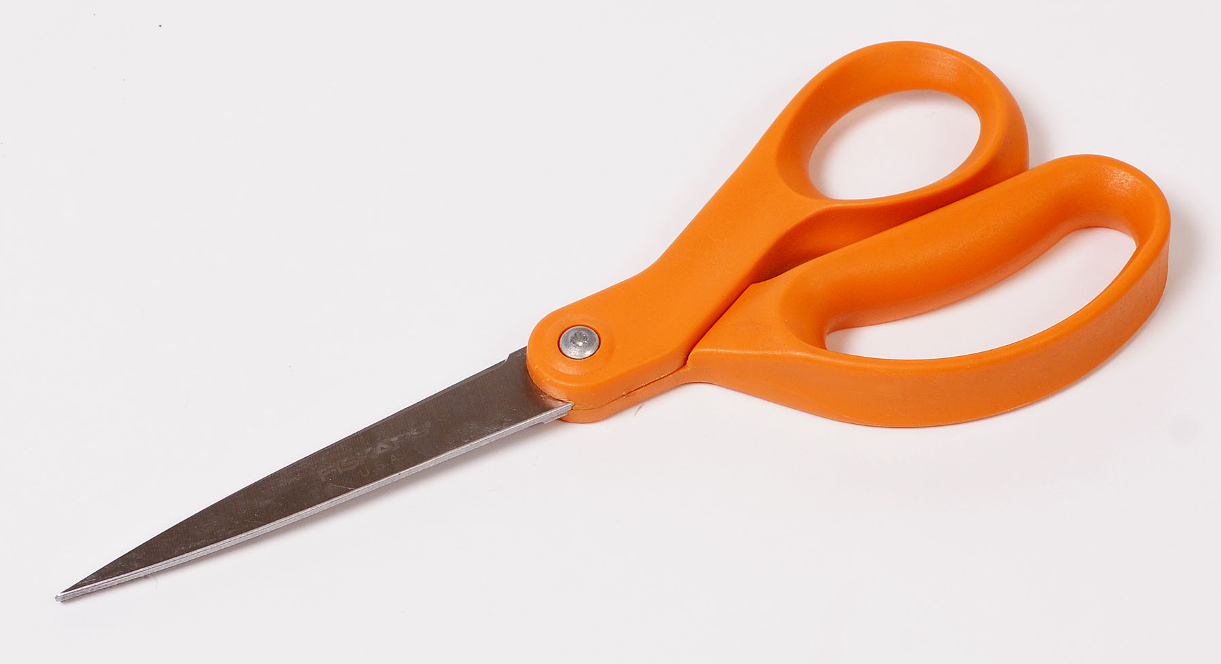




All About the Money
Aligned to the following standards:
FFA.PL-A; FFA.PL-C; FFA.PL-E; FFA.PL-F; FFA.PG-I; FFA.CS-M; CCSS.SL.9-10.1; CCSS.SL.9-10.2; CRP.04; CRP.10

Directions:
Part 1: Being able to correctly calculate sales tax and provide change is essential to any business. Complete the calculating sales tax problems below.
Example: The customer’s total before taxes is $12.50. The sales tax for your area is 7.5%.

$12.50 X 7.5% = __X___
$12.50 + X = Total due

$12.50 $12.50
X .075 + .94
.9375 rounds to $.94 (This is the amount the customer $13.44
will be charged for tax.)

The customer owes $13.44.

The customer’s total before tax is $25.75.
The sales tax is 9.5%.
The customer’s total before tax is $56.00.
The sales tax is 8%.

The customer’s total before tax is $72.25.
The sales tax is 8.5%.
The customer’s total before tax is $110.00.
The sales tax is 7.5%.

Part 2: Complete the providing change problems below.

Example: The customer’s total $12.50. They hand you $20. What is their change?

$20.00
- $12.50
$7.50

The customer gets back $7.50.

The customer’s total is $56.35.
They hand you $60.00.
The customer’s total is $25.76.
They hand you $26.00.

The customer’s total is $22.50.
They hand you $30.00.
The customer’s total is $12.75.
They hand you $15.00.
The customer’s total is $150.02.
They hand you $155.00.
The customer’s total is $75.10.
They hand you $80.00.

KEY: All About the Small Business
Aligned to the following standards:
FFA.PL-A; FFA.PL-C; FFA.PL-E; FFA.PL-F; FFA.PG-I; FFA.CS-M; CCSS.SL.9-10.1; CCSS.SL.9-10.2; CRP.04; CRP.10

Directions:
Answer the questions below as you watch the video “Madalyn Nissen – SAE – Bucke’s Feed & Grain.” The video URL is https://vimeo.com/289989687.

What is Madalyn’s SAE project?

Working at Bucke’s Feed and Grain
Beginning Steps:

Being given tasks in the back like sweeping floors and stocking shelves

Now being able to answer the phone and run the cash register

Skills Developed:

Communication skills
Value of a hard work ethic
Being on a team

Future:

The basics of customer service and working within the community

KEY: Inventory
Aligned to the following standards:
FFA.PL-A; FFA.PL-C; FFA.PL-E; FFA.PL-F; FFA.PG-I; FFA.CS-M; CCSS.SL.9-10.1; CCSS.SL.9-10.2; CRP.04; CRP.10

Directions:
Categorize the items below to create an inventory list. Cut out each item and tape or glue it into its respective category. Make sure to title your inventory lists on the next page.

Shop Supplies
Greenhouse Supplies
Office Supplies

Pencils/Pens
Paper clips
Scissors

Hammer
Screwdriver
Pliers
Duct tape

Pot
Soil
Seeds

KEY: All About the Money
Aligned to the following standards:
FFA.PL-A; FFA.PL-C; FFA.PL-E; FFA.PL-F; FFA.PG-I; FFA.CS-M; CCSS.SL.9-10.1; CCSS.SL.9-10.2; CRP.04; CRP.10

Directions:
Part 1: Being able to correctly calculate sales tax and provide change is essential to any business. Complete the calculating sales tax problems below.
Example: The customer’s total before taxes is $12.50. The sales tax for your area is 7.5%.

$12.50 X 7.5% = __X___
$12.50 + X = Total due

$12.50 $12.50
X .075 + .94
.9375 rounds to $.94 (This is the amount the customer $13.44
will be charged for tax.)

The customer owes $13.44.

The customer’s total before tax is $72.25.
The sales tax is 8.5%.

$78.39
The customer’s total before tax is $25.75.
The sales tax is 9.5%.

$28.20

The customer’s total before tax is $56.00.
The sales tax is 8%.

$60.48

The customer’s total before tax is $110.00.
The sales tax is 7.5%.

$118.25

Part 2: Complete the providing change problems below.

Example: The customer’s total $12.50. They hand you $20. What is their change?

$20.00
- $12.50
$7.50

The customer gets back $7.50.

The customer’s total is $56.35.
They hand you $60.00.

$3.65
The customer’s total is $25.76.
They hand you $26.00.

$0.24

The customer’s total is $22.50.
They hand you $30.00.

$7.50
The customer’s total is $12.75.
They hand you $15.00.

$2.25
The customer’s total is $75.10.
They hand you $80.00.

$4.90

The customer’s total is $150.02.
They hand you $155.00.

$4.98

