Maisie Jane
Directions:
Complete the worksheet while watching the video, “Maisie Jane Hurtado – SAE – Owner, Maisie Jane’s™ California Sunshine.” The video is available at https://vimeo.com/291685122.

Part 1

1) How did her SAE start?
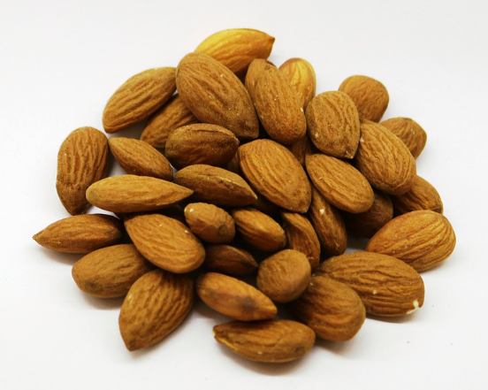
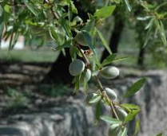
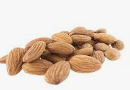

In what year did she change her SAE?
Circle the correct answer.
a. Sophomore
b. Senior
c. Freshmen
d. Junior

How many pounds of almonds did she begin with?
Circle the correct answer.
a. 1,500 pounds
b. 2,500 pounds
c. 2,000 pounds
d. 1,110 pounds

2. After doing research, what did she decide to do next as an SAE?

3.Where did she start selling her product?

Aligned to the following standards:
FFA.PL-A.; FFA.PL-B.; FFA.PL-D.; FFA. PL-F.; FFA.PG-H.; FFA.CS-M.; FFA.CS-N.; FFA.CS-O; CCSS.ELA-RI.9-10.4; CCSS.ELA-W.9-10.2; CCSS.W.9-10.4; CCSS.ELA-W.9-10.6; CCSS.ELA-SL.9-10.4; CCSS.ELA-WHST.9.10.2; CCSS.ELA-WHST.9.10.4; CCSS.ELA-WHST.9.10.6; MP1; MP2; MP6; CRP.04; CRP.06; CRP.08; CRP.11

Aligned to the following standards:
FFA.PL-A.; FFA.PL-B.; FFA.PL-D.; FFA. PL-F.; FFA.PG-H.; FFA.CS-M.; FFA.CS-N.; FFA.CS-O; CCSS.ELA-RI.9-10.4; CCSS.ELA-W.9-10.2; CCSS.W.9-10.4; CCSS.ELA-W.9-10.6; CCSS.ELA-SL.9-10.4; CCSS.ELA-WHST.9.10.2; CCSS.ELA-WHST.9.10.4; CCSS.ELA-WHST.9.10.6; MP1; MP2; MP6; CRP.04; CRP.06; CRP.08; CRP.11

Part 2
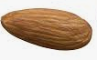
Choose three SAE Idea Cards available at https://FFA.box.com/v/saeideacards. Use the information to complete the appropriate boxes in the chart.
Do you have an SAE?
Yes
What 3 pieces of advice would you give to another student starting out with their SAE?
Go to the SAE Idea Cards (see link in instructions above). Choose 3 SAE Idea card areas/topics and write in this space:
From the 3 cards you chose, choose 1 card/area.

Topic:

How would you get started with this SAE area/topic? What would be the beginning steps? Identify and explain at least 2.
How has your SAE already impacted your daily life, goals, etc.?

No

Looking to the future, how do you foresee your SAE having an impact?
What doe SAE mean?

Aligned to the following standards:
FFA.PL-A.; FFA.PL-B.; FFA.PL-D.; FFA. PL-F.; FFA.PG-H.; FFA.CS-M.; FFA.CS-N.; FFA.CS-O; CCSS.ELA-RI.9-10.4; CCSS.ELA-W.9-10.2; CCSS.W.9-10.4; CCSS.ELA-W.9-10.6; CCSS.ELA-SL.9-10.4; CCSS.ELA-WHST.9.10.2; CCSS.ELA-WHST.9.10.4; CCSS.ELA-WHST.9.10.6; MP1; MP2; MP6; CRP.04; CRP.06; CRP.08; CRP.11
Part 3

Identify the brands below:




1. ___________________________ 2. ________________________ 3. __________________________

4. Why are these brands so recognizable?

5. Visit https://www.leightoninteractive.com/blog/five-components-of-a-strong-brand-an-infographic to learn more about components of a successful brand. Write the components in the boxes below.

6. Create your own logo for your brand. Use this rubric to help guide you through the process. Use the space below to design your brand.
Aligned to the following standards:
FFA.PL-A.; FFA.PL-B.; FFA.PL-D.; FFA. PL-F.; FFA.PG-H.; FFA.CS-M.; FFA.CS-N.; FFA.CS-O; CCSS.ELA-RI.9-10.4; CCSS.ELA-W.9-10.2; CCSS.W.9-10.4; CCSS.ELA-W.9-10.6; CCSS.ELA-SL.9-10.4; CCSS.ELA-WHST.9.10.2; CCSS.ELA-WHST.9.10.4; CCSS.ELA-WHST.9.10.6; MP1; MP2; MP6; CRP.04; CRP.06; CRP.08; CRP.11

Logo Component | Points Available | Total Points
Creative | 10
Color | 10
Explanation of components (Include at least 5) | 20
School Appropriate | 10

