Forgotten Farmers
Created: 12/2022 by the National FFA Organization
Description of Lesson: Our words can be so powerful, and we easily forget how those little words can be exclusive. In the retiring address of 2021-22 National FFA Eastern Region Vice President Mallory White, we will learn how to be more inclusive with our words and actions.

Student Learning Objectives:
After completing these activities, students will …
- Understand how powerful our words can be no matter how big or small.
- Develop a plan of action to be more inclusive and serve those easily forgotten.

Suggested Grade Level:
Grades 9 and 10 (This lesson is written so instructors can scale up or down based on class needs.)

Suggested Time: 60 minutes (*Time requirements may vary based upon student understanding and class schedule.)

Resources/References:
- Video: “Forgotten Farmers” | Mallory White 2022 Retiring Address, https://vimeo.com/777131643

Related Resources:
- Retiring Addresses and Keynote Speeches, FFA.org/ffa-video-center/convention-keynotes-and-retiring-addresses/.
- Spanish version: https://ffa.box.com/s/oy55kbnv3c8wbh1cwjfotwdnsmqeqwtr

Equipment and Supplies Needed:
- A copy of the “Forgotten Farmers” worksheet for each student
- Internet access to play the video in real time or embed it in a PowerPoint ahead of time

Vocabulary:
- Agriculture
- Farmer
- Inclusive
- Excluding

Cross-Curricular Connections:
English/Language Arts
Students collaborate to develop a written plan of action for serving others.

Virtual Instruction Ideas:
Have students download and watch the video on a device of their choice and complete the worksheet.

Student Activity Sheets:
PDF: https://ffa.app.box.com/file/1218323374192
Word: https://ffa.app.box.com/file/1218324310603
Non-Design Word: https://ffa.app.box.com/file/1218325534619
Google Doc: https://docs.google.com/document/d/1d8Cv9-gUgvCcrvLdaII-AzA26muEJSaA0u0lk2VyWn8/copy

These Activities Are Aligned to the Following Standards:
FFA Precept
- FFA.PL-A.Action: Assume responsibility and take the necessary steps to achieve the desired results, no matter what the goal or task at hand.
- FFA.PL-C.Vision: Visualize the future and how to get there.
- FFA.PL-E.Awareness: Understand personal vision, mission and goals.
- FFA.PG-J.Mental Growth: Embrace cognitive and intellectual development relative to reasoning, thinking and coping.
- FFA.CS-M.Communication: Effectively interact with others in personal and professional settings.
- FFA.CS-N.Decision Making: Analyze a situation and execute an appropriate course of action.
Common Core – Writing
- CCSS.ELA-Literacy.W.9-10.4: Produce clear and coherent writing in which the development, organization, and style are appropriate to task, purpose, and audience.
AFNR Career Ready Practices
- CRP.02: Apply appropriate academic and technical skills. Career-ready individuals readily access and use the knowledge and skills acquired through experience and education to be more productive.
- CRP.04: Communicate clearly, effectively, and with reason. Career-ready individuals communicate thoughts, ideas and action plans with clarity, whether using written, verbal and/or visual methods.
- CRP.06: Demonstrate creativity and innovation. Career-ready individuals regularly think of ideas that solve problems in new and different ways, and they contribute those ideas in a useful and productive manner to improve their organization.
- CRP.08: Utilize critical thinking to make sense of problems and persevere in solving them. Career-ready individuals readily recognize problems in the workplace, understand the nature of the problem, and devise effective plans to solve the problem.
Partnership for 21st Century Skills
- Communication
- Critical Thinking and Problem Solving
- Flexibility and Adaptability
- Initiative and Self-direction
- Leadership and Responsibility
- Think Creatively

Lesson Plan:
- Bell Ringer: Develop a list of ten characteristics of a farmer that you have seen in person or from media sources. Share as a class to see the consistency and the diversity of what classmates think of when they think of a farmer.

- Introduction: Hand out the worksheet “Forgotten Farmers” to each student. Today, we are going to watch a retiring address from the 95th National FFA Convention & Expo. This retiring address was given by 2021-22 National FFA Eastern Region Vice President Mallory White. In her speech, we learn how easy it is to forget about someone or a group of people and how that makes us feel. Additionally, we are reminded of how powerful our words can be, even little words like “and” and “but.”

Before watching the video, look over the questions on the “Forgotten Farmers” worksheet, and be ready for the answers as you view the video.

- Activity:
  - Part 1: Each student needs a copy of the worksheet “Forgotten Farmers.” Have students watch the retiring address of 2021-22 National FFA Eastern Region Vice President Mallory White. The video is available at https://vimeo.com/777131643. While students view the video, have them complete the questions.
  - Part 2: Students will work in groups to identify others that are often forgotten and come up with an action plan to do something for those who are forgotten. Their plans should honor or serve this forgotten group of people. Students will be able put those plans into action.

- Follow-up: Have groups share their plans from Part 2 with the class.

- Exit Ticket: Do you feel included in this class? How could I, as a teacher and/or FFA advisor, do a better job of making you feel more included?
Forgotten Farmers
Aligned to the following standards:
FFA.PL-A; FFA.PL-C; FFA.PL-E; FFA.PG-J; FFA.CS-N; CCSS.ELA.W.9-10.4; CRP.02; CRP.04; CRP.06; CRP.08
Part 1
Directions:
Complete the following activities while watching “Forgotten Farmers,” the retiring address of 2021-22 National FFA Eastern Region Vice President Mallory White. The video is available at https://vimeo.com/777131643.

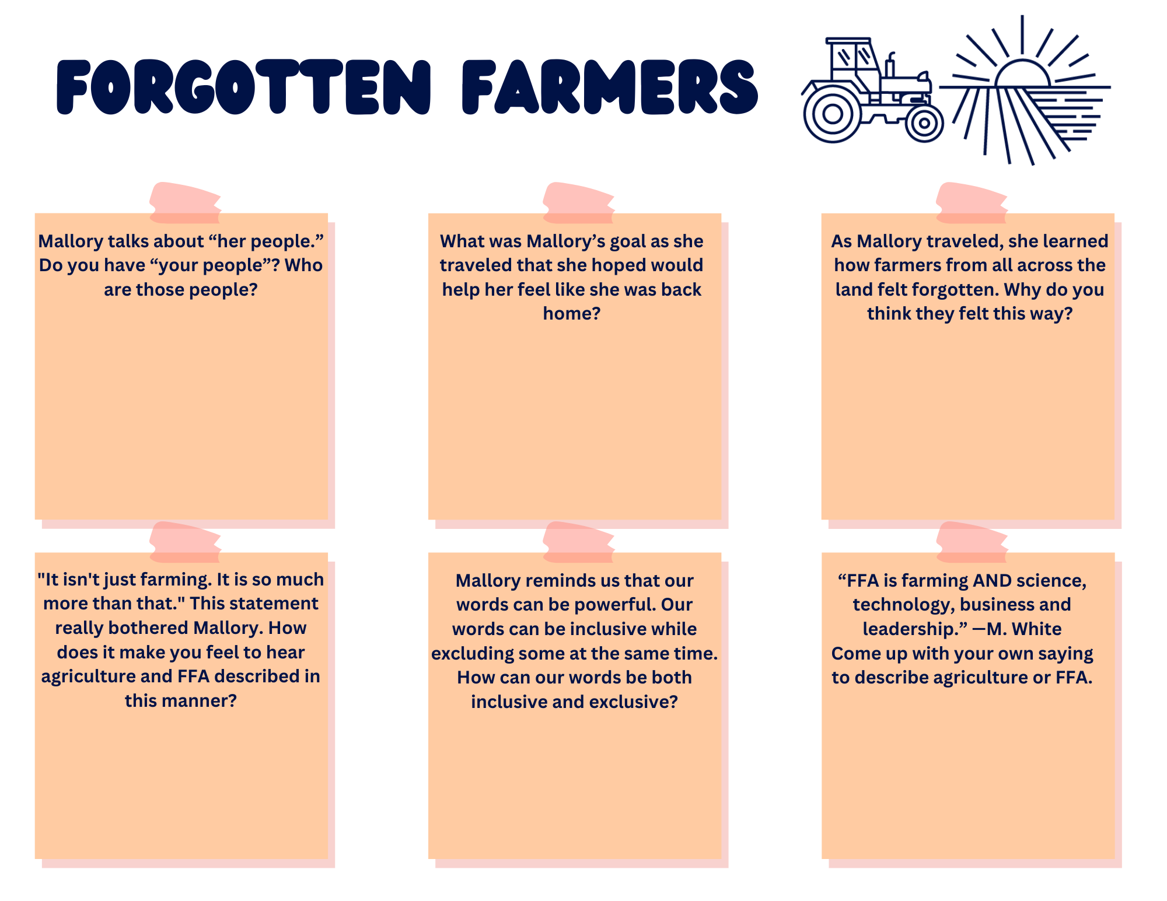
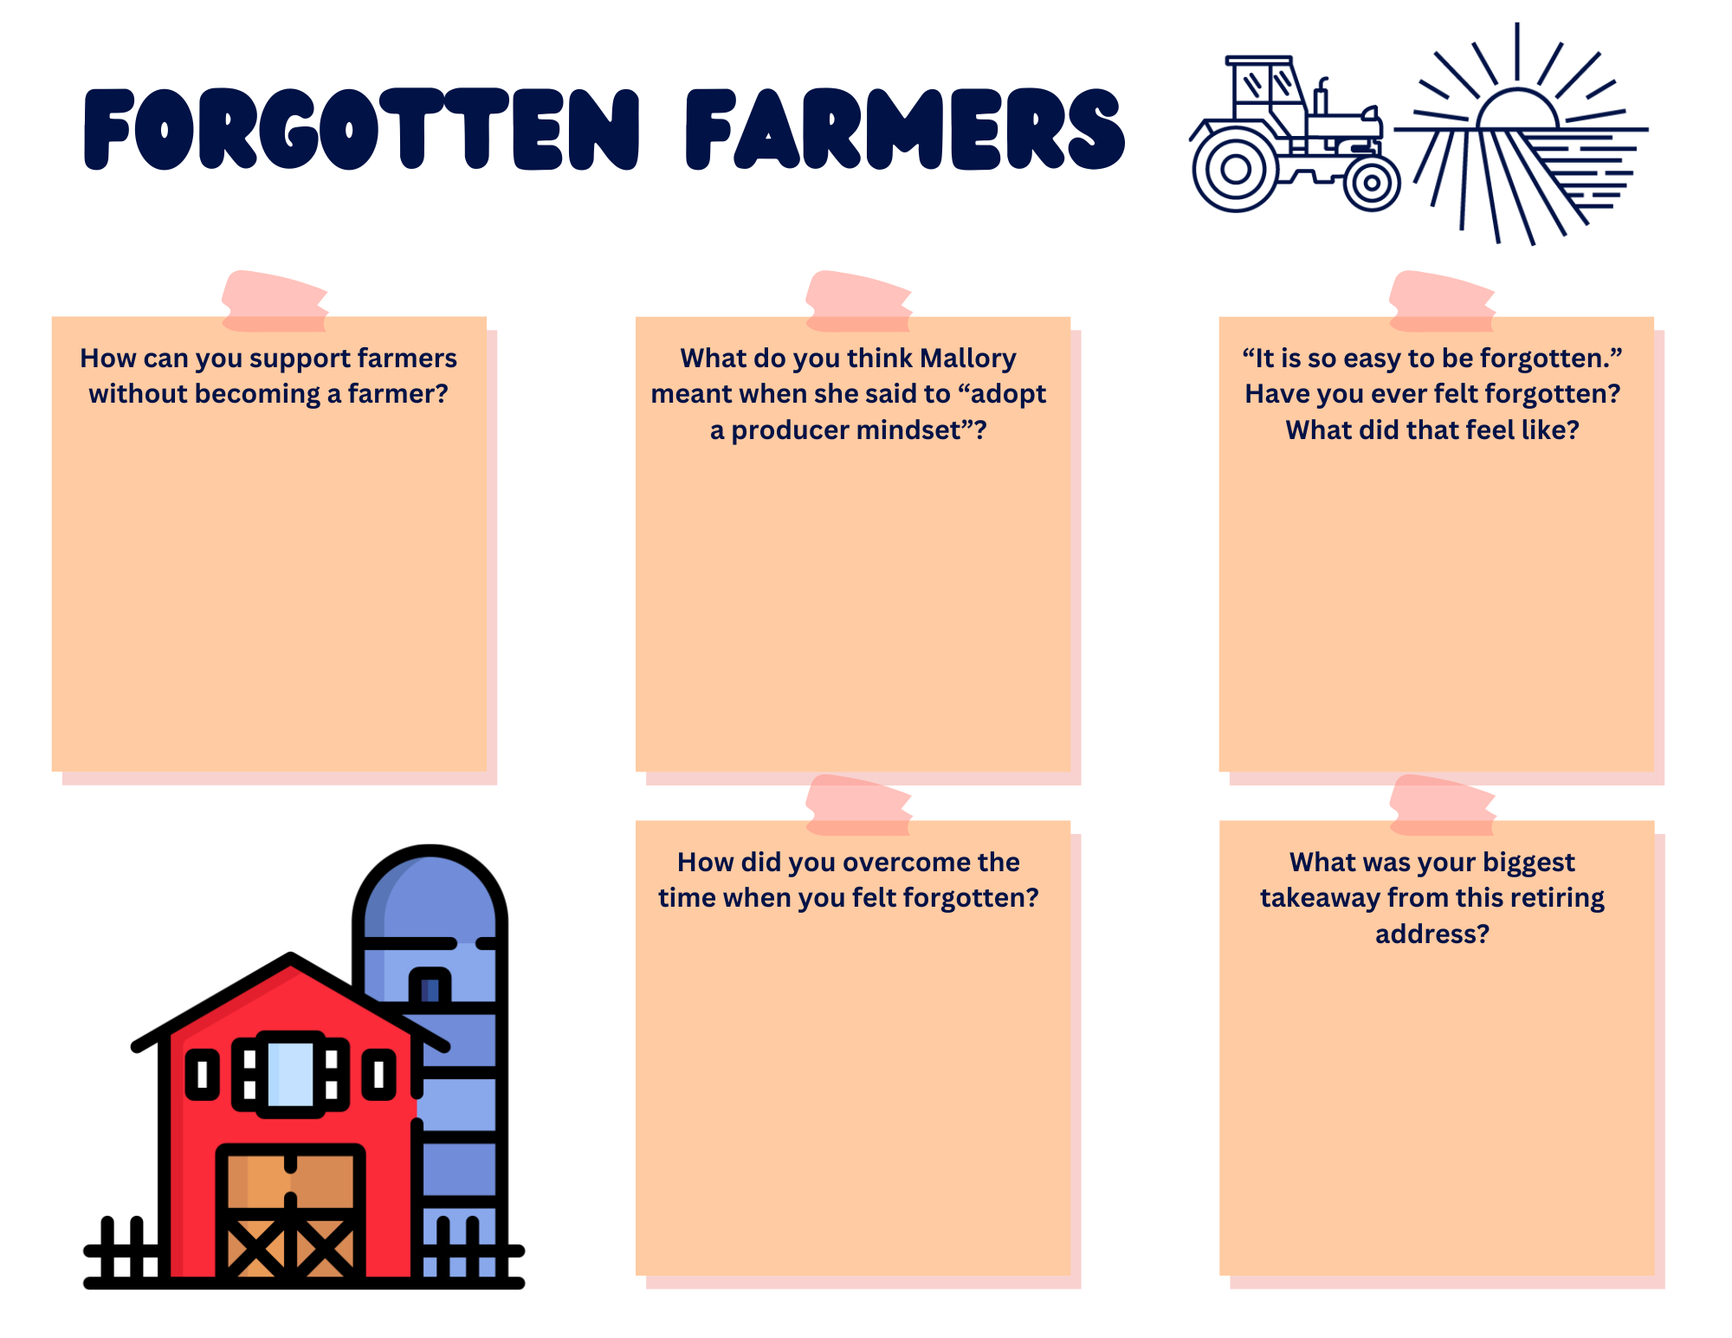
Part 2
Directions:
Think back to that time you felt left out. Think of a person or group of people in your school or community that may be easily forgotten. Work with your classmates to come up with a service project that can help honor or serve those that have been forgotten. Use the planning tool below to help you get started with your project. Follow the directions of your teacher for final steps and for putting your plan into action.

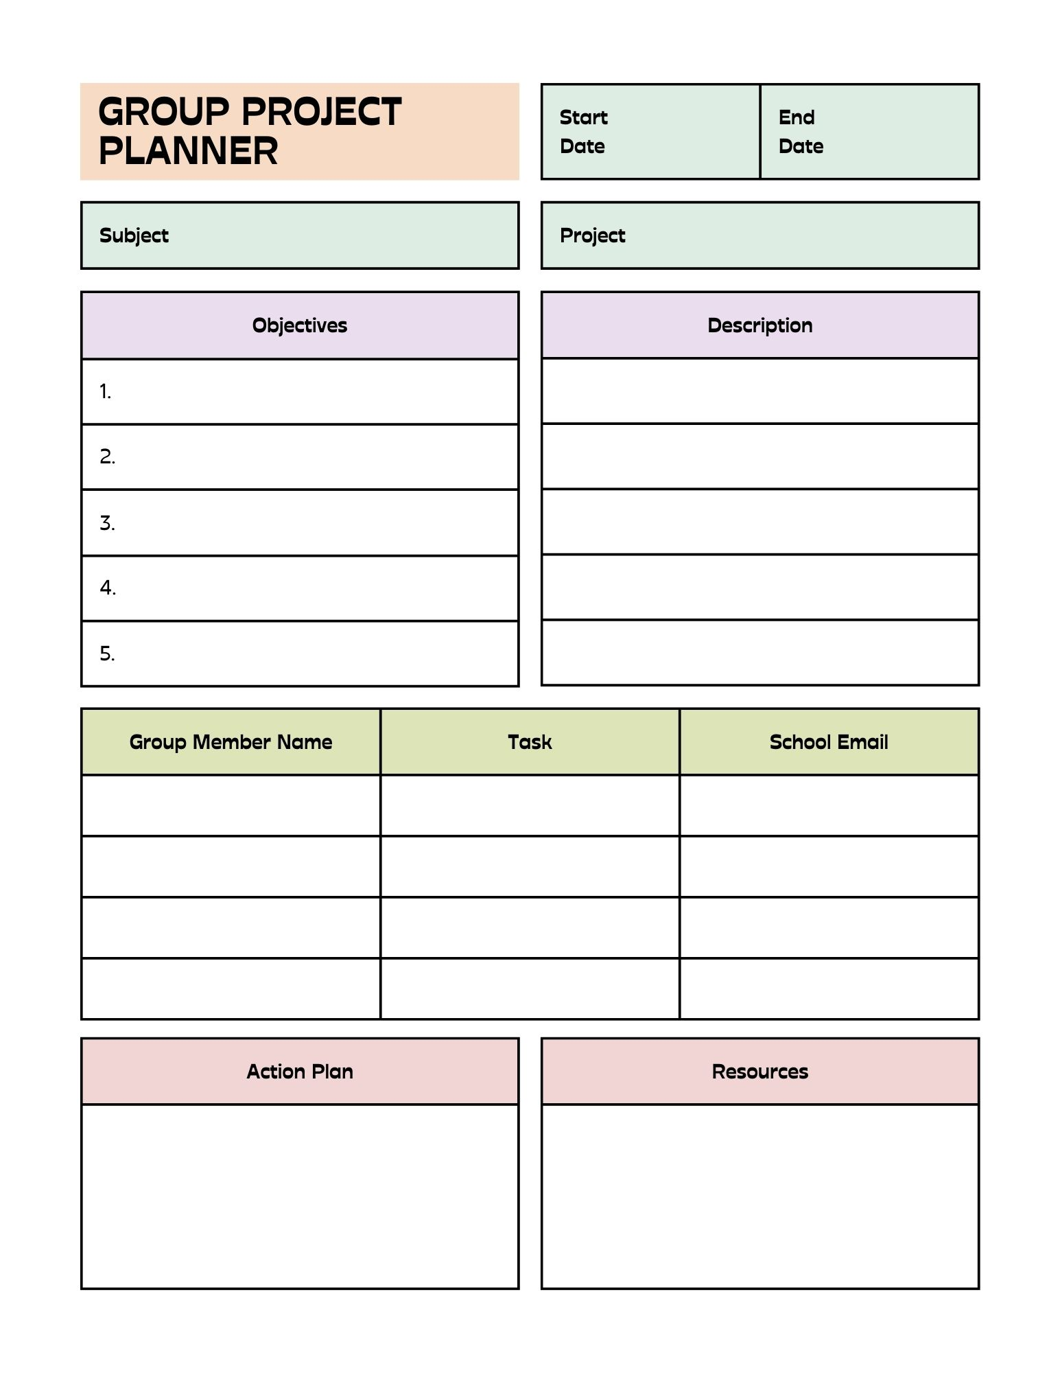

KEY: Forgotten Farmers
Part 1
Directions:
Complete the following activities while watching “Forgotten Farmers,” the retiring address of 2021-22 National FFA Eastern Region Vice President Mallory White. The video is available at https://vimeo.com/777131643.

Answers will vary.
Using words like “but” interjects and can isolate or leave out certain people, places or things.
Answers will vary.
Answers will vary.
To meet a farmer in every state she visited
Answers will vary.
Answers will vary.
Answers will vary.
Answers will vary.
Answers will vary.
Pursuing a career in the agriculture industry that supports production agriculturists like farmers and ranchers
Part 2
Directions:
Think back to that time you felt left out. Think of a person or group of people in your school or community that may be easily forgotten. Work with your classmates to come up with a service project that can help honor or serve those that have been forgotten. Use the planning tool below to help you get started with your project. Follow the directions of your teacher for final steps and for putting your plan into action.

Example project idea

Invitations and cards

Get culinary teacher’s permission to use her room.

Secure food items needed for lunch.

Secure plates, utensils, cups, etc.
Honor our school janitors with a special luncheon
Culinary classroom
Food
Thank you cards
Plates, utensils, napkins, cups, drinks
Money to purchase food and other needed materials
1. Get permission
2. Set date
3. Invite janitors
4. Get needed resources
5. Prepare lunch
6. Serve lunch
7. Clean up
Sally

Tom

Bob

Lucy
Put on a special meal just for them.

Provide them with a yummy lunch and dessert served to them by our class.

Write them thank you cards to give them at the lunch.
Recognize their hard work.

Appreciate all they do for our school.

Include a group that is easily forgotten.
Agriculture — serving others

