Quiet in Volume, Loud in Value
Aligned to the following standards:
FFA.PL-A; FFA.PL-C; FFA.PL-E; FFA.PG-J; FFA.CS-N; CCSS.ELA.W.9-10.4; CRP.02; CRP.04; CRP.06; CRP.08
Part 1
Directions:
Complete the following activities while watching “Quiet in Volume, Loud in Value,” the retiring address of 2019-20 National FFA Central Region Vice President Mamie Hertel. The video is available at https://vimeo.com/showcase/7865594/video/477811400.




What does the word “volume” mean to you?

According to Mamie, what does “quiet in volume, loud in value” mean?
What did Ellie do to change the lives around her?

- She held a clothing drive for those in need in her community.
- She organized a 5k to raise money for her school agriculture program.
- She worked with her elementary school to start an elementary agriculture program.
- She went to the state legislature asking them to require at least one school in every county to have an agriculture program.
Identify a time YOU were quiet in volume and loud in value.
_____________ is added when we don’t mind taking a _____________________ approach.
It is NOT about going ___________________; it’s about adding ___________________.
Approximately how many miles do National FFA Officers travel in a normal year?

- 20,000
- 50,000
- 75,000
- 100,000
Identify two people you have met, and their actions, that have been quiet in volume and loud in value.

2.

Part 2
Aligned to the following standards:
FFA.PL-A; FFA.PL-C; FFA.PL-E; FFA.PG-J; FFA.CS-N; CCSS.ELA.W.9-10.4; CRP.02; CRP.04; CRP.06; CRP.08
Directions:
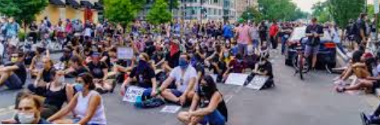


People every day are being quiet in volume and loud in value. Thinking about the examples of others being quiet in volume and loud in value, create a web of four ideas that you could do to be quiet in volume and loud in value. The center of the web lists the statement “quiet in volume and loud in value.” In each bubble after that, list one of your ideas. In the third/outermost bubble, describe how that action will impact others.

Quiet in Volume, Loud in Value
Example: Ellie spoke with her superintendent to ensure there would be an agriculture program in her school.
Example result: Students for years to come will benefit from the impact of the agriculture program.

