Sports Turf
Aligned to the following standards:
CS.05; FFA.PL-A; FFA.PL-C; FFA.PL-E; FFA.PL-F; FFA.I; FFA.PG-J; FFA.CS-M; FFA.CS-N; AG5; CCSS.ELA.RI.9-10.4; CCSS.ELA.W.9-10.1; CCSS.ELA.W.9-10.2; CCSS.ELA.SL.9-10.2; CCSS.ELA.RST.9.10.9; MP1; MP5; MP6; HS-ETS1-3; CRP.02; CRP.04; CRP.06; CRP.07; CRP.08
Directions:
Read over and answer the questions below while you watch the video “Michael Netherton – SAE – Sports Turf Management,” available at https://vimeo.com/313687256.
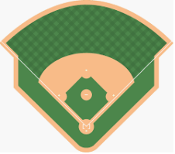

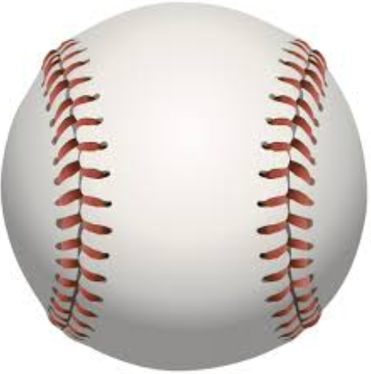
What does Michael like most about his SAE?
What other sport utilizes the stadium/turf where Michael works?

- Soccer
- Field hockey
- Lacrosse
- Little league

Where does Michael work?

- Louisville Slugger Stadium
- Cardinal Stadium
- Churchill Derby Stadium
- Louisville Bats Stadium

Directions:
The turf science industry is a large component of agriculture. Using your resources, find three college or professional stadiums that use either natural grass turf or artificial turf.
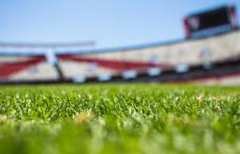
Natural Grass Stadiums

- ____________________________________
- ____________________________________
- ____________________________________
Artificial Turf Stadiums

- ____________________________________
- ____________________________________
- ____________________________________
Using your research skills, describe why a school or professional association would select one type of turf over another (artificial vs natural grass)? Give two specific examples.

Home Turf
Aligned to the following standards:
CS.05; FFA.PL-A; FFA.PL-C; FFA.PL-E; FFA.PL-F; FFA.I; FFA.PG-J; FFA.CS-M; FFA.CS-N; AG5; CCSS.ELA.RI.9-10.4; CCSS.ELA.W.9-10.1; CCSS.ELA.W.9-10.2; CCSS.ELA.SL.9-10.2; CCSS.ELA.RST.9.10.9; MP1; MP5; MP6; HS-ETS1-3; CRP.02; CRP.04; CRP.06; CRP.07; CRP.08
Directions:
With turf being such a crucial component to so many sports, including baseball, let’s take some time to look at the fields at your school!

Step 1: Identify the field and turf type present.

Which athletic field are you going to focus on?
What type of turf does your selected field have? Circle the correct response.

Artificial Grass

Step 2: Research and Analysis: What are the pros and cons to your selected field? Items to consider (there could be more):
- Maintenance of the turf (ex. cleaning and care)
- Usage ability (consider weather, seasons, etc.)

Cons
Pros

Step 3: Write a letter to the school board about what you feel the best option is for the athletic field that you analyzed. The letter should be persuasive so the school board will consider a turf-type change. If you think the turf the field has is the most appropriate, write a thank you letter explaining the positive attributes and benefits provided by the current turf. Questions to include and consider in your letter:
Aligned to the following standards:
NRS.01; AGPE01.01; CCSS.RI.9-10.3; CCSS.SL.9-10.1; RST.9.10.1; RST.9.10.2; RST.9.10.4; RST.9.10.5; RST.9.10.6; RST.9.10.8; RST.9.10.9; WHST.9.10.7; WHST.9.10.9; MP3; MP6; AG-NR2; HS-LS2-6; HS-LS2-7

- Would you change the type of turf you currently have? Why or why not?
- What are the benefits to staying with or changing the field turf?
- What would be/are the benefits of having this type of field available to students at your school?
- Anything else you feel is important to share.

Use the template on the next page to compose your letter.
Give two examples of specific colleges/universities that offer turf science programs.

- _______________________

- _______________________

To: _____________________________

____________________________________________________________________________________________________________________________________________________________________________________________________________________________________________________________________________________________________________________________________________________________________________________________________________________________________________________________________________________________________________________________________________________________________________________________________________________________________________________________________________________________________________________________________________________________________________________________________________________________________________________________________________________________________________________________________________________________________________________________________________________________________________________________________________________________________________________________________________________________________________________________________________________________________________________________________________________________________________________________________________________________________________________________________________________________________________________________________________________________________________________________________________________________________________________________________________________________________________________________________________________________________________________________________________________________________________________________________________________________________________________________________________________________________________________________________________________________________________________________________________________________________________________________________________________________________________________________________________________________________________________________________________________________________________________________________________________________________________________________________________________________________________________________________________________________________________________________________________________________________________________________________________________________________________________________________________________________________________________________________________________________________________________________________________________________________________________________________________________________________________________________________________________________________________________________________________________________________________________________________________________________________________________________

Sincerely,

