My-Celi-What?
Aligned to the following standards:
NRS.02; FFA.PL-A; FFA.PG-J; AG-NR2; AGPE01.03; CS.06; CCSS.RI.9-10.3; CCSS.SL.9-10.1; CCSS.RST.11-12.1; CCSS.RST.11-12.2; CCSS.RST.11-12.7; CCSS.RST.11-12.8; CCSS.RST.9.10.9; CCSS.WHST.9.10.2; CCSS.WHST.9.10.4; CCSS.WHST.9.10.7; CCSS.WHST.9.10.9; MP5; HS-ESS3-1; HS-ESS3-2; HS-ESS3-4; AFNR Career Cluster, Statement 1; CRP.02; CPR.04; CRP.06; CRP.07; CRP.08
Directions:
Complete the questions below as you watch the video “Mycelium SAE | Michaela Carmichael,” available at https://vimeo.com/342621734.


Why did Michaela start this SAE?
What is mycelium?

What steps did Michaela take to implement her SAE?

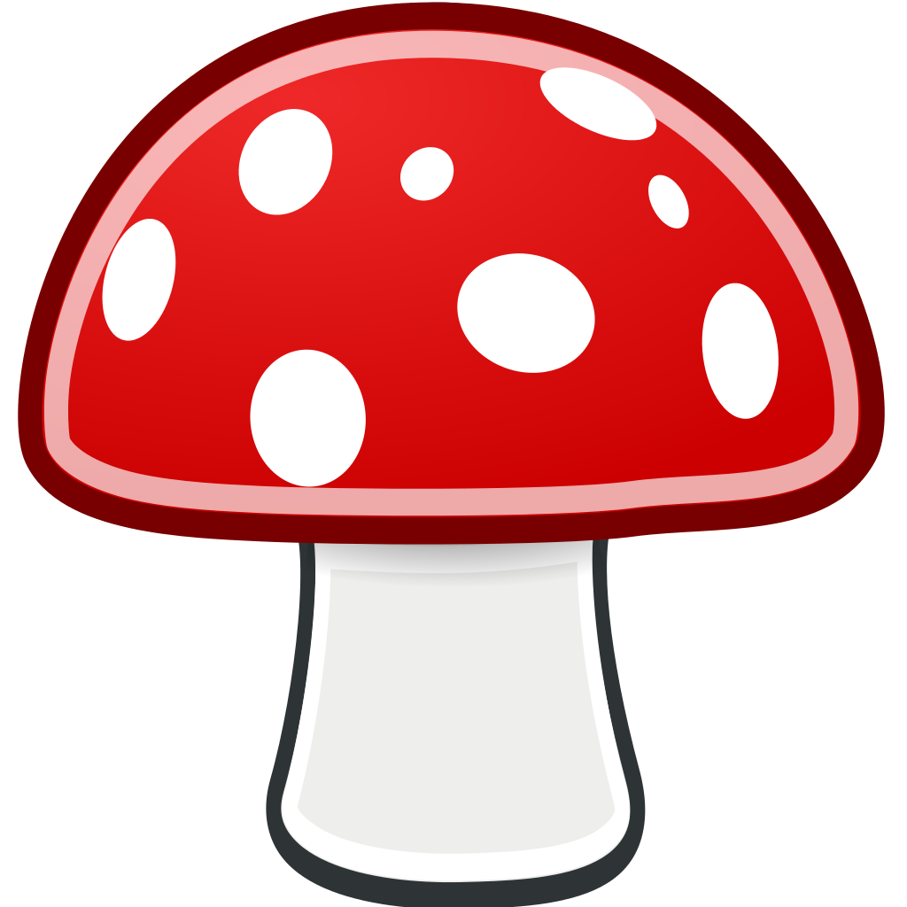

How does mycelium filter the wastewater?

What pollutants did Michaela identify?
- E. coli
- Coliform
- Heavy metals
- All of the above


What career does Michaela hope to have?
How will her SAE help her in her future career?

Fungus to the Rescue!
Aligned to the following standards:
NRS.02; FFA.PL-A; FFA.PG-J; AG-NR2; AGPE01.03; CS.06; CCSS.RI.9-10.3; CCSS.SL.9-10.1; CCSS.RST.11-12.1; CCSS.RST.11-12.2; CCSS.RST.11-12.7; CCSS.RST.11-12.8; CCSS.RST.9.10.9; CCSS.WHST.9.10.2; CCSS.WHST.9.10.4; CCSS.WHST.9.10.7; CCSS.WHST.9.10.9; MP5; HS-ESS3-1; HS-ESS3-2; HS-ESS3-4; AFNR Career Cluster, Statement 1; CRP.02; CPR.04; CRP.06; CRP.07; CRP.08
Directions:
Mycelium isn’t only useful for filtering water. Complete the following activities to learn more about fungi and its many potential uses.

Part 1
Directions:
Read both of the following short articles. (You can also watch the National Geographic summary video rather then read the article.) Write a paragraph summarizing each article and highlighting the uses of the fungi.
- “Nine Ways Mushrooms Could Drastically Improve the World,” https://blog.ted.com/9-ways-mushrooms-could-drastically-improve-the-world/
- “Surprising New Uses for Mushrooms, From Houses to Packaging,” https://www.nationalgeographic.com/news/2016/07/mushroom-surprising-uses-building-material-medicines-fungi/
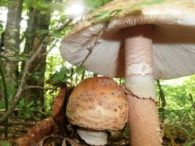
Summary of “Nine Ways Mushrooms Could Drastically Improve the World” | Summary of “Surprising New Uses for Mushrooms, From Houses to Packaging”

Part 2
Aligned to the following standards:
NRS.02; FFA.PL-A; FFA.PG-J; AG-NR2; AGPE01.03; CS.06; CCSS.RI.9-10.3; CCSS.SL.9-10.1; CCSS.RST.11-12.1; CCSS.RST.11-12.2; CCSS.RST.11-12.7; CCSS.RST.11-12.8; CCSS.RST.9.10.9; CCSS.WHST.9.10.2; CCSS.WHST.9.10.4; CCSS.WHST.9.10.7; CCSS.WHST.9.10.9; MP5; HS-ESS3-1; HS-ESS3-2; HS-ESS3-4; AFNR Career Cluster, Statement 1; CRP.02; CPR.04; CRP.06; CRP.07; CRP.08
Directions:
Identify the fungi use that you found most interesting. In the space below, share the innovative way the fungi are being used, a potential world problem it could help solve and why it stood out to you the most. You can share this information in any format you choose. You can write a short paper or speech, draw a picture, create a video storyboard or comic strip, etc.



 | 20–16 Points | 15–11 Points | 10–6 Points | 5–0 Points
Content | Covers topic in depth with details and examples; subject knowledge is excellent; focuses on an important concept | Includes essential knowledge about the topic; subject knowledge is good; focuses on an important concept | Includes essential information about the topic but there are one or two factual errors; focus may be unclear | Content is minimal OR there are several factual errors; focus is unclear.
Effort | Product shows a great amount of time spent and very careful, neat work. | Product shows a good amount of time spent and careful, neat work. | Product shows some amount of time spent and is slightly lacking neatness. | Product shows a minimal amount of time spent and is lacking neatness.
Originality and Creativity | Product shows a large amount of original thought and critical thinking. Work is creative and inventive. | Product shows some original thought and critical thinking. Work shows new ideas and insights. | A few original touches enhance the project to show some understanding of the material. | Shows little creativity, originality and/or effort in understanding the material or following project directions
Appearance (for artistic products)  and/or  Neatness and Grammar (for written products) | Makes excellent use of color, graphics, effects, etc. to enhance the product  Exceptionally neat in design, writing and layout with no grammatical or mechanical mistakes | Makes good use of color, graphics, effects, etc. to enhance the presentation  Neat in design, writing and layout with a few grammatical/ mechanical mistakes, which are not distracting | Makes some use of color, graphics, effects, etc. to enhance the presentation, but occasionally these detract from the content.  Acceptably neat but may be messy at times and/or show lack of organization with several grammatical/ mechanical mistakes, which are distracting | Use of minimal color, graphics, effects, etc. to enhance the presentation, which often detract from the content  Distractingly messy; does not show pride in work; has many grammatical or mechanical mistakes throughout the project; clearly not proofread
Overall Effectiveness and Completion | Project is engagingly organized and presents material that is captivating for the intended audience. | Project is somewhat organized, complete and holds the attention of the intended audience. | Project is disorganized and incomplete at times and is somewhat able to hold the attention of the intended audience. | Project is incomplete and not easy to follow.
Fungi Innovation Creative Project Rubric

