Honor Tradition
Aligned to the following standards:
FFA.PL-A; FFA.PL-C; FFA.PL-E; FFA.PG-J; FFA.CS-N; CCSS.ELA.W.9-10.4; CRP.02; CRP.04; CRP.06; CRP.08
Part 1
Directions:
Complete the following activities while watching the retiring address of 2020-21 National FFA Eastern Region Vice President Miriam Hoffman. The video is available at https://vimeo.com/640539042.

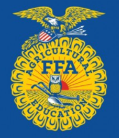

“How often do we ___________ at how things are done in this _____________, and we are confident we know a better ______________?”
Change that overlooks ________________ is not true _________________________.

- tradition; progress
- progress; tradition
- tradition; confidence
- progress; confidence
How can we know the choices that we make can lead to true progress?
What are the two mantras Miriam and her family follow?

1.

2.
What did Lane do to look at tradition differently?

True ____________________ + True ____________________ = True ____________________
What does the sun symbolize in the FFA emblem?

- Hard work
- Progress
- Tradition
- A new era
Draw a series of emojis that depicts how this retiring address impacted you.

Describe your emojis.
Part 2
Directions:

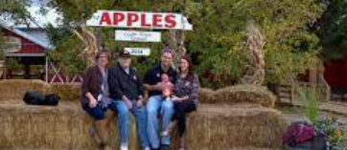

As we heard, tradition is an important component to progress. Select a tradition in your life that you have always thought could use a change, and walk through the steps below.
Describe the tradition you have selected.
Describe how you would change the tradition.
Does this change lead to true progress? Or is it just a change for the sake of change? Why or why not?
What steps would you have to take to make this change happen?
What would you tell someone about making change to ensure true progress?

