The Gift to the Whole World
Created: 01/2025 by the National FFA Organization
Description of Lesson: A gift you can give to the whole world is being a good person. In her retiring address, 2023-24 National FFA Eastern Region Vice President Morgan Anderson shares her story about the importance of being good.
Student Learning Objectives:
After completing these activities, students will …
- Reflect on the impact of personal actions on others and their community, recognizing how being a good person is a “gift to the world.”
- Explore actions that contribute positively to others.
- Visualize how small acts of kindness can create a ripple effect.

Suggested Grade Level:
Grades 9 and 10 (This lesson is written so instructors can scale up and down based on class needs.)

Suggested Time: 60 minutes (*Time requirements may vary based upon student understanding and class schedule.)

Resources/References:
- Video: “The Gift to the Whole World” | Morgan Anderson 2024 Retiring Address, https://vimeo.com/1023619551.

Related Resources:
- Retiring Addresses and Keynote Speeches, FFA.org/ffa-video-center/convention-keynotes-and-retiring-addresses/
- FFA Values Lesson Series, https://FFA.box.com/s/u9qnfyvape9sy3d3xc85hlgxdxghq3dg
- Keynote-Retiring Address Lessons, https://FFA.box.com/v/retiringaddresslessons

Equipment and Supplies Needed:
- A copy of the “The Gift to the Whole World” worksheet for each student
- Internet access to play the video in real time or embed it in a PowerPoint ahead of time

Vocabulary:
- Gift
- Good
- Kindness
Cross-Curricular Connections:
English/Language Arts
Create a web flow chart (site map) to connect ideas.

SAE and FFA Connections:
- Agricultural Communications and Education SAE Idea Cards, https://FFA.box.com/s/x7e4v2qzxcwkleuqkun3mt0421m5nejx
- Extemporaneous Public Speaking LDE, FFA.org/participate/ldes/extemporaneous-public-speaking/
- Prepared Public Speaking LDE, FFA.org/participate/prepared-public-speaking/
Student Activity Sheets:
Direct access to student activity sheets without lesson plan or answer key for easy upload to a learning management system or printing for classwork.

https://ffa.box.com/s/fblwu2d2ek1npzplpe4fjftk3zvwr9v8 (Word)
https://ffa.box.com/s/fblwu2d2ek1npzplpe4fjftk3zvwr9v8 (PDF)
https://docs.google.com/document/d/1vf_ZixGGmo8wv4t8My7pQFOWMu7UTNIcVGCj_IvUm8I/copy (Google)

These Activities Are Aligned to the Following Standards:
FFA Precept
- FFA.PL-A.Action: Assume responsibility and take the necessary steps to achieve the desired results, no matter
- what the goal or task at hand.
- FFA.PL-D.Character: Conduct oneself appropriately in relation to others regardless of the situation.
- FFA.CS-M.Communication: Effectively interact with others in personal and professional settings.
Common Core – Speaking and Listening
- CCSS.ELA-LITERACY.SL.9-10.4 Present information, findings, and supporting evidence clearly, concisely, and logically such that listeners can follow the line of reasoning and the organization, development, substance, and style are appropriate to purpose, audience, and task.
- CCSS.ELA-LITERACY.SL.9-10.5 Make strategic use of digital media (e.g., textual, graphical, audio, visual, and interactive elements) in presentations to enhance understanding of findings, reasoning, and evidence and to add interest.
AFNR Career Ready Practices
- CRP.04. Communicate clearly, effectively, and with reason. Career-ready individuals communicate thoughts, ideas and action plans with clarity, whether using written, verbal and/or visual methods.
Partnership for 21st Century Skills
- Collaboration
- Communication
- Initiative and Self-direction
- Productivity and Accountability
- Think Creativity
Lesson Plan:
- Bell Ringer: What is your definition of a “good person”?

- Introduction: Give a copy of the “The Gift to the Whole World” worksheet to each student. Today, we are going to watch a retiring address from the 97th National FFA Convention & Expo. This retiring address was given by 2023-24 National FFA Eastern Region Vice President Morgan Anderson. In her speech, we will learn about the gift to the whole world. As we are watching the video, look over the questions on the worksheet “The Gift to the Whole World” and be ready for the answers.

- Activity: Each student needs a copy of the worksheet “The Gift to the Whole World.”
  - Part 1: Have students watch the retiring address of the 2023-24 National FFA Eastern Region Vice President Morgan Anderson. The video is available at https://vimeo.com/1023619551. While students watch the video, have them answer the questions.
  - Part 2: Have students work in groups of three to reflect on the impact of their personal actions on others and the community. Students will create a kindness web for your classroom. If you are looking for a fun strategy to group your students, consider having students find their groups based on who is wearing a similar color or pattern (stripes, plaid, polka dot, flowered, etc.) or who has the same type of clothing (shorts, pants, skirt, dress, T-shirt, jeans, etc.).

- Follow-up: Have students brainstorm a list of positive actions they can enact over the next week.

- Optional – Extended Learning Opportunities (Not factored into time requirement):
  - This should take 15 minutes. On a large sheet of paper or whiteboard, draw a circle in the center labeled "Kindness." Have students fill in the bubble with one act of kindness throughout the week. The goal is to see how many ripples of kindness can be created. Document the outcomes with photos or stories to share at the end of the week.

- Exit Ticket: How can small actions make a big difference in the world?

The Gift to the Whole World
Aligned to the following standards:
FFA.PL-A; FFA.PL-D; FFA.CS-M; CCSS.ELA.SL.9-10.4; CCSS.ELA.SL.9-10.5; • CRP.04.
Part 1
Directions:
Answer the following questions while watching the retiring address of 2023-24 Eastern Region Vice President Morgan Anderson, “The Gift to the Whole World.” The video is available at https://vimeo.com/1023619551.

- What is Morgan's opening question?

- In one or two sentences, share what you think it means to be a good person.

- What phrase does Morgan sign her thank you cards with?

- Good does not equal ____________.

- When Morgan was explaining her painful experience in high school, what is one thing that she wishes she’d had in that moment?

- According to Morgan, what does it mean to be a good person?

- According to Morgan, good is a verb. How can you do good?



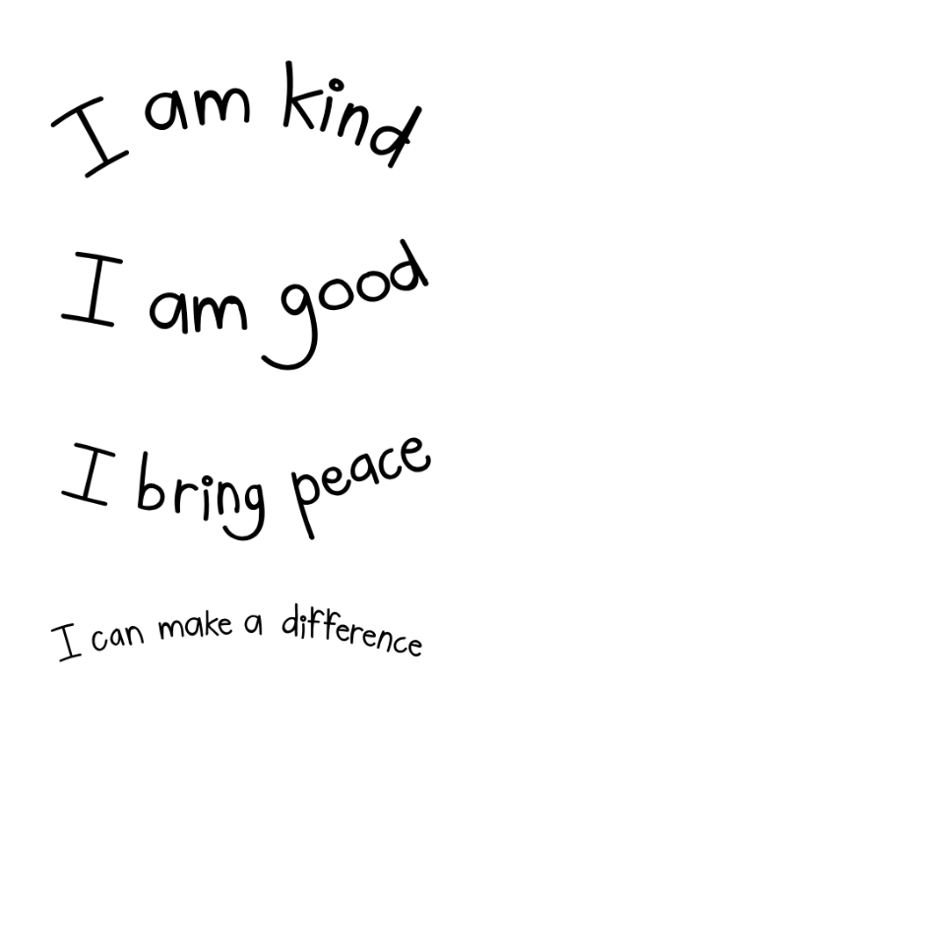
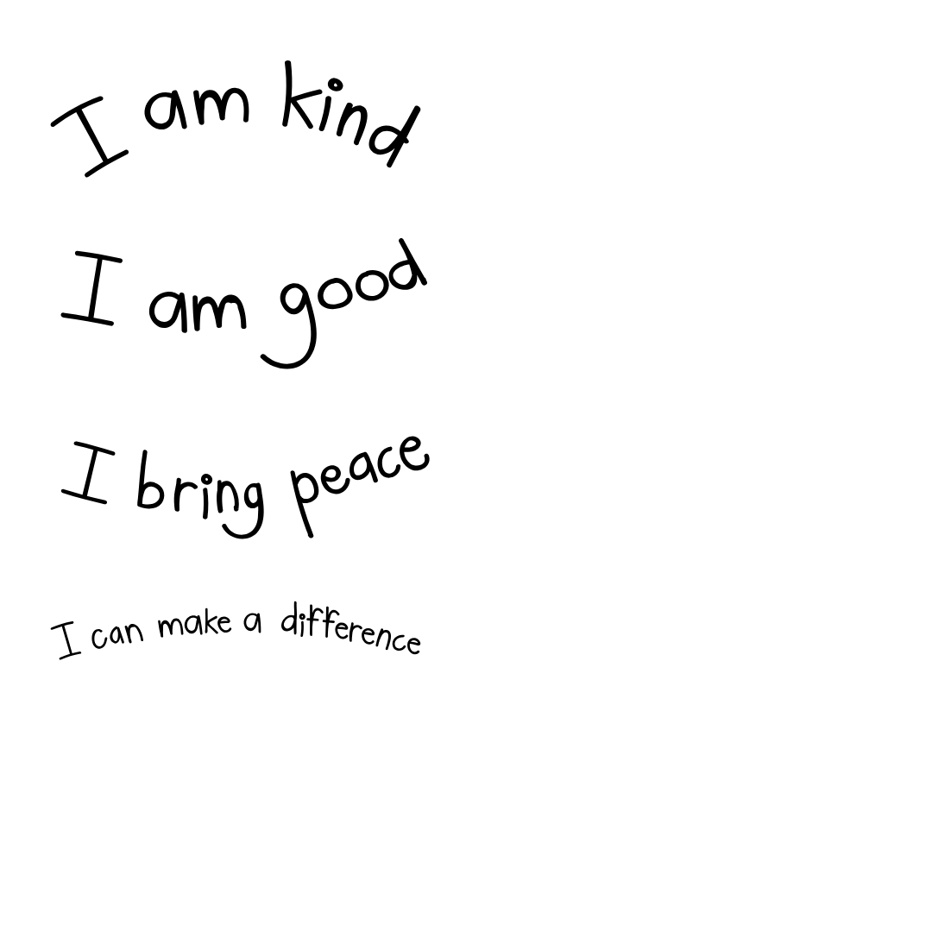
Part 2
Directions:
In Morgan Anderson's retiring address, she shares how being a good person is a gift to the whole world. In this activity, you will work in groups of three to reflect on the impact of personal actions on others and your community. Using the answers you come up with, you will create a kindness web for your classroom. Please answer the questions below.

- In the table below, share five examples of small, everyday acts of kindness that you have done (e.g., holding the door, helping with homework, smiling at someone) and how these actions positively influence others.

Acts of Kindness | Positive Impacts on Others

- Kindness Web: In the space below you will create a web chart. You will branch off the center labeled "Kindness." Each group member will need to share one act of kindness, writing it around the circle. Have each member pass their paper around the group to complete their act. For each act of kindness, discuss its potential ripple effects. Draw lines connecting the action to its impacts. Continue until the web shows a network of interconnected acts of kindness and their effects.
Helping a classmate
Boosts confidence
Improves school atmosphere

Kindness

- Describe a specific ripple effect that you have started or experienced before. What impact did this have on you and the other person(s)?

- How can you create more ripples of kindness in your school and community?

KEY: The Gift to the Whole World
Part 1
Directions:
Answer the following questions while watching the retiring address of 2023-24 Eastern Region Vice President Morgan Anderson, “The Gift to the Whole World.” The video is available at https://vimeo.com/1023619551.

- What is Morgan’s opening question?
What does it mean to be a good person?

- In one or two sentences, share what you think it means to be a good person.
Answers will vary.

- What phrase does Morgan sign her thank you cards with? “A good person is a gift to the whole world.”

- Good does not equal ____________. Perfect

- When Morgan was explaining her painful experience in high school, what is one thing that she wishes she’d had in that moment? She wishes the girl next to her would’ve told them to stop. She wishes someone would’ve pulled her away for an easy way out. She wishes someone would’ve followed her down the hallway to act like they cared. She wishes someone would have texted after school to check in and see how she was doing. She wishes someone would’ve done anything.

- According to Morgan, what does it mean to be a good person? A good person is someone who works to end the pain or suffering of others.

- According to Morgan, good is a verb. How can you do good? Answers will vary.

Part 2
Directions:
In Morgan Anderson's retiring address, she shares how being a good person is a gift to the whole world. In this activity, you will work in groups of three to reflect on the impact of personal actions on others and your community. Using the answers you come up with, you will create a kindness web for your classroom. Please answer the questions below.

- In the table below, share five examples of small, everyday acts of kindness that you have done (e.g., holding the door, helping with homework, smiling at someone) and how these actions positively influence others.

Acts of Kindness | Positive Impacts on Others
Answers will vary. | Answers will vary.

- Kindness Web: In the space below, you will create a web chart. You will branch off the center labeled "Kindness." Each group member will need to share one act of kindness, writing it around the circle. Have each member pass their paper around the group to complete their act. For each act of kindness, discuss its potential ripple effects. Draw lines connecting the action to its impacts. Continue until the web shows a network of interconnected acts of kindness and their effects.
Helping a classmate
Boosts confidence
Improves school atmosphere

Answers will vary.

Kindness

- Describe a specific ripple effect that you have started or experienced before. What impact did this have on you and the other person(s)?
Answers will vary.

- How can you create more ripples of kindness in your school and community?
Answers will vary.

