FFA New Horizons Teaching Guide: Index

Issue | Picture | Article | Article Description | Pathway | Activity | Online | Offline | Folder Location
Winter 2015 | 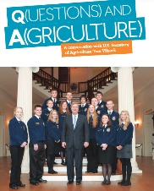 | Q(uestions) and A(griculture) | In an exclusive interview, U.S. Secretary of Agriculture Tom Vilsack shares his thoughts on the importance of agriculture, the future outlook of careers in agriculture, the role FFA members play in agricultural advocacy and the agriculture-related challenges facing the United States. | Any | “The Qs and As”  (Starts on Page 2)  The Qs and As KEY  “Q & A Round 2” |  | X  X (Must first determine who is in charge of agriculture in your state.) | https://ffa.box.com/s/wey2h8s2gndgupz2ih7rx8jmhi7vnqmx
Winter 2015 | 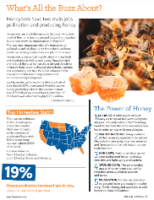 | What’s All the Buzz About? | Honeybees are essential to agriculture. Not only do humans need them to act as pollinators, but we also use the honey they produce for many purposes. The production of honey is on the rise, and that brings a significant economic impact as well. | Animal Systems | Appendix 3: A Buzz About Bees  (Starts on Page 9)  Appendix 3 Key: A Buzz About Bees  Appendix 4: It’s a Bee’s Life  (Starts on Page 13) | X  X |  | https://ffa.box.com/s/wey2h8s2gndgupz2ih7rx8jmhi7vnqmx
Winter 2015 | 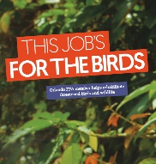 | This Job’s for the Birds | Anastasia Sturgis has worked at a bird rescue since she was in 10th grade. Her interest in birds has grown from a weekend hobby to an SAE to her future career. She also raises and breeds ducks for conservation purposes. She credits FFA with inspiring her to reach her goals. | Animal Systems | Appendix 5: That’s No Plane … It’s A Bird  (Starts on Page 15)  Appendix 5 Key: That’s No Plane … It’s A Bird |  | X | https://ffa.box.com/s/wey2h8s2gndgupz2ih7rx8jmhi7vnqmx
Winter 2016 | 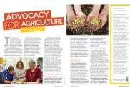 | Advocacy for Agriculture | This article discusses a major global agricultural company, Monsanto, and how it has launched three major grant programs under its America’s Farmers initiative, the company’s community outreach program for eligible schools and community groups. | Agribusiness Systems | Appendix 1: Advocacy for Agriculture  (Starts on Page 2)  Appendix 1 Key: Advocacy for Agriculture  Appendix 2: Interview a Farmer  (Starts on Page 5)  Appendix 2 Key: Interview a Farmer |  | X  X | https://ffa.box.com/s/pp2ialg063e64u9fpb68vuo9uw9l64ha
Winter 2016 | 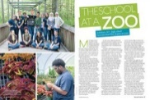 | The School at a Zoo | This article features a unique FFA chapter—one that is headquartered at a zoo! Check out this article about how the chapter got its start and the unique, hands-on learning opportunities. | Plant Science | Appendix 3: The School at a Zoo!  (Starts on Page 9)  Appendix 4: Get Involved in the Community!  (Starts on Page 11)  Appendix 4 Key: Get involved in the Community! | X  X |  | https://ffa.box.com/s/pp2ialg063e64u9fpb68vuo9uw9l64ha
Winter 2016 | 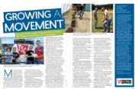 | Growing a Movement | The “Growing a Movement” article is about the Tractor Supply Company’s grant program with FFA chapters. The article describes two ways that chapters are currently implementing grant money and details the impacts those chapters are making. There is also information on obtaining a grant and why the grants are being offered. | Agribusiness Systems | Appendix 5: Growing a Movement  (Starts on Page 16)  Appendix 5 Key: Growing a Movement |  | X | https://ffa.box.com/s/pp2ialg063e64u9fpb68vuo9uw9l64ha
Winter 2016 |  | Find Your Future in Agriculture | This article discusses the career exploration tool AgExplorer. This project is the result of a partnership with the National FFA Organization, Discovery Education and AgCareers.com to create a tool that will help students find careers that are suited to them within the agricultural realm. | Any | Appendix 6: Find Your Future in Agriculture  (Starts on Page 22)  Appendix 6 Key: Find Your Future in Agriculture | X |  | https://ffa.box.com/s/pp2ialg063e64u9fpb68vuo9uw9l64ha
Summer 2016 | 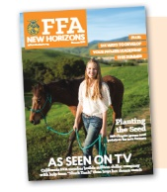 | Career Corner | Students will read the “Ag Career Profile” section and answer questions related to the two careers highlighted in the section. | Any | Appendix 2: Career Corner  (Starts on Page 3) |  | X | https://ffa.box.com/s/x8vzciylzfqnb230ho29sv6cjyudf34x
Summer 2016 |  | College Cruising | Students will research five colleges/universities that have agricultural programs. | Any | Appendix 3: College Cruising  (Starts on Page 5) | X |  | https://ffa.box.com/s/x8vzciylzfqnb230ho29sv6cjyudf34x
Summer 2016 |  | Ag. Designs | Students will design and develop an agriculturally related product that would be beneficial to consumers. | Agribusiness Systems | Appendix 4: Ag. Designs  (Starts on Page 7) | X | X | https://ffa.box.com/s/x8vzciylzfqnb230ho29sv6cjyudf34x
Fall 2016 | 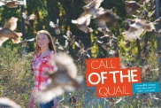 | Call of the Quail | In this article, Kansas FFA member Kacy Schlesener discusses how she made it her mission to help bring back bobwhite quail to her community after she noticed a decline in their population. | Animal Systems | Appendix 1: Call of the Quail Question and Answer  (Starts on Page 2)  Appendix 1 Key: Call of the Quail Question and Answer |  | X | https://ffa.box.com/s/8v8xf8kq4ektc04orqpe3ybenzs894zu
Fall 2016 | 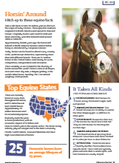 | Horsin’ Around | This Ag 101 article focuses on a variety of equine facts such as where and when they originated, their uses, the top equine states and the most popular horse breeds. Check out this article to learn everything you needed to know about horses! | Animal Systems | Appendix 2: Horsin’ Around  (Starts on Page 11)  Appendix 2 Key: Horsin’ Around |  | X | https://ffa.box.com/s/8v8xf8kq4ektc04orqpe3ybenzs894zu
Fall 2016 |  | Healthy, Happy Animals | Are you interested in a career within the animal industry? This article discusses three types of careers with Zoetis, the world’s largest animal health company. Check out this article to learn more about animal science related careers. | Animal Systems, Agribusiness Systems | Appendix 3: Career Corner  (Starts on Page 18)  Appendix 3: Career Corner Key |  | X | https://ffa.box.com/s/8v8xf8kq4ektc04orqpe3ybenzs894zu
Fall 2016 | 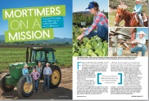 | Mortimers on a Mission | Agritourism is a fast-growing sector within agriculture. This article discusses how one farming family in Arizona uses their farm to teach the public about agriculture. They host a variety of events on the farm, ranging from fun fall activities to a Christmas in the village. Check out this article to see how the family works together to make this operation a success! | Agribusiness Systems | Appendix 4: Getting to Know Mortimers on a Mission  (Starts on Page 29)  Appendix 4 Key: Getting to Know Mortimers on a Mission | X |  | https://ffa.box.com/s/8v8xf8kq4ektc04orqpe3ybenzs894zu
Spring 2016 |  | Gimme’ Five | The Norco FFA Chapter in California has a capstone project that each senior FFA member must complete. It is the $5 Challenge, which has been conducted for the past eight years. Each senior is given a $5 bill, and they have four months to find a need in the community and help meet that need using the money. Students can work alone or as a group. Last year, around 40 students turned $210 into $1,200 that was donated to various organizations. | Any | Appendix 1: A Little Bit CAN Make a BIG Difference  (Starts on Page 2) |  | X | https://ffa.box.com/s/mlbr3i7d10qfk643w6gyzhg27i6k2mhw
Spring 2016 | 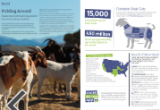 | Kidding Around | Meat goats are the fastest growing segment of the U.S. livestock industry. Goat meat has risen in popularity so quickly that millions of pounds of meat are imported each week to meet the growing demand. Goat meat is a lean protein source that is lower in calories, saturated fat and cholesterol than beef. | Animal Systems | Appendix 2: Kidding Around Crossword  (Starts on Page 7)  Appendix 2 Key: Kidding Around Crossword  Appendix 3: It’s the Goat Life  (Starts on Page 11)  Appendix 3 Rubric: It’s the Goat Life | X  X |  | https://ffa.box.com/s/mlbr3i7d10qfk643w6gyzhg27i6k2mhw
Spring 2016 | 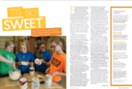 | ‘Tis so Sweet | Students in a food science and technology class in Ohio had the opportunity to learn about product development firsthand by working with the Velvet Ice Cream company to develop a new flavor of ice cream. Students learned about flavor profiles, went through several different ideas, created a marketing plan, developed the front and back labels and had other students in their high school taste test the new flavors. Velvet Ice Cream is even considering adding one of the flavors to their line as a limited edition. | Food Products and Processing Systems | Appendix 4: Flavor Creator  (Starts on Page 14)  Appendix 5: Food Is My Work  (Starts on Page 17) | X  X |  | https://ffa.box.com/s/mlbr3i7d10qfk643w6gyzhg27i6k2mhw
Fall 2017 | 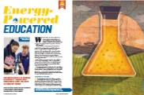 | Energy-Powered Education | Dive into this article for a peek inside a one-of-a-kind high school agriculture program that focuses on alternative energy. This article discusses how the students grow their own soybeans to produce biodiesel, which they use to power everything from cars and trucks to tractors and go-karts. | Biotechnology Systems; Natural Resources Systems; Power, Structural and Technical Systems | Appendix 1: Alternative Energy  (Starts on Page 6) | X |  | https://ffa.box.com/s/xbcep1x9uq35j2ax4wktv7vqsnrmu676
Fall 2017 | 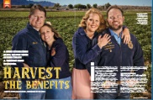 | Harvest the Benefits | Strong bonds forged while in FFA have carried over into a thriving farm operation. Read this article to find out how close friends in high school took what they learned as agriculture students and FFA members and applied it to their farming operations. | Food Products and Processing Systems | Appendix 2: Harvest the Benefits  (Starts on Page 13)  Appendix 2 Key: Harvest the Benefits  Appendix 3: Interview an Alumni Entrepreneur – Getting to Know Their Business  (Starts on Page 19) | X | X | https://ffa.box.com/s/xbcep1x9uq35j2ax4wktv7vqsnrmu676
Fall 2017 |  | We Can Do It! | Check out this article about how women can meet the growing demands in the American welding industry. This article discusses the worker shortage in the previously male-dominated welding industry and how females could be a key component in filling that gap. | Power, Structural and Technical Systems | Life of a Welder (PDF)  (Starts on Page 20)  Appendix 4: Life of a Welder  Appendix 4 Key: Life of a Welder | X |  | https://ffa.box.com/s/xbcep1x9uq35j2ax4wktv7vqsnrmu676
Fall 2017 |  | The Future Belongs to Agriculture | This article highlights what the top agriculture-related careers will be in 2020. The article also discusses how the need for agriculturists to grow more food with less will lead to job opportunities in science and research. | Biotechnology Systems; Agribusiness Systems; Power, Structural and Technical Systems; Natural Resource Systems; Food Products and Processing Systems | Appendix 5: Top 5 Careers  (Starts on Page 23)  Appendix 5 Key: Top 5 Careers | X |  | https://ffa.box.com/s/xbcep1x9uq35j2ax4wktv7vqsnrmu676
Fall 2017 |  | On the Record: Chris Johns | Chris Johns, a past Oregon FFA state president, describes his journey through FFA into photojournalism and becoming the editor-in-chief for National Geographic, without losing his agricultural education roots. | Agribusiness Systems | Photojournalism Guide (PDF) (Starts on Page 27)  Appendix 6: Photojournalism Guide  Appendix 7: Vocabulary Bingo  (Starts on Page 2) |  | X (need a camera)  X | https://ffa.box.com/s/xbcep1x9uq35j2ax4wktv7vqsnrmu676
Spring 2017 | 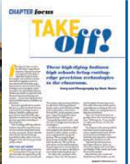 | Take Off | This article features two Indiana high school agriculture programs that have cutting-edge precision agriculture technology in their classrooms, provided by a public-private grant. | Environmental Service Systems; Power, Structural and Technical Systems | Take Off! (PDF) (Starts on Page 2)  Appendix 1: Take Off!  Appendix 1 Key: Take Off! | X |  | https://ffa.box.com/s/en54t57nqhhkpcjwope0e55mh8qwvq3g
Spring 2017 | 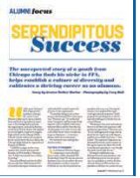 | Serendipitous Success | This article features the story of Corey Flourney, a past national officer and lifetime alumni member, and tells us how he started out with no agricultural experience but became successful in FFA and in his career. | Agribusiness Systems | What Is Your Plan? (PDF) (Starts on Page 13)  Appendix 2: What is Your Plan?  Appendix 3: All in This Together!  (Starts on Page 15) |  | X  X | https://ffa.box.com/s/en54t57nqhhkpcjwope0e55mh8qwvq3g
Spring 2017 |  | Write the Right Resume | This article highlights key pieces of information that should be included in a resume and discusses how technology can be integrated in resumes. It also mentions a resource that can aid students in creating the perfect resume — the FFA Resume Generator. | Agribusiness Systems, Agricultural Communications | Let’s Create It! (PDF) (Starts on Page 21)  Appendix 4: Let’s Create It!  Appendix 4 Key: Let’s Create It!  Appendix 5: Resume Review  (Starts on Page 24) | X | X (Create resume first before completing this activity.) | https://ffa.box.com/s/en54t57nqhhkpcjwope0e55mh8qwvq3g
Summer 2017 | 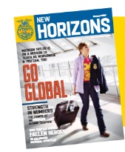 | 3-2-1 What Does My Community Need? | Students will read through statements to identify needs in their community and determine how they can take action. | Agricultural Education | Appendix 1: 3-2-1 What Does My Community Need?  (Starts on Page 2) |  | X | https://ffa.box.com/s/4dpc19uapwan006yk79ima4wywh84eqc
Summer 2017 |  | The 5 Whys Worksheet: Identifying Root Causes | Students will read the article, Grooming Future Leaders.” Students will then identify root causes and determine how they can make an impact with their service-learning project. | Agricultural Education | Appendix 2: The 5 Whys Worksheet: Identifying Root Causes  (Starts on Page 3)  Appendix 2 Key: Determine the Root Cause: 5 Whys |  | X | https://ffa.box.com/s/4dpc19uapwan006yk79ima4wywh84eqc
Summer 2017 |  | Career Profile | Students will utilize AgExplorer to research a career. Students will then use the information to complete a social media profile for their career choice. | Any | Activity: Career Profile  (Starts on Page 6) | X |  | https://ffa.box.com/s/4dpc19uapwan006yk79ima4wywh84eqc
Summer 2017 |  | Get to Know Your Alumni/  Supporters | Students will interview an alumni/supporter and complete the associated questions. | Any | Appendix 4: Get to Know Your Alumni/  Supporters  (Starts on Page 10) |  | X
Summer 2017 |  | Thank a Neighbor! | Students will read the article, “Dude. Be. Nice.” Just like the FFA members in the article started a campaign to help spread kindness in their community, you can easily do the same by writing a simple thank you note to a friend, neighbor, supporter of your FFA chapter, etc. Use the templates to write a simple thank you note to three people. Once completed, cut out the notes and deliver them to the recipients. | Any | Appendix 5: Thank a Neighbor!  (Starts on Page 12) |  | X | https://ffa.box.com/s/4dpc19uapwan006yk79ima4wywh84eqc
Summer 2017 |  | What Type of Service Is It? | Students will read through scenarios and determine the type of service being described. | Agricultural Education | Appendix 6:What Type of Service Is It?  (Starts on Page 14)  Appendix 6 Key: What Type of Service Is It? |  | X | https://ffa.box.com/s/4dpc19uapwan006yk79ima4wywh84eqc
Summer 2017 |  | What Is the Process? | Students will read the article “Ag 101: From Farm to Food.” Just as in the Ag 101 article, there is a process for everything. Students will answer questions to think through a process for their favorite event, activity or hobby. | Agricultural Education | Appendix 7:What Is the Process?  (Starts on Page 17) |  | X | https://ffa.box.com/s/4dpc19uapwan006yk79ima4wywh84eqc
Spring 2018 | 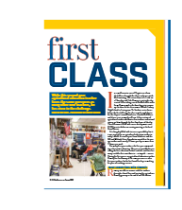 | First Class | Agriculture teachers are some of the busiest teachers in the school. They spend more time with students than other teachers, practicing for FFA career and leadership development events, planning community service events, and engaging in fundraising efforts for the agriculture program and FFA chapter. Many students may not be aware of all that goes on during the “typical” day of an agriculture teacher. Read this article to learn more! | Agricultural Education | Appendix 1: Careers and Skills (PDF) (Starts on Page 2) | X | X | https://ffa.box.com/s/bd6zdylevo9fnc5dwb1cyud6s12tkxp3
Spring 2018 | 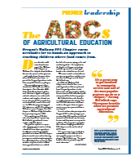 | The ABCs of Agricultural Education | In this article, read about the Wallowa FFA Chapter in Oregon and a community service project their members look forward to each year. The statewide Oregon Agriculture in the Classroom Literacy Project is so popular, students campaign within their chapter to take on the role of the project’s committee chair. Read this article to learn more. | Agricultural Education | Appendix 3: The ABCs of Agricultural Education (PDF) (Starts on Page 11) | X | X | https://ffa.box.com/s/bd6zdylevo9fnc5dwb1cyud6s12tkxp3
Spring 2018 | 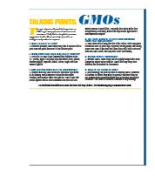 | Talking Points: GMOs | Within today’s agriculture, debatable, hot-button topics abound — and genetically modified organisms or GMOs is one of them. This article will help you learn more about GMOs and answer general questions on the topic. | Biotechnology Systems, Plant Systems | Appendix 4: Debate It! (PDF) (Starts on Page 21) | X |  | https://ffa.box.com/s/bd6zdylevo9fnc5dwb1cyud6s12tkxp3
Spring 2018 | 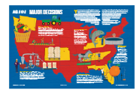 | Ag 101: Study Guide | With spring comes thoughts about college for many high school juniors and seniors. Many universities and colleges have unique agriculture programs available. Read this article to learn about some of those unique programs. | Agricultural Education | Appendix 5: Study Up … Learn About College! (PDF) (Starts on Page 29) | X | X | https://ffa.box.com/s/bd6zdylevo9fnc5dwb1cyud6s12tkxp3
Spring 2018 | 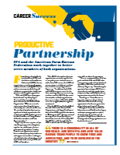 | Productive Partnerships | What is an MOU? Read this article to learn about the agreement between National FFA and the American Farm Bureau Federation and what it means for both organizations. | Agribusiness Systems | Appendix 6: What Is an MOU? (PDF) (Starts on Page 36) | X |  | https://ffa.box.com/s/bd6zdylevo9fnc5dwb1cyud6s12tkxp3
Fall 2018 |  | On the Record: Tyler White | The article “On the Record: Tyler White” is a question and answer session with a former FFA member about the impact FFA has had on him. Tyler White is a professional baseball player. White discusses the activities that helped him in his career as well as some of the highlights of his time as an FFA member. | Any | Appendix 1: What Happens After High School? (PDF) (Starts on page 4) | X | X (if you print off the list of famous alumni) | https://ffa.box.com/s/zc06swl3a5adgcfpusg5vzyylwez3kvb
Fall 2018 | 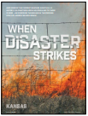 | When Disaster Strikes | Throughout 2017, the United States experienced some of the worst natural disasters it has ever encountered. These setbacks ranged from tropical cyclones and inland flooding to drought and wildfires. However, even in times of struggle, FFA members take action through community service whenever they can. This article walks through two such instances in which FFA members stepped up in times of need. | Animal Systems, Environmental Service Systems, Natural Resources Systems, Plant Systems | Appendix 2: When Disaster Strikes (PDF) (Starts on Page 11) | X | X | https://ffa.box.com/s/zc06swl3a5adgcfpusg5vzyylwez3kvb
Fall 2018 | 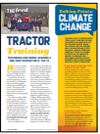 | Talking Points: Climate Change | Climate change is at the forefront of conversations about the environment and the careers needed to address the growing issue. Take the opportunity to look at what climate change means and if it is normal or not. Apply this terminology to determine the impact that climate change has and will have on agriculture and the ability to feed the growing population. | Biotechnology Systems, Natural Resources Systems, Plant Systems | Appendix 3: Climate Change (PDF) (Starts on Page 15) | X |  | https://ffa.box.com/s/zc06swl3a5adgcfpusg5vzyylwez3kvb
Fall 2018 | 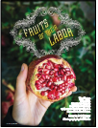 | Fruits of Their Labor | The Moapa Valley FFA Chapter in Nevada has learned about a fruit that most would not expect to grow well in the Nevada desert climate — pomegranates. This fruit grows well on the chapter’s diverse farm. Check out this article to learn how the chapter grows the fruit, promotes FFA and teaches the community about pomegranates at a local festival. | Plant Systems | Appendix 4: The Fruits of Their Labor (PDF) (Starts on Page 25) | X |  | https://ffa.box.com/s/zc06swl3a5adgcfpusg5vzyylwez3kvb
Fall 2018 | 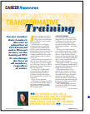 | Transformative Training | Learn how former FFA member Kate Lambert was positively impacted by FFA, regardless of how proficient she was in FFA activities. Check this article out to learn how the FFA (or other organizations) can have a profound impact on your life. | Any | Appendix 5: What’s Your Brand? (PDF) (Starts on Page 29)  Appendix 6: Career Success Reflection (PDF) (Starts on Page 31) | X | X | https://ffa.box.com/s/zc06swl3a5adgcfpusg5vzyylwez3kvb
Fall 2018 | 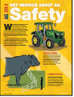 | Ag 101: Get Serious About Ag Safety | Safety is no laughing matter. Read this article to learn practical safety tips for agricultural equipment use, such as tractors, ATVs and grain bins. These tips will help you be more aware of your surroundings and your actions. | Power, Structural and Technical Systems | Appendix 7: Get Serious About Ag Safety (PDF) (Starts on Page 37) | X | X | https://ffa.box.com/s/zc06swl3a5adgcfpusg5vzyylwez3kvb
Summer 2019 | 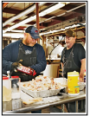 | It’s All About the Kids! | The West Rowan Alumni chapter was recognized at the National FFA Convention & Expo as the 2018 Outstanding Alumni Chapter. Read about what they do and why they do it. | Any | Appendix 1: Giving Back (Word) |  | X | https://ffa.box.com/s/fiohuagkdfjza5npgtb1jv38qsobqis4
Summer 2019 |  | Help After the Hurricane | In 2017, Puerto Rico was hit by two separate hurricanes that destroyed many parts of the island. Learn how communities came together and supported each other as they put their lives back together. | Environmental Service Systems, Natural Resources Systems | Appendix 2: Preparing for the Worst (Word) | X |  | https://ffa.box.com/s/kza659pwnm19zlmzx4qu7u0cniq6doi7
Summer 2019 | 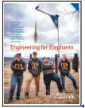 | Engineering for Elephants | Discover how a chapter designed and implemented a project to build hay feeders for the elephants at the local zoo. | Animal Systems; Power, Structural and Technical Systems | Appendix 3: Engineering and Agriculture (Word) | X |  | https://ffa.box.com/s/mkcas8a83j805tni98k0owxxg8m8gg1w
Summer 2019 | 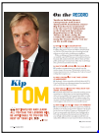 | On the Record: Kip Tom | Northern Indiana farmer, entrepreneur and former FFA Foundation trustee, Kip Tom is the new U.S. ambassador to the Food and Agriculture Organization of the United Nations in Rome, Italy. Read this article to see how he credits FFA with teaching him many life lessons that he now uses on the world stage. | Any | Appendix 4: Future (Word) | X |  | https://ffa.box.com/s/ocwl2e3ti1hm372syad1j0xrlfe0703r
Summer 2019 | 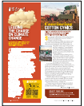 | Convincing Cotton Cynics | Find out how an FFA member proved naysayers wrong by successfully growing cotton in northern Missouri. | Plant Systems | Appendix 5: Convincing Cotton Cynics (Word) | X |  | https://ffa.box.com/s/ocwl2e3ti1hm372syad1j0xrlfe0703r
Summer 2019 | 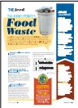 | Talking Points: Food Waste | The amount of food wasted in the United States is a growing problem. Read this article to learn key points and facts with information from No Taste for Food Waste. | Environmental Service Systems | Appendix 6: Talking Points: Food Waste (Word) | X |  | https://ffa.box.com/s/d1ue9ep4do7vw7txzvbsbmnvqkec5z4a
Fall 2019 | 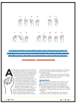 | Sign of the Times | Did you know there are schools for the deaf? And some of them have FFA chapters! Read this article to learn how the North Carolina School for the Deaf became the third FFA chapter in the nation for members who are deaf and hard of hearing. | Any | Appendix 1: Let’s Learn Sign Language! (Word) | X |  | https://ffa.box.com/s/thqbtiiugdg9z4saycuo73e0l4m7ywag
Fall 2019 |  | Here’s to our Hispanic Members | The number of Latino members in FFA continues to grow. From Sept. 15 to Oct. 15, we recognize National Hispanic Heritage Month. Find out more about an FFA chapter that celebrates the contributions of Latino members year-round. | Any | Appendix 2: National Hispanic Heritage Month (Word) | X | X | https://ffa.box.com/s/ym9mxuglk7b8fbrdo0v4se4d00g0k5dx
Fall 2019 | 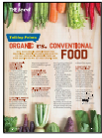 | Talking Points-Organic vs. Conventional Foods | Do you get asked or even wonder yourself about the difference in organic versus conventional foods? Read the talking points presented in this article to learn more about these foods and how to answer questions that you may get on this topic. | Food Products and Processing Systems | Appendix 5: Organic vs. Conventional Foods (Word) | X |  | https://ffa.box.com/s/qz6thkckdrdm2zziqogcr3jlwoxpyzvh
Fall 2019 | 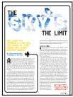 | The Sky’s The Limit | Box Elder FFA members in Utah have a unique opportunity to learn about aviation. They have access to aviation classes and learn about the many ways aviation technology impacts the agriculture industry. | Power, Structural and Technical Systems | Appendix 4: The Sky’s the Limit (Word) | X |  | https://ffa.box.com/s/puwd11t3nauh731sr5vycr1omypc5r76
Fall 2019 | 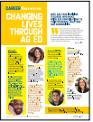 | Changing Lives Through Ag Ed | Agricultural education teachers have the unique opportunity to develop leadership, personal growth and career success in students, which can have a lasting impact on students’ lives. Learn what current agriculture educators have to say about their experiences. | Any | Appendix 3: Educating the Future (Word) | X |  | https://ffa.box.com/s/vtod5d3o7qygugn1zpjhhsdeatjpjci5
Winter 2019 | 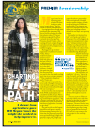 | Charting Her Path | How can agriculture help you gain a career, even if it’s not in the agriculture industry? Read this exciting story about how one former member used her FFA experience to end up in satellite imagery. | Agribusiness Systems | Appendix 5: Charting Her Path (Word)  Appendix 5: Charting Her Path (PDF) | X  X |  | https://ffa.box.com/s/dldove6bwqodxgzebkoz13uxuz5my0dq
Winter 2019 | 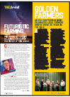 | Space Farmer | Ever wonder what agriculture and space have in common? This article discusses how a former FFA member found his way to NASA and the connection FFA, agriculture and space have in his life. | Food Products and Processing Systems | Appendix 2: Space Farmer (Word)  Appendix 2: Space Farmer (PDF) | X  X |  | https://ffa.box.com/s/fap4nnt3cdcguf8wnkxf8d4pnpffyoaa
Winter 2019 | 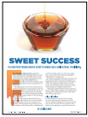 | Sweet Success | Who doesn’t enjoy maple syrup on their pancakes on Saturday morning? But where does syrup come from? In this article, read about FFA chapters that produce maple syrup and the process they go through each year. | Agribusiness Systems; Food Products and Processing Systems; Plant Systems | Appendix 1: Sweet Success (Word)  Appendix 1: Sweet Success (PDF) | X  X |  | https://ffa.box.com/s/5d3133pbuuguiiz067mjlqbatat8u445
Winter 2019 | 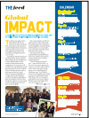 | Making a Global Impact | When you have a connection with a school in another country, you learn about that school and find ways to work with and learn from the students. One U.S. school found their sister school in Congo and were determined to help make a difference. | Animal Systems | Appendix 6: Making a Global Impact (Word)  Appendix 6: Making a Global Impact (PDF) | X  X |  | https://ffa.box.com/s/lg70oyn2949i2qscx9fkprmy36t32kkt
Winter 2019 | 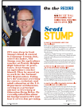 | On the Record: Scott Stump | Read this Q and A about Scott Stump, Assistant Secretary for Career, Technical and Adult Education at the U.S. Department of Education, to learn how his background in FFA helps him in his career. | Agricultural Education | Appendix 4: On the Record (Word)  Appendix 4: On the Record (PDF) | X  X |  | https://ffa.box.com/s/0wb93itn30fpa0x7qfnein7lu8v9ax5f
Winter 2019 |  | How to Become a Chapter Officer | Check out this quick read to learn some great tips from agriculture teachers and FFA advisors about applying and interviewing for a chapter officer position. | Any | Appendix 3: How to Become a Chapter Officer (Word)  Appendix 3: How to Become a Chapter Officer (PDF) | X |  | https://ffa.box.com/s/h94qbe6s1lt1jgifm4wrhsrpt77kr1hq
Spring 2019 | 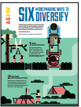 | Ag 101: Six Moneymaking Ways to Diversify | Do you want to make some money? Check out this quick read for tips on how to diversify a business or project to make cash! Tips range from starting a yard maintenance business to small engine repair. | Agribusiness Systems | Appendix 5: Ag 101 (Word) | X |  | https://ffa.box.com/s/8uf5uvuy6mxpjbyit7b5l0n8gyku5ou9
Spring 2019 | 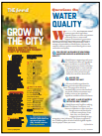 | Water Quality | Dive into this short read to learn why water quality and water conservation are an important issue in agriculture. This article also discusses how Purina focuses some of its efforts on water conservation. | Natural Resources Systems | Appendix 6: Water Quality (Word) | X |  | https://ffa.box.com/s/3ky2nvp9emencii6bzjrbft8vabzdc10
Spring 2019 |  | The Fight for Female Membership | Women joined FFA in 1969 and have been making a lasting impact ever since. | Any | Appendix 4: Female Leadership (Word) | X | X | https://ffa.box.com/s/9r9w9uc1k71vl9evzpa7xgdm4i55flqo
Spring 2019 | 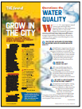 | Grow in the City | Farming is not always a vast field in the middle of nowhere. In Maryland, students are learning about growing food in downtown Baltimore. | Plant Systems | Appendix 3: Plants Are Amazing! (Word) | X |  | https://ffa.box.com/s/x8jrkzhfr3wtd4mw91995oymau6iflha
Spring 2019 | 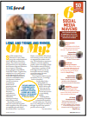 | Lions, Tiger and Rhinos, Oh My! | Students travel to Africa and gain hands-on skills working with large animals. | Animal Systems | Appendix 2: Lions and Tigers and Rhinos, Oh My! (Word) | X |  | https://ffa.box.com/s/xclm9516xjiqjemhm6yo3hw6pfk58mye
Spring 2019 |  | Service for Service | Learn how the Center FFA Chapter in Center, N.D., worked with a local group to help connect a service dog with a local veteran. In addition to connecting the service dog with a partner, they helped raise funds to purchase care package items for the new animal owner. | Animal Systems | Appendix 1: Service for Service (Word) | X |  | https://ffa.box.com/s/mkhn626uqw2dh1uktosi2fh9xx39mj9h
Summer 2020 | 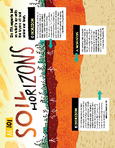 | Soil | To some, soil is just the material we walk and drive on. But to others, soil is a dynamic accumulation of layers that plays a large role in our lives. | Plant Systems, Natural Resources Systems, Environmental Service Systems | Appendix 3: Soil (Word)  Appendix 3: Soil (PDF) | X  X |  | https://ffa.box.com/s/lmmk43ct9lc30oa02lzbz9pg1gumkjw3
Summer 2020 | 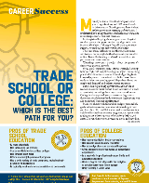 | Trade School or College | When deciding what path to travel after high school, there is no one set direction for everyone. Identify the pros and cons of a college education to determine which path may best suit your skills and career plans. | Any | Appendix 1: Trade School or College: Which Is the Best Path for You?  (Word)  Appendix 1: Tread School or College: Which Is the Best Path for You? (PDF) | X  X |  | https://ffa.box.com/s/3jl59r1dm3ilxf7i76hvu56spvmj8sfd
Summer 2020 | 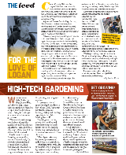 | High-Tech Gardening | Read this article to learn how FFA members in Oregon are learning about FarmBot and putting it to use in their school greenhouse. | Plant Systems | Appendix 6: High-Tech Gardening (Word)  Appendix 6: High-Tech Gardening (PDF) | X  X |  | https://ffa.box.com/s/3gizjslyxemtf2oo47b6pkfluhg3k3bb
Summer 2020 | 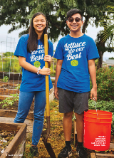 | One Big Ohana | Read this article to learn about the ecosystem and history of Hawaii and to discover what FFA activities and SAEs are like in the Hawaii FFA Association. | Agricultural Education | Appendix 5: One Big Ohana (Word)  Appendix 5: One Big Ohana (PDF) | X  X |  | https://ffa.box.com/s/61yhwqqz16mthtwq86r99oos06aplgjt
Summer 2020 | 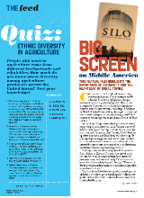 | Big Screen on Middle America | Read this article to learn how a feature film, Silo, highlights the importance of agriculture safety. | Power, Structural and Technical Systems | Appendix 4: Big Screen on Middle America (Word)  Appendix 4: Big Screen on Middle America (PDF) | X  X |  | https://ffa.box.com/s/qqsp915u231n54vsl30r31wweqgp3tzq
Summer 2020 |  | Shelter From the Storm | What would happen to the animals in your community if a disaster were to hit? In this article, find out how FFA members are helping to plan for disaster. | Animal Systems | Appendix 2: Shelter from the Storm (Word)  Appendix 2: Shelter from the Storm (PDF) |  | X  X | https://ffa.box.com/s/paybrk3c0fn4czbx8dvy6p06yykbb528
Spring 2020 | 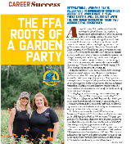 | The FFA Roots of a Garden Party | Have you ever wondered how what you do in high school can get you started in your own career? Learn about two individuals whose passion began by being part of FFA and competing in a CDE. | Agribusiness Systems, Plant Systems | Appendix 1: The FFA Roots of a Garden Party (Word)  Appendix 1: The FFA Roots of a Garden Party (PDF) | X  X |  | https://ffa.box.com/s/09593grzn7t09qx167tofzfazwwsb520
Spring 2020 | 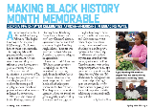 | Black History Month | This article highlights a Georgia FFA chapter that celebrate African Americans in unique and engaging ways through a variety of activities. | Agricultural Education | Appendix 5: Black History Month (Word)  Appendix 5: Black History Month (PDF) | X  X |  | https://ffa.box.com/s/x2ziei2b13pr4qug60rr8f113j7zrg36
Spring 2020 | 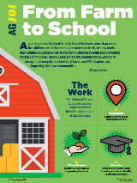 | Ag 101: Farm to School | This quick read discusses the farm-to-school initiative. Learn how the National Farm to School Network is working to change food insecurity and how local FFA chapters are helping to improve their communities. | Agricultural Education, Plant Systems | Appendix 4: Ag 101: Farm to School (Word)  Appendix 4: Ag 101: Farm to School (PDF) | X  X |  | https://ffa.box.com/s/4flql23wk3jiax592imbq5gojl7ekdqz
Spring 2020 | 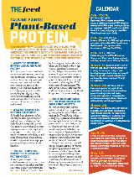 | Plant-Based Protein | Plant-based protein options are making headlines across the United States. But what are plant-based proteins all about? Learn about this hot topic through a Q&A session followed by a debate. | Animal Systems, Biotechnology Systems, Plant Systems | Appendix 3: Plant-Based Protein (Word)  Appendix 3: Plant-Based Protein (PDF) | X  X |  | https://ffa.box.com/s/5xlnyqvf98j66z9s0t47991ildim7v6g
Spring 2020 |  | Come Together | Did you know there is a school in Arkansas with such a diverse student body that there are more than 10 different languages spoken? Learn about this unique school and the opportunities FFA students have through this diversity. | Any | Appendix 2: Come Together (Word)  Appendix 2: Come Together (PDF) | X  X | X  X | https://ffa.box.com/s/cd0g1vlwob9f2mo02ilbzjezub7il06g
Fall 2020 | 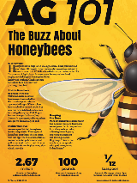 | The Buzz About Honeybees | Honeybees are a crucial component of the agriculture industry. Learn about honeybees and their role in the industry. | Food Products and Processing Systems; Natural Resources Systems | Appendix 3: The Buzz About Honeybees (Word)  Appendix 3: The Buzz About Honeybees (PDF) | X  X |  | https://ffa.box.com/s/ojd4wpww72yw4yzibhtnyxoczring5q6
Fall 2020 | 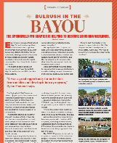 | Bulrush in the Bayou | Read this article to learn how an FFA chapter in Louisiana is helping to restore wetlands in the state. | Natural Resource Systems | Appendix 7: Bulrush in the Bayou (Word)  Appendix 7: Bulrush in the Bayou (PDF) | X  X |  | https://ffa.box.com/s/bnwfipmgjuskxffj9cvoofi4vla5cm25
Fall 2020 | 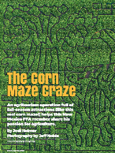 | Corn Maze | The agritourism industry is a vital part of engaging and educating the public about the agriculture industry. Explore how one agritourism site works to engage the community, and learn how you could engage the community in your state. | Any | Appendix 2: Corn Maze (Word)  Appendix 2: Corn Maze (PDF) | X  X |  | https://ffa.box.com/s/luicdratjgjx4yh974gdh9j9yndg55ok
Fall 2020 | 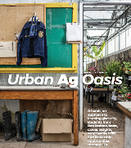 | Urban Ag Oasis | A leader in grain production and home to innovation such as John Deere, Corteva Agricience, Kemin Industries, the World Food Prize, FarmHer and more, Iowa is deep seated in agriculture and rural experiences. Typically, FFA in Iowa has focused on rural communities. However, the trend today is urban. Read this article to learn about the new chapters in some of the state’s largest cities. | Agricultural Education | Appendix 6: Urban Ag Oasis (Word)  Appendix 6: Urban Ag Oasis (PDF) | X  X |  | https://ffa.box.com/s/reukgmi2dpnjbanwx0rerce1y20adnai
Fall 2020 |  | #SpeakAg | Understanding consumers and how they gain information about the agriculture industry is critical, but we also need to know how we can best share accurate information. Discover how we can educate the public in a world that is full of information. | Any | Appendix 5: #SpeakAg (Word)  Appendix 5: #SPeakAg (PDF) | X  X |  | https://ffa.box.com/s/w609xkg65rd2d49l8vf55t34xwwduu2f
Fall 2020 | 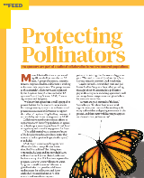 | Protecting Pollinators | Monarch butterflies are disappearing from the landscape. A group of scientists, conservationists, corporate leaders and farmers are working to increase the butterfly population through habitat creation and restoration. Read this article to learn more about what efforts are being made to help with the monarch butterfly population. | Natural Resources Systems | Appendix 4: Protecting Pollinators (Word)  Appendix 4: Protecting Pollinators (PDF) | X  X |  | https://ffa.box.com/s/e1xx4wr7yaezin5wq8jbkpvuxsvyebfa
Fall 2020 |  | On the Record: Eric Shanks | Eric Shanks is a former FFA member who is now the chief executive officer and executive producer of FOX Sports. Learn about the impact FFA had on his career path. | Any | Appendix 1: On the Record: Eric Shanks (Word)  Appendix 1: On the Record: Eric Shanks (PDF) | X  X | X  X | https://ffa.box.com/s/bgq2ugprijprnjazswtd4vh9c7zeqpxa
Fall 2020 | 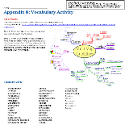 | Vocabulary Activity | Students can focus on the vocabulary throughout this issue by completing this activity. | Any | Appendix 8: Vocabulary Activity (Word)  Appendix 8: Vocabulary Activity (PDF) |  | X  X | https://ffa.box.com/s/srp0qj1dy00cnqksb30n0oss7qetf1ls
Spring 2021 | 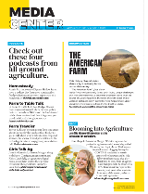 | Media Center | Podcasts, blogs and documentaries are growing in popularity in today’s digital world. This article highlights several podcasts, blogs and documentaries that have ties to agriculture. Check this article out to learn more. | Any | Appendix 6: Media Center (Word)  Appendix 6: Media Center (PDF) | X  X |  | https://ffa.box.com/s/ctra9jnya61rzz8g8z55nxigt5t9a2tk
Spring 2021 | 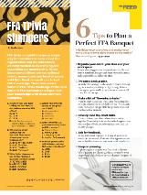 | Banquet | Banquets are a great way to celebrate the accomplishments of those that share common interests and goals. In this article, readers will learn about the important components that need to be considered when planning a banquet. | Any | Appendix 2: Banquet (Word)  Appendix 2: Banquet (PDF) |  | X  X | https://ffa.box.com/s/5qhopkkzka28lolkf29pigqb2aduxuvv
Spring 2021 | 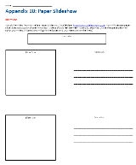 | Paper Slideshow | Complete a paper slideshow to share understanding about a concept. | Any | Appendix 10: Paper Slideshow (Word)  Appendix 10: Paper Slideshow (PDF) | X  X |  | https://ffa.box.com/s/19rcbiu8spe527ojvr0bsnve82r6sasb
Spring 2021 | 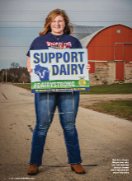 | Devoted to Dairy Strong | Recently, schools and FFA chapters have been faced with new challenges, including FFA and school events being canceled or conducted differently, virtual learning, etc. The Waupun FFA Chapter in Wisconsin faced similar challenges when their FFA and school events were changed and/or canceled. Members also recognized the impact the COVID-19 pandemic had on the community. Read this article to learn how the chapter members worked together to make a positive impact on their community. | Animal Systems, Agricultural Education | Appendix 8: Devoted to Dairy Strong (Word)  Appendix 8: Devoted to Dairy Strong (PDF) |  | X  X | https://ffa.box.com/s/v3dbmudydsdsfyxhhslckqvlds5dnpop
Spring 2021 | 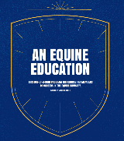 | An Equine Education | The equine industry is an important part of the agriculture industry as a whole. At a school in Kentucky, students receive hands-on experience in the equine industry through the three-circle model, which prepares them for a career in the industry. | Animal Systems | Appendix 5: An Equine Education (Word)  Appendix 5: An Equine Education (PDF) | X  X |  | https://ffa.box.com/s/ukues097ym3uj073sx3s7ixepxzboe2o
Spring 2021 | 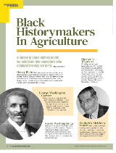 | Black Innovators in Agriculture | There are numerous individuals who have made major contributions to the agriculture industry. This article explores five innovators who changed the way we farm thanks to their contributions. | Any | Appendix 7: Black Innovators in Agriculture (Word)  Appendix 7: Black Innovators in Agriculture (PDF) |  | X  X | https://ffa.box.com/s/z7nr48ln84cq3rap50nfvz2c09xwio7t
Spring 2021 |  | Wellness in the Worry | Due to the COVID-19 pandemic, the level of stress experienced by students is at an all-time high. Self-care is now more important than ever to help maintain overall health. Read about self-care and ways to incorporate self-care each day. | Any | Appendix 4: Wellness in the Worry (Word)  Appendix 4: Wellness in the Worry (PDF) | X  X |  | https://ffa.box.com/s/566841n3ijtwtg476czprplled8h08x8
Spring 2021 | 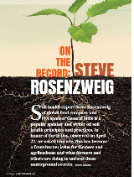 | On the Record with Steve Rosenzweig | Soil health is important in food production and many other facets of our day-to-day lives. In this article, read how soil health has become more important than ever and why a focus has been placed on this important topic. | Natural Resources Systems, Plant Systems | Appendix 3: On the Record with Steve Rosenweig (Word)  Appendix 3: On the Record with Steve Rosenweig (PDF) |  | X  X | https://ffa.box.com/s/efx4kny7e22lu6vw5lio5fztbp98iaaq
Spring 2021 | 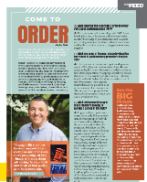 | The Feed: Come to Order | Parliamentary procedure is used across many industries and organizations. In this article, Dr. Foster discusses his interest in and passion for parliamentary procedure. | Any | Appendix 1: The Feed: Come to Order (Word)  Appendix 1: The Feed: Come to Order (PDF) |  | X  X | https://ffa.box.com/s/b5id80yeyxfz6crzptxadvuz67dfjxoq
Spring 2021 | 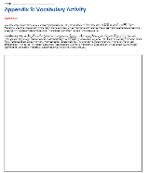 | Vocabulary Activity | Students can focus on the vocabulary throughout this issue by completing this activity. | Any | Appendix 9: Vocabulary Activity (Word)  Appendix 9: Vocabulary Activity (PDF) |  | X  X | https://ffa.box.com/s/zgp6d6fx4b4667y1l8y6kbs4e7ism3ex
Fall 2021 | 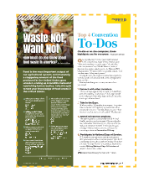 | Waste Not, Want Not | Food is vital for every person in the world and is the greatest output of the agriculture industry. In this quiz, students will answer questions about the amount of food that is wasted everyday. | Environmental Service Systems | Appendix 1: Waste Not, Want Not (Word)  Appendix 1: Waste Not, Want Not (PDF) | X |  | https://ffa.box.com/s/b2wndyxalv8ih133a2rlry8vsvmq4zqw
Fall 2021 | 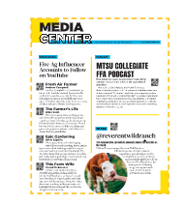 | Arts and Culture in Agriculture | Information sources such as videos on YouTube, podcasts and blogs are popular methods for learning and consuming information. In this lesson, students will explore YouTube influencers, podcasts and blogs in agriculture to understand the role they play in the industry. | Any | Appendix 2: Arts and Culture in Agriculture  (Word)  Appendix 2:  Arts and Culture in Agriculture  (PDF) | X |  | https://ffa.box.com/s/djjazbf1ndi8c083d1399xnp4kkkvtx7
Fall 2021 | 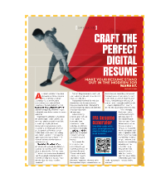 | Craft the Perfect Digital Resume | As communications become more digital, so do resumes. Since resumes are now commonly submitted through email or posted on career websites, it is important to ensure your resume will grab the attention of a future employer. | Any | Appendix 3: Craft the Perfect Digital Resume  (Word)  Appendix 3: Craft the Perfect Digital Resume  (PDF) | X |  | https://ffa.box.com/s/ql9malmenp65lqgbaz9l3ktdhuq7t4lz
Fall 2021 | 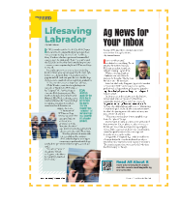 | Lifesaving Labrador | In this article, read about how the North Clay FFA Chapter is working to raise enough money to provide a service dog to one of their chapter members. | Animal Systems | Appendix 4: Lifesaving Labrador  (Word)  Appendix 4:  Lifesaving Labrador  (PDF) | X |  | https://ffa.box.com/s/eocd98w5ho6yolxbe5t95ysxzeqpdzn7
Fall 2021 | 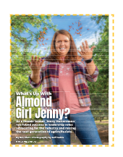 | What’s Up With Almond Girl Jenny? | Production agriculture, the heart of agriculture education and FFA involvement holds a special place in Jenny Holtermann’s life. As a female farmer, she has found success in leadership roles advocating for the industry and raising the next generation of agriculturists. | Animal Systems, Food Products and Processing | Appendix 5: What’s Up With Almond Girl Jenny?  (Word)  Appendix 5: What’s Up With Almond Girl Jenny?  (PDF) | X |  | https://ffa.box.com/s/7sh8skujb0bjvgavy2fvmdpzrge2qrl9
Fall 2021 | 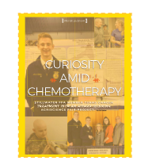 | Curiosity Amid Chemotherapy | Stillwater FFA member turns cancer treatment into an award-winning agriscience fair project. | Natural Resources Systems, Power, Structural and Technical Systems | Appendix 6: Curiosity Amid Chemotherapy  (Word)  Appendix 6: Curiosity Amid Chemotherapy  (PDF) | X |  | https://ffa.box.com/s/2q7yqmmio5jagb5fmuuaybzepu4048en
Fall 2021 | 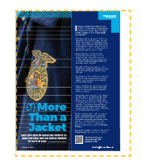 | More Than a Jacket | Learn more about the famous blue corduroy FFA jacket that has been worn by members for nearly 90 years. | Agricultural Education | Appendix 7: More Than a Jacket  (Word)  Appendix 7: More Than a Jacket  (PDF) | X |  | https://ffa.box.com/s/anhzl26lchz7kbf4iki3iwahao6f6x18
Fall 2021 |  | Honor The Heritage | In this article, Monte Cummins discusses how he came to love ranching and how he established his own herd. Cummins also learned a valuable skill from his father – leatherworking. | Animal Systems | Appendix 8: Honor the Heritage  (Word)  Appendix 8: Honor the Heritage (PDF) | X |  | https://ffa.box.com/s/7ills3oopa3hn99ee7et7v11lplrt70s
Spring 2022 | 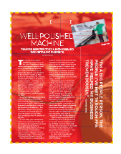 | Well-Polished Machine | For his supervised agricultural experience, Boys started a car-detailing business. He never dreamed how successful it could be, and he now has a full-time business. | Agricultural Education  Power, Structural and Technical Systems | Appendix 1: Well-Polished Machine  (Word)  Appendix 1: Well-Polished Machine  (PDF) | X |  | https://ffa.box.com/s/gc9jx3cy4xu3w84yw9hcelujrudjylb2
Spring 2022 | 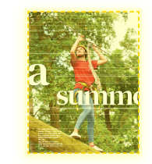 | A Summertime Staple | FFA Summer camps hold a lasting impact for those that have had the opportunity to attend. Forever friendships, engaging team-building activities, leadership skills and lifelong memories are just a few of the gains attendees take away when attending this wonderful FFA experience. | Any | Appendix 2: A Summertime Staple  (Word)  Appendix 2: A Summertime Staple  (PDF) |  | X | https://ffa.box.com/s/rtysco4fri6j3br4fdjy92iuf6lsp50q
Spring 2022 | 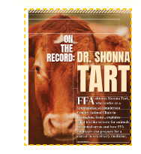 | On the Record: Dr. Shonna Tart | Hear from Dr. Shonna Tart on her exciting career in the veterinary science field. | Animal Systems | Appendix 3: On the Record: Dr. Shonna Tart  (Word)  Appendix 3: On the Record: Dr. Shonna Tart  (PDF) | X |  | https://ffa.box.com/s/db90r952oxct4ee273ykmk14ji2eqhmu
Spring 2022 | 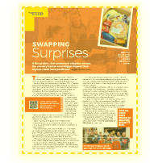 | Swapping Surprises | A fun project that connected chapters across the country had an even bigger impact than anyone could have predicted. | Any | Appendix 4: Swapping Surprises  (Word)  Appendix 4: Swapping Surprises  (PDF) |  | X | https://ffa.box.com/s/mgwwpy9vvcy90uz4vodzg062ytu67nyr
Spring 2022 | 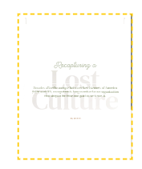 | Recapturing a Lost Culture | Decades after the merger between New Farmers of America (NFA) and FFA, recognition is long overdue for an organization that shaped the blue and gold as we know it. | Agricultural Education | Appendix 5: Recapturing a Lost Culture  (Word)  Appendix 5: Recapturing a Lost Culture  (PDF) | X |  | https://ffa.box.com/s/rjgwdeg2im7dh2pe11ivuaxymhuo1ofs
Spring 2022 | 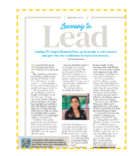 | Learning To Lead | Joining FFA helped Bennett Perez go from shy to self-assured and gave her the confidence to chase her dreams. | Agricultural Education | Appendix 6: Learning To Lead  (Word)  Appendix 6: Learning To Lead | X |  | https://ffa.box.com/s/02o63kual57u27oufkic82lkdr16bfsk
Spring 2022 | 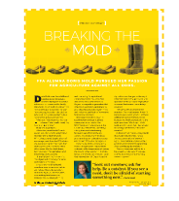 | Breaking The Mold | FFA alumna Doris Mold pursued her passion for agriculture against all odds. | Agricultural Education | Appendix 7: Breaking The Mold  (Word)  Appendix 7: Breaking The Mold  (PDF) |  | X | https://ffa.box.com/s/gjpy32jlvkm9jyuod5u32usrlbjgjszj

