Mushroom Farming
Created: 07/2020 by the National FFA Organization

Nathan Gore’s supervised agricultural experience (SAE) program is mushroom farming. Learn how to grow, manage and harvest a mushroom crop.

Student Learning Objectives:
After completing these activities, students will …
- Describe the step-by-step process used to grow mushrooms on cut logs.
- Research the propagation methods for five commercially relevant mushroom varieties.
- Examine the characteristics of popular specialty mushrooms.

Time Required: 90 minutes
Resources/References:
- Video: “Mushroom Farming SAE | Nathan Gore,” https://vimeo.com/355395940
- Article: “Six Gourmet and Medicinal Mushrooms You Can Easily Grow in Your Garden,” https://www.tyrantfarms.com/6-gourmet-and-medicinal-mushrooms-you-can-easily-grow-in-your-garden/

Equipment and Supplies Needed:
- A copy of the “Mushroom on a Log” worksheet for each student
- A copy of the “The Wonders of the Mushroom” worksheet for each student
- Internet access to play the video in real time or embed it in a PowerPoint ahead of time

Student activity sheets:
Direct access to student activity sheets without lesson plan or answer key for easy upload to learning management system or printing for classwork.
https://ffa.box.com/s/zqcysik626t8cu23clx8ff4feon2vkdx (Word)
https://ffa.box.com/s/in5lvwferganhcu7azdwgh8rbl45l1ik (PDF)

Cross-Curricular Connections:
Science
Research the propagation methods for five commercially relevant mushroom varieties.

These activities are aligned to the following standards:

AFNR Performance Element
- CS.06. Analyze the interaction among AFNR systems in the production, processing and management of food, fiber and fuel and the sustainable use of natural resources.
FFA Precept
- FFA.PL-A.Action: Assume responsibility and take the necessary steps to achieve the desired results, no matter what the goal or task at hand.
- FFA.PG-J.Mental Growth: Embrace cognitive and intellectual development relative to reasoning, thinking and coping.
- FFA-CS-M.Communication: Effectively interact with others in personal and professional settings.
Common Career Technical Core
- AG6 Analyze the interaction among AFNR systems in the production, processing, and management of food, fiber, and fuel and the sustainable use of natural resources.
Common Core – Reading: Informational Text
- CCSS.ELA-Literacy.RI.9-10.3 Analyze how the author unfolds an analysis or series of ideas or events, including the order in which the points are made, how they are introduced and developed, and the connections that are drawn between them.
Common Core – Writing
- CCSS.ELA-Literacy.W.9-10.2 Write informative/explanatory texts to examine and convey complex ideas, concepts, and information clearly and accurately through the effective selection, organization, and analysis of content.
Common Core – Speaking and Listening
- CCSS.ELA-Literacy.SL.9-10.1 Initiate and participate effectively in a range of collaborative discussions (one-on-one, in groups, and teacher-led) with diverse partners on grades 9-10 topics, texts, and issues, building on others' ideas and expressing their own clearly and persuasively.
Common Core – Science & Technical Subjects
- CCSS.ELA-Literacy.RST.9.10.4 Determine the meaning of symbols, key terms, and other domain-specific words and phrases as they are used in a specific scientific or technical context relevant to grades 9-10 texts and topics.
AFNR Career Ready Practices
- CRP.02. Apply appropriate academic and technical skills. Career-ready individuals readily access and use the knowledge and skills acquired through experience and education to be more productive.
- CRP.04. Communicate clearly, effectively, and with reason. Career-ready individuals communicate thoughts, ideas and action plans with clarity, whether using written, verbal and/or visual methods.
- CRP.05. Consider the environmental, social and economic impact of decisions. Career-ready individuals understand the interrelated nature of their actions and regularly make decisions that positively impact and/or mitigate negative impact on other people, organizations and the environment.
- CRP.07. Employ valid and reliable research strategies. Career-ready individuals are discerning in accepting and using new information to make decisions, change practices or inform strategies.
- CRP.08. Utilize critical thinking to make sense of problems and persevere in solving them. Career-ready individuals readily recognize problems in the workplace, understand the nature of the problem, and devise effective plans to solve the problem.
Partnership for 21st Century Skills
- Communication
- Critical Thinking and Problem Solving
- Information, Communications, and Technology Literacy

Lesson Plan:
- Bell Ringer: Are you a fan of mushrooms? Why or why not?

- Introduction: Over the last decade, growing mushrooms for profit on a small scale has become quite popular. This has led to gourmet varieties of mushrooms being more readily available to the general public. Today, we’ll learn about an FFA member who produces and sells mushrooms that his family grows. We’ll learn the step-by-step process they follow to achieve a successful mushroom crop.

- Activity: Each student needs a copy of the worksheet “Mushroom on a Log.” Have students complete the worksheet as they watch the video “Mushroom Farming SAE | Nathan Gore,” available at https://vimeo.com/355395940. After they are done, give each student a copy of the worksheet “The Wonders of the Mushroom.” Students will research five commercially popular mushroom varieties that can be grown in a small garden or backyard.

- Follow-up: Have students share if they or anyone they know grows mushrooms. Discuss the possibilities of creating a small side business by maintaining a few logs of mushrooms, and have students speculate on the potential profits for such an endeavor. If time allows, have students quickly research the profits of small, part-time mushroom farmers.

- Optional — Extended Learning Opportunities (Not factored into time requirement):
  - If you have the space and resources available, consider growing a small crop of mushrooms. When students are involved from the beginning, they will get hands-on experience in a variety of areas, and this also provides another opportunity for school-based enterprises.
  - If growing mushrooms isn’t possible, find a local mushroom grower and invite them to speak to the class about their experiences.

- Exit Ticket: Even if you don’t like mushrooms, does growing a mushroom crop appeal to you? Why or why not?

Mushroom on a Log
Aligned to the following standards:
CS.06; PL-A.; PG-J.; CS-M.; AG6; CCSS.RI.9-10.3; CCSS.W.9-10.2; CCSS.SL.9-10.1; CCSS.RST.9.10.4; CRP.02; CRP.04; CRP.05; CRP.07; CRP.08
Directions:
Answer the questions below as you watch the video “Mushroom Farming SAE | Nathan Gore,” available at https://vimeo.com/355395940.

What is Nathan’s SAE?

Describe the step-by-step process he uses to grow the mushrooms.


How has the mushroom farming operation grown?

How are logs stacked?

What is Nathan’s favorite part of his SAE?

The Wonders of the Mushroom
Directions:
Over the last decade, growing mushrooms for profit on a small scale has become quite popular. This has led to gourmet varieties of mushrooms being more readily available to the general public. Using the suggested resource, complete the table to learn about five species of mushrooms that you might be able to grow at your home!
(Suggested Resource: “Six Gourmet and Medicinal Mushrooms You Can Easily Grow in Your Garden,” https://www.tyrantfarms.com/6-gourmet-and-medicinal-mushrooms-you-can-easily-grow-in-your-garden/)

Mushroom  (Insert, paste or draw a picture) | Where Do They Grow? | Taste | Medicinal Properties | Growing Season
Wine Cap
Shiitake
Maitake
Oyster
Chicken of the Woods
Aligned to the following standards:
CS.06; PL-A.; PG-J.; CS-M.; AG6; CCSS.RI.9-10.3; CCSS.W.9-10.2; CCSS.SL.9-10.1; CCSS.RST.9.10.4; CRP.02; CRP.04; CRP.05; CRP.07; CRP.08

KEY: Mushroom on a Log
Aligned to the following standards:
CS.06; PL-A.; PG-J.; CS-M.; AG6; CCSS.RI.9-10.3; CCSS.W.9-10.2; CCSS.SL.9-10.1; CCSS.RST.9.10.4; CRP.02; CRP.04; CRP.05; CRP.07; CRP.08
Directions:
Answer the questions below as you watch the video “Mushroom Farming SAE | Nathan Gore,” available at https://vimeo.com/355395940.

What is Nathan’s SAE?
Mushroom farming

Describe the step-by-step process he uses to grow the mushrooms.
Start in the dormant season between December and February.
Cut logs that are 40 inches in length and two to eight inches in diameter. Thin bark is better.
Let log sit for 24 hours.
Drill holes in the log six to eight inches apart.
Fill the holes with mushroom mycelium, which is spawn and mushroom spores.
Stack the logs up to 50 logs high for four to six months.
They start pinning, which is the mushrooms penetrating through the bark.
Logs are moved to the fruiting house, which is basically a greenhouse.
Old logs are moved out, and new logs are moved in.
Start the force fruiting cycle by submerging them in water for 24 hours.
Two to three days later, you harvest the mushrooms.
Take them to market.
How has the mushroom farming operation grown?

They started with 500 logs. Through trial and error and research, they have grown to 2,500 logs.
How are logs stacked?

Each layer of logs is perpendicular to the layer below it.

What is Nathan’s favorite part of his SAE?

His favorite part is harvesting because he gets to see what he has helped create come to life.

KEY: The Wonders of the Mushroom
Directions:
Over the last decade, growing mushrooms for profit on a small scale has become quite popular. This has led to gourmet varieties of mushrooms being more readily available to the general public. Using the suggested resource, complete the table to learn about five species of mushrooms that you might be able to grow at your home!
(Suggested Resource: “Six Gourmet and Medicinal Mushrooms You Can Easily Grow in Your Garden,” https://www.tyrantfarms.com/6-gourmet-and-medicinal-mushrooms-you-can-easily-grow-in-your-garden/)

Mushroom  (Insert, paste or draw a picture) | Where Do They Grow? | Taste | Medicinal Properties | Growing Season
Wine Cap  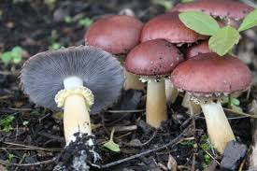 | Grow on hardwood mulch/wood chips; can inoculate mulched walking paths and mulched no-till garden beds | combination of portobello mushrooms with notes of white potatoes and red wine | No research suggests this | Fruit in the spring and again in the fall
Shiitake  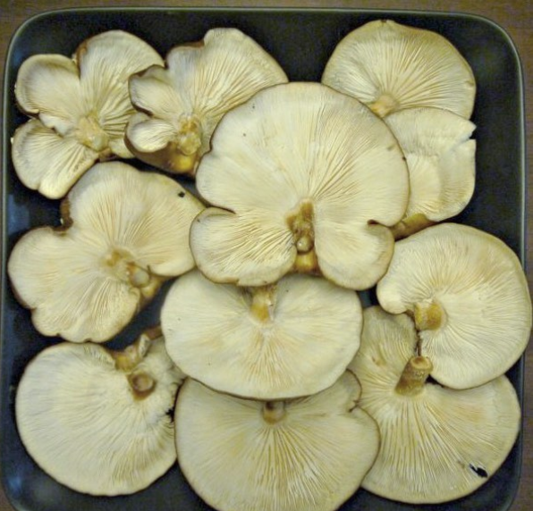 | Grow on cut hardwood logs | Mild, delicious, yet meaty  Umami might be the best word to describe their flavor, which is why they are one of the most popular culinary mushrooms in the world. | Boost the immune system and can help lower cholesterol and reduce weight gain | Depends on the variety; some fruit in cool weather and others in warm
Maitake  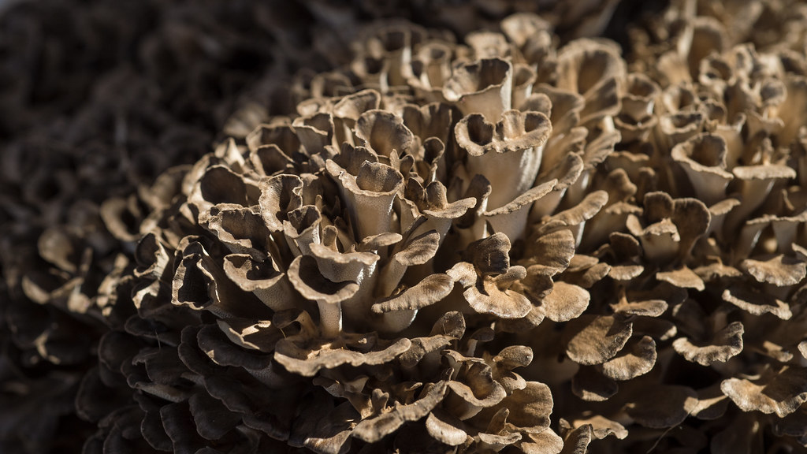 | Grow on sick or dying tree bases/roots, cut hardwood logs or specialized substrate in grow bags | considered one of the most valued culinary mushrooms in the world, offering a rich umami flavor | stimulate both the innate and adaptive immune system, lower blood sugar (good for diabetes) and inhibit cancer cell growth | Fruit in the late summer through fall
Oyster  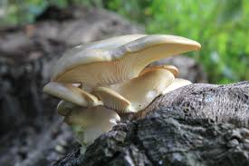 | grow on cut logs, dead or dying trees or specialized substrate in grow bags | A somewhat mild seafood flavor, akin to scallops | Peer reviewed studies show a long list of medicinal properties. | Different subspecies grow in different seasons  Winter oyster mushrooms fruit throughout the fall and winter, but other types fruit in the spring and summer
Chicken of the Woods  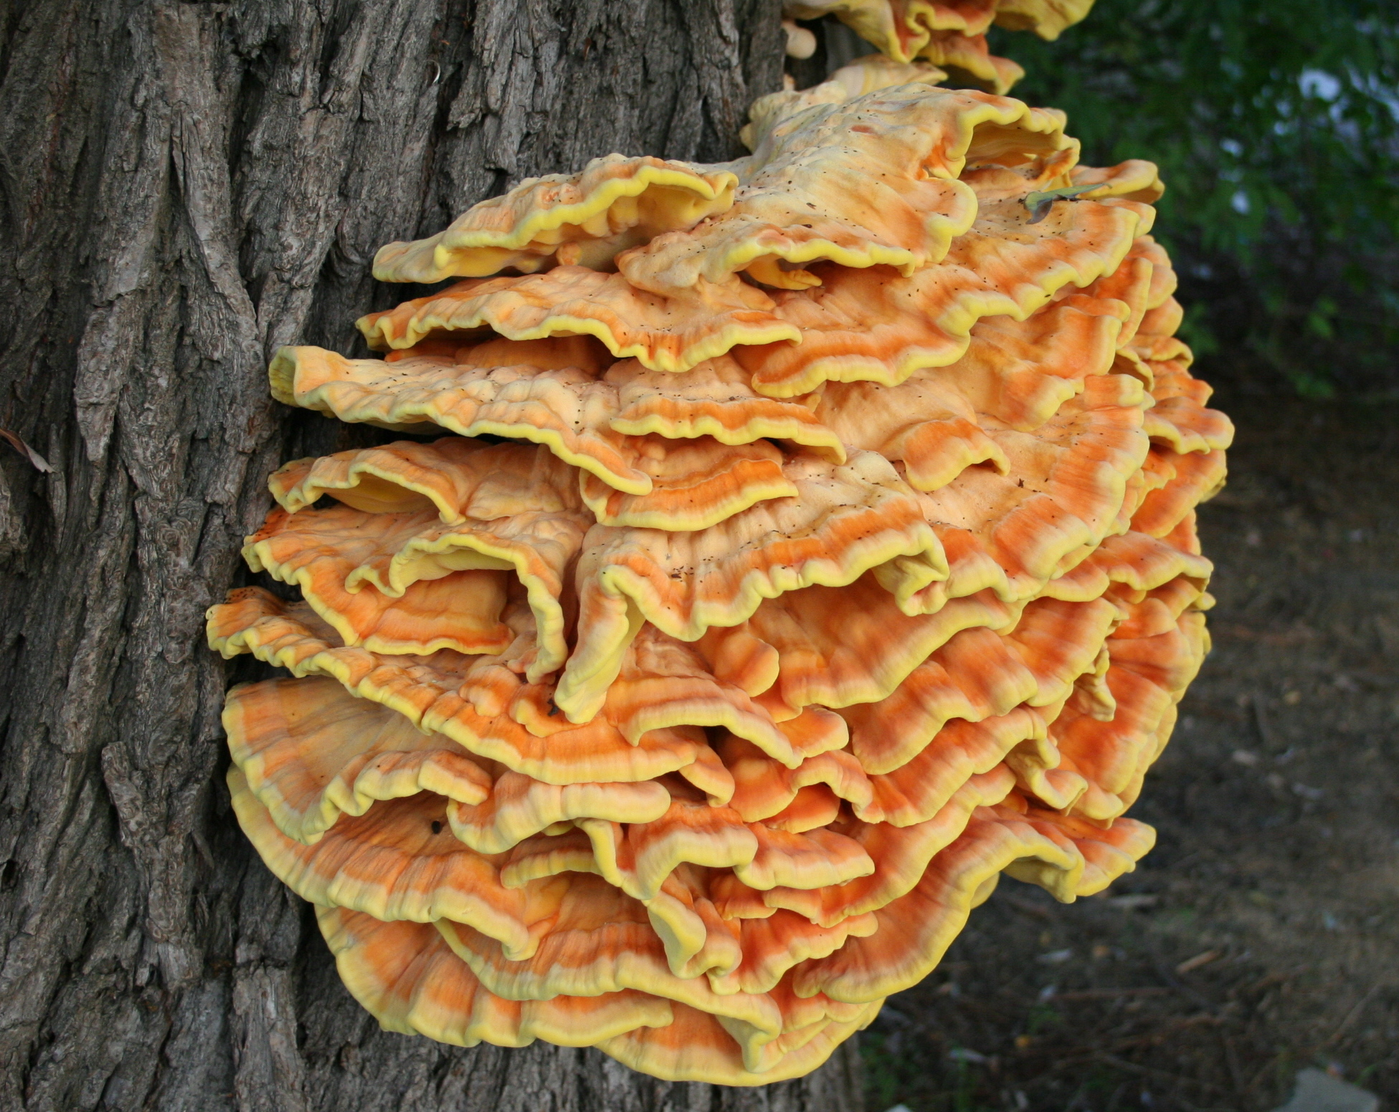 | Grows on dead or dying trees (some species grow on the tree, some from the underground roots). They also grow on cut hardwood logs or specialized substrate in grow bags. | Tastes exactly like chicken  Even has the same texture as chicken | Inhibition of gram-positive bacteria and Candida, diabetes prevention/control and inhibition of HIV-1 reverse transcriptase | Depends on the species, better when harvested young
Aligned to the following standards:
CS.06; PL-A.; PG-J.; CS-M.; AG6; CCSS.RI.9-10.3; CCSS.W.9-10.2; CCSS.SL.9-10.1; CCSS.RST.9.10.4; CRP.02; CRP.04; CRP.05; CRP.07; CRP.08

