National FFA

Agricultural Technology and Mechanical Career Development Event
Team Activity
November 1, 2024

Building a Concrete Form for a Parking Bumper

Scenario

Fred Farmer is opening a Tourism Center on his farm. He wants new parking bumpers for the parking lot. To do this, he will need a concrete form. An illustration of the parking bumper can be seen in Figure 1. Your challenge is to make a form that will support the concrete when poured to create a parking bumper.

The objective of this team activity is to build a concrete form to create a parking bumper that will accommodate cars to park in the lot in front of the Tourism Center. Your team will then pour concrete in this form to make a parking lot bumper. This final product is illustrated in Figure 1.
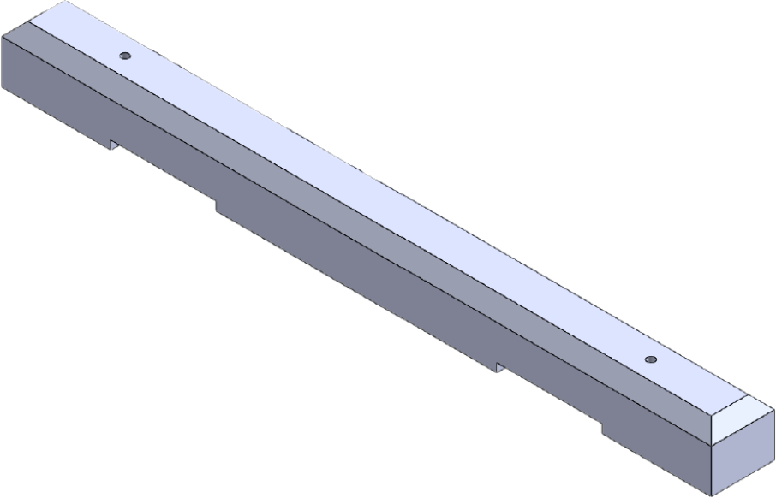

While the parking lot will require 45 bumpers, your team is to create only one concrete form. Time and materials will not allow your team to build all 45 bumpers. The other teams will build the rest.

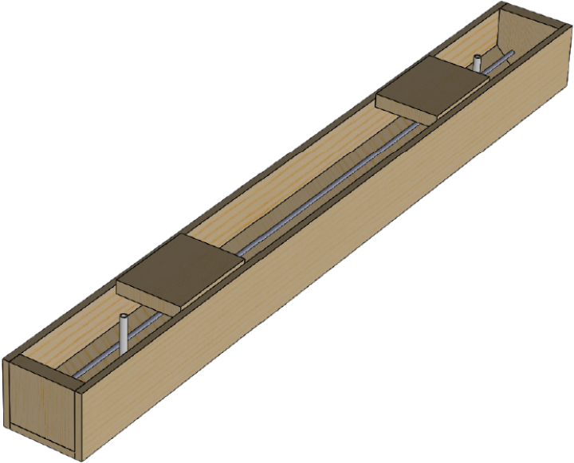
84”
7¼”
8¾”
Figure 2

Isometric drawing of the concrete form

Figure 2 illustrates an isometric drawing of the finished concrete form. The dimensions in Figure 2 are the outside dimensions of the form. The actual dimensions of the bumper are the inside dimensions which will be 7¼” wide, 6½” tall, and 81” long.

Two blocks will be placed in the forms to create a space where a forklift can be used to lift and move the bumper. Two holes will also be placed in the forms so rebar can be pounded through the bumper to anchor it to the asphalt parking lot. Figure 3 provides the dimensions for locating these blocks and holes. The forklift block is 12 inches long and is placed 12 inches from the inside of the end block on the form. The PVC pipe for the holes will be placed so the center of the PVC pipe is 10 inches from the end of the bumper. This pipe should also be centered between the sidewalls of the bumper.

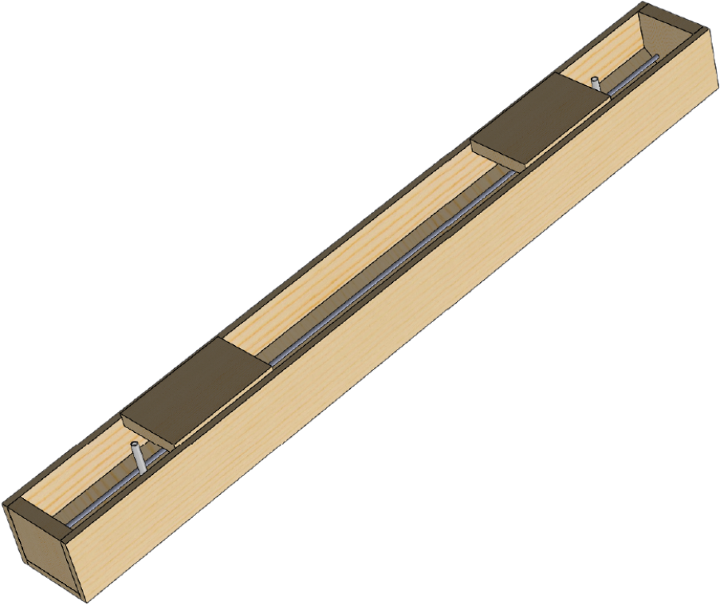
Figure 3
12”
12”
10”

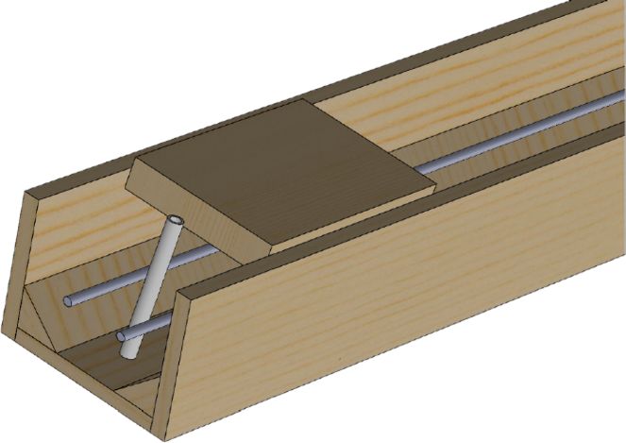
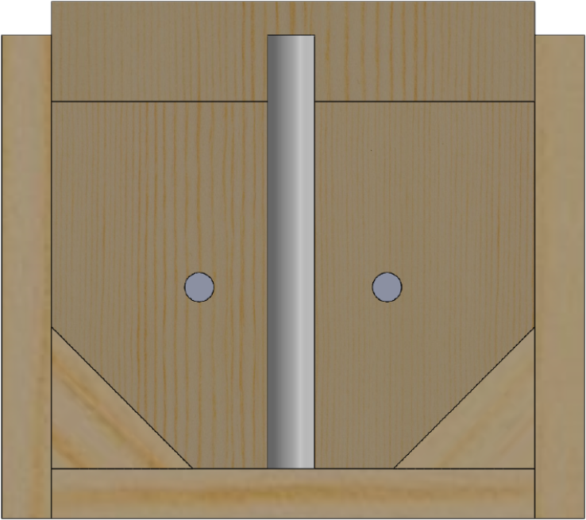
Figure 4 provides the names of the parts from a cross sectional view.
Figure 4.
Side wall
1 x 8 board
Bottom board
1 x 8 board
Block for forklift holes
2 x 8 dimension lumber
¾ Inch PVC
7/16 inch fiberglass rebar
Precut 1½ x 1½ angled boards

Figure 5 provides dimensions of the forklift block, the PVC pipe, and the rebar placements. This is illustrated in a cross-sectional view. The PVC pipe should be centered between the sidewalls. The fiberglass rebar should be 2 inches from the sidewall and 2½ inches from the bottom. The forklift hole block will be set 1 inch from the top of the form. The rebar should be cut to a length of 79 inches to allow for one inch clearance between the rebar and the end block.

2”
Center PVC pipe between side walls.
2½”
Figure 5
1”

Steps for construction:

Follow these steps to construct the forms and pour the parking lot bumper.
- Throughout this activity be sure to follow all safety procedures.
- Read through the directions to understand the complete task.
- Locate the materials (lumber, rebar, etc.). Let a CDE official know if you are missing anything.
- Cut the sidewall and bottom pieces to length from the 1 x 8.
- Cut the end blocks and forklift blocks to length from the 2 x 8.
- Fasten the sidewalls and the bottom piece to the end blocks with the screws provided.
- Fasten the sidewalls to the bottom piece along the length of the form. Place these screws approximately 16 to 20 inches apart.
- Cut the angle pieces to length and fasten them in the forms.
- Cut the PVC pipe to length.
- Cut rebar to length. Allow one inch clearance on each end.
- Mix the concrete mix in the tub.
  - Pour the water in the tub. A 60-pound bag of concrete mix requires approximately four pints (1.9 L) of clean water.
  - Add approximately three-quarters of the concrete mix in one end of the tub.
  - Use the rake to pull a little mix at a time and mix it with the water. When you have mixed all the concrete mix with the water, you will have a soupy mix.
  - Add the remainder of the of the mix in.
  - Adjust the next bags based on your first mix. Note that a mix that is to wet will have less strength than one that is correct.
- Place PVC pipes in the correct location.
- Pour approximately 2½ inches of concrete in the form.
- Place the rebar on top of the concrete.
- Have the CDE official check the location of the rebar.
- Pour more concrete in the form until it is 1 inch from the top.
- Place the forklift blocks and screw them in place.
- Pour the remaining space of the form with concrete to bring the level to the top of the form.
- Finish the concrete.
- Turn in your finished bumper.
  - Label the form with the name of your state.
  - Attach handles to your forms.
  - Move your bumper to the grading area.
  - Remove your handles and return them so another group can use them.
- Complete your paper and turn it in.
- Clean up your station and ready it for the next group.

Tools needed:

You will be provided these tools to use when making this concrete form:
Tools provided:
- Power circular saw
- Tape measure
- Heavy Duty ½-inch DeWalt drill Concrete Trowel
- Phillips screwdriver bit
- Framing square
- Hacksaw
- Phillips screwdriver bit
- Carpenter’s level
- Sawhorse
- Rake
- Trowel

Personal protective equipment that your team will provide:

- Safety glasses
- Appropriate clothing
- Latex or comparable gloves

Other items
- Pencils
- Laptop computer
- Calculator

Materials provided:

You will be provided these materials to use when making this concrete form:
- 1 piece of 1 x 8 x 14 pine for the side (or bottom) pieces.
- 1 piece of 1 x 8 x 7 pine for the bottom (or side) piece.
- 1 piece of 2 x 8 x 4 pine for the end blocks and the forklift blocks.
- 1 piece of 7/16” fiberglass rebar for reinforcing the concrete.
- 2 piece of 1½ x 1½ x 8 precut triangular cut pine for angled pieces.
- 1 piece of ¾” PVC pipe for creating holes in the bumper to anchor it to the ground.
- An assortment of sheetrock screws to fasten the forms together.

Problem-solving and decision-making:

Your team is to solve a problem set related to the cost of fabricating the parking lot bumpers.

Prices:
Item Yield Cost per item
- One 60-pound bag of Quickcrete 0.45 cu. Ft. $3.79 per bag
- Fiberglass rebar – 7/16 $4.89 per 20-foot length
- PVC pipe – ¾ inch diameter $4.29 per 10-foot piece
- 1” x 8” x 14’ pine board $16.39 per 14-foot piece
- 2” x 8” x 8’ dimension lumber $6.63 per 8-foot piece
- 2” x 2” x 8’ pine furring pine strips $2.87 per 8-foot piece
- 1-5/8” sheetrock screws 165 screws per lb. $4.97 per 1 lb. box

Redi-Mix concrete costs $165.00 per cubic yard delivered.

Problem-solving calculations:

- Calculate the cost of constructing one parking lot bumper form.
- Calculate the cost of concrete, rebar, and PVC pipe to pour 45 bumpers using Quickrete.

Decision-Making:

Your order is to make 45 parking lot bumpers. You can make these with bags of Quickrete, or you can order Redi-Mix concrete to be delivered. In either case, you will be creating the form(s) for the bumper.

Discuss the advantages and disadvantages for each option.
- What are the advantages of using bags of Quickrete?
- What are the disadvantages of using Quickrete?
- What are the advantages of ordering Redi-Mix?
- What are the disadvantages of ordering Redi-Mix?
Choose the option your team would recommend.
Discuss your rationale for choosing that option.

Written report
Your team is to submit a summary report at the conclusion of the team activity. The purpose of this report is to summarize your activities as well as provide a document that a construction business could use as a guide to create this concrete parking bumper.

You are advised to work on this summary report throughout this timed event. The summary report is to include the following items in the order listed:

  - A title page including the title of this project, the name of your FFA chapter including city and state, the names of your team members and today’s date. See example on the last page of this document.

  - Begin with a brief introductory paragraph describing the entire project completed.

  - A description of the roles of your team members that completed these activities.

  - The costs of materials as calculated in the problem-solving section.

  - The discussion of your decision as concluded in the problem-solving section.

  - A concluding paragraph that includes your team as contact for technical support needed to complete the parking bumpers.

Team Evaluation
Your team will be evaluated on the following:
- Teamwork process: 100 points.
- Team report: 50 points.
- Finished product: 250 points.
- Total for team activity: 400 points.

