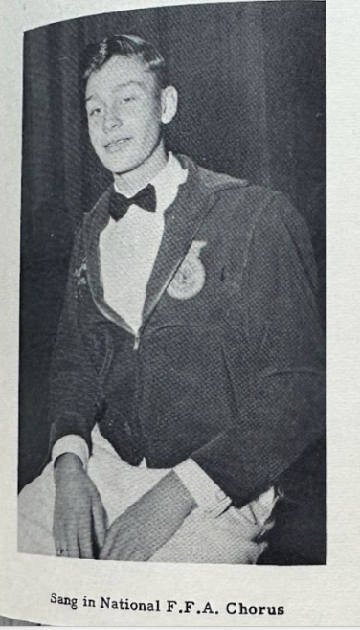
National FFA Chorus Jacket
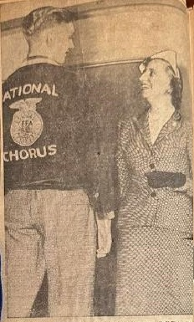
The National FFA Chorus jacket was provided for this display by David Laatsch, a retired agriculture teacher in Wisconsin and FFA history expert. The jacket belonged to a former FFA member, Charles John Christians, from Parkersburg, Iowa. Charles was a member of the Parkersburg FFA Chapter from 1947-1951. In 1950, Charles was a member of the National FFA Chorus. During his time in the National FFA Chorus, Charles had the opportunity to meet President Truman’s daughter, Margaret, and received her signature and best wishes in the chorus (Margaret loved to sing too!).
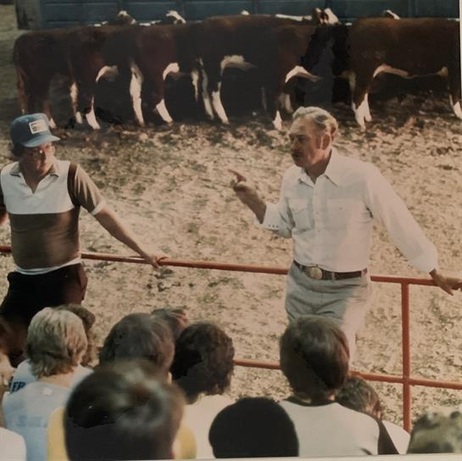
Charles graduated from Parkersburg High School in 1951 and went on to pursue a bachelor’s degree in animal science at Iowa State University, where he met his future wife, Betty Anderson. Charles and Betty moved to Fargo, N.D., after getting married, and Charles finished his master’s degree in animal breeding at NDSA. They then moved to Stillwater, Okla., where Charles completed his Ph.D. in animal science at Oklahoma State University. In Oklahoma, they were blessed with two children, John Charles and Linda Lou. After working as an assistant professor of animal science in Mississippi, Charles accepted a position at the University of Minnesota as an assistant professor in 1964. Here they expanded their family with a son, Neil Allen, and a daughter, Cheryl Kay. Charles continued as a professor of animal and life science at the U of M until he retired in November 1995.

Charles received many awards throughout his career, including induction into the Minnesota Livestock Breeder’s Association Hall of Fame and retiring as a full colonel in the Army Reserve. Although there is not enough room here to list all his numerous awards, Charles would say his greatest accomplishments are the relationships he made while helping and serving others. Charles was a person of deep faith and knew he was put on this earth for a purpose.

