SOCIAL MEDIA
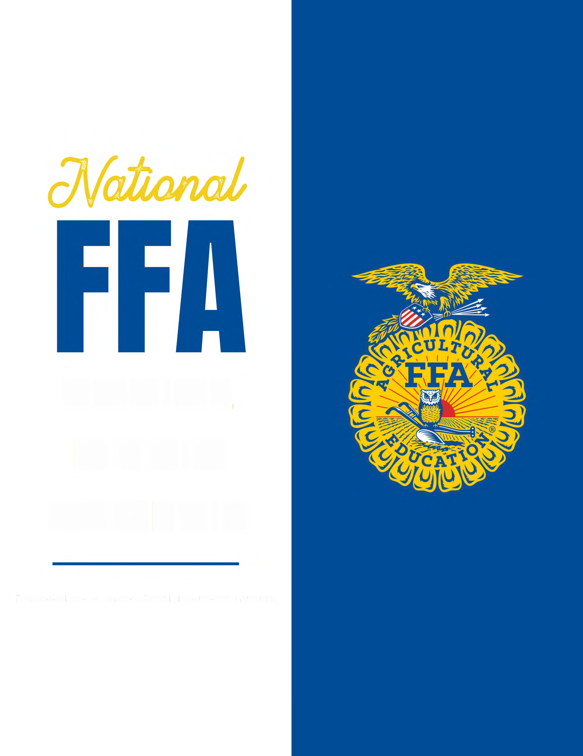
TOOLKIT

TIPS and TRICKS
Consistent Branding and Voice: Maintain a consistent brand identity across all your social media channels.
Create Engaging Content: Mix your content formats, including images, videos and infographics.
Be Authentic and Transparent: Share behind-the-scenes glimpses of your chapter, showcase your team members and highlight activities.
Regularly Engage with Your Audience: Encourage interaction through likes, comments, shares and reposts.

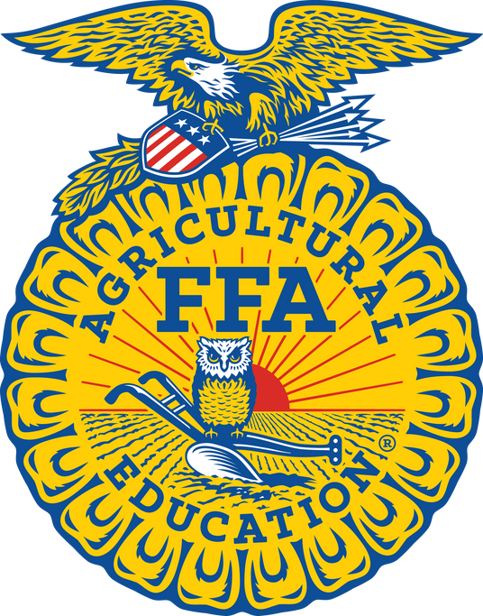
BEST PRACTICES
Define Your Audience:
Tailor your content and engagement strategies according to your audience’s preferences and behaviors.
Exciting News:
Remember to post about exciting news, events or awards received. Every win is important!

Consistency Is Key:
The sweet spot for posting static posts is one to three per week between 11 a.m. and 3 p.m.
Hashtag Tips:
Use 25 to 30 branded hashtags to reach new audiences.
This is how users search.
POST PRACTICES

Posting to Your Grid:
One to three times per week

Stories:
At least three times per day

Engaging:
15 minutes a day

Reels + TikToks:
At least one per month

Caption:

EXAMPLE

🌟🚜 Exciting News Alert! 🚜🌟

Our local FFA chapter is bursting with excitement as we announce some incredible news! 🎉
Stay tuned as we unveil how our passionate members are making waves in the community and beyond. From groundbreaking projects to empowering initiatives, we can’t wait to share the journey with you! 🌱

Hashtags:
#FFA #NationalFFA #FFAlove #FFAmily #FFAProud #FFA23 #Agriculture #Leadership #foreverblue #bluejackets #bluejacket #ffasupporters #futurefarmersofamerica #futurefarmers #ffanational #ffacommunity #nonprofit #supportag #futureofagriculture #agriculture #agtech #agricultureadvocacy #agadvocacy #agknowledge
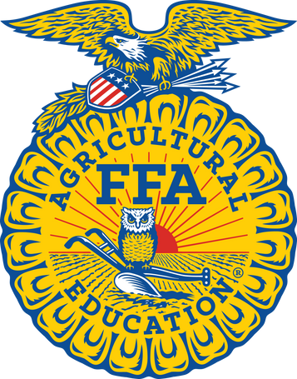



FFA BRAND
GUIDELINES

- Essential color selection
- Appropriate uses of
typography
- Proper use of the lettermark
and emblem
- Link to brand guidelines:
FFA.org/media-center/
FFA WEBSITE & SOCIAL MEDIA

ORGANIZATION WEBSITE

FFA.org

NATIONAL FFA FACEBOOK
National FFA Organization

NATIONAL FFA INSTAGRAM
@nationalffa

NATIONAL FFA LINKEDIN
National FFA Organization

NATIONAL FFA X (TWITTER)
@NationalFFA

NATIONAL FFA SNAPCHAT
nationalffa

NATIONAL FFA TIKTOK
@nationalffaorg

