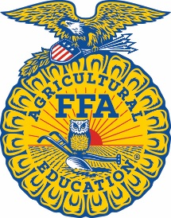
National FFA Week Proclamation

Whereas, FFA and agricultural education provide a strong foundation for the youth of America and the future of food, fiber and natural resources systems; and

Whereas, FFA promotes premier leadership, personal growth and career success among its members; and

Whereas, agricultural education and FFA ensure a steady supply of young professionals to meet the growing needs in the science, business and technology of agriculture; and

Whereas, the FFA motto — “Learning to Do, Doing to Learn, Earning to Live, Living to Serve” — gives direction and purpose to these students who take an active role in succeeding in agricultural education; and

Whereas, FFA promotes citizenship, volunteerism, patriotism and cooperation.

Therefore, I do hereby designate the week of Feb. 21-28, 2026, as National FFA Week.

______________________________________________ _____________________
Signature Date

