National FFA Week on Social Media 2025 
Directions:
Use the following template to create your social media plan for the week and get approval from the chapter advisor and school administration. Ideas and special events for each day are bulleted. Need examples? Use these examples to guide your plan. Make sure to tag @NationalFFA and use #FFAWeek.
______________________________________________________________________________________________________________________________________________________________________________________________________
- Post how your chapter will be celebrating #FFAWeek!
Sat. 15
@NationalFFA


______________________________________________________________________________________________________________________________________________________________________________________________________
- Share a photo and your SAE story! #SAESunday
Sun. 16

______________________________________________________________________________________________________________________________________________________________________________________________________
- Share what your chapter is doing to serve your community.
Mon. 17

______________________________________________________________________________________________________________________________________________________________________________________________________
- Connect with FFA alumni who inspire you and tell them why. #FFAalumni
Tues. 18


______________________________________________________________________________________________________________________________________________________________________________________________________
- Share how an agriculture teacher or FFA advisor has impacted your life! #TeachAg
Wed. 19
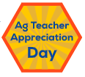

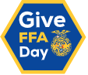
______________________________________________________________________________________________________________________________________________________________________________________________________
- Encourage friends and family to give to FFA today! #GiveFFADay
Thurs. 20

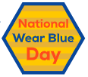
______________________________________________________________________________________________________________________________________________________________________________________________________
- Post a selfie of you wearing blue today!
Fri. 21

______________________________________________________________________________________________________________________________________________________________________________________________________
- Share photos of your #FFAWeek celebration!
Sat. 22

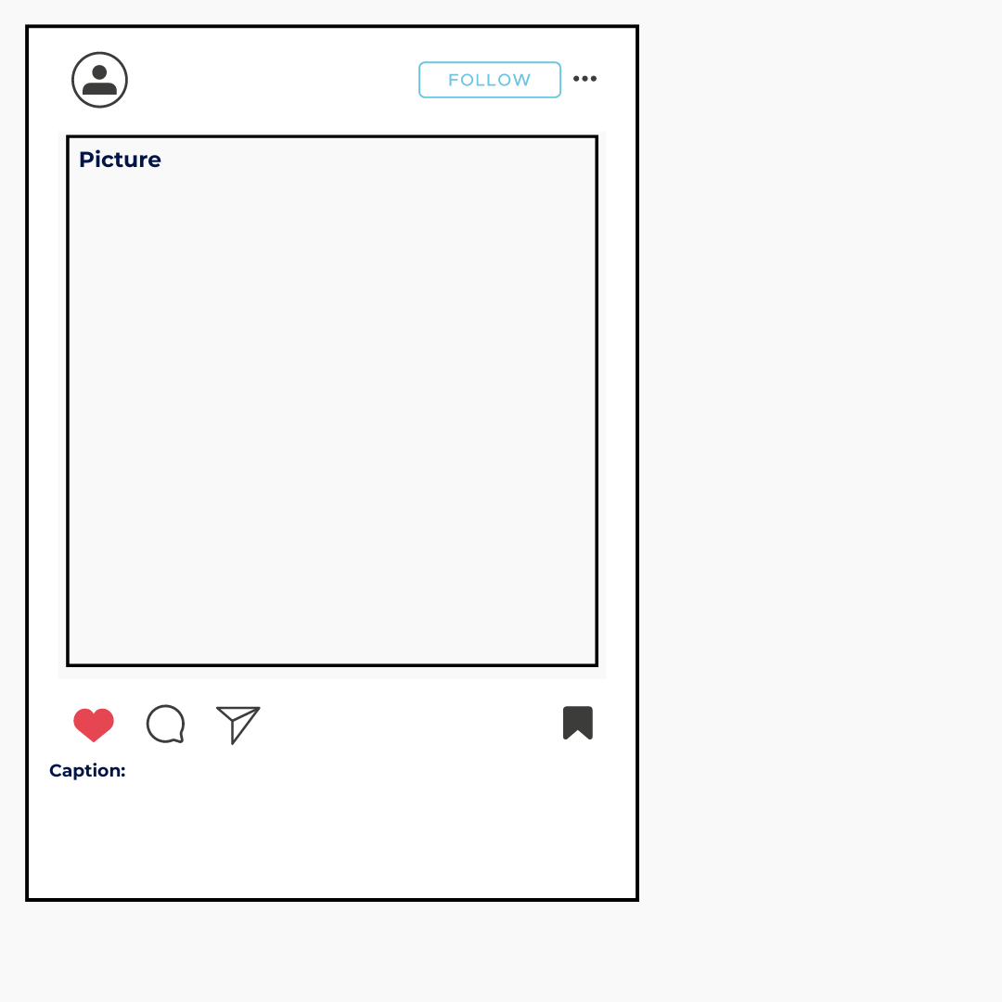

Date:

Date:

Date:

Date:

Social Media Post Examples
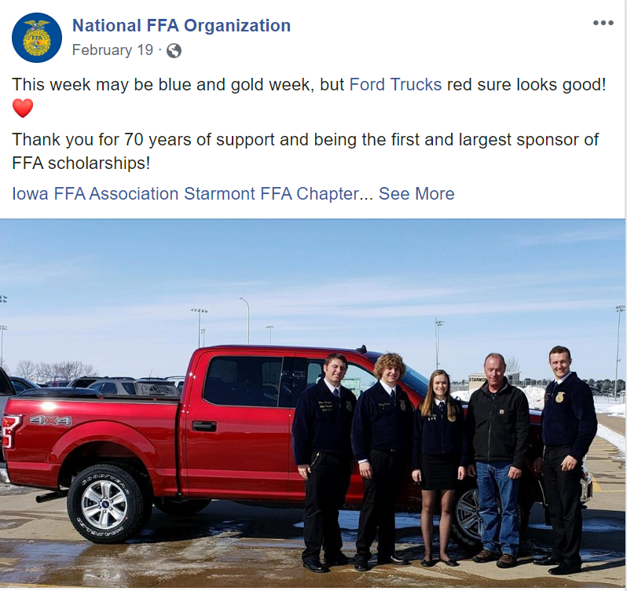
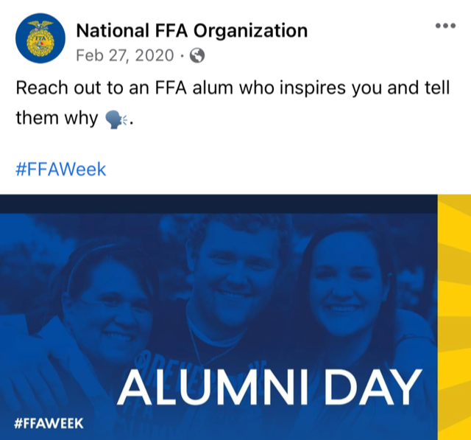
Sample Facebook Posts

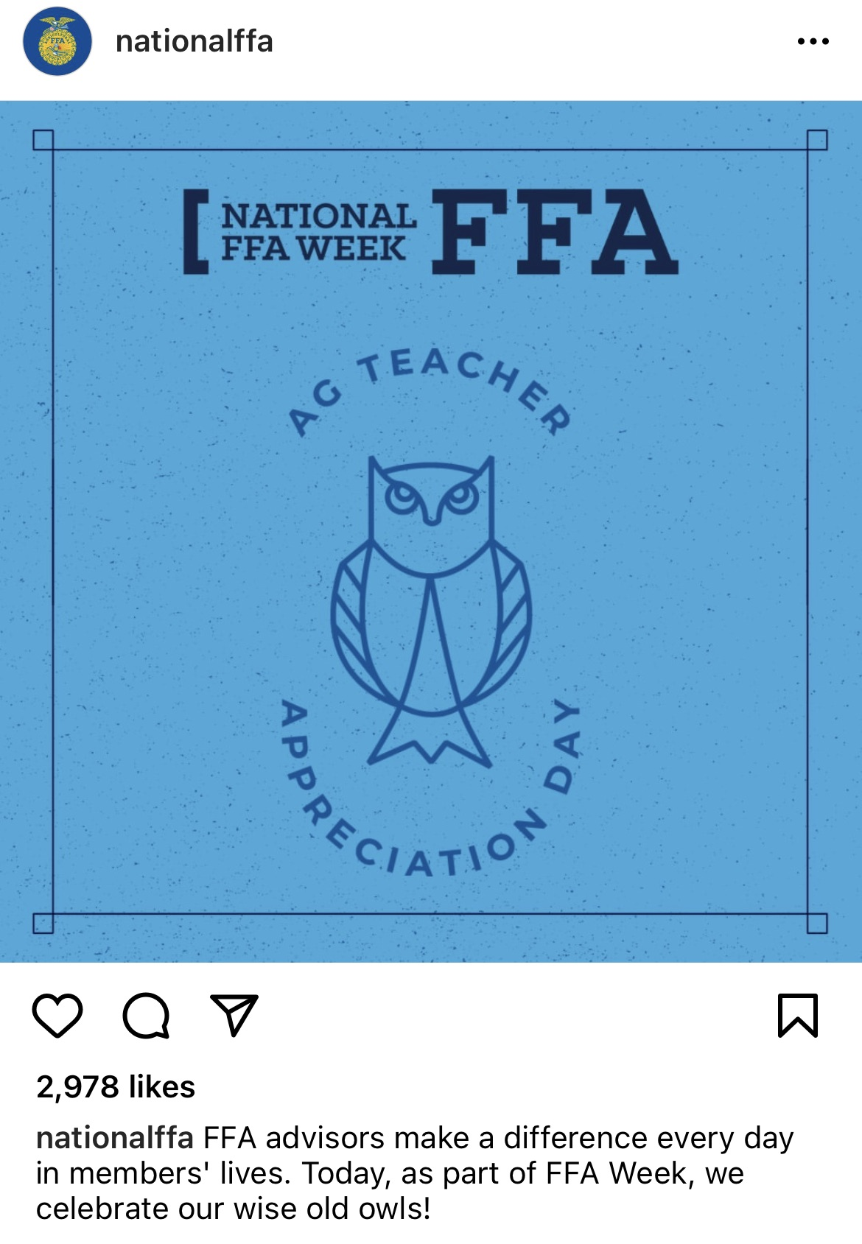
Sample Instagram Posts
