Savory Treats
Part 1
Directions:
Watch this video about a Humane Society SAE, available at https://vimeo.com/315691987, to complete the activities below.

Circle in RED each of the ingredients that Nicole uses in her dog treats for the humane society.

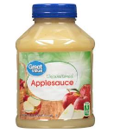

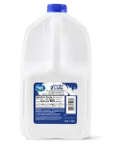

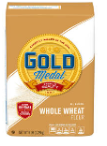
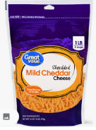
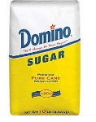

Research another simple dog treat recipe that is different from Nicole’s recipe. List the needed ingredients in the box below to complete the recipe.

List two foods you should not use in dog treats or otherwise feed to dogs. Explain why.



What motivates Nicole within her SAE?



What motivates you in life?

Which command does she practice with the dog in the video?

Draw five common obedience commands for dogs.

Nicole’s career plans are ____________________________________. In the box below, list three animals she is likely to work with in her future career.

Using an emoji, rate your thoughts and feelings about having an SAE like Nicole’s.

Part 2
Directions:
Students will utilize the website below to learn more about the purpose of a humane society and how they can get involved at their local shelters.

Nicole’s SAE involved working at a humane society. Let us look at what a humane society is and how you can get involved at your local facility. Use the following website to help you with this portion of the activity: https://www.kyhumane.org/.


Describe in your own words what a humane society is and what roles it serves in local communities.


What programs does the Kentucky Humane Society offer?

Humane societies and local animal shelters depend on donations and volunteers. List three ways you could help your local facility.





Selecting an Ideal Dog Food
Directions:
Review the provided handout “Supplemental Information: Basics of Animal Nutrition” along with the listed websites to help you complete the activities below.

Comparing and Evaluating Dog Foods
*Utilizing the two dog foods listed here, compare these two dog foods by answering the questions below. Use the links provided to access information about each of the foods.

Dog Food A: Hill’s Science Diet Small Breed https://www.tractorsupply.com/tsc/brand/Hill%27s+Science+Diet?

Dog Food B: Hill’s Science Diet Large Breed https://www.tractorsupply.com/tsc/brand/Hill%27s+Science+Diet?

Which dog food has a higher protein content?
Which health features do both dog foods provide?
Which dog food has a higher fiber content?
Which dog food has a higher fat content?
After analyzing these two dog foods, what are two conclusions you can make about why the nutritional content is different for these two dog foods?

Comparing and Evaluating Dog Foods
*Utilizing the two dog foods listed here, compare these two dog foods by answering the questions below. Use the links provided to access information about each of the foods.

Dog Food A: Diamond Naturals Skin-Coat-Formula All Life Stages https://www.tractorsupply.com/tsc/product/diamond-naturals-skin-coat-formula-all-life-stages-dog-food-30-lb?cm_vc=-10005

Dog Food B: Merrick Grain-Free All Life Stages Digestion Support
https://www.tractorsupply.com/tsc/product/merrick-grain-free-real-chicken--sweet-potato-4-lb-bag?cm_vc=-10005
Which dog food has salmon and fish meal as its main two ingredients?
Which dog food has a higher caloric content?
Which dog food would be ideal for a dog that has digestive troubles?
What is the feeding recommendation for pregnant or lactating dogs for Dog Food A?
Based on the price of each of these dog foods, which would be ideal for a family that is on a limited budget but still wants to feed good-quality dog food? Explain your choice.

Which Dog Food Would You Recommend?
*Utilize the following website and your knowledge of feeding dogs to recommend at least two dog food options for each of the scenarios below: https://www.tractorsupply.com/tsc/catalog/dog-food.

Scenario A
Manuel lives in an apartment in town with his miniature schnauzer, Rosie. She is a four-year-old spayed female in great health. She weighs 14.4 lbs. and spends most of her days lounging around the house. Manuel works a lot and doesn’t get to take Rosie to the park often, so she is limited in exercise. Manuel wants to feed Rosie a high-quality dog food and is not too concerned with the cost of the food as she does not eat a whole lot.
Recommendation 1: | Support of Food Choice:
Recommendation 2: | Support of Food Choice:

Scenario B
Baylee lives on a small hobby farm with his parents and two brothers. He is taking on the responsibility of their family’s dog Okie. Okie is a 10-month-old three-fourths Australian shepherd and one-fourth blue heeler mix that is not yet neutered. Baylee keeps Okie in a kennel during the school day and lets him run and play during the evenings and on the weekends. Okie loves to play in the barn and around the livestock. Baylee and his family want to feed their dog good quality dog food for his age and breed. They do have to consider the price of the dog food as they have other animals to feed as well.
Recommendation 1: | Support of Food Choice:
Recommendation 2: | Support of Food Choice:

Scenario C
Sandy is concerned about her 13-year-old Labrador retriever Kami as she seems to be struggling to keep weight on. Kami is a spayed female that is in good health for her age. Sandy is looking for dog food that will help Kami maintain her body weight and enjoy the rest of her days. Kami enjoys a good walk with her mom but, for the most part, spends her time lounging around the house with her mom, who is retired. Sandy is looking for quality dog food for her older dog and is not concerned with the price of the food.
Recommendation 1: | Support of Food Choice:
Recommendation 2: | Support of Food Choice:

Analysis
- Why do you think Tractor Supply offers so many brands and types of dog foods?

- Do you think other stores offer as many options as possible? Explain.

- How can we better educate pet owners about the importance of feeding quality foods that are meant for their specific animal?

- What role do we as humans play in ensuring good nutrition for the animals in our lives?

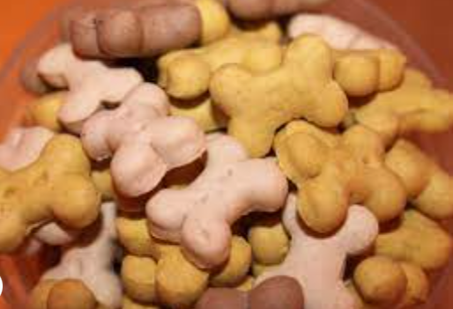
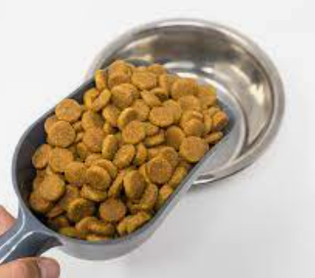

Supplemental Information: Basics of Animal Nutrition
In today’s society, one can’t turn on the TV or read a newspaper without seeing or reading information about health issues. What is the major factor discussed in these issues? Nutrition. Along with nutrition, genetics and environment are all factors that influence your health. Just like in humans, animals in agriculture are influenced by these same factors. If animals don’t have proper nutrition, their growth rate, reproduction rate, immunity and well-being are all affected. Just as proper nutrition is vital for your good health and proper function, it is just as vital for the health and function of agriculture animals.
Importance of Nutrition and Digestion
Nutrition is important for a variety of reasons. Animals need the proper nutrition for growth and maintenance and to provide energy for work and vital functions. Maintenance is the nutrition required for an animal to maintain its current weight. Energy is the ability of the body to perform functions. Proper nutrition is also needed to maintain body temperature, produce milk, reproduce and develop proper bone structures. Without proper nutrition, animals can develop health problems, which could result in treatment costs or even fatality. Good nutrition is essential for all the systems of an animal to function and work together properly.

Animals that do not receive the proper nutrition are more likely to develop health and reproductive problems and be less productive and marketable. Nutrition is important for having healthy animals, and in turn, healthy animals help ensure profitability in agricultural operations.

Producers must understand not only what nutrition an animal needs but also how to supply that needed nutrition. Producers must know what ration is appropriate for a specific animal and how to provide a balanced ration. A ration is the feed an animal receives over a 24-hour period. A variety of feedstuffs, or basic ingredients, are used in rations, and producers must choose those that best suit their needs. A ration with all the nutrients an animal needs is a balanced ration.

Digestion is the process of breaking down feeds into simple substances that can be absorbed into the bloodstream and used by the body’s cells. It is important for producers to understand the digestive process because it helps in selecting the proper feed for the animal’s type of digestive system. The digestive system is the system in which food is acted upon through physical (chewing) and chemical (stomach acids) means. It includes all parts from the mouth to the anus.

Understanding the digestive system can help the animal owner become more efficient in feeding, resulting in a more cost-effective animal enterprise. It also helps the owner to have a better understanding of animal health and problems that may occur. Understanding the chemical and physical changes that take place after an animal eats are important in noticing health problems related to digestion.



How Nutrients Are Used
Does a pregnant dog need the same nutrients as a dog that goes on an occasional walk with its owner? No. The nutrient requirements of animals differ because of factors such as age and pregnancy. Animals that need nutrients to sustain the body condition they are in (no weight loss or gain) need nutrients for maintenance. Animals that require maintenance levels of nutrients are not pregnant, lactating or producing products such as wool.

Young, growing animals require nutrients to meet the needs of the specific growth stages. Young animals need the proper nutrition for growth and development of bones, muscles and organs. Some agriculture animals, such as chickens, grow rapidly. As animals grow, their nutrient needs change, and as they mature, their diets become closer to those of adult animals. Older animals may have health problems related to aging, which could require different nutritional needs such as vitamin and mineral supplements.

Animals that are pregnant or lactating have specific and increased nutritional needs. Pregnant animals need nutrition not only for themselves but also for the developing babies. Some agriculture animals commonly give birth to only one offspring (cattle and horses) while others give birth to multiple offspring (pigs, chickens, sheep and goats). Animals that are lactating or nursing their young also need specific nutrients to provide nourishing milk to their offspring.

Animals that exert large quantities of energy, known as working animals, need additional nutrients. Working animals are used for some type of work such as pulling heavy loads. Additionally, horses that are used for competitive events require different rations than horses that are ridden only for pleasure.

Have you ever worn a wool sweater? If so, the wool came from sheep that needed the proper nutrients to produce good quality wool. Many agricultural animals are raised for meat and products such as eggs, milk, or wool. In order to produce products or have the quality of meat consumers will purchase, proper nutrition is essential.
Classes and Sources of Nutrients
What nutrients do animals need? There are six major classes of nutrients: water, protein, carbohydrates, fats, minerals and vitamins. Nutrients can be obtained from various sources. Common sources of nutrients for agriculture animals include roughages and concentrates. Roughages include feed that is high in fiber and low in energy, such as grasses, hays and silages. Concentrates include feed that is high in energy and low in fiber, such as grains.
Water
1. Plays a role in biochemical reactions, including respiration, digestion and assimilation
2. Transports nutrients
3. Transports wastes
4. Regulates body temperature
5. Gives the body its form
Protein
1. Develop and repair body organs and tissues like muscles, nerves, skin, hair, hooves and feathers
2. Used to produce milk, wool and eggs
3. Develop the fetus
4. Generate some enzymes and hormones
5. Form a part of DNA

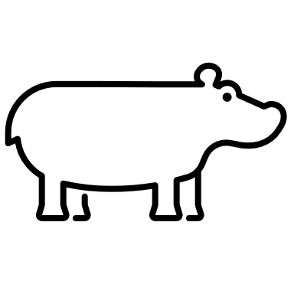



Carbohydrates (Sugar, Starch and Fiber)
1. Provide energy that powers muscle movement required for exercise and essential functions, such as breathing, digestion and beating of the heart
2. Produce body heat
3. Stored as body fat
Fats
1. Function as a valuable energy source
2. Provide body heat
3. Carry some vitamins
Minerals
1. Supply materials for building skeleton and teeth
2. Form a part of body regulators, such as enzymes and hormones

Vitamins
1. Regulate the digestion, absorption and metabolism of nutrients
2. Regulate the formation of new cells
3. Regulate the development of vision, bones, hair, feathers, skin and muscles
4. Help protect against diseases
5. Develop and maintain the nervous system

