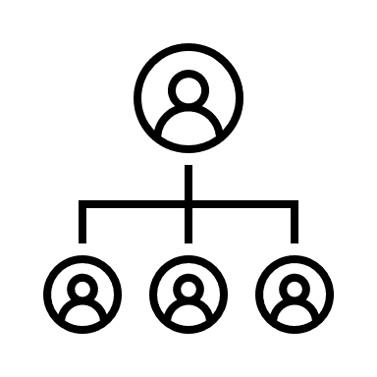
Activity 8: Backgrounds
Directions:
Today, you will have the opportunity to learn more about some amazing agriculturists and how their backgrounds have contributed to the industry. Follow the steps below to complete this activity.

- Who will you research (select one a person from the list and write the name on the line): ____________________________________________________
A World Food Prize Laureate Dr. Temple Grandin Norman Borlaug
George Washington Carver A Wonder Woman of Agriculture

- Using the template below, develop a LinkedIn profile for the scientist you selected.

  - Tip: LinkedIn is a professional networking tool that allows professionals to make meaningful connections in the industry.
  - Name: ____________________________________
  - Current Title: _________________________________________________________
  - Position Description:

  - Brief description of the impact on the agriculture industry.

  - Draw an image of the person you are creating a profile for.

  - Where did this person grow up? __________________________________________________________________________
  - What is/was this person’s home like?

  - What struggles did this person have to overcome to get to where they are today?

  - What about this person’s background do you think led them to the field of study they are known for?
List the skills this person has:
Message

Thinking about the individual you just highlighted, what about this person’s background stood out to you? What personal struggle did this person have to overcome?

How do different backgrounds lead to advancements in any industry, especially agriculture?

How can/could your personal background impact the agriculture industry?

Using this space, develop a collage that depicts how different backgrounds come together to impact an industry that society relies on.

