Cotton Chronicles
Aligned to the following standards:
CS.01; CS.02; CS.05; CS.06; FFA.PL-A; FFA.PL-C; FFA.PL-E; FFA.PG-I; FFA.CS-P; CCSS.W.9-10.2; CCSS.W.9-10.3; CCSS.W.9-10.4; CCSS.W.9-10.6; CCSS.W.9-10.7; CCSS.W.9-10.8; CCSS.SL.9-10.2; CCSS.SL.9-10.5; CCSS.RI.9-10.1; CCSS.RI.9-10.4; CRP.02; CRP.04; CRP.05; CRP.06; CRP.07; CRP.08; CRP.11
Part 1
Directions:
Watch the SAE video “Fiber & Oil Crop Production SAE,” https://vimeo.com/857891450, and answer the questions below.

- Mitch grows which two crops:
  - Cotton
  - Sunflowers
  - Soybeans
  - Tobacco
- Fill in the blanks for the process of cotton at his farm:

- In the fall, Mitch runs the cotton ___________________________.

- After harvest, they tag their cotton ________________, or modules.

- The cotton ________________ then comes to collect the bales.

- The cotton gin takes the ____________________, the cotton ___________________ and any unwanted material out of the cotton.

- The cotton gin puts the cotton in the _______________________________ for storage.

- Why is operating the equipment Mitch’s favorite part?

- What caused stress within his SAE?

- What is Mitch’s advice for students starting an SAE?

Part 2
Directions:
Complete three activities from the choice board provided below. All activities focus on cotton. Some activities will require you to research topics, go to specific websites or watch a video. Then answer the final question at the bottom.

Eli Whitney and The Cotton Gin  Using this video, write a one-page essay about Eli Whitney and his invention. Be sure to answer the following questions in your essay:  - Who is Eli Whitney?  - Why did he see a need for the cotton gin?  - When did he invent the cotton gin?  - Where was the cotton gin most needed?  - How does the cotton gin work?  - What was the impact that the cotton gin had on cotton production at that time?  Video: https://www.youtube.com/watch?v=GiV3kswk4aI | The Cotton Belt  Using this link, label and color in the Cotton Belt on the United States map provided by your teacher.  Then, using this link, research each Cotton Belt state to learn how many harvested acres of cotton are recorded for the most recent year. Write the total for each state.  (Tip: Click on the state, then the Agricultural Overview document.)  Based on the number from the step above, place a star on the state that harvested the most cotton.  Link 1: https://hundredpercentcotton.com/farm/cotton-belt/  Link 2: https://www.nass.usda.gov/Statistics_by_State/index.php | Parts of Cotton  On a blank sheet of paper, draw and label a cotton plant including the following parts: boll, flower, square, leaf, branch and stem.  (Use this link to see an example.)  On the same paper or the back, draw and label a cotton boll including the following parts: cotton boll (with seed still inside), calyx, cotton separated and seed separated.  (Use this link to see an example.)  Link 1: https://www.cottonacres.com/wp-content/uploads/2016/03/lesson-plan-social-studies-science-for-grade-1st-8th.jpg  Link 2: https://thesoilhuggersjourney.files.wordpress.com/2014/08/cotton-parts-copy-small1.jpg
Made From Cotton  Many items we use daily come from cotton. Create a poster on a blank sheet of paper that showcases five items made from cotton. Include a drawing of each item and tell how we use the item.  Use this infographic to help learn about items made from cotton.  Link: https://www.cottonboard.org/assets/2889/bale_of_cotton_infographic_final_(1).pdf | Cotton Bales  One bale of cotton can produce many different things. Complete the webquest worksheet about cotton bales provided by your teacher. You will need to use Google or another search engine to find the answers. | The Journey of Cotton  Read this article about cotton from Britannica. Then, on a blank sheet of paper, draw a timeline that showcases the journey of cotton from seed to end product. You should include the following stages: planting, harvesting, gins, manufacturing and products. For each stage on your timeline, include a brief description of what happens, how long it can take and three facts specific to that stage that you learned from the article.  Link: https://kids.britannica.com/students/article/cotton/273829

Based on the information learned from the activities selected above, explain why cotton is such a valuable crop in the U.S. Please include two or three examples from your activities.

Map of the United States

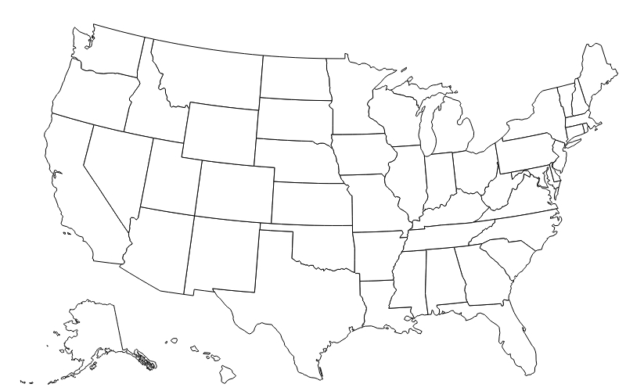

Cotton Bales

- How much does one cotton bale weigh?

- How many $100 bills can one bale of cotton make?

- How many T-shirts can one bale of cotton make?

- How many pairs of jeans can one bale of cotton make?

- How many diapers can one bale of cotton make?

- Name two things that can be made from cotton linters.

- Name two things that can be made from cottonseed hulls.

- Name two things that can be made from cottonseed oil.

- How many yards of cotton are in a regulation baseball?

- One bale of cotton produces enough oil to cook how many snack-size bags of potato chips?

