Aligned to the following standards:
FFA.PL-A; FFA.PL-F; FFA.CS-N; ELA.RI.9-10.2; ELA.W.9-10.4; ELA.W.9-10.5; CRP.02; CRP.04; CRP.06

Appendix 4: Swapping Surprises
Part 1
Directions:
Read the article “Swapping Surprises” in the spring 2022 issue of FFA New Horizons and
complete the following activities as you read.

- What state organized the box exchange during National FFA Week in 2021? Color and label the state below.
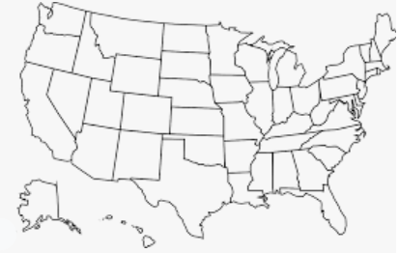

- How many states participated? _______

- Chapters were matched based upon their p______________________.

- Explain the broken crayons that were sent.

- How could the “broken crayon” concept help you?

- If you were to do an exchange box, would you want it to be with a group that is similar to what you are used to or different? Why?

- What role could an exchange box have on a student organization? This can be any group, club, team, etc.

Part 2
Directions:
Exchange boxes can be a great way to learn more about other states, students and industries. Today, you are going to put together an exchange box that will represent where you live. For your box, you will select three items to describe the agriculture in your area/state (Ex. Indiana is second in popcorn production), three items that represent your state (Ex. An Indy Car to represent the Indianapolis 500) and three items that represent you (Ex. Picture of your pet).
Agriculture | State | You
1. | 1. | 1.
2. | 2. | 2.
3. | 3. | 3.

Create a gift tag to hang on each item you selected above.
Be creative with your message. Be sure to decorate each of your tags!
Part 3
Directions:
In the space below, develop a fun note that you would send with your box. Be sure to include (1) opening instructions, (2) background information about yourself and your group and (3) a kind greeting. Be sure to be creative and decorate your note to make it more personal!

- What impact do you think sending an exchange box like this could have on you and your peers?

