Activity 7: Communication Is Key
Part 1
Directions:
In the box below, use each of the letters in the word “influence” and identify for each letter one word that comes to mind when you hear the phrase “to influence others, you must …” See the box to the right for an example.
Acceptance
Growth
Respect
Individual
Community
Understanding
Leadership
Teamwork
Unity
Resilient
Experience
I

N

F

L

U

E

N

C

E

What does the word “influence” have to do with communication?

Think back through the past week and write down a scenario when you tried to influence someone. This could be a family member, friend or teacher.

What are the four types of influential communication? Unscramble the following words to find out! Be sure to include two examples as a reference.
Scrambled Term | Unscrambled Term | Example Shared in Class by Your Teacher | Develop Your Own Example
- mminucaocti

- sbeeifl

- tttseduia

- nnnttsiioe

- noticsa

- Let’s look at three techniques for being persuasive by matching the term with the definition. Then, to the left of the term in the box provided, draw an image to help you remember the term.

Logic/Logos These statements bring about strong feelings through personal references.

Emotion/Pathos These statements are supported by evidence such as facts, testimonials and expert opinion.

Credibility/Ethos These statements establish the communicator as believable and trustworthy through competence and sincerity.

- Using the three pieces of persuasive communication (logic, emotion, credibility), identify which method of influencing is being described in each scenario.

- ______________ According to the United States Department of Agriculture, “poor nutrition is a leading cause of illness in the United States.”
- ______________ Eminent domain took part of my family farm to put in a highway.
- ______________ I am a doctor of veterinary medicine and specialize in small animal nutrition. When considering the feline diet, protein is an important component to proper nutrition.
In the space provided, develop a concept map to depict the relationship among the terms we have used:
Example concept map: Answers will vary.
Using the space below, create a concept map to depict the relationship among the terms we have used in the lesson today. Check out this resource from UNC to learn more about concept maps.

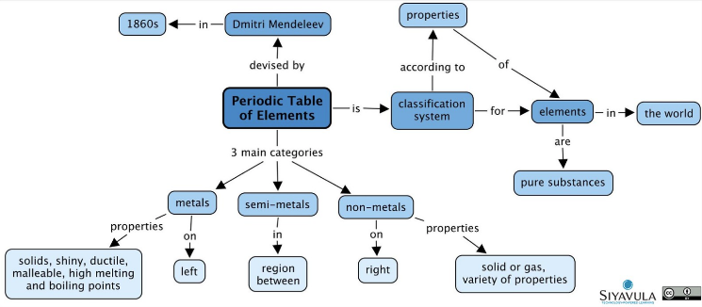
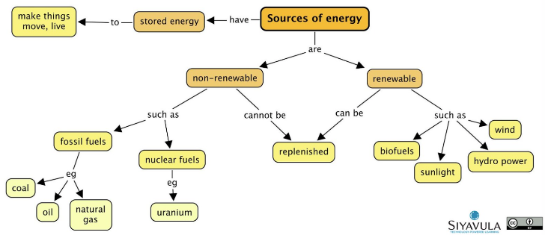

Part 2
Directions:
Using the space below, plan a two- to 4-minute podcast about a misconception that exists in the agriculture industry. You may pick any misconception that you feel strongly about.
- Be sure to include statements that utilize logic, emotion and credibility while keeping in mind the way in which communication can influence others when developing your podcast.
- Be sure your podcast is organized in a manner that flows and has a beginning, middle and end to your topic to ensure clarity and understanding from your listener.

- Topic: ________________________________________________________________________________________________________________
  - Logic

  - Emotion

  - Credibility

  - How will I convince others?

- Introduction:

- Middle:

- Conclusion:
Podcast Rubric
Area | 4 Points | 3 Points | 2 Points | 1 Point
Content | All content is accurate. There are no factual errors. | Most of the content is accurate, but there is one piece of information that seems inaccurate. | The content is generally accurate and interview based, but one piece of information is clearly inaccurate. | Content is confusing or contains more than one factual error.
Clarity and Creativity | The podcast is easy to understand, and all elements are clearly written or spoken. Creativity was used. | The podcast is easy to understand, and most elements are clearly written or spoken. Some creativity was used. | The podcast is hard to understand with very quiet speaking or very hard to read writing. Little creativity was used. | The podcast is hard to understand, and one cannot follow the thought process. No creativity was used.
Narration and Preparedness | The podcast is clearly rehearsed and presented with no mistakes.  Student spoke slowly and clear. | One mistake is heard in the podcast. | Two mistakes are heard in the podcast. | Three or more mistakes are heard in the podcast.  Student spoke very fast and was unclear.
Logic, Emotion and Credibility Statements | All three statements were included fluidly. | Two statements were included fluently. | One statement was included fluently. | Logic, credibility and emotion statements were not included or were extremely weak.
Time | Video was two to four minutes in length. |  |  | Student was either under or over the allotted time frame.

Comments: Total: ________/20

