Activity 2: Values
Part 1
Directions:
- Imagine the circle below as one week.
- Divide the circle to represent the amount of time that you spend on each activity you take part in. You can divide the circle however you would like if it is representative of the time being spent on the selected activity. These activities can be anything that you do during the week: school, sleep, work, homework, religious time, music, friends, video games, athletics, clubs/organizations, family time, etc.
  - NOTE: Everything should equal 168 hours (one week). Each activity should have a different color and contain a label for the activity and time used (Example: FFA practice 3 hours).
Answer the following questions about the circle you just completed.

- Are you satisfied with the sizes of your slices? Are there any that surprise you?

- Ideally, how large would you want each slice to be?

- What could you do to change the size of some of your slices?

Part 2:
Directions:
Watch the video “Values | Ethics Defined” from Texas McCombs at https://youtu.be/SCjYaatMJuY and complete the activities below.
What are values?

Where do our values come from?

Can values change over time? Why or why not?

What role do values play in our everyday lives?

Create a statement you could share with someone that does not know anything about values and their role in our lives.

To better understand the values that you have, complete the following statements about yourself.
- I would prefer to keep to myself that …

- I will share only with my friends that …

- I would quietly take a position in favor of …

- I would argue strongly in favor of …

- I would be willing to physically fight for …

- I would be willing to die for …

Based on your responses above, identify three main values you hold in life.

- ____________________________________________________

- ____________________________________________________

- ____________________________________________________
Thinking about the chart activity and what you just learned about values, create an image below that depicts your three most important values. Use color and pictures to highlight your values.

Part 3:
Directions:
Read the FFA Creed and use a highlighter to identify the values that you find.
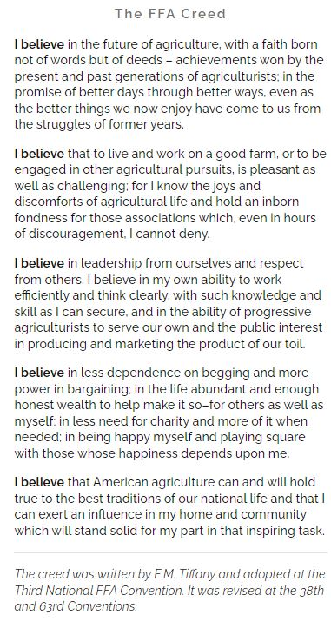
Which value do you resonate with the most?

Why?
What application does the FFA Creed have to you?
What role do you think the FFA Creed plays in the overall organization?

Directions:
Create a shield that represents your own personal creed.

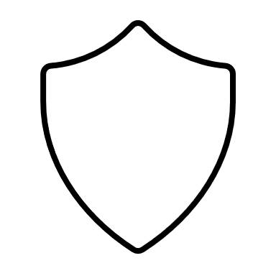
Part 4
Directions:
Develop three scenarios in which your values would drive how you would react and how a friend may react based on their values. Use the values that were hung up around the classroom to inform yourself about the values of your classmates.
Scenario | My First Reaction to This Scenario | My Reaction Based on My Values | A Classmate’s Reaction Based on Their Values
Example: Your best friend posted a picture of their family on the beach in Mexico on social media. | I value family, and I appreciate that a classmate is enjoying time with their family. | Family is important to me, and I understand when family comes first for others. | I value travel and world view so I appreciate that someone is in Mexico to experience a different culture.

How can your personal values impact your future career?

Exit Ticket:

What are values?

What are two ways values impact our understanding of others?

What are three ways values play a role in our day-to-day lives?
1.

2.

3.

