Appendix 1: Committed to Constant Improvement
Aligned to the following standards: CS.02, CS.06, FFA.PL-E, FFA.CS-M, FFA.CS-N, CCSS.ELA-Literacy.RI.9-10.1, CCSS.ELA-Literacy.WHST.9.10.6, CCSS.ELA-Literacy.RST.9-10.9, CCSS.ELA-Literacy.SL.9-10.2, CCSS.ELA-Literacy.SL.9-10.4, AGC10.03

Part 1
Directions:
Read the article “Committed to Constant Improvement” in the spring 2023 issue of FFA New Horizons and complete the following questions.

1. What leadership roles did Mr. Ching serve in during his FFA career?
Chapter Level: ____________________________________________________________________________
State Level: _______________________________________________________________________________
National Level: ____________________________________________________________________________

2. How did he make history? ______________________________________________________________________________________

3. Which career pathway did Ching start out in with his family’s business? Highlight the pathway below in BLUE.

Agribusiness Systems | Animal Systems | Biotechnology Systems
Plant Systems | Power, Structure, and Technical Systems | Sustainability

4. How did/does Ching inspire others? _________________________________________________________________________________

5. Investigate the purpose of the Hawaii Department of Agriculture (HDOA). What are the main roles and responsibilities of this agency?

Roles:

Responsibilities:

6. What surprised you the most while reading this article? ____________________________________________________________

7. What is one question you still have after reading this article? ________________________________________________________ ________________________________________________________________________________________________________________________

Part 2
Directions:
Learn about Hawaiian agriculture by completing the activities below. In the space below, draw the Hawaiian Islands and then complete the activities in the box below. Utilize the USDA National Agriculture Statistics survey website (https://www.nass.usda.gov/Quick_Stats/Ag_Overview/stateOverview.php?state=HAWAII) and the National Agriculture in the Classroom website (https://agclassroom.org/teacher/agfacts/).

- Label each of the islands of Hawaii.
- Draw a * on the two islands that raise cattle and hogs.
- In blue, shade the two islands that receive snow.
- Identify the island that receives the greatest impact from pineapple production. Draw a pineapple image next to the island.
- In green, shade the island that has a substantial number of dairy and egg farms.



Identify the flower in the image. ______________________________

What connection does it have to Hawaii? _______________________________

Hawaii Agriculture | Topic to Compare | Your State: __________________
 | Population
 | Average size farm
 | Total number of farms
 | Total acres in farm operation
 | State average temperature
 | Average annual precipitation
 | Top commodities
 | Acres of coffee grown

*Draw and label the state tree for Hawaii and your own state in the box below.
Hawaii | Your State: _______________________

*Draw and label the state bird for Hawaii and your own state in the box below.
Hawaii | Your State: _______________________

*What is the biggest takeaway for you when comparing Hawaiian agriculture to your own state’s agriculture?

Part 3
Directions:
Now that you have learned a little about Hawaiian agriculture, take your knowledge and put it to use developing a one- page infographic that could be used to enlighten others about agriculture in Hawaii. This infographic should visually represent the agriculture industry of Hawaii and show that there is more to Hawaii than beautiful beaches for vacationing. Use the space below to develop your infographic, and follow your teacher’s instructions for the final format to turn in for this project.

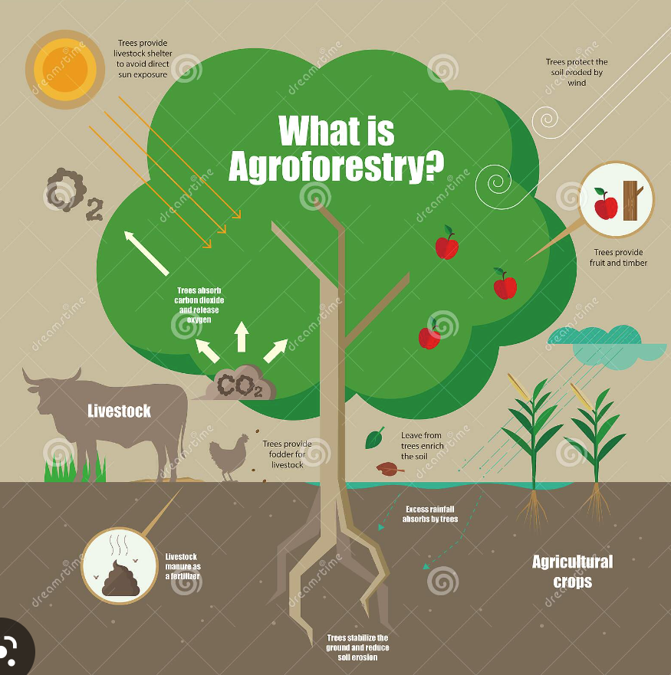
Example Infographic: What to Include:
- Title
- Primarily images and graphics
- Few words — statistics and facts that are short and to the point
- Color — draw attention to the info.
- Organized — easy to view and follow

Brainstorm: Use the box below to help you plan your infographic.

*Use the box below to develop your infographic.

